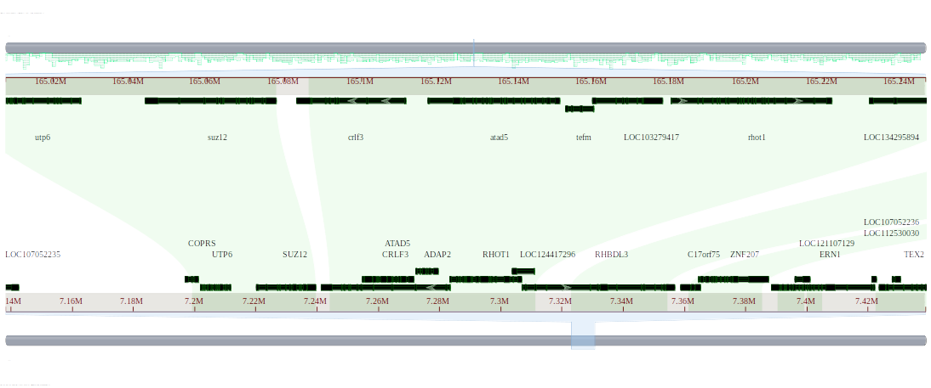
Figure 1. Comparative genome alignment of the genomic region containing the ADAP2 gene in Gallus gallus and the corresponding region in Anolis carolinensis.
This figure shows alignment of the genomic region containing the ADAP2 gene in Gallus gallus (assembly bGalGal1.mat.broiler.GRCg7b: GCF_016699485.2) and the corresponding region in Anolis carolinensis (assembly rAnoCar3.1.pri: GCF_035594765.1) using the NCBI Comparative Genome Viewer. The ADAP2 gene (arf-GAP with dual PH domain-containing protein 2) is located on chromosome 18 of Gallus gallus (Chr18: 7,272,534–7,279,640). No corresponding gene is annotated in the aligned region of Anolis carolinensis.

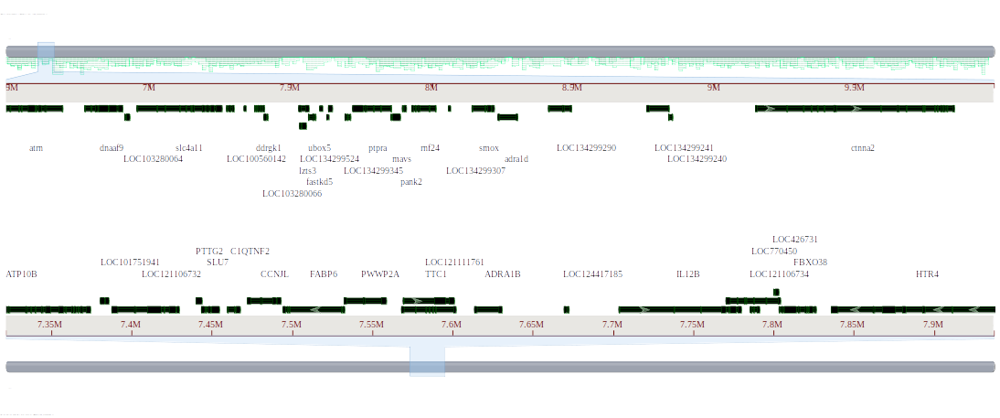
Figure 2. Comparative genome alignment of the genomic region containing the ADRA1B gene in Gallus gallus and the corresponding region in Anolis carolinensis.
This figure shows a focused view of the genomic region containing the ADRA1B gene (alpha-1B adrenergic receptor) in Gallus gallus (assembly bGalGal1.mat.broiler.GRCg7b) and the corresponding region in Anolis carolinensis (assembly rAnoCar3.1.pri) using the NCBI Comparative Genome Viewer. The ADRA1B gene is located on chromosome 13 of Gallus gallus (Chr13: 7,613,466–7,630,518).
No annotated gene is present in the corresponding Anolis carolinensis region, and no visible alignments were detected in this genomic region.

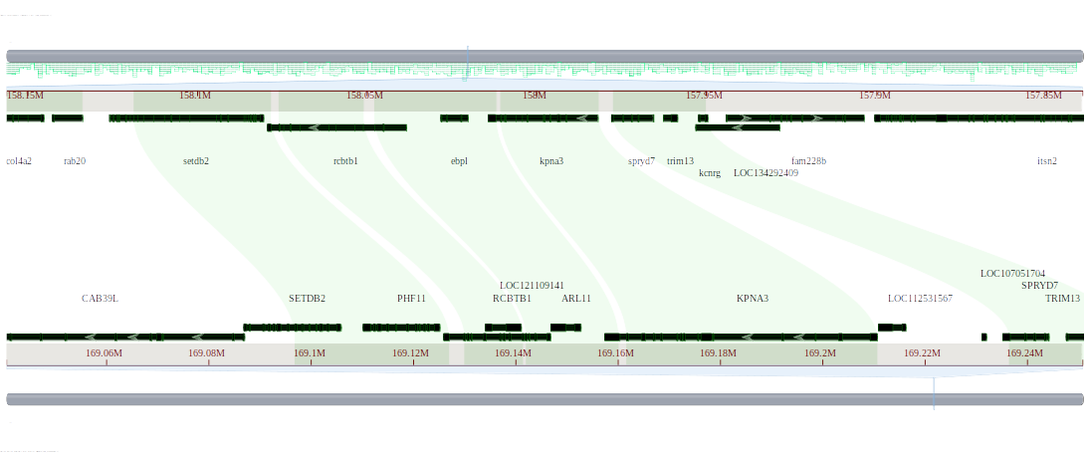
Figure 3. Comparative genome alignment of the genomic region containing the ARL11 gene in Gallus gallus and the corresponding region in Anolis carolinensis.
This figure shows a focused genome alignment of the ARL11 gene region (ADP-ribosylation factor-like protein 11 isoform X2) in Gallus gallus (assembly bGalGal1.mat.broiler.GRCg7b) and the corresponding region in Anolis carolinensis (assembly rAnoCar3.1.pri) using the NCBI Comparative Genome Viewer. The ARL11 gene is located on chromosome 1 of Gallus gallus (Chr1: 169,146,947–169,152,771). No corresponding gene is annotated in the aligned region of Anolis carolinensis.

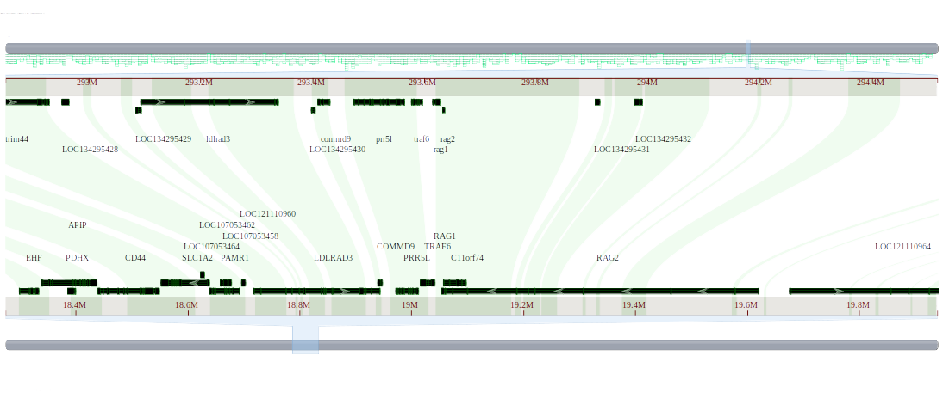
Figure 4. Comparative genome alignment of the genomic region containing the C11orf74 gene in Gallus gallus and the corresponding region in Anolis carolinensis.
This figure shows a focused genome alignment of the C11orf74 gene region (C11orf74 homolog) in Gallus gallus (assembly bGalGal1.mat.broiler.GRCg7b) and its corresponding region in Anolis carolinensis (assembly rAnoCar3.1.pri), using the NCBI Comparative Genome Viewer. The C11orf74 gene is located on chromosome 5 of Gallus gallus (Chr5: 19,057,069–19,096,454). No annotated gene is detected in the aligned region of Anolis carolinensis.

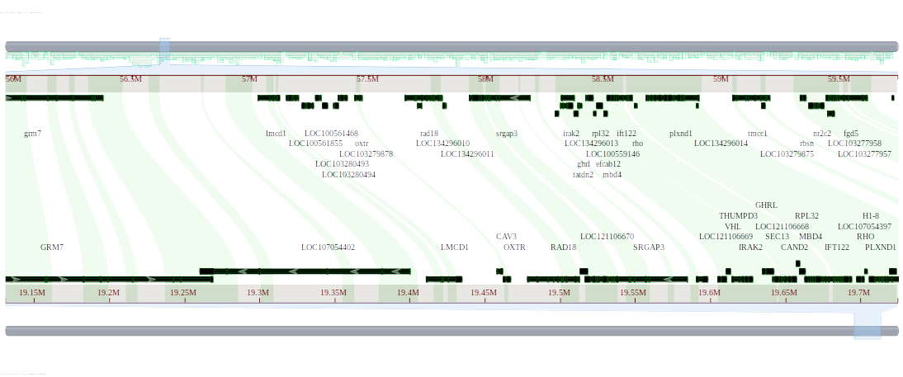
Figure 5. Comparative genome alignment of the genomic region containing the CAV3 gene in Gallus gallus and the corresponding region in Anolis carolinensis.
This figure shows a focused genome alignment of the CAV3 gene region (caveolin 3) in Gallus gallus (assembly bGalGal1.mat.broiler.GRCg7b) and its corresponding region in Anolis carolinensis (assembly rAnoCar3.1.pri), visualized using the NCBI Comparative Genome Viewer. The CAV3 gene is located on chromosome 12 of Gallus gallus (Chr12: 19,458,124–19,461,512). No annotated gene is present in the corresponding region of Anolis carolinensis.

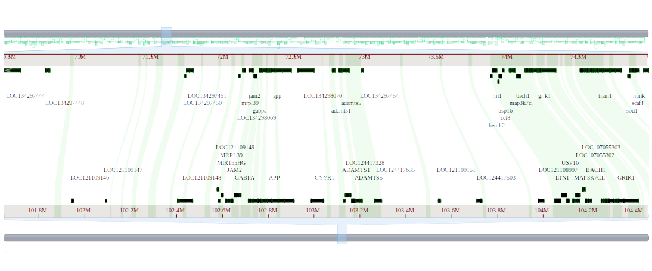
Figure 6. Comparative genome alignment of the genomic region containing the CYYR1 gene in Gallus gallus and the corresponding region in Anolis carolinensis.
This figure shows a focused genome alignment of the CYYR1 gene region (cysteine and tyrosine-rich protein 1 isoform X1) in Gallus gallus (assembly bGalGal1.mat.broiler.GRCg7b) and its corresponding region in Anolis carolinensis (assembly rAnoCar3.1.pri), using the NCBI Comparative Genome Viewer. The CYYR1 gene is located on chromosome 1 of Gallus gallus (Chr1: 102,985,156–103,041,917). No corresponding gene is detected in the aligned region of Anolis carolinensis.
Green lines indicate forward alignments, showing conserved genomic segments that are aligned in the same orientation in both species. This suggests structural conservation in the CYYR1 locus between Gallus gallus and Anolis carolinensis.

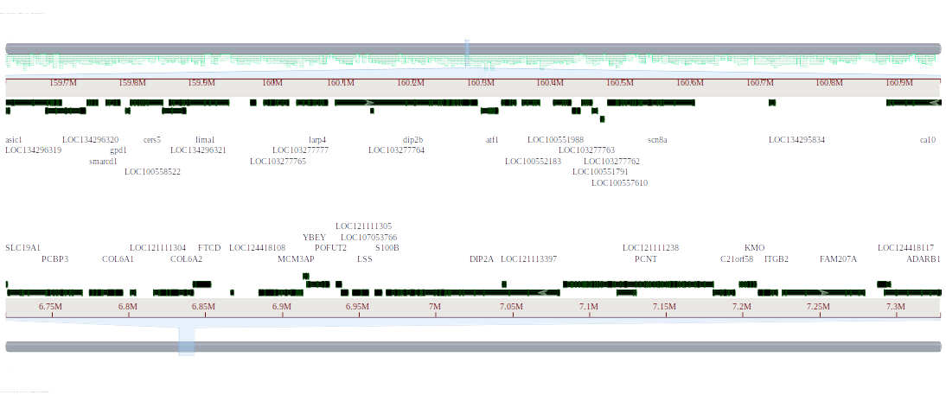
Figure 7. Comparative genome alignment of the genomic region containing the DIP2A gene in Gallus gallus and the corresponding region in Anolis carolinensis.
This figure shows a focused genome alignment of the DIP2A gene region (disco-interacting protein 2 homolog A isoform X4) in Gallus gallus (assembly bGalGal1.mat.broiler.GRCg7b) and the corresponding region in Anolis carolinensis (assembly rAnoCar3.1.pri) using the NCBI Comparative Genome Viewer. The DIP2A gene is located on chromosome 7 of Gallus gallus (Chr7: 6,968,238–7,080,552).
No gene annotation or alignment was detected in the corresponding region of Anolis carolinensis, as indicated by the absence of visible alignments.

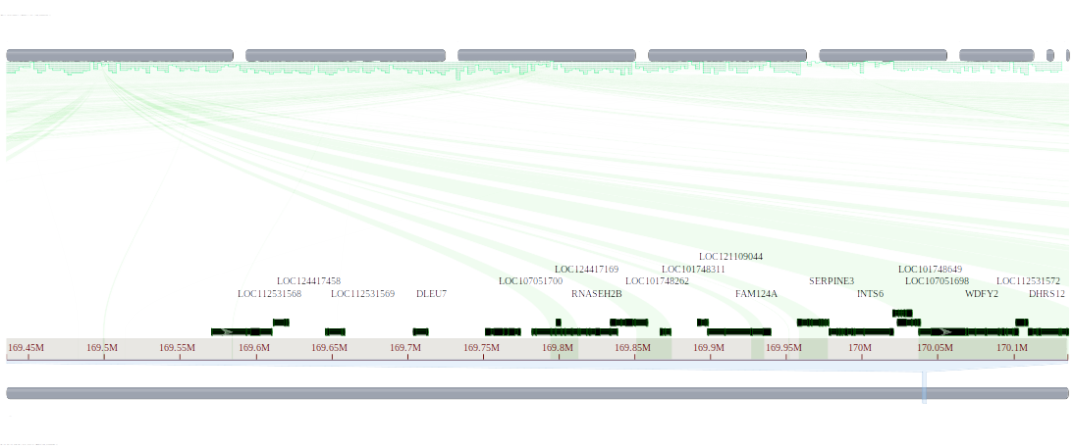
Figure 8. Comparative genome alignment of the genomic region containing the DLEU7 gene in Gallus gallus and the corresponding region in Anolis carolinensis.
This figure shows alignment of the genomic region containing the DLEU7 gene (leukemia-associated protein 7) in Gallus gallus (assembly bGalGal1.mat.broiler.GRCg7b: GCF_016699485.2) and the corresponding region in Anolis carolinensis (assembly rAnoCar3.1.pri: GCF_035594765.1) using the NCBI Comparative Genome Viewer. The DLEU7 gene is located on chromosome 1 of Gallus gallus (Chr1: 169,704,013–169,713,454). No corresponding gene is annotated in the aligned region of Anolis carolinensis.

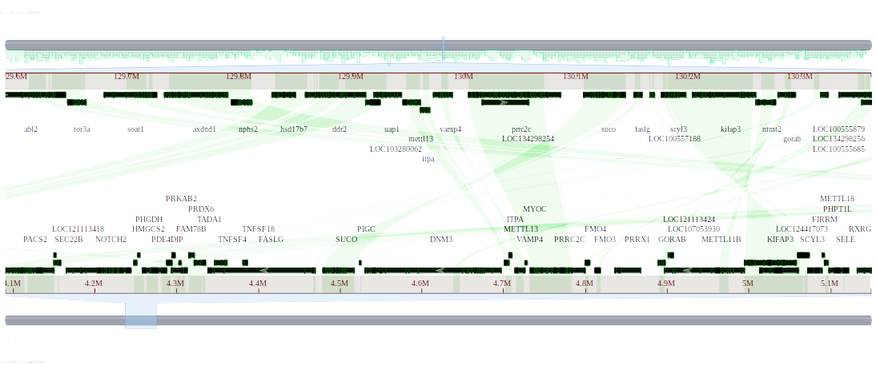
Figure 9. Comparative genome alignment of the genomic region containing the DNM3 gene in Gallus gallus and the corresponding region in Anolis carolinensis.
This figure shows alignment of the genomic region containing the DNM3 gene (dynamin-3 isoform X14) in Gallus gallus (assembly bGalGal1.mat.broiler.GRCg7b: GCF_016699485.2) and the corresponding region in Anolis carolinensis (assembly rAnoCar3.1.pri: GCF_035594765.1) using the NCBI Comparative Genome Viewer. The DNM3 gene is located on chromosome 8 of Gallus gallus (Chr8: 4,530,786–4,697,586). No corresponding gene is annotated in the aligned region of Anolis carolinensis.

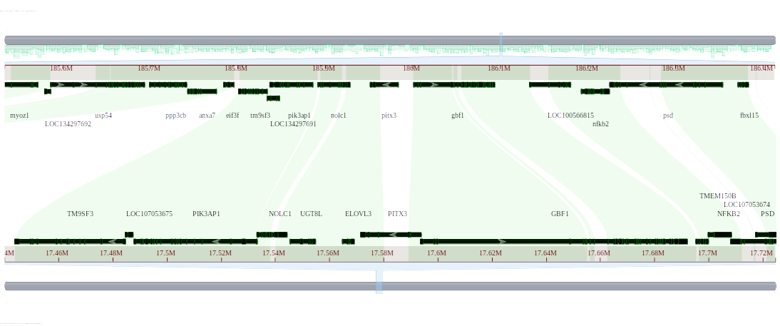
Figure 10. Comparative genome alignment of the genomic region containing the ELOVL3 gene in Gallus gallus and the corresponding region in Anolis carolinensis.
This figure shows alignment of the genomic region containing the ELOVL3 gene (ELOVL fatty acid elongase 3) in Gallus gallus (assembly bGalGal1.mat.broiler.GRCg7b: GCF_016699485.2) and the corresponding region in Anolis carolinensis (assembly rAnoCar3.1.pri: GCF_035594765.1) using the NCBI Comparative Genome Viewer. The ELOVL3 gene is located on chromosome 6 of Gallus gallus (Chr6: 17,564,778–17,569,174). No corresponding gene is annotated in the aligned region of Anolis carolinensis.

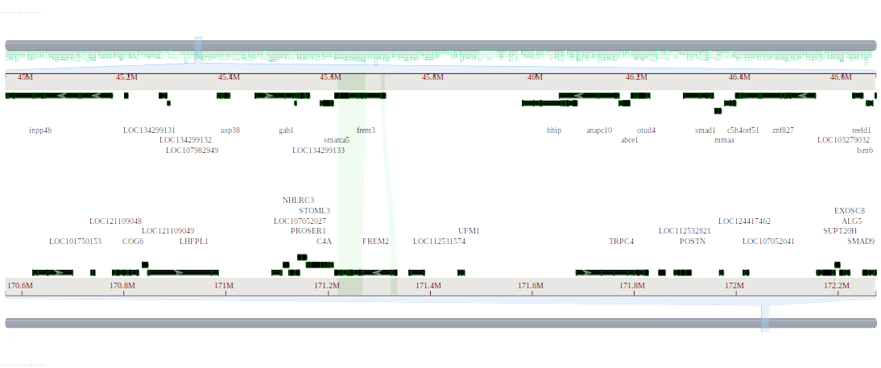
Figure 11. Comparative genome alignment of the genomic region containing the FREM2 gene in Gallus gallus and the corresponding region in Anolis carolinensis.
This figure shows alignment of the genomic region containing the FREM2 gene (FRAS1-related extracellular matrix protein 2) in Gallus gallus (assembly bGalGal1.mat.broiler.GRCg7b: GCF_016699485.2) and the corresponding region in Anolis carolinensis (assembly rAnoCar3.1.pri: GCF_035594765.1) using the NCBI Comparative Genome Viewer. The FREM2 gene is located on chromosome 1 of Gallus gallus (Chr1: 171,213,674–171,335,742). No corresponding gene is annotated in the aligned region of Anolis carolinensis.
Green lines represent forward alignments (regions with the same orientation in both genomes), while purple lines represent reverse alignments (regions aligned in opposite orientation).

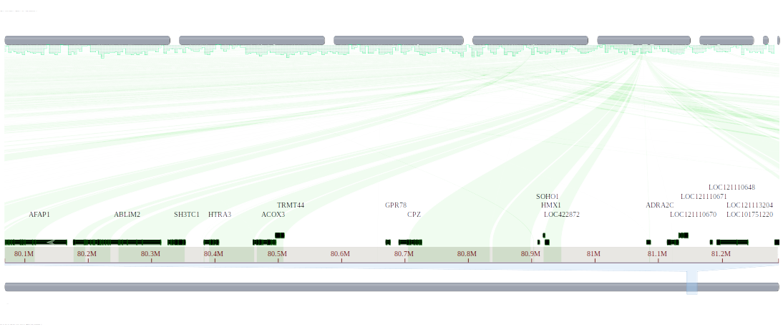
Figure 12. Comparative genome alignment of the genomic region containing the GPR78 gene in Gallus gallus and the corresponding region in Anolis carolinensis.
This figure shows alignment of the genomic region containing the GPR78 gene (G-protein coupled receptor 78) in Gallus gallus (assembly bGalGal1.mat.broiler.GRCg7b: GCF_016699485.2) and the corresponding region in Anolis carolinensis (assembly rAnoCar3.1.pri: GCF_035594765.1) using the NCBI Comparative Genome Viewer. The GPR78 gene is located on chromosome 4 of Gallus gallus (Chr4: 80,670,212–80,677,171). No corresponding gene is annotated in the aligned region of Anolis carolinensis.

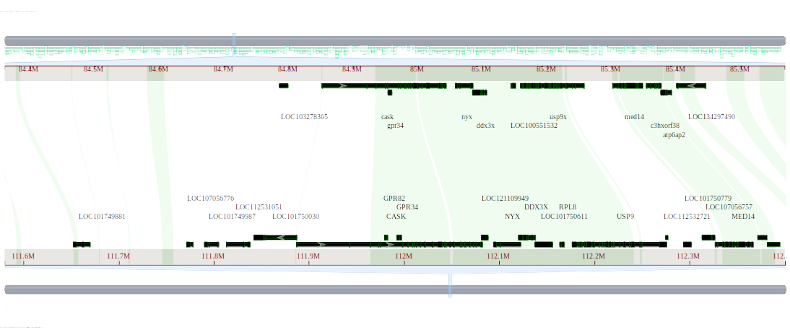
Figure 13. Comparative genome alignment of the genomic region containing the GPR82 gene in Gallus gallus and the corresponding region in Anolis carolinensis.
This figure shows alignment of the genomic region containing the GPR82 gene (probable G-protein coupled receptor 82) in Gallus gallus (assembly bGalGal1.mat.broiler.GRCg7b: GCF_016699485.2) and the corresponding region in Anolis carolinensis (assembly rAnoCar3.1.pri: GCF_035594765.1) using the NCBI Comparative Genome Viewer. The GPR82 gene is located on chromosome 1 of Gallus gallus (Chr1: 111,979,663–111,982,516). No corresponding gene is annotated in the aligned region of Anolis carolinensis.

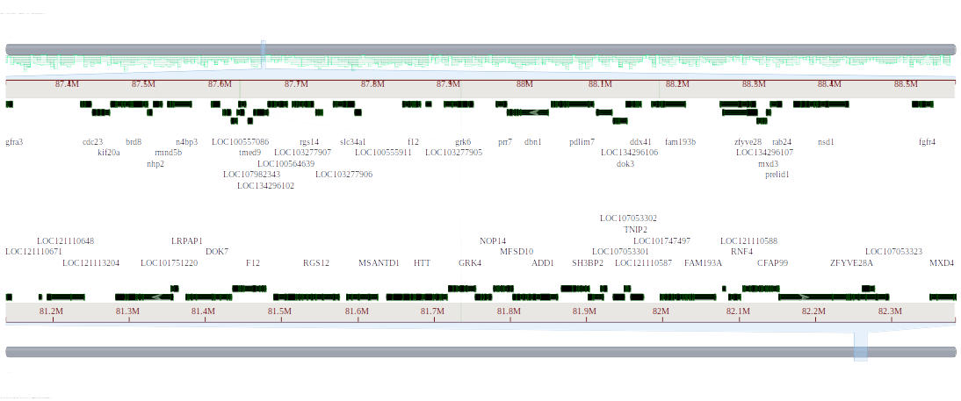
Figure 14. Comparative genome alignment of the genomic region containing the GRK4 gene in Gallus gallus and the corresponding region in Anolis carolinensis.
This figure shows alignment of the genomic region containing the GRK4 gene (G protein-coupled receptor kinase 4) in Gallus gallus (assembly bGalGal1.mat.broiler.GRCg7b: GCF_016699485.2) and the corresponding region in Anolis carolinensis (assembly rAnoCar3.1.pri: GCF_035594765.1) using the NCBI Comparative Genome Viewer. The GRK4 gene is located on chromosome 4 of Gallus gallus (Chr4: 81,719,570–81,754,068). No corresponding gene is annotated in the aligned region of Anolis carolinensis.

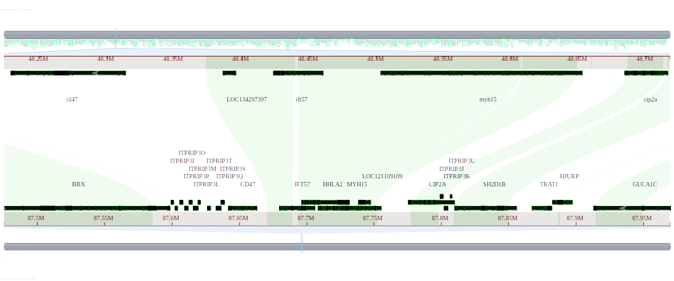
Figure 15. Comparative genome alignment of the genomic region containing the HHLA2 gene in Gallus gallus and the corresponding region in Anolis carolinensis.
This figure shows alignment of the genomic region containing the HHLA2 gene (HERV-H LTR-associating protein 2 isoform X1) in Gallus gallus (assembly bGalGal1.mat.broiler.GRCg7b: GCF_016699485.2) and the corresponding region in Anolis carolinensis (assembly rAnoCar3.1.pri: GCF_035594765.1) using the NCBI Comparative Genome Viewer. The HHLA2 gene is located on chromosome 1 of Gallus gallus (Chr1: 87,696,608–87,731,926). No corresponding gene is annotated in the aligned region of Anolis carolinensis.

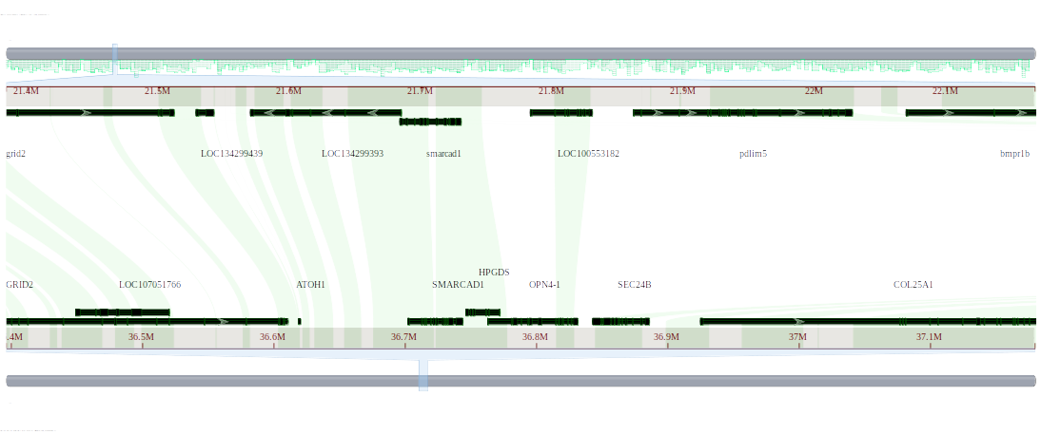

Figure 16. Comparative genome alignment of the genomic region containing the HPGDS gene in Gallus gallus and the corresponding region in Anolis carolinensis.
This figure shows alignment of the genomic region containing the HPGDS gene (hematopoietic prostaglandin D synthase) in Gallus gallus (assembly bGalGal1.mat.broiler.GRCg7b: GCF_016699485.2) and the corresponding region in Anolis carolinensis (assembly rAnoCar3.1.pri: GCF_035594765.1) using the NCBI Comparative Genome Viewer. The HPGDS gene is located on chromosome 4 of Gallus gallus (Chr4: 36,746,784–36,772,199). No corresponding gene is annotated in the aligned region of Anolis carolinensis.

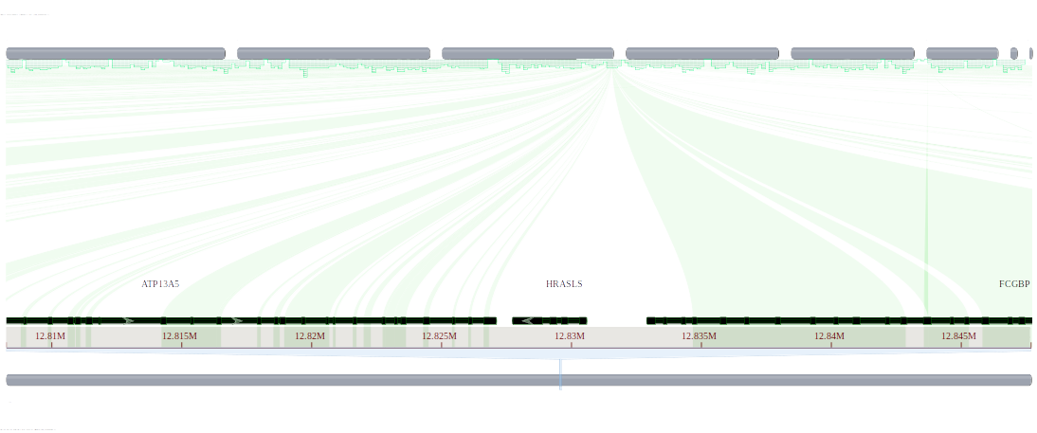
Figure 17. Comparative genome alignment of the genomic region containing the HRASLS gene in Gallus gallus and the corresponding region in Anolis carolinensis.
This figure shows alignment of the genomic region containing the HRASLS gene (phospholipase A and acyltransferase 1 isoform X1) in Gallus gallus (assembly bGalGal1.mat.broiler.GRCg7b: GCF_016699485.2) and the corresponding region in Anolis carolinensis (assembly rAnoCar3.1.pri: GCF_035594765.1) using the NCBI Comparative Genome Viewer. The HRASLS gene is located on chromosome 9 of Gallus gallus (Chr9: 12,827,756–12,830,575). No corresponding gene is annotated in the aligned region of Anolis carolinensis.

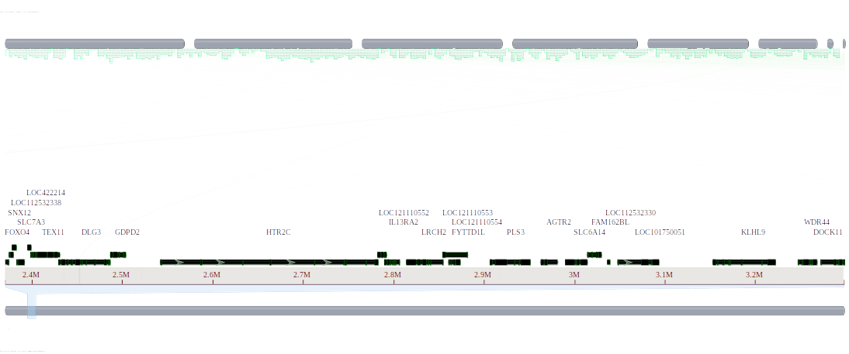
Figure 18. Comparative genome alignment of the genomic region containing the IL13RA2 gene in Gallus gallus and the corresponding region in Anolis carolinensis.
This figure shows alignment of the genomic region containing the IL13RA2 gene (interleukin 13 receptor subunit alpha 2) in Gallus gallus (assembly bGalGal1.mat.broiler.GRCg7b: GCF_016699485.2) and the corresponding region in Anolis carolinensis (assembly rAnoCar3.1.pri: GCF_035594765.1) using the NCBI Comparative Genome Viewer. The IL13RA2 gene is located on chromosome 4 of Gallus gallus (Chr4: 2,790,286–2,806,275). No corresponding gene is annotated in the aligned region of Anolis carolinensis.

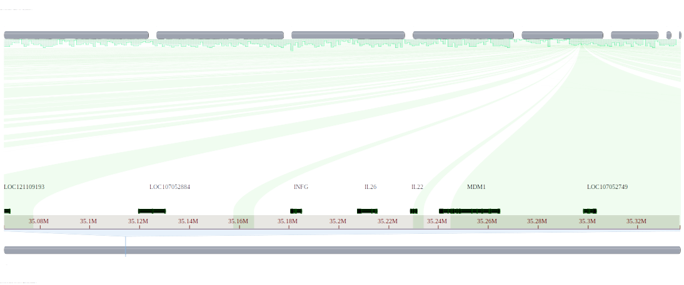
Figure 19. Comparative genome alignment of the genomic region containing the IL26 gene in Gallus gallus and the corresponding region in Anolis carolinensis.
This figure shows alignment of the genomic region containing the IL26 gene (interleukin 26) in Gallus gallus (assembly bGalGal1.mat.broiler.GRCg7b: GCF_016699485.2) and the corresponding region in Anolis carolinensis (assembly rAnoCar3.1.pri: GCF_035594765.1) using the NCBI Comparative Genome Viewer. The IL26 gene is located on chromosome 1 of Gallus gallus (Chr1: 35,207,551–35,215,479). No corresponding gene is annotated in the aligned region of Anolis carolinensis.

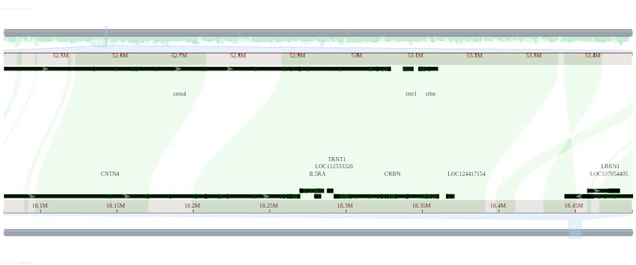
Figure 20. Comparative genome alignment of the genomic region containing the IL5RA gene in Gallus gallus and the corresponding region in Anolis carolinensis.
This figure shows alignment of the genomic region containing the IL5RA gene (interleukin 5 receptor subunit alpha) in Gallus gallus (assembly bGalGal1.mat.broiler.GRCg7b: GCF_016699485.2) and the corresponding region in Anolis carolinensis (assembly rAnoCar3.1.pri: GCF_035594765.1) using the NCBI Comparative Genome Viewer. The IL5RA gene is located on chromosome 12 of Gallus gallus (Chr12: 18,269,804–18,285,446). No corresponding gene is annotated in the aligned region of Anolis carolinensis.

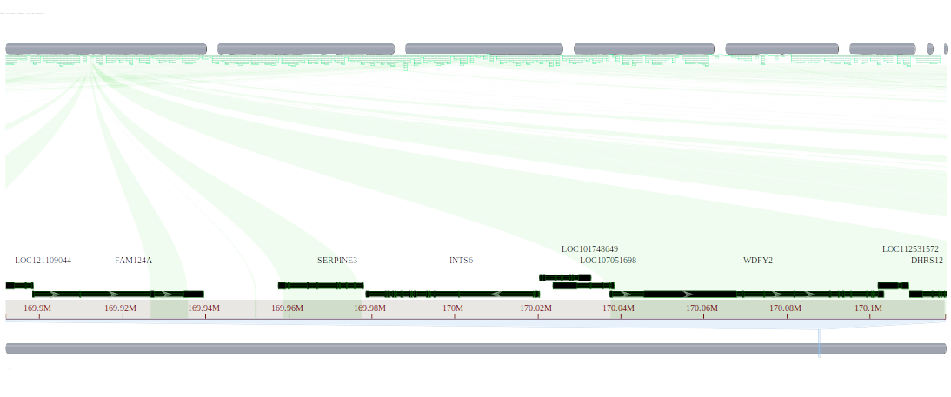
Figure 21. Comparative genome alignment of the genomic region containing the INTS6 gene in Gallus gallus and the corresponding region in Anolis carolinensis.
This figure shows alignment of the genomic region containing the INTS6 gene (integrator complex subunit 6 isoform X1) in Gallus gallus (assembly bGalGal1.mat.broiler.GRCg7b: GCF_016699485.2) and the corresponding region in Anolis carolinensis (assembly rAnoCar3.1.pri: GCF_035594765.1) using the NCBI Comparative Genome Viewer. The INTS6 gene is located on chromosome 1 of Gallus gallus (Chr1: 169,978,669–170,020,436). No corresponding gene is annotated in the aligned region of Anolis carolinensis.

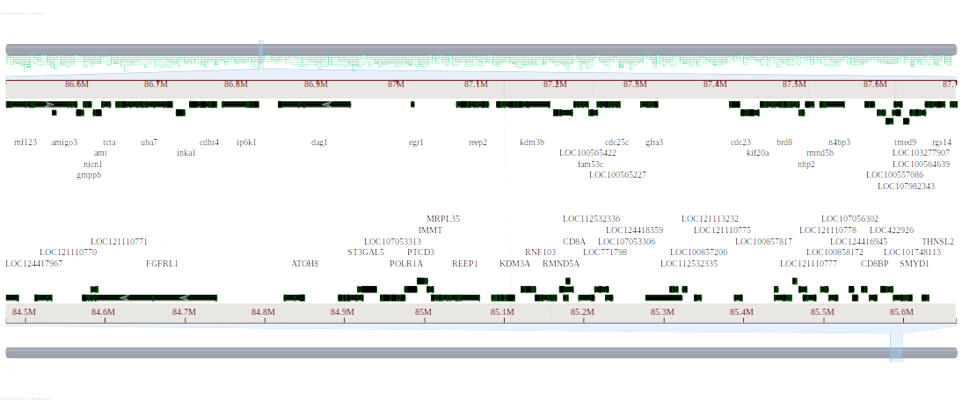
Figure 22. Comparative genome alignment of the genomic region containing the KDM3A gene in Gallus gallus and the corresponding region in Anolis carolinensis.
This figure shows alignment of the genomic region containing the KDM3A gene (lysine demethylase 3A) in Gallus gallus (assembly bGalGal1.mat.broiler.GRCg7b: GCF_016699485.2) and the corresponding region in Anolis carolinensis (assembly rAnoCar3.1.pri: GCF_035594765.1) using the NCBI Comparative Genome Viewer. The KDM3A gene is located on chromosome 4 of Gallus gallus (Chr4: 85,084,875–85,113,033). No corresponding gene is annotated in the aligned region of Anolis carolinensis.

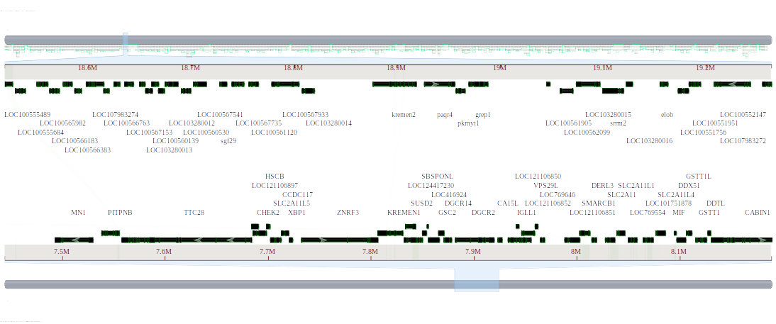
Figure 23. Comparative genome alignment of the genomic region containing the KREMEN1 gene in Gallus gallus and the corresponding region in Anolis carolinensis.
This figure shows alignment of the genomic region containing the KREMEN1 gene (kremen protein 1) in Gallus gallus (assembly bGalGal1.mat.broiler.GRCg7b: GCF_016699485.2) and the corresponding region in Anolis carolinensis (assembly rAnoCar3.1.pri: GCF_035594765.1) using the NCBI Comparative Genome Viewer. The KREMEN1 gene is located on chromosome 15 of Gallus gallus (Chr15: 7,806,537–7,830,690). No corresponding gene is annotated in the aligned region of Anolis carolinensis.

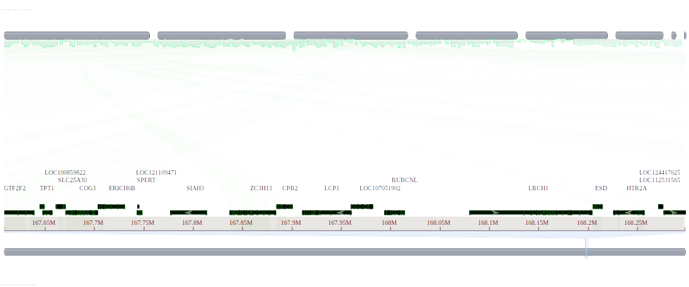

Figure 24. Comparative genome alignment of the genomic region containing the LCP1 gene in Gallus gallus and the corresponding region in Anolis carolinensis.
This figure shows alignment of the genomic region containing the LCP1 gene (ubiquitin like domain containing CTD phosphatase 1) in Gallus gallus (assembly bGalGal1.mat.broiler.GRCg7b: GCF_016699485.2) and the corresponding region in Anolis carolinensis (assembly rAnoCar3.1.pri: GCF_035594765.1) using the NCBI Comparative Genome Viewer. The LCP1 gene is located on chromosome 13 of Gallus gallus (Chr13: 10,216,599–10,229,403), and a corresponding gene is annotated in Anolis carolinensis on chromosome 2 (Chr2: 90,521,382–90,541,731).

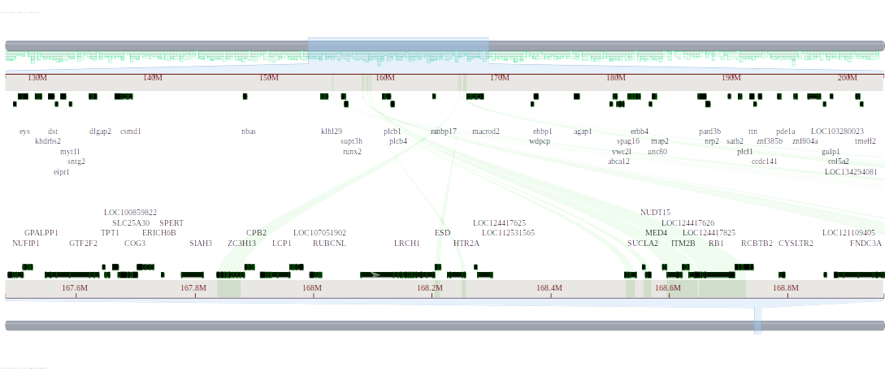

Figure 25. Comparative genome alignment of the genomic region containing the LRCH1 gene in Gallus gallus and the corresponding region in Anolis carolinensis.
This figure shows whole genome alignment between Gallus gallus (assembly bGalGal1.mat.broiler.GRCg7b: GCF_016699485.2) and Anolis carolinensis (assembly rAnoCar3.1.pri: GCF_035594765.1) using the NCBI Comparative Genome Viewer. The LRCH1 gene (leucine-rich repeat and calponin homology domain-containing protein 1 isoform X13) is annotated on chromosome 1 of Gallus gallus (Chr1: 168,080,147–168,204,194). No corresponding gene annotation was found in Anolis carolinensis for this region in the current assembly.

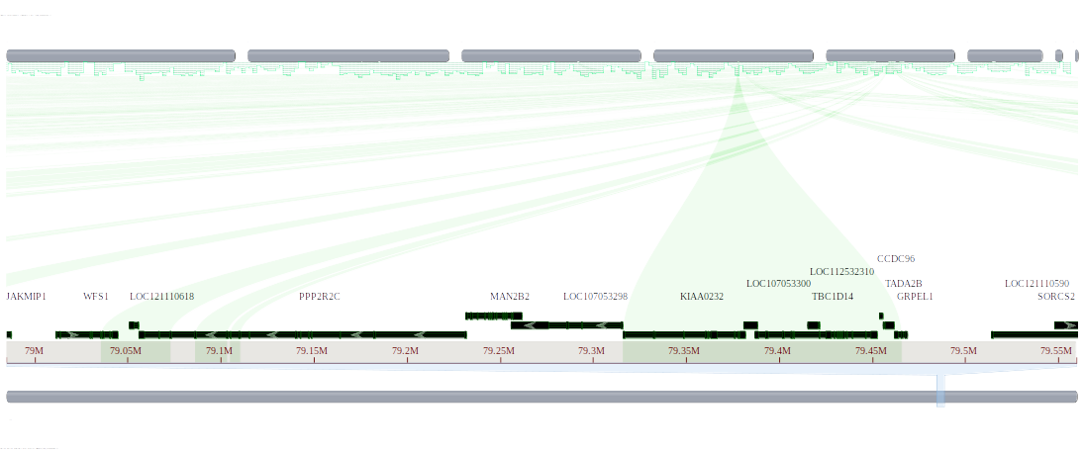
Figure 26. Comparative genome alignment of the genomic region containing the MAN2B2 gene in Gallus gallus and the corresponding region in Anolis carolinensis.
This figure shows whole genome alignment between Gallus gallus (assembly bGalGal1.mat.broiler.GRCg7b: GCF_016699485.2) and Anolis carolinensis (assembly rAnoCar3.1.pri: GCF_035594765.1) using the NCBI Comparative Genome Viewer. The MAN2B2 gene (epididymis-specific alpha-mannosidase) is annotated on chromosome 4 of Gallus gallus (Chr4: 79,231,547–79,261,514). No corresponding gene annotation was found in Anolis carolinensis for this region in the current assembly.

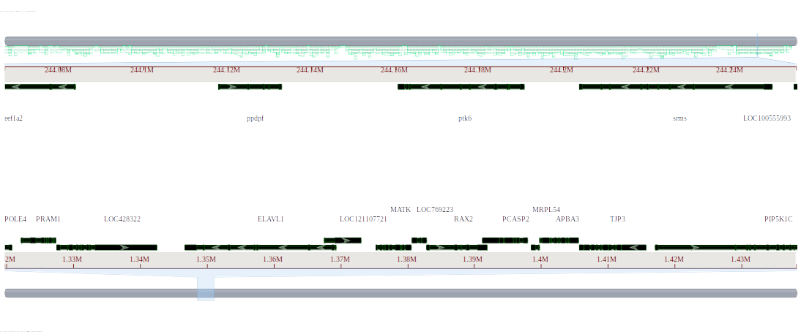
Figure 27. Comparative genome alignment of the genomic region containing the MATK gene in Gallus gallus and the corresponding region in Anolis carolinensis.
This figure shows whole genome alignment between Gallus gallus (assembly bGalGal1.mat.broiler.GRCg7b: GCF_016699485.2) and Anolis carolinensis (assembly rAnoCar3.1.pri: GCF_035594765.1) using the NCBI Comparative Genome Viewer. The MATK gene (megakaryocyte-associated tyrosine-protein kinase isoform X1) is annotated on chromosome 28 of Gallus gallus (Chr28: 1,375,292–1,380,561). No corresponding gene annotation was found in Anolis carolinensis for this region in the current assembly.

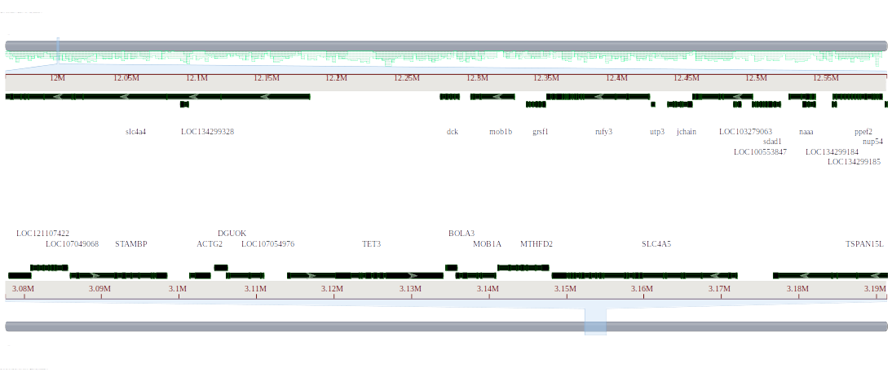
Figure 28. Comparative genome alignment of the genomic region containing the MOB1A gene in Gallus gallus and the corresponding region in Anolis carolinensis.
This figure shows whole genome alignment between Gallus gallus (assembly bGalGal1.mat.broiler.GRCg7b: GCF_016699485.2) and Anolis carolinensis (assembly rAnoCar3.1.pri: GCF_035594765.1) using the NCBI Comparative Genome Viewer. The MOB1A gene (MOB kinase activator 1A) is annotated on chromosome 22 of Gallus gallus (Chr22: 3,135,818–3,140,881). No corresponding gene annotation was found in Anolis carolinensis for this region in the current assembly.

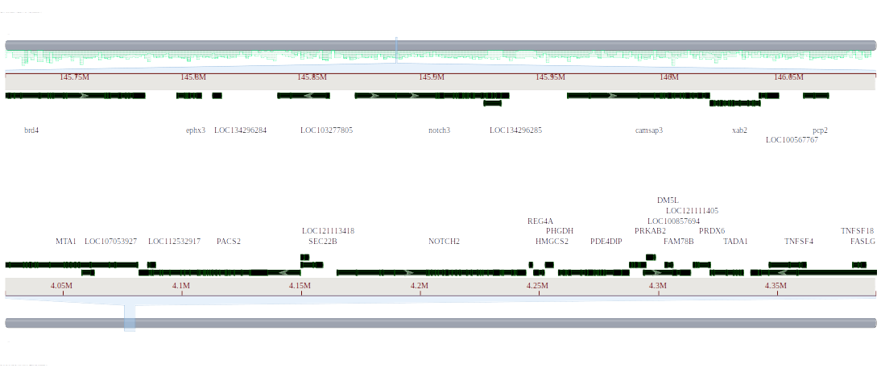
Figure 29. Comparative genome alignment of the genomic region containing the NOTCH2 gene in Gallus gallus.
This figure shows whole genome alignment between Gallus gallus (assembly bGalGal1.mat.broiler.GRCg7b: GCF_016699485.2) and Anolis carolinensis (assembly rAnoCar3.1.pri: GCF_035594765.1) using the NCBI Comparative Genome Viewer. The NOTCH2 gene is annotated on chromosome 8 of Gallus gallus (Chr8: 4,165,167–4,244,193).

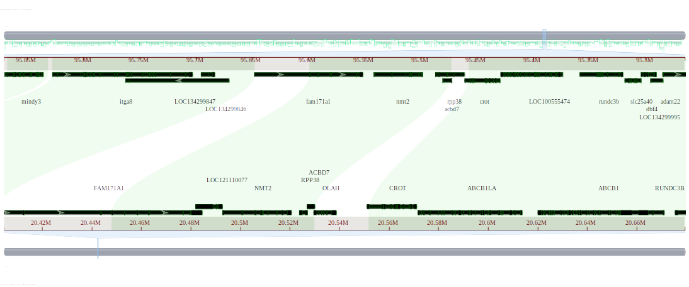
Figure 30. Comparative genome alignment of the genomic region containing the OLAH gene in Gallus gallus and the corresponding region in Anolis carolinensis.
This figure shows whole genome alignment between Gallus gallus (assembly bGalGal1.mat.broiler.GRCg7b: GCF_016699485.2) and Anolis carolinensis (assembly rAnoCar3.1.pri: GCF_035594765.1) using the NCBI Comparative Genome Viewer. The OLAH gene (S-acyl fatty acid synthase thioesterase, medium chain isoform X2) is annotated on chromosome 2 of Gallus gallus (Chr2: 20,529,740–20,538,655). No corresponding gene annotation was found in Anolis carolinensis for this region in the current assembly.

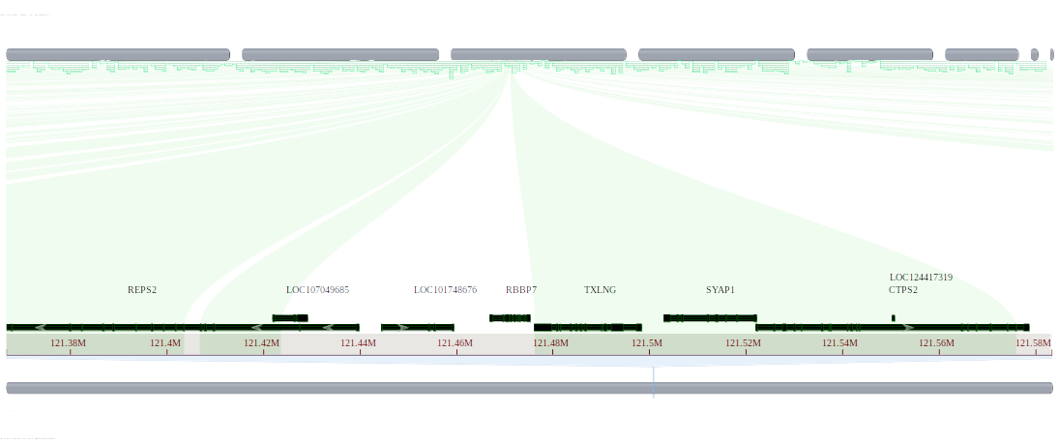
Figure 31. Comparative genome alignment of the genomic region containing the RBBP7 gene in Gallus gallus and the corresponding region in Anolis carolinensis.
This figure shows whole genome alignment between Gallus gallus (assembly bGalGal1.mat.broiler.GRCg7b: GCF_016699485.2) and Anolis carolinensis (assembly rAnoCar3.1.pri: GCF_035594765.1) using the NCBI Comparative Genome Viewer. The RBBP7 gene (RB binding protein 7, chromatin remodeling factor) is annotated on chromosome 1 of Gallus gallus (Chr1: 121,466,984–121,475,207). No corresponding gene annotation was found in Anolis carolinensis for this region in the current assembly.

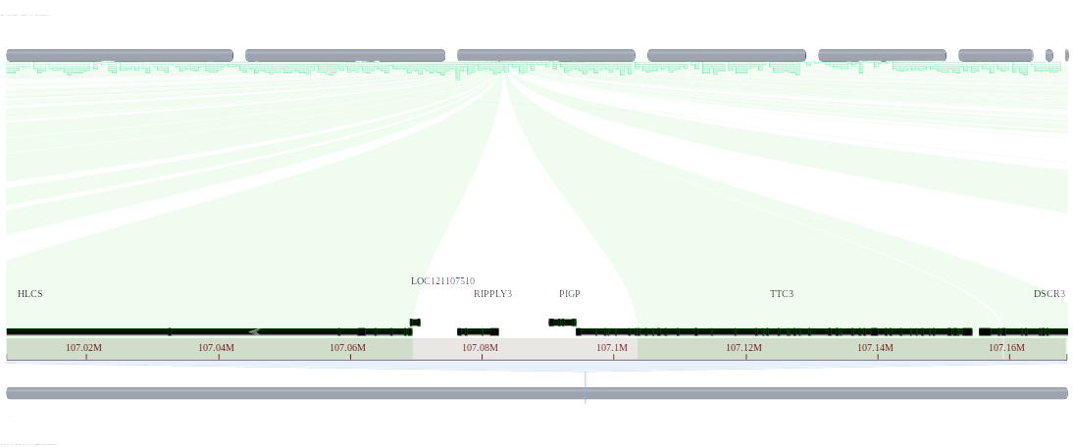
Figure 32. Comparative genome alignment of the genomic region containing the RIPPLY3 gene in Gallus gallus and the corresponding region in Anolis carolinensis.
This figure shows whole genome alignment between Gallus gallus (assembly bGalGal1.mat.broiler.GRCg7b: GCF_016699485.2) and Anolis carolinensis (assembly rAnoCar3.1.pri: GCF_035594765.1) using the NCBI Comparative Genome Viewer. The RIPPLY3 gene (protein ripply3 isoform X1) is annotated on chromosome 1 of Gallus gallus (Chr1: 107,076,338–107,082,448). No corresponding gene annotation was found in Anolis carolinensis for this region in the current assembly.

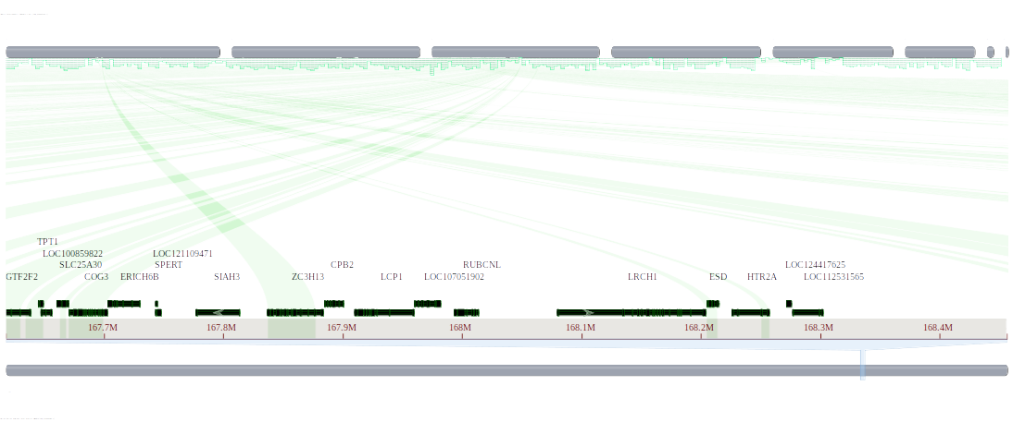
Figure 33. Comparative genome alignment of the genomic region containing the RUBCNL gene in Gallus gallus and the corresponding region in Anolis carolinensis.
This figure shows whole genome alignment between Gallus gallus (assembly bGalGal1.mat.broiler.GRCg7b: GCF_016699485.2) and Anolis carolinensis (assembly rAnoCar3.1.pri: GCF_035594765.1) using the NCBI Comparative Genome Viewer. The RUBCNL gene (protein associated with UVRAG as autophagy enhancer isoform X2) is annotated on chromosome 1 of Gallus gallus (Chr1: 167,993,956–168,013,779). No corresponding gene annotation was found in Anolis carolinensis for this region in the current assembly.

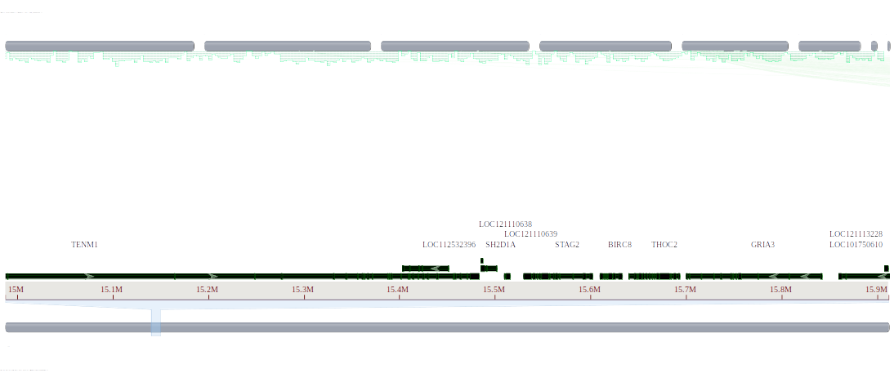
Figure 34. Comparative genome alignment of the genomic region containing the SH2D1A gene in Gallus gallus and the corresponding region in Anolis carolinensis.
This figure shows whole genome alignment between Gallus gallus (assembly bGalGal1.mat.broiler.GRCg7b: GCF_016699485.2) and Anolis carolinensis (assembly rAnoCar3.1.pri: GCF_035594765.1) using the NCBI Comparative Genome Viewer. The SH2D1A gene (SH2 domain-containing protein 1A) is annotated on chromosome 4 of Gallus gallus (Chr4: 15,485,698–15,501,642). No corresponding gene annotation was found in Anolis carolinensis for this region in the current assembly.

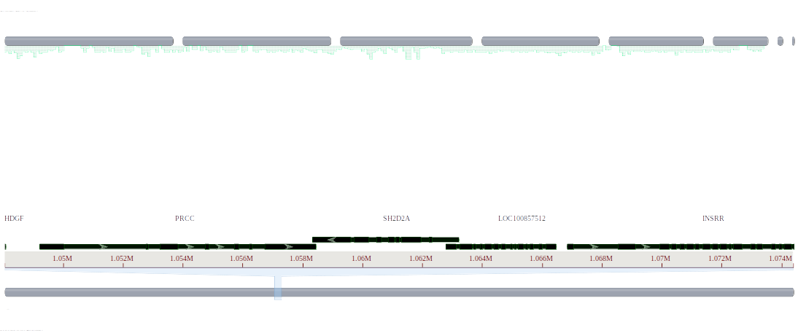
Figure 35. Comparative genome alignment of the genomic region containing the SH2D2A gene in Gallus gallus and the corresponding region in Anolis carolinensis.
This figure shows whole genome alignment between Gallus gallus (assembly bGalGal1.mat.broiler.GRCg7b: GCF_016699485.2) and Anolis carolinensis (assembly rAnoCar3.1.pri: GCF_035594765.1) using the NCBI Comparative Genome Viewer. The SH2D2A gene (SH2 domain-containing protein 2A isoform X1) is annotated on chromosome 25 of Gallus gallus (Chr25: 1,058,344–1,063,205). No corresponding gene annotation was found in Anolis carolinensis for this region in the current assembly.

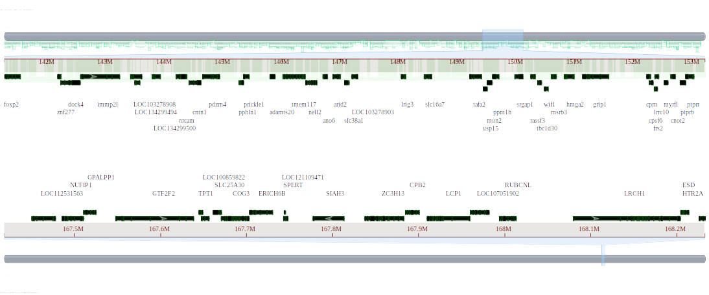
Figure 36. Comparative genome alignment of the genomic region containing the SIAH3 gene in Gallus gallus and the corresponding region in Anolis carolinensis.
This figure shows whole genome alignment between Gallus gallus (assembly bGalGal1.mat.broiler.GRCg7b: GCF_016699485.2) and Anolis carolinensis (assembly rAnoCar3.1.pri: GCF_035594765.1) using the NCBI Comparative Genome Viewer. The SIAH3 gene (seven in absentia homolog 3) is annotated on chromosome 1 of Gallus gallus (Chr1: 167,777,273–167,813,521). No corresponding gene annotation was found in Anolis carolinensis for this region in the current assembly.

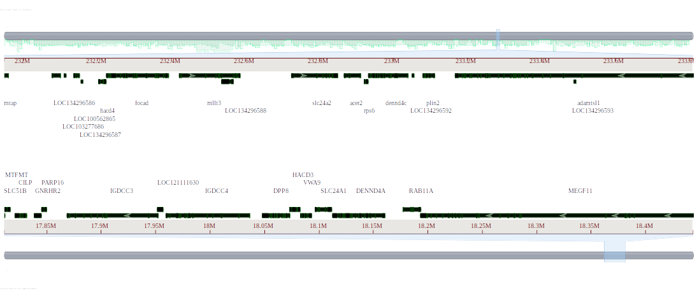
Figure 37. Comparative genome alignment of the genomic region containing the SLC24A1 gene in Gallus gallus and the corresponding region in Anolis carolinensis.
This figure shows whole genome alignment between Gallus gallus (assembly bGalGal1.mat.broiler.GRCg7b: GCF_016699485.2) and Anolis carolinensis (assembly rAnoCar3.1.pri: GCF_035594765.1) using the NCBI Comparative Genome Viewer. The SLC24A1 gene (solute carrier family 24 member 1) is annotated on chromosome 10 of Gallus gallus (Chr10: 18,096,637–18,111,597). No corresponding gene annotation was found in Anolis carolinensis for this region in the current assembly.

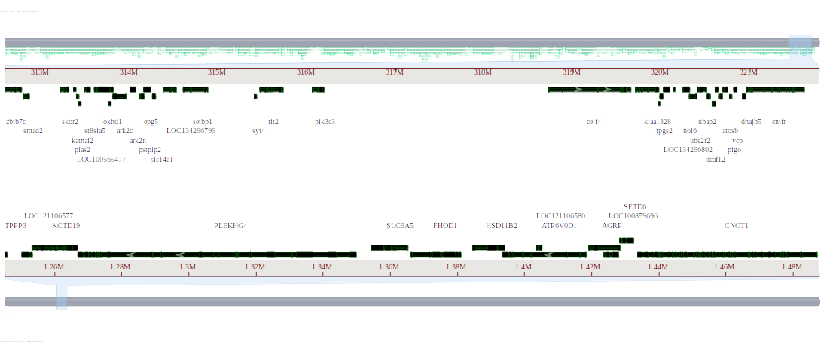
Figure 38. Comparative genome alignment of the genomic region containing the SLC9A5 gene in Gallus gallus and the corresponding region in Anolis carolinensis.
This figure shows whole genome alignment between Gallus gallus (assembly bGalGal1.mat.broiler.GRCg7b: GCF_016699485.2) and Anolis carolinensis (assembly rAnoCar3.1.pri: GCF_035594765.1) using the NCBI Comparative Genome Viewer. The SLC9A5 gene (sodium/hydrogen exchanger 5) is annotated on chromosome 11 of Gallus gallus (Chr11: 1,354,457–1,365,252). No corresponding gene annotation was found in Anolis carolinensis for this region in the current assembly.

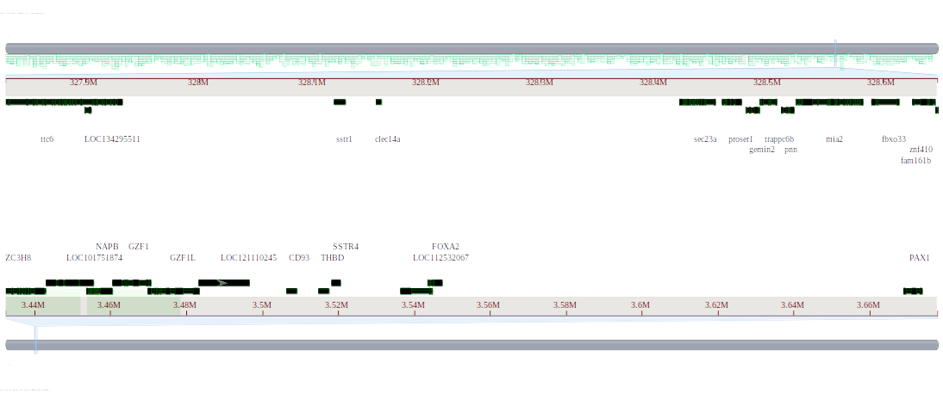
Figure 39. Comparative genome alignment of the genomic region containing the SSTR4 gene in Gallus gallus and the corresponding region in Anolis carolinensis.
This figure shows whole genome alignment between Gallus gallus (assembly bGalGal1.mat.broiler.GRCg7b: GCF_016699485.2) and Anolis carolinensis (assembly rAnoCar3.1.pri: GCF_035594765.1) using the NCBI Comparative Genome Viewer. The SSTR4 gene (somatostatin receptor 4) is annotated on chromosome 3 of Gallus gallus (Chr3: 3,518,339–3,520,480). No corresponding gene annotation was found in Anolis carolinensis for this region in the current assembly.

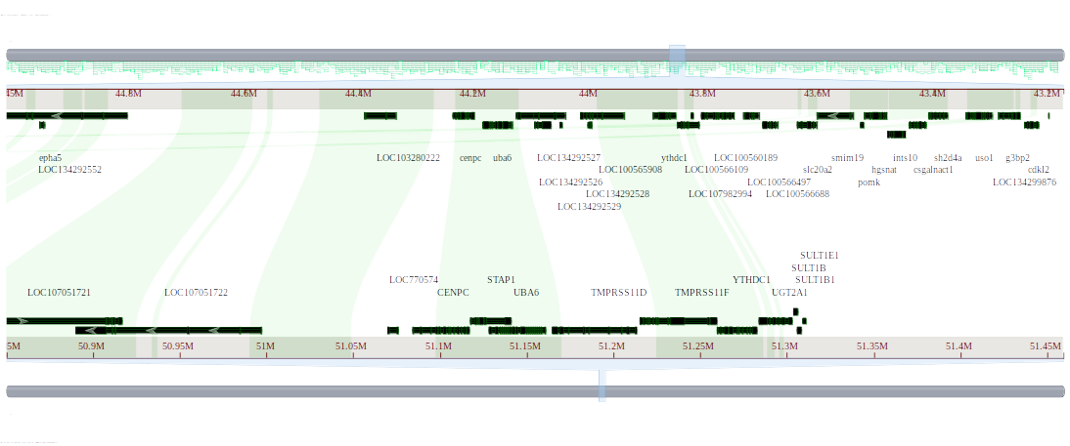
Figure 40. Comparative genome alignment of the genomic region containing the STAP1 gene in Gallus gallus and the corresponding region in Anolis carolinensis.
This figure shows whole genome alignment between Gallus gallus (assembly bGalGal1.mat.broiler.GRCg7b: GCF_016699485.2) and Anolis carolinensis (assembly rAnoCar3.1.pri: GCF_035594765.1) using the NCBI Comparative Genome Viewer. The STAP1 gene (signal-transducing adaptor protein 1) is annotated on chromosome 4 of Gallus gallus (Chr4: 51,117,634–51,140,784). No corresponding gene annotation was found in Anolis carolinensis for this region in the current assembly.

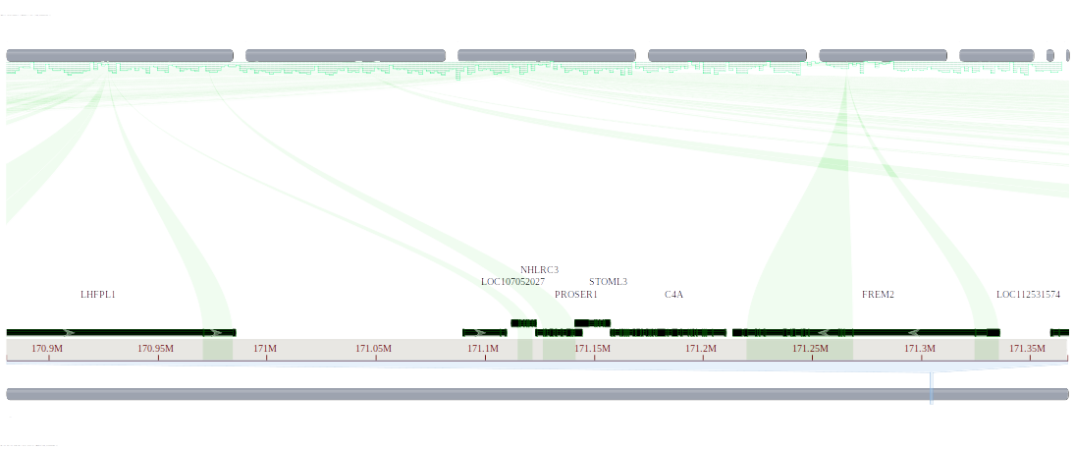
Figure 41. Comparative genome alignment of the genomic region containing the STOML3 gene in Gallus gallus and the corresponding region in Anolis carolinensis.
This figure shows whole genome alignment between Gallus gallus (assembly bGalGal1.mat.broiler.GRCg7b: GCF_016699485.2) and Anolis carolinensis (assembly rAnoCar3.1.pri: GCF_035594765.1) using the NCBI Comparative Genome Viewer. The STOML3 gene (stomatin-like protein 3) is annotated on chromosome 1 of Gallus gallus (Chr1: 171,141,631–171,157,413). No corresponding gene annotation was found in Anolis carolinensis for this region in the current assembly.

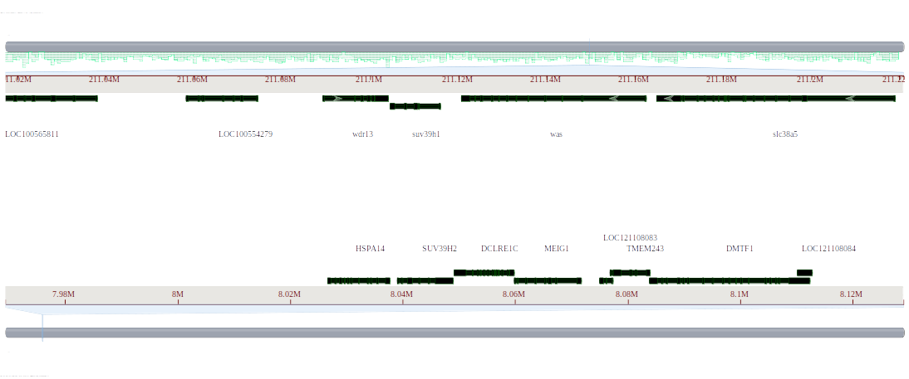
Figure 42. Comparative genome alignment of the SUV39H2 gene in Gallus gallus and the corresponding region in Anolis carolinensis.
This figure presents the whole genome alignment between Gallus gallus (assembly bGalGal1.mat.broiler.GRCg7b: GCF_016699485.2) and Anolis carolinensis (assembly rAnoCar3.1.pri: GCF_035594765.1) using the NCBI Comparative Genome Viewer. The SUV39H2 gene (suppressor of variegation 3-9 homolog 2) is annotated on chromosome 1 of Gallus gallus (Chr1: 8,039,132–8,048,882). No corresponding gene annotation was found in Anolis carolinensis for this genomic region in the current assembly.

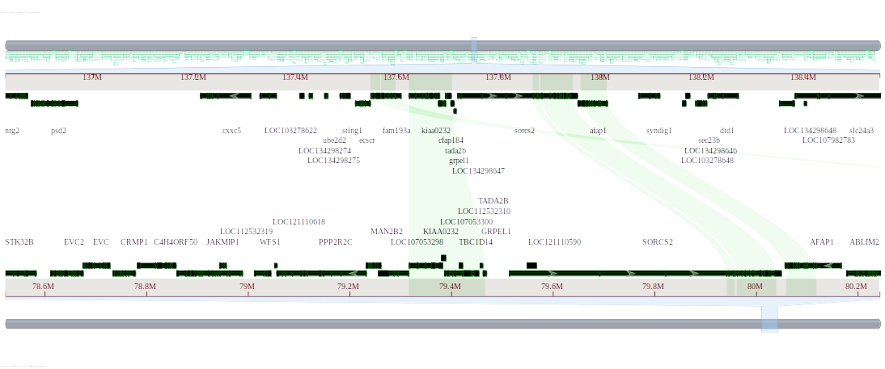
Figure 43. Comparative genome alignment of the TBC1D14 gene in Gallus gallus and the corresponding region in Anolis carolinensis.
This figure shows the whole genome alignment between Gallus gallus (assembly bGalGal1.mat.broiler.GRCg7b: GCF_016699485.2) and Anolis carolinensis (assembly rAnoCar3.1.pri: GCF_035594765.1) using the NCBI Comparative Genome Viewer. The TBC1D14 gene (TBC1 domain family member 14) is annotated on chromosome 4 of Gallus gallus (Chr4: 79,387,287–79,452,683). No corresponding gene was found in Anolis carolinensis for this region in the current assembly.

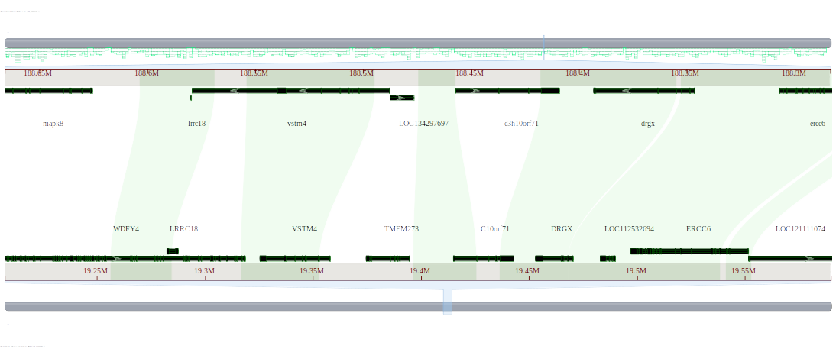
Figure 44. Comparative genome alignment of the C10orf128/TMEM273 gene in Gallus gallus and the corresponding region in Anolis carolinensis.
This figure shows the genome alignment between Gallus gallus (assembly bGalGal1.mat.broiler.GRCg7b: GCF_016699485.2) and Anolis carolinensis (assembly rAnoCar3.1.pri: GCF_035594765.1). The C10orf128 gene (transmembrane protein 273 isoform X3) is located on chromosome 6 of Gallus gallus (Chr6: 19,374,587–19,394,523). There is no corresponding gene identified on the Anolis carolinensis genome in this alignment.

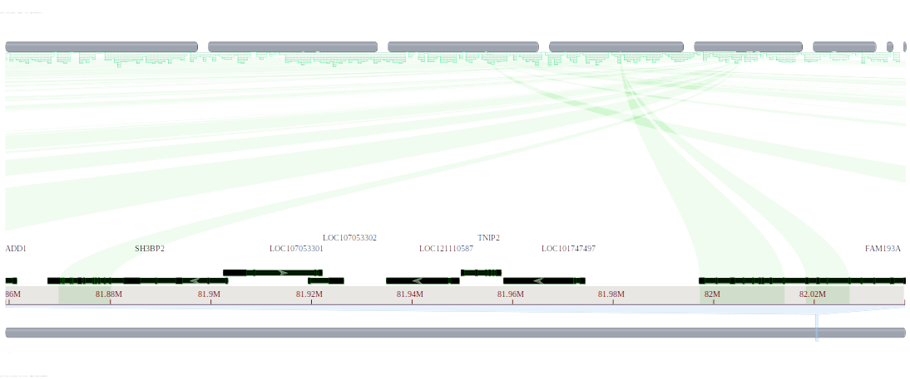
Figure 45. Comparative genome alignment of the TNIP2 gene in Gallus gallus and the corresponding region in Anolis carolinensis.
This figure shows the alignment between Gallus gallus (assembly bGalGal1.mat.broiler.GRCg7b: GCF_016699485.2) and Anolis carolinensis (assembly rAnoCar3.1.pri: GCF_035594765.1). The TNIP2 gene (TNFAIP3 interacting protein 2) is located on chromosome 4 of Gallus gallus (Chr4: 81,949,813–81,957,766). No corresponding gene was identified on the Anolis carolinensis genome in this alignment.

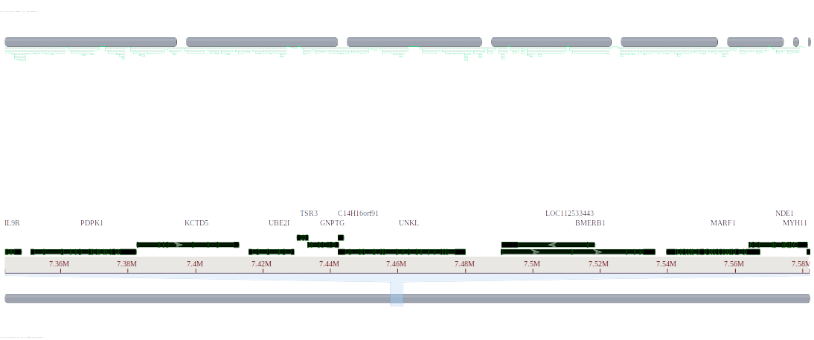
Figure 46. Comparative genome alignment of the UNKL gene in Gallus gallus and the corresponding region in Anolis carolinensis.
This figure shows the alignment of the putative E3 ubiquitin-protein ligase UNKL gene (isoform X3) between Gallus gallus (assembly bGalGal1.mat.broiler.GRCg7b: GCF_016699485.2) and Anolis carolinensis (assembly rAnoCar3.1.pri: GCF_035594765.1). The UNKL gene is located on chromosome 14 of Gallus gallus (Chr14: 7,442,468–7,480,047). No corresponding gene was found in the Anolis carolinensis genome in this alignment.

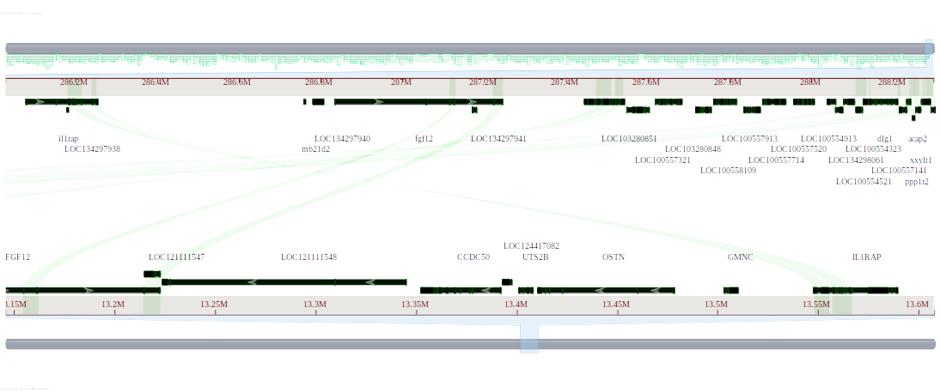
Figure 47. Comparative genome alignment of the UTS2B gene in Gallus gallus and the corresponding region in Anolis carolinensis.
This figure shows the alignment of the UTS2B gene (urotensin 2B) between Gallus gallus (assembly bGalGal1.mat.broiler.GRCg7b: GCF_016699485.2) and Anolis carolinensis (assembly rAnoCar3.1.pri: GCF_035594765.1). The UTS2B gene is located on chromosome 9 of Gallus gallus (Chr9: 13,401,200–13,408,002). No corresponding gene was found in the Anolis carolinensis genome in this alignment.

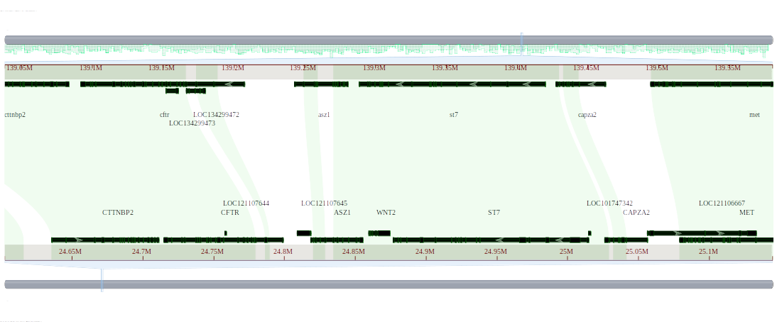
Figure 48. Comparative genome alignment of the WNT2 gene in Gallus gallus and Anolis carolinensis.
This figure shows alignment of the WNT2 gene (protein Wnt-2 isoform X1) between Gallus gallus (assembly bGalGal1.mat.broiler.GRCg7b: GCF_016699485.2) and Anolis carolinensis (assembly rAnoCar3.1.pri: GCF_035594765.1) using the NCBI Comparative Genome Viewer. The WNT2 gene is located on chromosome 26 of Gallus gallus (Chr1: 24,859,642–24,874,657), and a no corresponding gene is annotated in Anolis carolinensis.

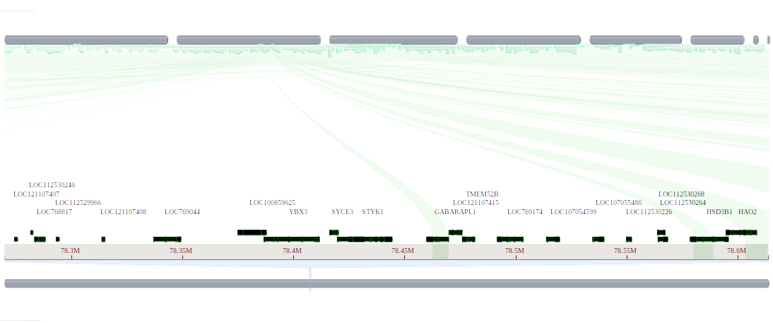
Figure 49. Comparative genome alignment of the YBX3 gene in Gallus gallus and the corresponding region in Anolis carolinensis.
This figure shows the whole genome alignment between Gallus gallus (assembly bGalGal1.mat.broiler.GRCg7b: GCF_016699485.2) and Anolis carolinensis (assembly rAnoCar3.1.pri: GCF_035594765.1) using the NCBI Comparative Genome Viewer. The YBX3 gene (Y-box binding protein 3) is annotated on chromosome 1 of Gallus gallus (Chr1: 78,386,950–78,411,520). No corresponding gene was found in Anolis carolinensis for this region in the current assembly.

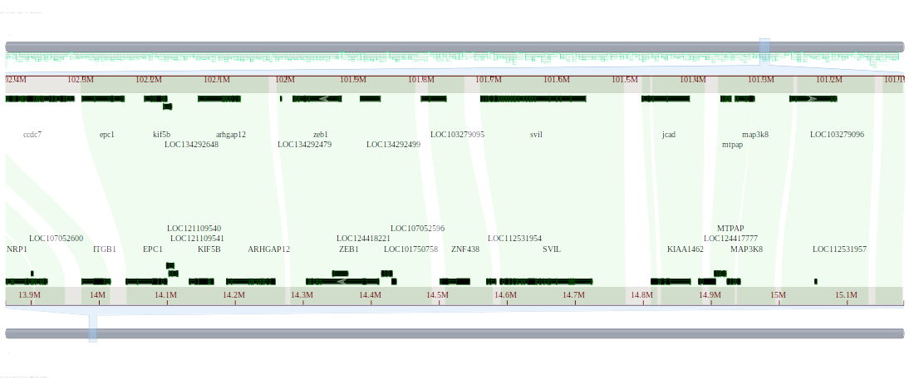
Figure 50. Comparative genome alignment of the ZNF438 gene in Gallus gallus and the corresponding region in Anolis carolinensis.
This figure shows the whole genome alignment between Gallus gallus (assembly bGalGal1.mat.broiler.GRCg7b: GCF_016699485.2) and Anolis carolinensis (assembly rAnoCar3.1.pri: GCF_035594765.1) using the NCBI Comparative Genome Viewer. The ZNF438 gene (zinc finger protein 438 isoform X1) is annotated on chromosome 2 of Gallus gallus (Chr2: 14,502,340–14,545,191). No corresponding gene was found in Anolis carolinensis for this region in the current assembly.

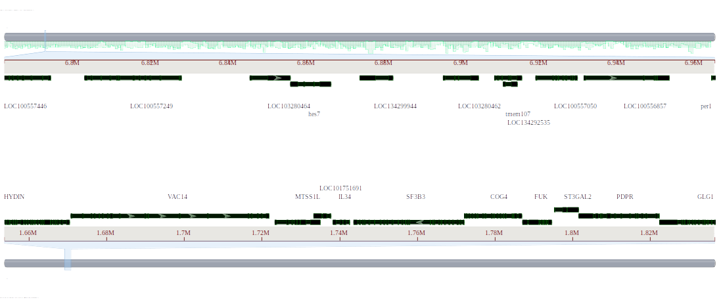
Figure 51. Comparative genome alignment of the IL34 gene in Gallus gallus and the corresponding region in Anolis carolinensis.
This figure shows the whole genome alignment between Gallus gallus (assembly bGalGal1.mat.broiler.GRCg7b: GCF_016699485.2) and Anolis carolinensis (assembly rAnoCar3.1.pri: GCF_035594765.1) using the NCBI Comparative Genome Viewer. The IL34 gene (interleukin-34) is annotated on chromosome 11 of Gallus gallus (Chr11: 1,738,296–1,742,625).

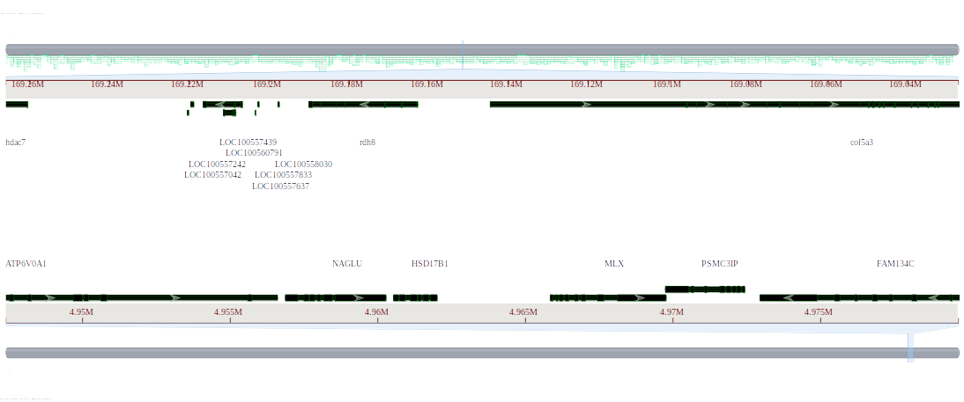
Figure 52. Comparative genome alignment of the HSD17B1 gene in Gallus gallus and the corresponding region in Anolis carolinensis.
This figure presents the whole genome alignment between Gallus gallus (assembly bGalGal1.mat.broiler.GRCg7b: GCF_016699485.2) and Anolis carolinensis (assembly rAnoCar3.1.pri: GCF_035594765.1) using the NCBI Comparative Genome Viewer. The HSD17B1 gene (hydroxysteroid 17-beta dehydrogenase 1) is located on chromosome 27 of Gallus gallus (Chr27: 4,960,560–4,961,998). No corresponding gene or aligned region is detected in the Anolis carolinensis genome.

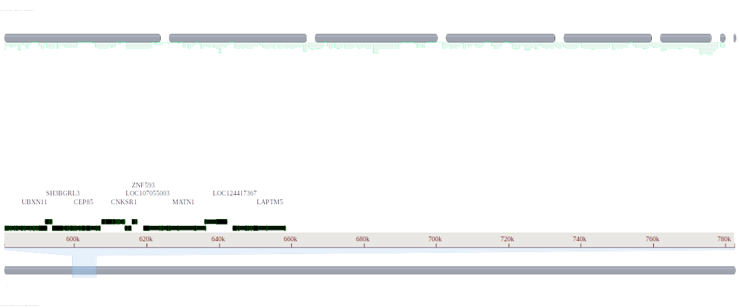
Figure 53. Comparative genome alignment of the LAPTM5 gene in Gallus gallus and the corresponding region in Anolis carolinensis.
This figure shows the whole genome alignment between Gallus gallus (assembly bGalGal1.mat.broiler.GRCg7b, GCF_016699485.2) and Anolis carolinensis (assembly rAnoCar3.1.pri, GCF_035594765.1) using the NCBI Comparative Genome Viewer. The LAPTM5 gene (lysosomal-associated transmembrane protein 5) is annotated on chromosome 23 of Gallus gallus (Chr23: 643,935–658,364). No corresponding gene was found in Anolis carolinensis for this region in the current assembly.

