1. Expand the graph, click on the red highlighted arrow

1. Click on download CSV, and save to your convenient location

1. Now, in the google browser, type worldbank.org and click on the country, for example I selected “Malaysia”.

1. Now, you can select or download the data. Click on download on right hand side, I downloaded the excel format.

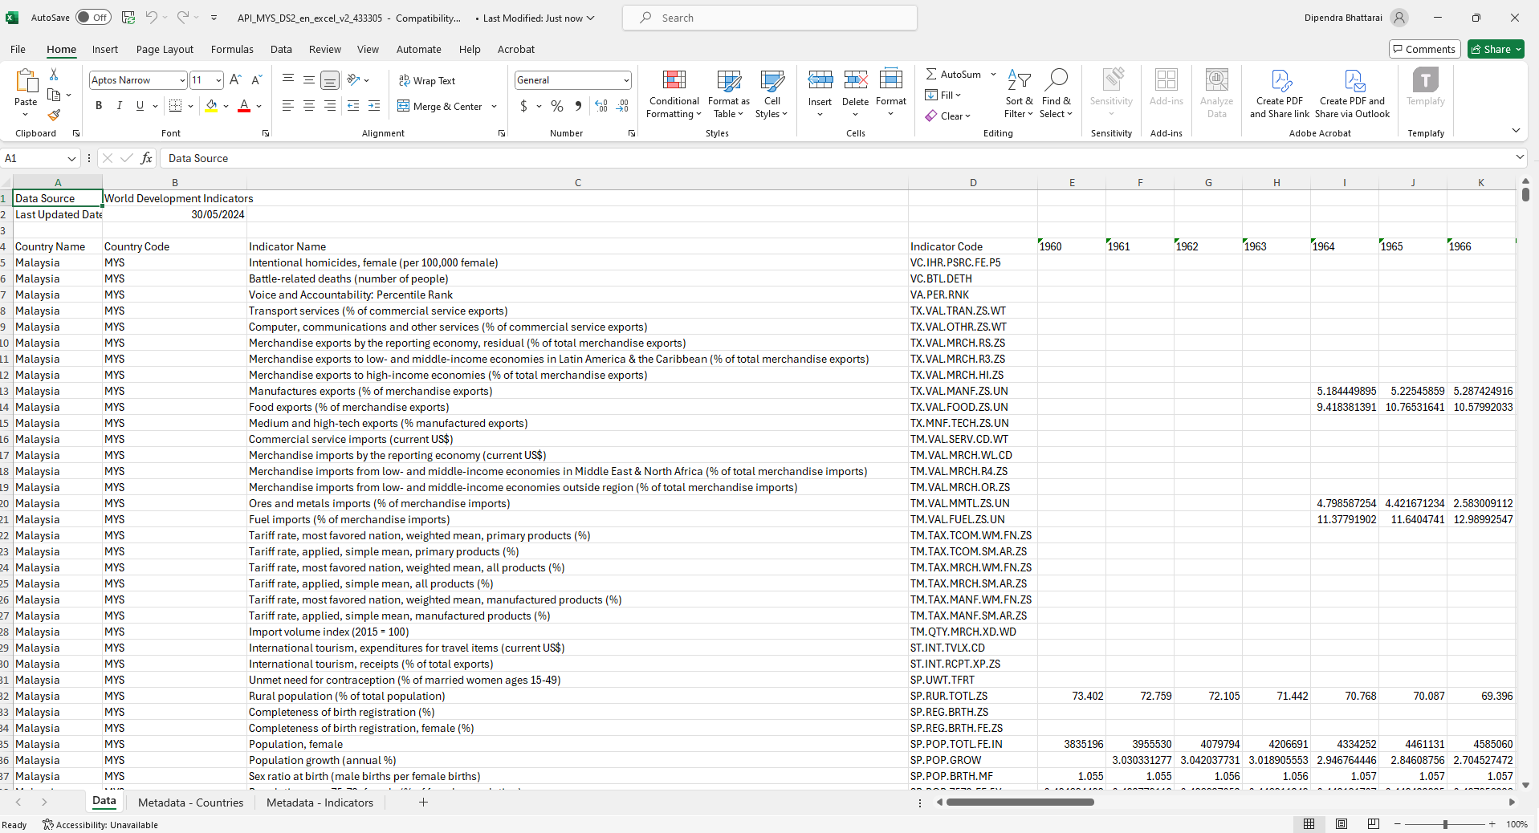

1. Now, you will get the data for a country, select which indicator you want to use. I choose GDP.

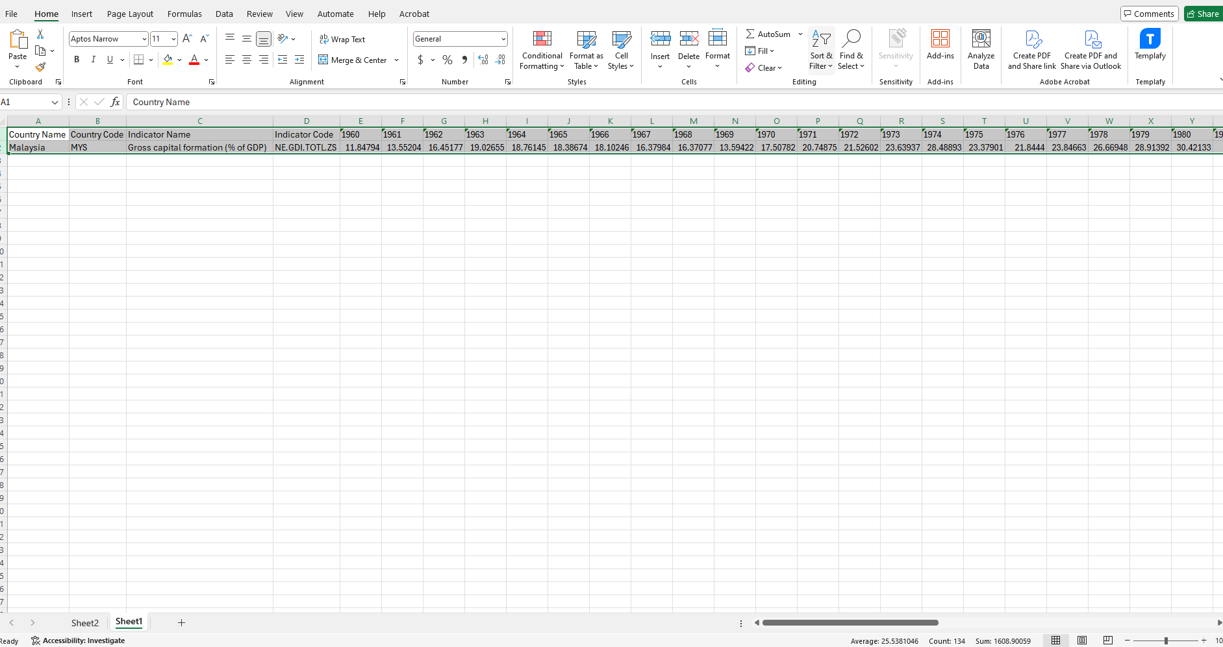

1. Copy the GDP data and year, something similar to the attached excel spreadsheet screenshot. We only have nighttime data downloaded for 2014 to 2022, and now we will select the GDP for the same year and make a table simar to this.

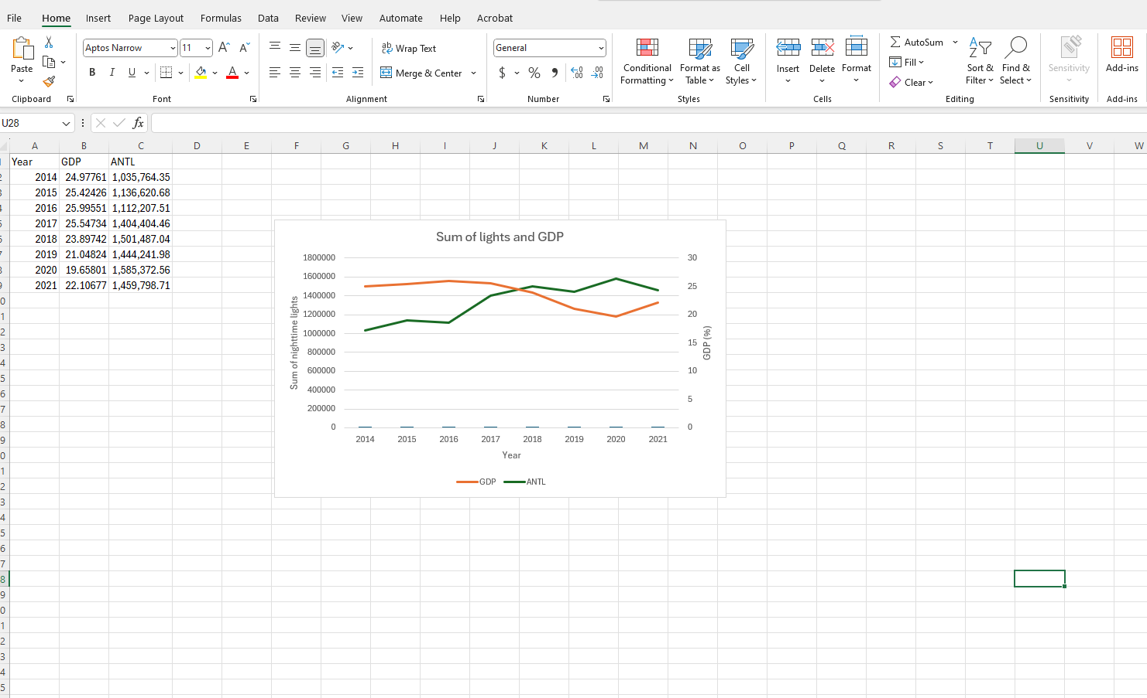

1. Now, plot this nice table to compare. And you also can conduct statistical analysis, when required.