|  |
| --- |
|  |
| **RTL_EXERCISE_1 BOUND FLASHER** |
|  |
| |  |  | | --- | --- | | Author |  | | Date | 2022/03/04 | | Version | 1.1 | |
|  |
|  |

|  |
| --- |
|  |

Contents

1. Interface 2

2. Functional implementation. 3

3. Internal implementation. 5

3.1. Overall. 5

3.2. State Machine 6

4. History 7

# 1. Interface

|  |
| --- |
| 16  1  1  16  flick  rst  clk  **bound_flasher_sys**  LED |
| Figure 1: the figure of Bound Flasher System |

|  |  |  |  |
| --- | --- | --- | --- |
| Signal | Width | In/Out | Description |
| flick | 1 | In | Determine module’s operation, depend on current state |
| clk | 1 | In | Master clock signal, for apply pulse for module purpose |
| rst | 1 | In | To reset the module |
| LED | 16 | Out | 16 single LEDs in 1 column |

Table 1: Description of signals in Bound Flasher

# 2. Functional implementation.

* Implement a 16-bits LEDs system
* System’s Operation base on three input signals
  + Reset
  + Clock
  + Flick
* The system specification
* Clock signal is provided for system inspire of function status. The function operate state’s transition at positive edge of the clock signal.
* Reset signal:
* LOW-ACTIVE Reset = 0: System is restarted to Initial State.
* HIGH-ACTIVE Reset = 1: System is started with initial state.
* Flick signal: special input for controlling state transfer.
* At the initial state, all lamps are OFF. If flick signal is ACTIVE, the flasher start operating:
* The lamps are turned ON gradually from lamp[0]to lamp[5]**.**
* The lamps are turned OFF gradually from lamp[5] **(max)** to lamp[0] **(min)**.
* The lamps are turned ON gradually from lamp[0]to lamp[10].
* The lamps are turned OFF gradually from lamp[10] **(max)** to lamp[5] **(min)**.
* The lamps are turned ON gradually from lamp[5] to lamp[15].
* The lamps are turned OFF gradually from lamp[15] to lamp[0], return to initial state.

At each kickback point (lamp[5] and lamp[10]), if flick signal is ACTIVE, the lamps will turn OFF gradually again to the min lamp of the previous state, then continue operation as above description.

For simple, kickback point is considered only when the lamps are turned ON gradually, except the first state.

* Some insulations:
* When flick = 0 at kickback points

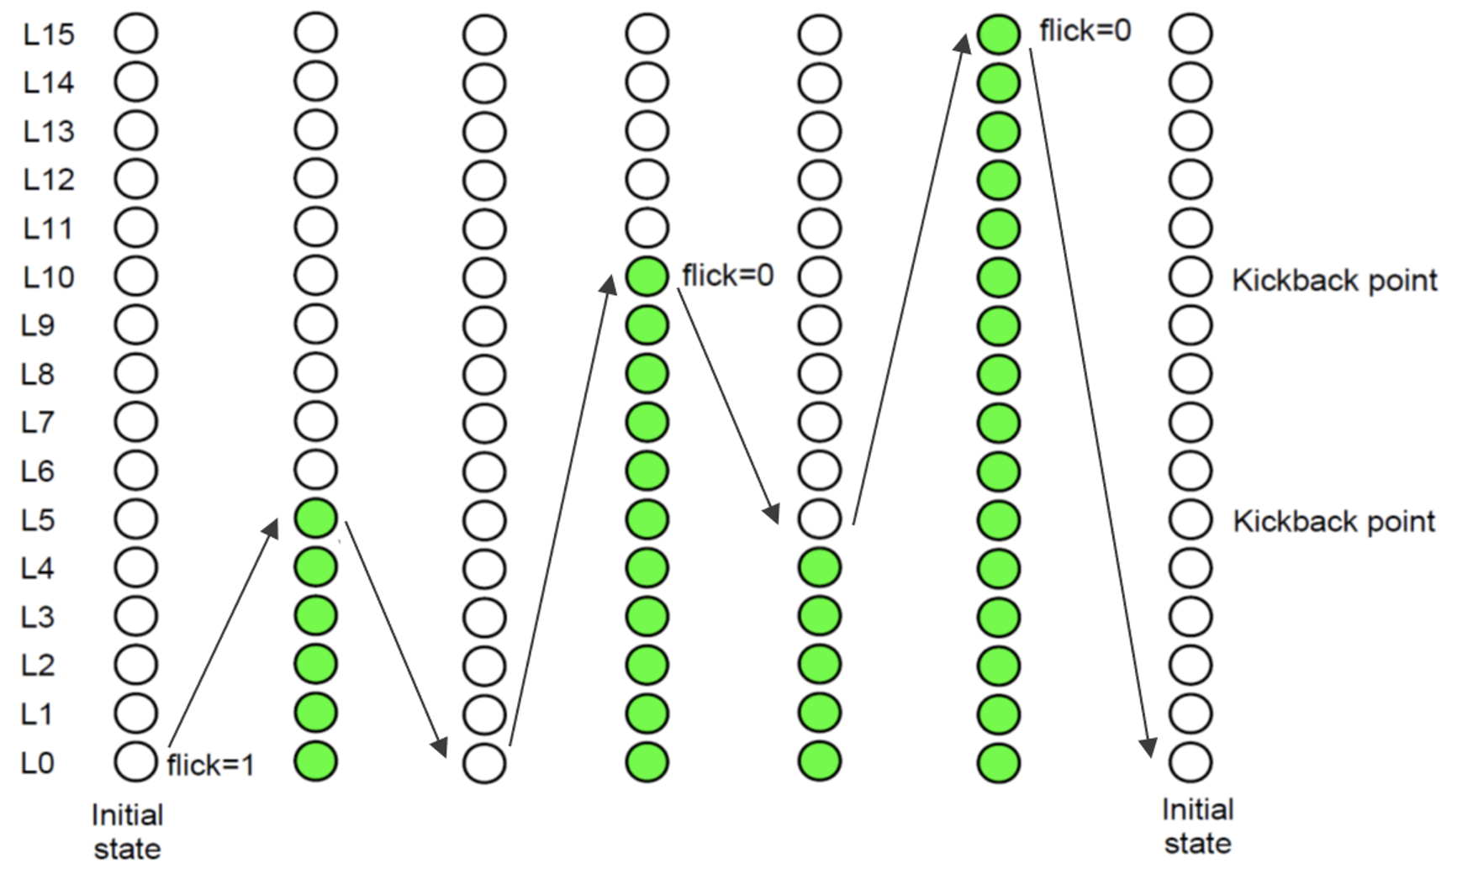

* When flick = 1 at kickback points (lamp[10])

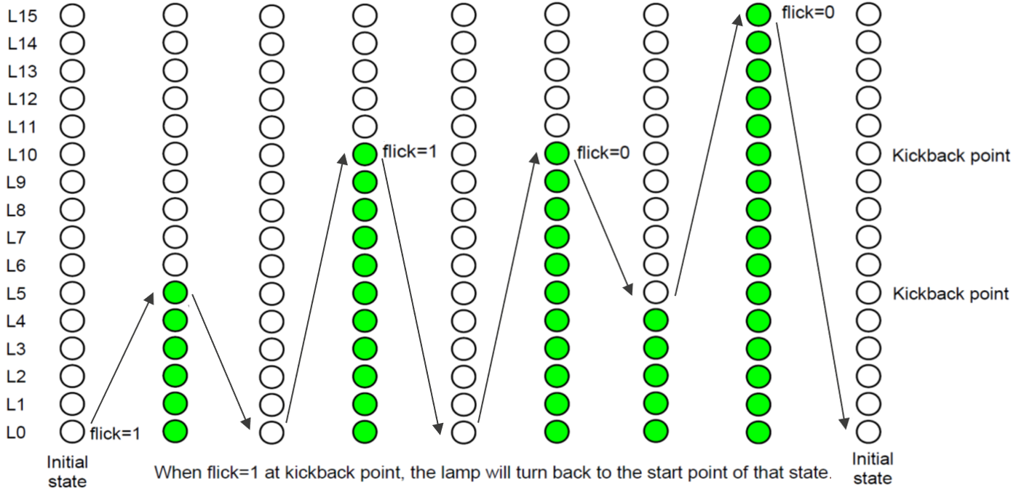

# 3. Internal implementation.

## 3.1. Overall.

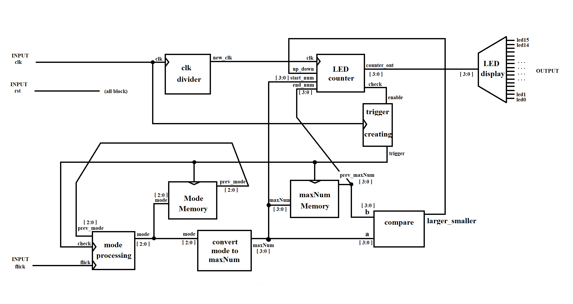

Figure 3.1: Block diagram of Bound Flasher

|  |  |  |  |  |  |  |  |  |  |  |  |  |  |  |  |  |  |  |  |  |  |  |  |  |  |  |  |  |  |  |
| --- | --- | --- | --- | --- | --- | --- | --- | --- | --- | --- | --- | --- | --- | --- | --- | --- | --- | --- | --- | --- | --- | --- | --- | --- | --- | --- | --- | --- | --- | --- |
| |  |  |  | | --- | --- | --- | | **Module** | **Signal** | **Description** | | clk_divider | **input** clk  **output** new_clk |  | | LED_counter | **input** clk  **input** up_down  **[3:0] input** start_num  **[3:0] input** end_num **[3:0] output** counter_out  **output** check |  | | LED_display | **[3:0] input** counter_out  **[15:0] output** led_out |  | | trigger_creating | **input** enable  **input** clk  **output** trigger |  | | Mode_memory | **[2:0] input** mode  **input** trigger  **[2:0] output** prev_mode |  | | maxNum_Memory | **input** trigger  **[3:0] input** maxNum  **[3:0]** **output** prev_maxNum |  | | mode_processing | **[2:0] input** prev_mode  **input** check  **input** flick  **[2:0]** **output** mode |  | | convert_mode_to_maxNum | **[2:0] input** mode  **[3:0] output** maxNum |  | | compare | **[3:0] input** a  **[3:0] input** b  **output** larger_smaller |  | |

Table 3.1: Block diagram of Bound Flasher Description

## 3.2. State Machine

Figure 3.2: State Machine of Bound Flasher

Table 3.2: variable name of State machine

(à là giải thích tên biến)

Table 3.3: state name of State machine

(giải thích state)

# 4. History

|  |  |  |  |
| --- | --- | --- | --- |
| Date | Author | Modified part | Description |
| 2017/03/28 |  | All | New creation |
|  |  |  |  |
|  |  |  |  |
|  |  |  |  |