***User’s Guide for the Fertilizer Emission Scenario Tool for CMAQ (FEST-C) Version 1.0***

U.S. EPA Contract No. EP-W-09-023, “Operation of the Center for Community Air Quality Modeling and Analysis (CMAS)”

Prepared for: Dr. Ellen Cooter

Atmospheric Exposure Integration Branch

Atmospheric Modeling and Analysis Division

USEPA/ORD/NERL

E243-02

Research Triangle Park, NC 27711

Prepared by: Limei Ran, Verel Benson, Dongmei Yang, and Adel Hanna

Institute for the Environment

The University of North Carolina at Chapel Hill

137 E. Franklin St., CB 6116

Chapel Hill, NC 27599-6116

Date: October 25, 2013

Table of Contents

1. The FEST-C System 1

1.1 Components 3

1.2 Installation and Requirements 3

1.3 Interface Launch 4

2. File Structures for EPIC Modeling 6

3. Scenario Management Selections under the File Menu 14

4. The Pre-EPIC File Generation Tools 17

4.1 BELD4 Data Generation 19

4.2 Crop Site Info Generation 21

4.3 WRF/CMAQ to EPIC 23

5. EPIC Spinup Run Tools 26

5.1 EPIC Site File Generation 26

5.2 Soil Match for EPIC Spinup 28

5.3 Management File Generation for Spinup 29

5.4 View/Edit EPIC Inputs 31

5.5 EPIC Runs for Spinup 31

6. EPIC Application Run Tools 34

6.1 Management File Generation for Application 34

6.2 EPIC Runs for Application 36

7. Output Processing and Visualizing Tools 38

7.1 EPIC Yearly Extraction 38

7.2 EPIC to CMAQ 40

7.3 Visualization 43

8. Future Work 44

Acknowledgments 45

# 1. The FEST-C System

The Fertilizer Emission Scenario Tool for CMAQ (FEST-C) (http://www.cmascenter.org/fest-c/) is a Java-based interface system that is used to simulate daily fertilizer application information using the Environmental Policy Integrated Climate (EPIC) model (http://epicapex.tamu.edu/epic/) and to extract the EPIC daily output that is a required input for bidirectional NH3 modeling performed using the **Community Multiscale Air Quality (**CMAQ) (<http://www.cmascenter.org/cmaq/>). The FEST-C interface system and spatial data processing tools were developed by the University of North Carolina at Chapel Hill (UNC)’s Institute for the Environment, while work on EPIC modeling for the FEST-C system was conducted by Benson Consulting. All work was performed under contract to the U.S. EPA Office of Research and Development.

The EPA EPIC implementation requires no previous estimates of fertilizer application; it estimates daily fertilizer applications based entirely on simulated plant demand in response to local soil and weather conditions. The FEST-C interface integrates CMAQ with EPIC through the current release of the Spatial Allocator (SA) Raster Tools system (http://www.cmascenter.org/sa-tools/) that has been developed under the Community Modeling and Analysis System (CMAS) Center. Figure 1 displays the process diagram of FEST-C linked with the Weather Research and Forecasting (WRF) and CMAQ modeling system. The Biogenic Emissions Landcover Database version 4 (BELD4), which is generated using the newly released BELD4 tool in the SA Raster Tools System, is consistently used in the FEST-C system as well as the WRF/CMAQ modeling system. The WRF/CMAQ system provides daily weather inputs, optionally with nitrogen (N) deposition, to the FEST-C system. In return, FEST-C generates initial soil and pH conditions and daily N information for specific crops assumed to reside in the agricultural land areas of the CMAQ bidirectional NH3 modeling grids. The FEST-C system can be used in assessing not only the impacts of agricultural fertilization and management practices on air quality (NH3) and climate (N2O), but also the impacts of meteorology/climate and air quality (N deposition) on crop yield, soil erosion, and overall nitrogen-carbon-phosphorus biogeochemical status of the agricultural ecosystem.

FEST-C is designed to be used for CMAQ domains in North America, particularly for domains covering the conterminous United States (U.S.) as well as the southern region of Canada where detailed crop census data are available. The current version of the EPIC system for CMAQ has complete modeling capabilities for grids located within the U.S. To apply this system to other regions, users have to modify the databases (particularly for soil) that were created within the FEST-C system and to change the agricultural management file generation, as different regions will likely have different agricultural management practices as well as different soil data. For areas outside the U.S., the bidirectional CMAQ internally estimates these inputs for regions in Canada and Mexico. The system works for domains at different resolutions and in any of the four WRF projection coordinate systems: longitude/latitude, Lambert Conformal Conic, Universal Polar Stereographic, and Mercator.



**Figure 1**. The FEST-C process diagram.

## 1.1 Components

Version 1.0 release of the FEST-C system, including Java interface programs, EPIC FORTRAN codes, and SA Raster Tools C++ programs, was developed in Linux-based operating systems. The FEST-C Java interface is licensed under the Gnu Public License (GPL) version 3. The downloaded FEST-C system contains the following two directories:

* festc – contains the Java-based interface.
* epic – stores EPIC model version 0509, which has been modified by the EPA to meet CMAQ input requirements, and related utilities and data. The EPIC model description can be obtained from Texas A&M University (TAMU), College Station, TX (<http://epicapex.tamu.edu/files/2013/02/epic0509usermanualupdated.pdf> ). The documentation of the modified EPIC modeling system for CMAQ is included in the release of the FEST-C system. It provides detailed information on how this particular application of EPIC was developed.

The FEST-C system requires that the SA Raster Tools system be installed on the same system where FEST-C resides. For visualization, users can configure FEST-C to view NetCDF files using VERDI (or NCVIEW). Both the SA Raster Tools and the VERDI system and their documentation can be obtained from the CMAS web site (http://www.cmascenter.org/).

## 1.2 Installation and Requirements

Assuming that the downloaded FEST-C system is installed under the **${FESTC_HOME}** directory, users should perform the following steps:

1. Modify **${FESTC_HOME}/**config.properties to set:

* work.dir – working directory.
* epic.home – epic home directory, which should be **${FESTC_HOME}/epic**.
* sa.home – installed Spatial Allocator directory - **${SA_HOME}**.
* visual.program.home – directory containing VERDI program.
* queue.cmd - queue job submission command such as qsub or bsub. Queue configuration (includes queue.name and queue.bigmem as well) for job submission has to be modified based on the user’s Linux system.
* queue.name - queue name.
* queue.bigmem - big memory setup to be used by the *EPIC to CMAQ* tool
* debug - set to “true” to print out debug message. It is recommended that users do not change it.
* allow.diff.check - set to “true” for checking consistent input in "Minimum Crop Acres" and "Fertilizer Year" fields from different sub-interfaces. It is recommended that users do not change it.

1. Make a directory called “**festc**” under the user’s home directory, which is assumed to be **${USER_HOME}**, then copy **${FESTC_HOME}/**config.properties to **${USER_HOME}/festc** directory. Change the work.dir setting if needed.
2. Modify **${FESTC_HOME}/festc/**festc file to set:

* FESTC_HOME to **${FESTC_HOME}/festc**.
* –Xmx1024M to -Xmx2048M (optional) if users want to use 2 GB of RAM to run the interface.
* JAVA path (optional) if users do not want to use the Standard Edition Runtime Environment (JRE) version 6 for Linux 32-bit that is included in the FEST-C release.

1. Modify **${FESTC_HOME}/**festc_setup.csh to:
   * Set **${FESTC_HOME}** and **${SA_HOME}** directories.
   * Source the file in the user’s .cshrc file.

## 1.3 Interface Launch

The FEST-C interface facilitates the creation of the spatial associations, input files, soil initialization, and application processes required by EPIC. After preliminary site information and soils are assigned to each grid cell, a 25-year “spinup” simulation is required to generate initial soil and annual nitrogen demand conditions that represent the management system the user has defined. These initial conditions are provided to the year-specific application and management scheme.To launch the FESTC interface system, type:

* festc or **${FESTC_HOME}/festc/**festc

The FEST-C interface allows the user to create, select, and manage different scenario management schemes under the File menu for EPIC modeling and thirteen subinterface tools (see Figure 2). The system is described in detail in the following sections of this document:

* Section 2: File Structures for EPIC Modeling
* Section 3: Scenario Management Selections under the File menu
* Section 4: The Pre-EPIC File Generation Tools:

1. BELD4 Data Generation
2. Crop Site Info Generation
3. WRF/CMAQ to EPIC

* Section 5: EPIC Spinup Run Tools:

1. EPIC Site File Generation
2. Soil Match for EPIC Spinup
3. Management File Generation for Spinup
4. View/Edit EPIC Inputs
5. EPIC Runs for Spinup

* Section 6: EPIC Application Run Tools:

1. Management File Generation for Application
2. EPIC Runs for Application

* Section 7: Output Processing and Visualizing Tools:

1. EPIC Yearly Extraction
2. EPIC to CMAQ
3. Visualization

* Section 8: Future Work

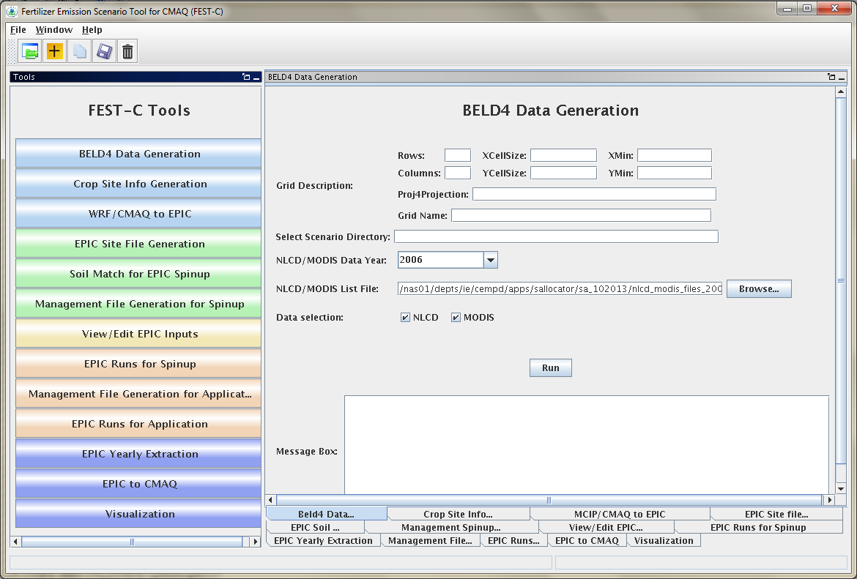

**Figure 2.** The FEST-C interface system.

# 2. File Structures for EPIC Modeling

The EPIC model and related utilities and data are stored under the **${FESTC_HOME}/epic** directory. The file structure for EPIC modeling within the FEST-C system is displayed in Figure 3.



**Figure 3**. File structure for EPIC modeling (directory names in black and files in blue)

The epic directory contains five subdirectories: **model, util, common_data, scenarios,** and **doc**). These are described below.

* **model** – used to store the EPIC0509 model. It includes one subdirectory:
* **current**: contains two current EPIC models for spinup and application simulations. The models were developed for the CMAQ modeling based on the EPIC0509 version of the EPIC model, obtained from the AgriLife Research, Blackland Research & Extension Center (<http://epicapex.tamu.edu/epic/>) at TAMU. The documentation on the development of the EPIC modeling system for CMAQ is included under the **${FESTC_HOME}/epic/doc** directory.
* **util** – contains utility programs developed by Benson Consulting to generate site, soil, and management input files required by EPIC. It has three subdirectories:
  + **siteCreate:** contains two programs used by the *EPIC Site File Generation* tool. The programs will not only generate EPIC site files but also link EPIC sites (grid cell centroids) to the BELD4 crop grid assignments and the 8-digit hydrologic cataloging units (HUCs) that contain the grid cells to be used in the soil matching program. Based on BELD4, this program assigns only those crops to a grid cell that BELD4 indicates are present at that location. This minimizes the number of crop-specific simulations performed across large domains.
  + **soilMatch:** contains six soil matching programs used by the *Soil Match for EPIC Spinup* tool. Soils are selected on the basis of the U.S. Department of Agriculture (USDA) Natural Resource Inventory (NRI) assignment of each crop in each 8-digit HUC to its most common HUC-8 soil type.
  + **manageCreate:** contains programs to create EPIC management files for spinup and application simulations by the *Management File Generation for Spinup* and *Management File Generation for Application* tools.
* **common_data** – contain data sets needed for EPIC and utility programs. Also provided under this subdirectory is the file EPIC_42crop_names.txt, which contains the crop names and numbers used in the FEST-C system. This directory has the following subdirectories:
* **BaumerSoils**: contains the soil data sets (22,838 soils) built with soil parameters from the Baumer database developed by Dr. Otto Baumer. Dr. Baumer used the SOILS5 database and soil pedon data to develop the representative EPIC data sets. Dr. Verel Benson of Benson Consulting used this information to create a subset of soil parameters in 22,838 soil files to be used with EPIC. Detailed information on the data set creation can be obtained from the documentation of the EPIC modeling system for CMAQ.
* **EPIC_model**: contains common data files required by EPIC spinup and application runs in the two following subdirectories:
  + **spinup** – has common files used for EPIC spinup simulations. For all crops except potatoes, the spinup is set to run for 25 years using the EPIC statistical weather generator (see the weather generator discussion in the EPIC documenta­tion from TAMU). We (UNC, Benson Consulting, and EPA) have arbitrarily set the starting year as 1978 in EPICCONT.DAT. For potatoes, the spinup is set to run for 100 years from 1903 in EPICCONT_POTATOES.DAT.
  + **app –** contains common files used for EPIC application simulations. In the FEST-C system, users input the year (1 year) for the EPIC application simulation. When a new scenario is created, EPICCONT.DAT from this directory is copied to the **scenarios/“scenario name”/share_data** directory and the simulation period is changed to 2 years starting from the year previous to the simulation year. Two years of weather data are needed to support production of fall-sown crops. At present, the same weather is used for both years. In the future, an option may be added to support input of two unique weather time series.
* **gisFiles:** includes U.S. counties, U.S. states with some boundaries from Canada and Mexico, and U.S. 8-digit HUC shapefiles and elevation and slope image files. The readme file in the directory describes each file and associated attributes in detail.
* **statWeath:** contains weather station climate statistics files distributed with the standard EPIC package.
* **util:** includes common files used by the utility programs. This directory has two subdirectories:
  + **soilMatch** – has input files used by the soil matching program to create EPIC soil files for the *EPIC Runs for Spinup* tool.
  + **manageCreate –** contain files to be used in generating EPIC spinup and application management files. We developed management data with fertilizer types applied in 2001 and 2006 for each of 10 production regions (Northeast, Appalachia, Southeast, Lake States, Corn Belt, Delta States, Northern Plains, Southern Plains, Mountain, and Pacific) (see the region map in Cooter et al., 2012 that is listed in the Online Resources section of the FEST-C web site). Fertilizer types (but not amounts) applied are based on fertilizer sales of 62 major fertilizer types by state. Users can obtain detailed information from the documentation for the EPIC modeling system for CMAQ. It is recommended that 2001 be used for applications prior to 2006, and that 2006 be used for applications from 2006 through 2010. In the future, a 2011 fertilizer type file will be created to coincide with the 2011 NLCD release. Fertilizer types applied are used by the EPIC management file generation for application and they are stored under the following two subdirectories:
  + **2001**: for 2001 fertilizer year management file generation. Regional fertilizer data information is stored under the directory:
    - **regionFert**
  + **2006:** for 2006 fertilizer year management file generation. Regional fertilizer data information is stored under the directory:
    - **regionFert**
* **scenarios** – contains EPIC application scenarios and is described separately below this bulleted list.
* **doc** – contains documents on the EPIC modeling system for CMAQ (EPA_EPIC_application_v1_10252013.pdf).

In general, users should not change the data files described in the above directories. All files generated by users’ applications are stored under the **${FESTC_HOME}/epic/scenarios** directory. When the user creates a scenario by selecting “*New Scenario*” under the File menu, the following items are created:

* **scenariosInfo** – stores information for the created scenario, which is assumed to be named by the user as “**scenario name”.** This directory contains:
* **“scenario name”:** an xml file that stores the scenario information.
* **logs:** directory containing the script file used to create (copy or delete as well) the scenario and execution log file.
* **“scenario name”** – scenario directory that will contain all generated files for this scenario.

Under each scenario directory, the following directories are created for EPIC modeling:

* **share_data** – contains all data sets generated for EPIC modeling and to be used by all crops modeled. After users generate EPIC site files and daily weather, it will contain the following two subdirectories:
  + **SIT**: contains EPIC site files.
  + **dailyWETH**: contains daily weather and N files for EPIC modeling.
* **scripts** – stores script and log files created to run the tools within the FEST-C interface. All tools are executed through the Linux queue system. Users should always check the log file to make sure that the queue job has completed correctly. Unwanted files under this directory should be cleaned out periodically.
* **work_dir** – contains some intermediate or temporary files created by the FEST-C tools. Currently, not many files are created under this directory.
* **21 crop dirs (ALFALFA, BARLEY, BEANS, CANOLA, CORNG, CORNS, COTTON, EBEANS, HAY, OATS, OTHER, OTHGRASS , PEANUTS, POTATOES, RICE, RYE, SORGHUMG, SORGHUMS, SOYBEANS, SWHEAT, WWHEAT)** – the 21 crop directories are created by the EPIC *Site File Generation* tool. Under each crop directory there are many files that are created for generating EPIC input files. The following two subdirectories are also created from management file generation and EPIC runs for spinup and application:
* **spinup:** contains files created from the EPIC management file generation and EPIC runs for spinup tools. It contains the following three subdirectories:
  + **manage** – contains EPIC run files and EPIC site management files created by the *Management File Generation for Spinup* tool. Management files are contained under the following subdirectory:
    - **OPC:** contains the management schedule for each domain grid cell containing rain-fed and irrigated crop. Variables (schedule) can be interpreted using the documentation for the EPIC modeling system for the CMAQ.
  + **rainf** – contains files for each domain grid cell containing this crop created by the *EPIC Runs for Spinup* tool from rain-fed crops. It contains the following output directories (see the EPIC documentation from TAMU):
    - **DFA:** daily fertilizer and other output.
    - **NCM:** monthly fertilizer and other output.
    - **NCS:** monthly soil output.
    - **OUT:** standard EPIC output file that contains various budget tables and summaries of the simulation that are useful for debugging.
    - **SOL:** soil output files that are used as initial values for the application.
    - **TNA:** annual fertilizer and other output.
    - **TNS:** annual soil output.
  + **irr** – contains files for each domain grid cell containing this crop created by the *EPIC Runs for Spinup* tool from irrigated crops. It contains the following output directories:
    - **DFA:** daily fertilizer and other output
    - **NCM:** monthly fertilizer and other output
    - **NCS:** monthly soil output
    - **OUT:** standard EPIC output file that contains various budget tables and summaries of the simulation that are useful for debugging.
    - **SOL:** soil output files
    - **TNA:** annual fertilizer and other output that are useful for debugging.
    - **TNS:** annual soil output
* **app:** contains files created from the management file generation and EPIC runs for application tools. It contains the following three subdirectories:
  + **manage** – contains EPIC run files and EPIC site management files created by the *Management File Generation for Application* tool. Management files are contained under the following subdirectory:
    - **OPC**: contains the management schedule for each domain grid cell containing rain-fed and irrigated crop. Variables (schedule) can be interpreted using the documentation for the EPIC modeling system for the CMAQ.
  + **rainf** – contains files created by the *EPIC Runs for Application* tool from rain-fed crops. It contains the following output directories (see the EPIC documentation from TAMU):
    - **DFA:** daily fertilizer and other output.
    - **NCM:** monthly fertilizer and other output.
    - **NCS:** monthly soil output.
    - **OUT:** standard EPIC output file that contains various budget tables and summaries of the simulation (useful for debugging).
    - **SOL:** soil output files.
    - **TNA:** annual fertilizer and other output.
    - **TNS:** annual soil output.
  + **irr** – contains files created by the *EPIC Runs for Application* tool from rain-fed crops. It contains the following output directories:
    - **DFA:** daily fertilizer and other output.
    - **NCM:** monthly fertilizer and other output.
    - **NCS:** monthly soil output.
    - **OUT:** standard EPIC output file that contains various budget tables and summaries of the simulation (useful for debugging).
    - **SOL:** soil output files.
    - **TNA:** annual fertilizer and other output.
    - **TNS:** annual soil output.
* **output4CMAQ** – stores EPIC output files and extracted NetCDF files for quality assurance (QA) and CMAQ bidirectional NH3 modeling. This directory contains the two following subdirectories:
* **spinup:** contains all files created from EPIC spinup simulations for CMAQ. It contains the following three subdirectories:
  + **5years** – contains extracted average EPIC output for each crop from the last five years of the spinup simulation. Files are named as “BELD4 Crop Number”.dat (see Table 1 in Section 4 for crop numbers).
  + **daily** – stores daily EPIC output files for the EPIC simulation of each crop. “BELD4 Crop Number”.NCS is for soil output and “BELD4 Crop Number”.NCD is for fertilizer and other daily output.
  + **toCMAQ** – contains created NetCDF files with EPIC spinup output for selected modeling grid cells with crop data. The NetCDF output files are created using the FEST-C tools by extracting data files stored under the **5years** or **daily** directories listed above.
* **app:** stores files created from EPIC application simulations for CMAQ. The following three subdirectories are under this directory:
  + **year** – contains extracted average EPIC output for the EPIC application year. Files are named as “BELD4 Crop Number”.dat.
  + **daily –** stores daily EPIC output files for each crop’s EPIC application simulation. “BELD4 Crop Number”.NCS is for soil output and “BELD4 Crop Number”.NCD is for fertilizer and other daily output.
  + **toCMAQ** – contains created NetCDF files with EPIC application simulation results for selected modeling grid cells with crop data. The NetCDF output files are created using the FEST-C tools by extracting data files stored under the **year** or **daily** directories listed above.

# 3. Scenario Management Selections under the File Menu

There are five scenario management selections (as well as Exit) under the File menu at the upper left of the FEST-C tool bar: Open Scenario, New Scenario, Copy Scenario, Save Scenario, and Delete Scenario.

* Open Scenario – to open a created scenario for users to work on. Users can select any one of the scenarios under the **${FESTC_HOME}/epic/scenarios/scenariosInfo** directory. After users open a scenario, information for the scenario, such as the domain description, will be automatically filled in by the FEST-C tool interface. Within the FEST-C system, users have to work within a scenario to execute any of the tools except the *Visualization* tool. Figure 4 shows the interface used to open the test case created in the FEST-C system.

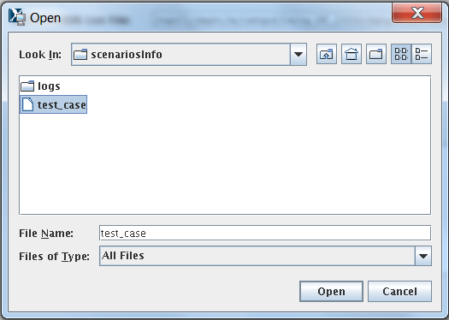

**Figure 4.** Open Scenario selection window used to open the test_case scenario.

* New Scenario – to create a new scenario. Users always need to create or open a scenario to work on. In creating a new scenario, the user has to provide the following information for a CMAQ modeling domain and EPIC simulation year (see Figure 5):
  + Rows, Columns: the number of rows and columns for the domain.
  + XCellSize, YCellSize: x and y resolution for the grid cell.
  + XMin, YMin: x and y coordinates of the lower left corner of the lower left grid cell. Users can often find this information in the GRIDDESC file in the Meteorology-Chemistry Interface Processor (MCIP) output.
  + Proj4Projection: domain projection defined in Proj4 format (see details at <http://www.remotesensing.org/geotiff/proj_list/>). The interface sets the Lambert Conformal Conic projection, which is used by the CMAQ U.S. 12-km domain as the default. Users can change it to any projection supported for CMAQ modeling.
  + Grid Name: user-supplied name for the domain, using no more than 16 alphanumeric characters and no spaces.
  + Simulation Year: year (YYYY) for the EPIC simulation. FEST-C is designed to simulate yearly fertilizer application information for the CMAQ bidirectional NH3 modeling.
  + Scenario Name: name for the scenario, using alphanumeric characters and no spaces.

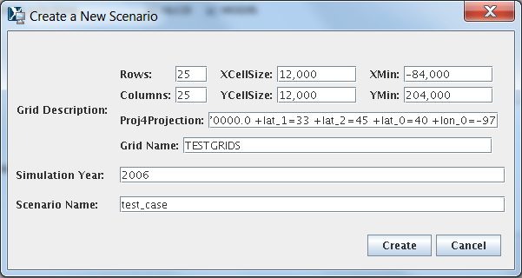

**Figure 5**. New Scenario selection window with input to create the test_case scenario within FEST-C.

When a new scenario is created, the following files and directories are created:

* **${FESTC_HOME}/epic/scenarios/scenariosInfo**/“scenario name”– xml file to store the scenario information.
* **${FESTC_HOME}/epic/“scenario name” –** directory to store all generated information for this scenario. Some subdirectories are also generated under this scenario directory (see Section 2 for file structures).
* **${FESTC_HOME}/epic/“scenario name”/share_data/**EPICCONT.DAT – contains EPIC constant parameters. The simulation period is a 2-year period starting with the year before the simulation year.
* Copy Scenario – to copy an existing scenario under the **${FESTC_HOME}/epic/scenarios/scenariosInfo** directory to a new scenario with a defined simulation year, which can be the same as or different from the existing scenario year (see Figure 6). If the existing scenario contains many crop simulations, this action can take a long time to complete in the background queue job.

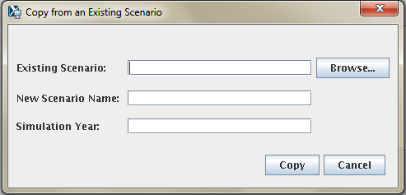

**Figure 6.** Copy Scenario selection window.

* Save Scenario – to save a scenario after a user works on the scenario. Only the input information for the scenario tool interfaces will be saved. When the user performs the FEST-C tool actions, generated files are always saved under different directories, described in Section 2.
* Delete Scenario – to delete a scenario. This is also run as a background submission and can take some time. All directories and subdirectories for that scenario are deleted completely.
* Exit – to exit the FEST-C interface. You will be asked if you want to save the scenario you were working on before exiting the tool.

The action performed by making a selection under the File menu (e.g., copy, create, delete) is executed by a script file through the queue job. The script and log files are stored under the **${FESTC_HOME}/epic/scenarios/scenariosInfo/logs** directory.Users should check the log files under the directory to make sure that the selection action has been completely correctly.

# 4. The Pre-EPIC File Generation Tools

The first three tools in the FEST-C interface are used to prepare site crop and spatial data for EPIC input file generation and to generate required daily weather data and optional nitrogen deposition data for the EPIC simulation year. In describing the FEST-C tools, we use the test_case scenario in the FEST-C system to demonstrate the input and output components on the tool interface. The test_case scenario is a small 12-km domain with 25 rows and 25 columns in the CMAQ standard projection. The domain is located in the northwest corner of Iowa and crosses into Minnesota, South Dakota, and Nebraska. Figure 7 illustrates the domain grid cells with the identification numbers (GRIDID) used in the FEST-C system; colors are used to indicate the crop percentage for each grid cell generated from 2006 NLCD data. All 625 (25×25) 12-km grid cells in this test domain have crop coverage, and most of them have more 75% crop coverage.



**Figure 7**. FEST-C test case 12-km domain in the northern Central Plains of the U.S. Each grid cell has an identification number (GRIDID) associated with it, along with a color that indicates crop coverage percentage. The cells are numbered from 1 for the lower left corner cell to 625 (25 rows × 25 columns) for the upper right corner cell of the domain.

## 4.1 BELD4 Data Generation

The *BELD4 Data Generation* tool was developed in the SA Raster Tools system. For detailed information on this tool, users can view the SA Raster Tools documentation: <http://www.cmascenter.org/sa-tools/documentation/4.0/html/Raster_Users_Guide_4_0.htm>.

EPIC modeling for a CMAQ domain needs to have the BELD4 data, which is used for selecting grid cells with crop coverage. This tool allows users to compute the BELD4 dataset for a selected scenario. Figure 8 shows the interface used to compute the BELD4 dataset for the test_case scenario.

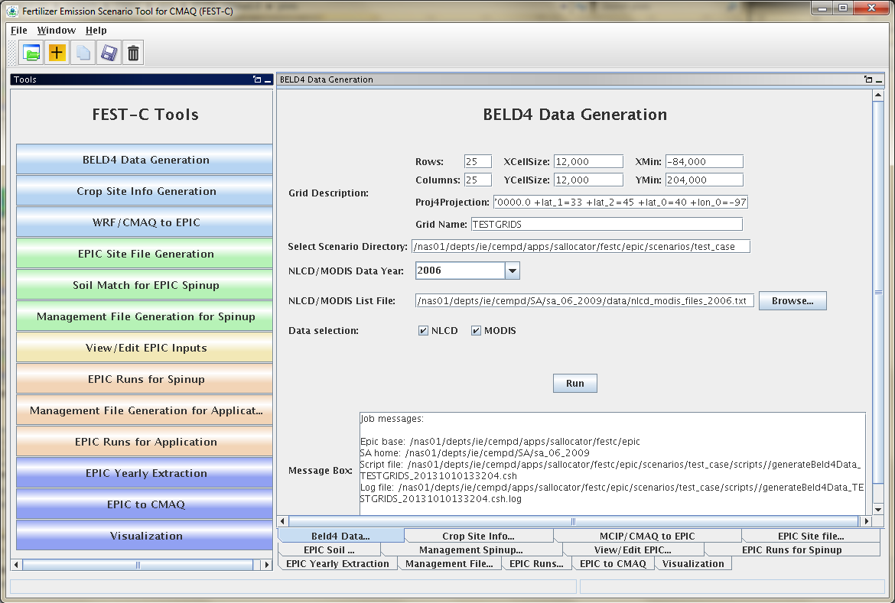

**Figure 8**. The *BELD4 Data Generation* tool interface for the test_case scenario.

Users need only to make sure that the following two entries are correct for their scenarios:

* NLCD/MODIS Data Year – set this to 2001 or 2006. The default on the interface is 2006. Processed 2001 and 2006 crop tables from the U.S. and Canada are stored under the **${SA_HOME}/data** directory for this tool. The 42 rain-fed and irrigated crops generated from the BELD4 tool and modeled in the FEST-C system are displayed in Table 1. In addition to crop numbers used in BELD4 (new version), the table also lists BELD3 (older version) numbers, because we started building the FEST-C system using the BELD3 data. Crop numbers used in EPIC modeling often follow the BELD3 crop numbers (from 22 to 63), but the output files from EPIC modeling for use in CMAQ use the BELD4 crop numbers (from 1 to 42). If a new crop is to be modeled in the FEST-C system, new crop tables under the SA **data** directory have to be generated and the BELD4 tool has to be modified as well.

**Table 1**. The 42 rain-fed and irrigated crops modeled in the FEST-C system.



* NLCD/MODIS List File – set to the fixed-format text file that contains downloaded NLCD land use, imperviousness, and canopy data files and downloaded tiled MODIS land cover (MCD12Q1) data sets. The interface sets the file ${SA_HOME}/data/ nlcd_modis_files_2006.txt as the default file. Users need to download NLCD and MODIS land cover data sets and modify the text file accordingly using the paths and names for the downloaded data sets. The text file has to have the same fixed titles and format as in the default file. If users want to generate a 2001 BELD4 data set, 2001 NLCD and MODIS land cover data sets have to be downloaded from the NLCD web site (http://imsdemo.cr.usgs.gov/webappcontent/mrlc/nlcdrlc.php) and MODIS land products web site (https://lpdaac.usgs.gov/products/modis_products_table/mcd12q1), and the nlcd_modis_files_2001.txt list file has to be created following the format of the 2006 list file.

When the Run button on the *BELD4 Data Generation* tool interface is clicked, a csh script file is generated under the **${FESTC_HOME}/epic/scenarios/”scenario name”/scripts** directory.The script file is submitted to the system as a queue job after the user clicks OK, and a log file for the job execution will be generated after the queue job is finished.Users should always make sure that there are no error messages in the log file, based on the information in the Message Box (shown in Figure 8).The outputs produced by the tool are the following two files, which are stored under the **${FESTC_HOME}/epic/scenarios/”scenario name”/share_data** directory:

* beld4_{Gird Name}_{year}.nc (beld4_TESTGRIDS_2006.nc for the test case) – a NetCDF file containing gridded percentage data for imperviousness, canopy, 194 tree species, 40 NLCD/MODIS land cover classes, and 42 BELD4 crops. This domain- and resolution-specific data file is a required input to the *Crop Site Info Generation* tool.
* beld4_{Grid Name}_{year}.txt (beld4_TESTGRIDS_2006.txt for the test case ) – a text table containing gridded percentage data for imperviousness, canopy, and 40 NLCD/MODIS land cover classes for a specific domain and grid resolution.

## 4.2 Crop Site Info Generation

The *Crop Site Info Generation* tool is used to compute EPIC site (grid cells) and crop information for EPIC modeling. This tool was also developed in the SA Raster Tools system. The tool processes spatial boundary shapefiles and elevation and slope image data to generate site information data needed in EPIC modeling. Figure 9 displays the tool interface used to compute the crop site information for the test_case scenario. The tool uses the spatial data sets stored under **${FESTC_HOME}/epic/common_data/gisFiles** and input files from the **${SA_HOME}/data** directory. Users need only to choose the following two entries for this tool:

* BELD4 NetCDF File – this should be the BELD4 NetCDF file generated using the previous tool. It should be: beld4_{Gird Name}_{year}.nc (beld4_TESTGRIDS_2006.nc for the test case). If this file exists, the interface will set it to the default. Otherwise, users have to run the previous tool to generate this data set or input a BELD4 NetCDF file anywhere within the computer system as long as the BELD4 file domain is the same as the scenario’s domain with which the users are working.

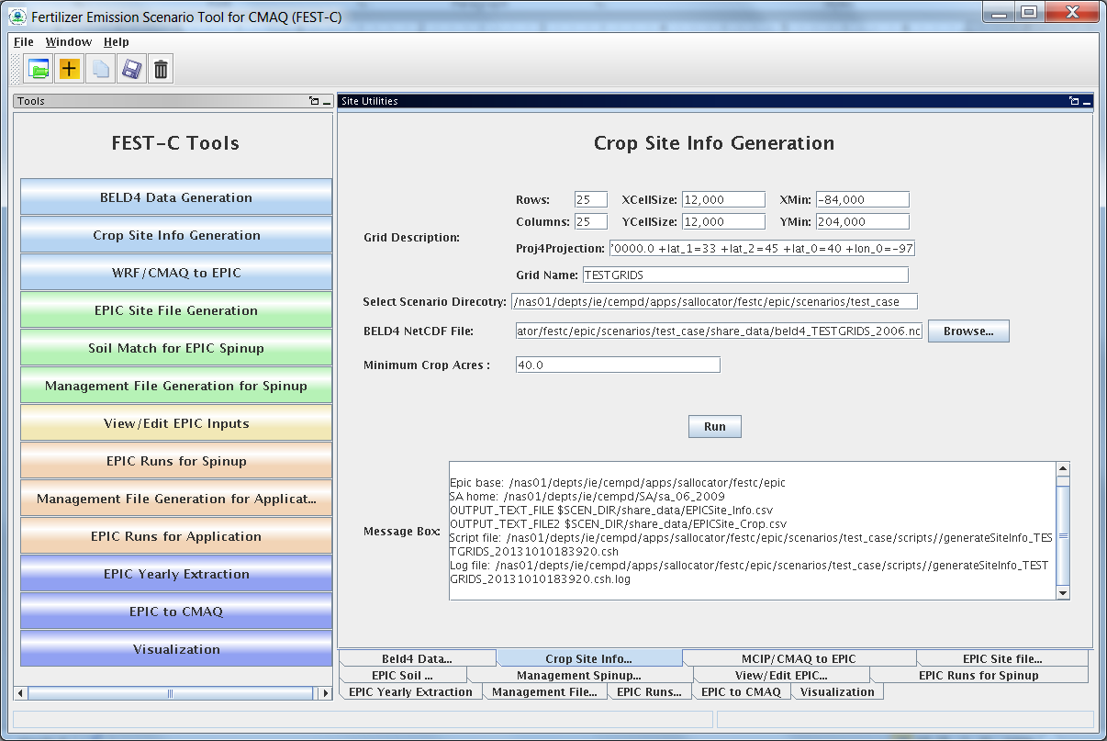

**Figure 9**. The *Crop Site Info Generation* tool interface used for the test_case scenario.

* Minimum Crop Acres – this is the minimum crop area for at least one of the 42 possible crops in a grid cell if the grid cell is to be selected for EPIC simulation. The default is set to 40 acres, which is what we have used for CMAQ 12-km grid modeling. It is intended to represent the smallest commercially viable farm size. For smaller grid resolutions or for domains in which smaller commercial enterprises make up a significant fraction of farms (e.g., orchards, some vegetable and specialty crops), users may need to reduce this minimum to adequately characterize the distribution of agricultural lands. This choice can increase the number of simulated grid cells (sites), which can also increase run time.

After the queue job has completed, users should check the log file under their scenario’s **scripts** directory to make sure that no errors occurred during the execution. The tool generates the following two text output files stored under **${FESTC_HOME}/epic/scenarios/”scenario name”/share_data**:

* EPICSites_Info.csv – contains the GRIDID, XLONG, YLAT, ELEVATION, SLOPE_P, HUC8, REG10, STFIPS, CNTYFIPS, GRASS, CROPS, CROP_P, COUNTRY, and COUNTRY-PROVINCE items used for creating EPIC site files.
* EPICSites_Crop.csv – contains the GRIDID, acreages of 42 possible crops within each grid cell, COUNTRY, and HUC8 items used in EPIC site and soil file generation.

## 4.3 WRF/CMAQ to EPIC

The *WRF/CMAQ to EPIC* tool is used to generate EPIC daily weather and, if the option is selected, N deposition input files to be used in EPIC application simulations. The tool reads EPIC grid cell information stored in the EPICSites_Info.csv file generated using the previous tool. The *WRF/CMAQ to EPIC* tool was also developed in the SA Raster Tools system. It extracts EPIC daily weather input data from WRF simulation output. There are three options currently available for the inclusion of daily atmospheric data: (1) no deposition, (2) the original EPIC default (assumes a constant N concentration of 0.8 ppm in precipitation and no dry deposition), and (3) CMAQ hourly output files (DRYDEP, WETDEP1) from a previous CMAQ run (unidirectional or bidirectional). (In the future, a fourth option will be added that provides a field of daily multiyear average wet and dry speciated CMAQ atmospheric deposition.) In the vicinity of areas receiving significant atmospheric dry deposition, such as areas immediately surrounding large animal feeding operations, this information can impact EPIC biogeochemistry and subsequent estimates of plant N application needs. If speciated N deposition is available, oxidized wet and dry deposition are assumed to enter the EPIC soil nitrate pool and reduced wet and dry deposition is assumed to enter the EPIC soil ammonium pool. The MCIP and CMAQ domains have to be the same as the domain defined in the EPIC scenario. Figure 10 demonstrates this tool interface as used for the test_case scenario.

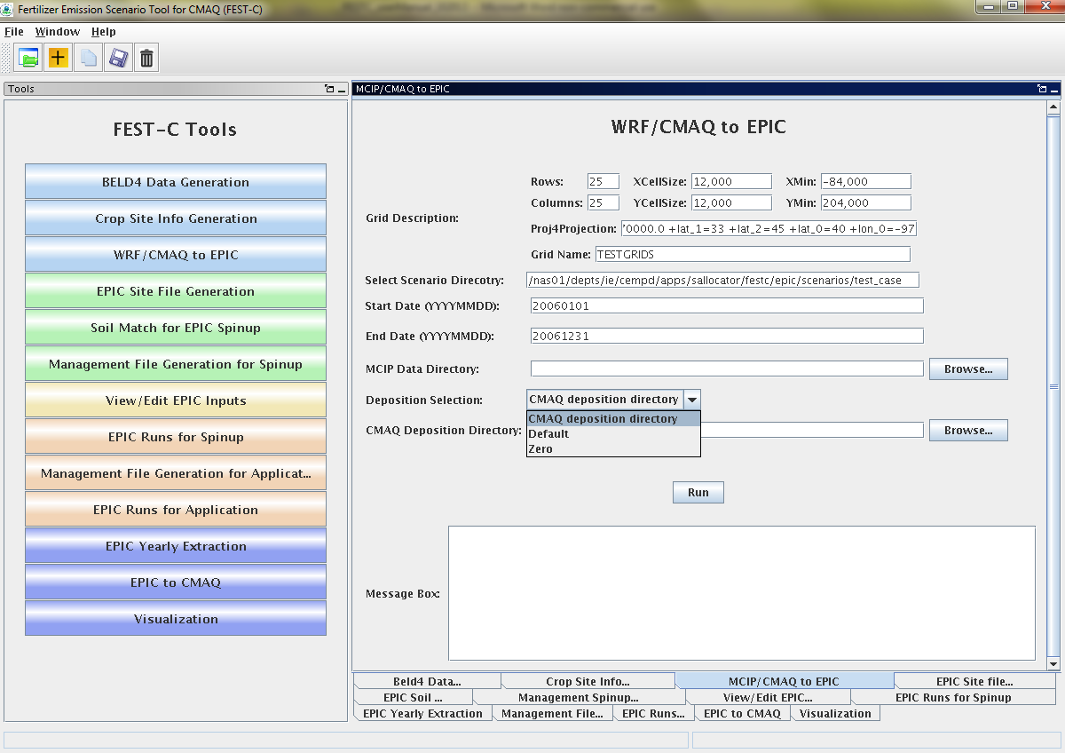

**Figure 10**. The *WRF/CMAQ to EPIC* tool interface used for the test_case scenario.

Users have to provide input for the following three items in the interface in order to run this tool:

* MCIP Data Directory – this directory contains processed WRF files output by MCIP for the EPIC simulation year. This tool requires only MCIP METCRO2D output files. METCRO2D output files have to be named as METCRO2D*{DATE} in which * can be any non-digit characters and {DATE} can be in one of four date formats: YYYYMMDD, YYMMDD, YYYYDDD, or YYDDD (e.g., METCRO2D_051226 )
* Deposition Selection – used to select one of the following three options:
* CMAQ deposition directory: to use CMAQ deposition output files. If this is selected, users have to set the CMAQ deposition file directory in the next field on the interface.
* Default: assume that N mixing ratio is 0.8 ppm for wet oxidized N deposition. The tool computes wet oxidized N deposition based only on the rainfall, and other N deposition variables are assumed to be zero.
* Zero: assume that there is no atmospheric N.
* CMAQ Deposition Directory – used to set the directory containing the CMAQ dry and wet deposition output files for the simulation year if “CMAQ deposition directory” was chosen in the previous field. The dry and wet deposition file names must contain the string “DRYDEP” or “WETDEP”. In addition, the deposition file names must end with “*{DATE}” in the format that is described for the MCIP files above (e.g., an MCIP file can be named as METCRO2D_20030416 and the deposition files can be named as CCTM_M2f_v14soa_v3.4beta3_2003.DRYDEP.20030416 and CCTM_M2f_v14soa_v3.4beta3_2003.WETDEP1.20030416)

After the queue job run is finished, users should check the log file under their scenario’s **scripts** directory to make sure that there were no errors during the job execution. The output files produced by the tool are stored under **${FESTC_HOME}/epic/scenarios/”scenario name”/share_data** as follows:

* **dailyWETH**/”GRIDID”.dly – daily weather and N files for each selected grid cell for EPIC modeling. “GRIDID” is the identification number for a selected grid cell (see Figure 7). Each daily file contains 14 formatted data items (see Table 2) to be used in the EPIC runs for the simulation year (same as the weather year). This daily weather file is duplicated for the year before the simulation year because we specify the EPIC model to run for a 2-year period using daily time steps.
* EPICW2YR.2YR – daily weather file list to be used in EPIC application modeling. It is defined in **${FESTC_HOME}/epic/common_data/EPIC_model/app/**EPICFILE.DAT.
* site_weather_dep_${YEAR}0101_to_${YEAR}1231.nc – a single NetCDF file with daily time steps for the simulation year. It contains extracted daily weather and N deposition data for the EPIC grid cells in the EPICSites_Info.csv file. Users can use the *Visualization* tool (discussed in Section 7) to display the values of a selected variable spatially.

**Table 2**. EPIC daily weather and nitrogen deposition variables

|  |  |  |  |
| --- | --- | --- | --- |
| Index | Variable | Index | Variable |
| 1 | Year | 8 | Daily Average Relative Humidity |
| 2 | Month | 9 | Daily Average 10m Windspeed (m s^-1) |
| 3 | Day | 10 | Daily Total Wet Oxidized N (g/ha) |
| 4 | Daily Total Radiation (MJ m^02) | 11 | Daily Total Wet Reduced N (g/ha) |
| 5 | Daily Maximum 2m Temperature (C) | 12 | Daily Total Dry Oxidized N (g/ha) |
| 6 | Daily minimum 2m temperature (C) | 13 | Daily Total Dry Reduced N (g/ha) |
| 7 | Daily Total Precipitation (mm) | 14 | Daily Total Wet Organic N (g/ha) |

# 5. EPIC Spinup Run Tools

Users must run EPIC spinup simulations to generate soil files and initial annual plant N demand data, which are used in EPIC application year simulations. Users can use the tools in this section sequentially to generate files needed for EPIC spinup simulations. *Note:* Although there are 42 rain-fed and irrigated crops in the FEST-C system, the current system is not yet set to model the DRY BEANS (BEANS) crop; users should therefore not select BEANS in running the FEST-C tools. Users can obtain detailed information on building the EPIC databases using developed programs from the documentation for the EPIC modeling system for CMAQ, and on the file formats and parameter descriptions from the EPIC model documentation from TAMU (<http://epicapex.tamu.edu/files/2013/02/epic0509usermanualupdated.pdf>).

## 5.1 EPIC Site File Generation

The *EPIC Site File Generation* tool uses the FORTRAN programs stored under **${FESTC_HOME}/epic/util/siteCreate**. The tool generates EPIC site files for the selected grid cells with the minimum crop acreage limit criterion. It also creates 21 crop directories with a crop site list file that is to be used in the other tools. Figure 11 displays the tool interface for the test_case scenario. Users can change the Minimum Crop Acres if the 40-acre-limit is too large for their modeling domain grids.

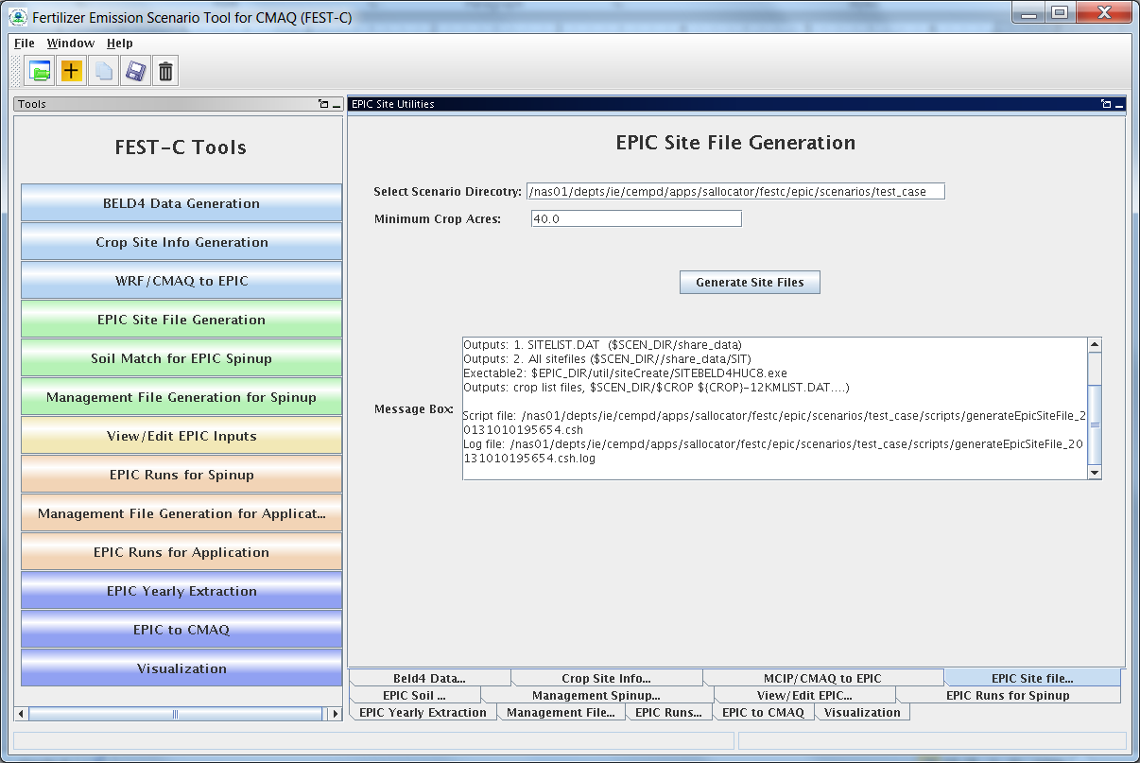

**Figure 11**. The *EPIC Site File Generation* for the test_case scenario.

After the queue job run is finished, users should check the log file under their scenario’s **scripts** directory to make sure that there were no errors during the job execution. The tool generates the following files and directories:

* **”scenario name”/share_data/SIT**/”GRIDID”0.SIT – EPIC site files to be used by all crop EPIC modeling. A description of the file format can be obtained from the EPIC model documentation.
* **”scenario name”/share_data/**SITELIST.DAT – EPIC site list file for all crops to be used in EPIC modeling.
* **”scenario name”/ “crop name” /**”crop name”-LIST.DAT – EPIC site list for this crop, to be used in the *Soil Match for EPIC Spinup* tool in the following section. If there are no grid cells that contain this crop, this file will be an empty file.

## 5.2 Soil Match for EPIC Spinup

The *Soil Match for EPIC Spinup* tool selects a soil for each crop within a grid cell and creates the EPIC soil file. The EPIC soil datasets are built to represent the sample point soils selected for USDA NRI data points at the HUC-8 spatial scale. This tool links built EPIC soil datasets – **BaumerSoils** to the soil series from the USDA NRI for the crop and grid cell. This tool uses the FORTRAN programs stored under **${FESTC_HOME}/epic/util/soilMatch** with the common data files stored under **${FESTC_HOME}/epic/common_data/util/soilMatch** and the generated soil list data under each crop directory. Figure 12 shows the tool interface used to match soils for all crops except BEANS (as explained earlier in Section 5) for the current version of FEST-C. After selecting the crops, users click the Run button to run the tool in the queue. Users should check the queue job and log file in the “**scenario name”/scripts** directory based on the information seen in the Message Box shown in Figure 12.

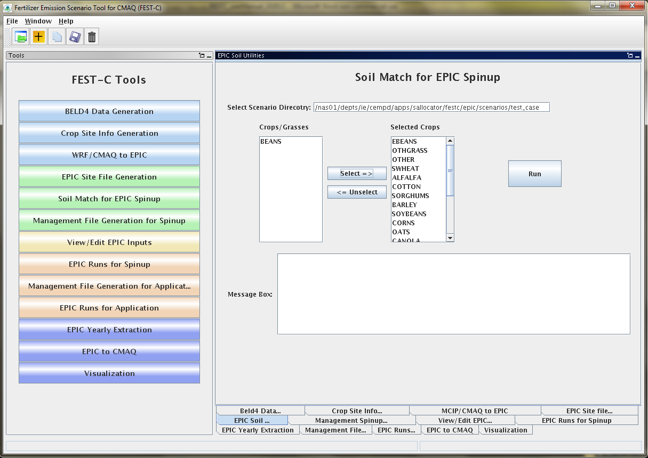

**Figure 12**. *The Soil Match for EPIC Spinup* tool interface used for the test_case scenario. Users can select single or multiple crops (except the BEANS crop, for the current FEST-C version).

The tool will generate many output files under each crop directory, but most of them are intermediate files. The final data file created for the EPIC spinup simulation is:

* **”scenario name”/ “crop name”/**SOILLIST.DAT – contains matched **BaumerSoils** soil file with other parameters for each grid cell under each crop directory.

## 5.3 Management File Generation for Spinup

The *Management File Generation for Spinup* tool interface is used to create the EPIC management for each crop within a grid cell. The EPICRUN file that has the linkages for the grid cell, statistical weather and wind files, soil files, and management files is also created for the rain-fed and irrigated crop. This tool uses the FORTRAN program ManGenSU.exe stored under **${FESTC_HOME}/epic/util/manageCreate** with the common data files stored under **${FESTC_HOME}/epic/common_data/util/manageCreate** and many other data files generated under each crop directory. Figure 13 shows the tool interface used to generate management files for the test_case scenario. Users need to make sure that the following two fields are selected correctly:

* Fertilizer Year – select 2001 or 2006 for choosing common data sets stored under **${FESTC_HOME}/epic/common_data/util/manageCreate** accordingly.
* Selected Crops – select one or multiple crops (except BEANS).

After clicking the Run button and then “OK”, a queue job to generate management files for each selected crop will be submitted. Users should check the queue log file under the “**scenario name”/scripts** directory based on the information in the Message Box (shown in Figure 13) to make sure that the job completed with no errors.

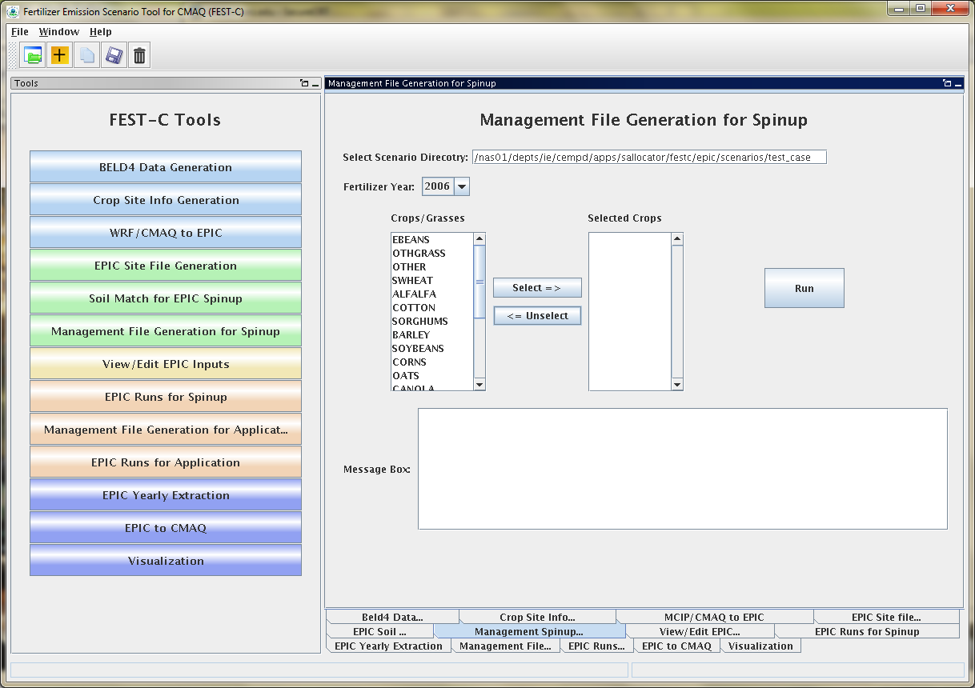

**Figure 13**. The *Management File Generation for Spinup* tool used for the test_case scenario.

There are many output files generated under each crop, but many of these are used just for verification. The tool generates the following files to be used for the EPIC spinup simulations under the directory **”scenario name”/ “crop name” /spinup/manage** for each crop:

* EPICRUNFILERAIN.DAT – EPIC run file for rain-fed spinup simulation of this crop.
* EPICRUNFILEIRR.DAT – EPIC run file for irrigated spinup simulation of this crop.
* GRIDS_OPC.DAT – the list of management file names to be used in EPIC modeling.
* **OPC**/”GRIDID”0”BELD3 Crop Number”.OPC – grid cell EPIC management files under the **OPC** directory. Table 1 in Section 4 lists the crop numbers in the BELD3 and BELD4 data.

## 5.4 View/Edit EPIC Inputs

The *View/Edit EPIC Inputs* interface allows users to view or edit five main EPIC simulation files (shown in Figure 14). Users generally do not need to edit those files, but viewing them can be helpful for debugging. The user has to select a crop first and then select the EPIC simulation type. The simulation type can be SPINUP if the *Management File Generation for Spinup* tool is executed for the selected crop. The user can select the simulation type APP after the *Management File Generation for Application* tool is executed for the crop. Figure 14 shows the tool interface for the test_case scenario.

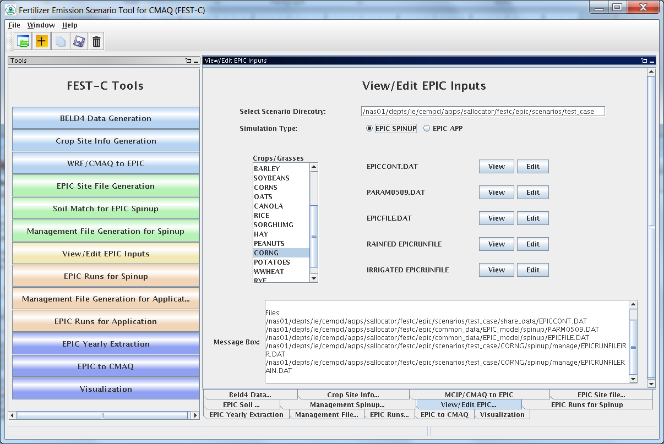

**Figure 14**. The *View/Edit EPIC Inputs* tool for the test_case scenario.

## 5.5 EPIC Runs for Spinup

The *EPIC Runs for Spinup* tool interface is used to run the EPIC model for spinup (EPIC0509su.exe), which is stored under the directory **${FESTC_HOME}/epic/model/current**. The tool uses input files stored primarily in the following directories:

* $**{FESTC_HOME}/epic/common_data/EPIC_model/spinup** – for the common model input files.
* $**{FESTC_HOME}/epic/scenarios/”scenario name”/share_data** – for site files and list file.
* $**{FESTC_HOME}/epic/common_data/statWeath** – for observed climate station statistical data (see <http://epicapex.tamu.edu/epic/>)
* $**{FESTC_HOME}/epic/scenarios/”scenario name”/ “crop name” /spinup/manage** – for the run files, management files, and management list file.
* $**{FESTC_HOME}/epic/scenarios/”scenario name”/ “crop name”** – for the soil list file.

The main purpose for performing a spinup simulation is to generate EPIC soil files to be used as initial conditions in the application run for the simulation year. For all crops except potatoes, the spinup simulation is run for 25 years starting from 1978, while for potatoes it is run for 100 years starting from 1903 (as discussed in Section 2). Figure 15 displays the tool interface used for the test_case scenario. Users can select one or multiple crops (except BEANS) for the simulation. After clicking the Run button, a script file is generated to run the rain-fed and irrigated EPIC spinup simulations for each crop. After submitting the script file to the queue (by clicking OK), the user can check the queue job. After the job has finished, users should always check the log file in the “**scenario name”/scripts** directory based on the information in the Message Box (shown in Figure 15) to make sure the runs completed without any errors.

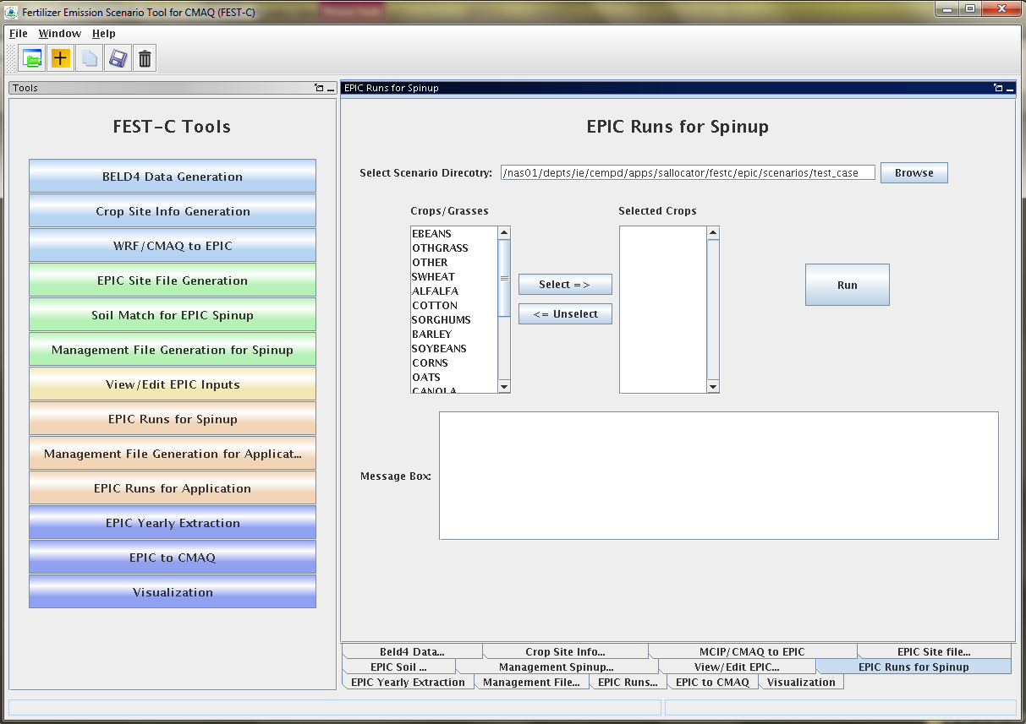

**Figure 15**. The *EPIC Runs for Spinup* tool used for the test_case scenario.

The tool generates many directories and files for each crop. The original EPIC output files are stored under the two following directories in the ”**scenario name”/“crop name”/spinup** directory:

* **rainf** – contains output from EPIC rain-fed spinup simulations for this crop. Soil files to be used in the EPIC application simulation are:
  + **SOL**/”GRIDID”0”BELD3 Crop Number”.SOL
* **irr** – contains output from EPIC irrigated spinup simulations for this crop. Soil files to be used in the EPIC application simulation are:
  + **SOL**/”GRIDID”0”BELD3 Crop Number”.SOL

The output data created for CMAQ modeling are used primarily for QA purposes, and are stored under the following two directories in the **”scenario name”/output4CMAQ/spinup** directory:

* **5years** – contains average EPIC output data from the last five years of the spinup simulations for the crops.
* **daily** – stores daily EPIC output data from EPIC spinup runs for the crops simulated.

# 6. EPIC Application Run Tools

After users complete the EPIC simulations for spinup, they can proceed to the EPIC application run tools for the simulation year. The spinup simulations need to be run only once for a given domain and grid resolution—in other words, the initial conditions can be re-used for multiple application years. The first step in running an EPIC application is to generate management files for the application year. The application management program needs to be run only once for a given domain and grid resolution; it is not year-specific. The user can then run the EPIC model for the application year if the daily weather and N deposition files for the scenario have been generated using the *WRF/CMAQ to EPIC* tool interface (described in Section 4.3).

## 6.1 Management File Generation for Application

The *Management File Generation for Application* tool interface is used to create the EPIC management files for each crop to be used in the EPIC application year modeling. The EPICRUN file, which contains the linkages for the statistical weather and wind files, the soil files, and the management files for EPIC grid cells, is also generated for the rain-fed and irrigated simulations. This tool uses the FORTRAN program ManGenFERT.exe stored under the **${FESTC_HOME}/epic/util/manageCreate** directory with the common data files stored under **${FESTC_HOME}/epic/common_data/util/manageCreate** and many other data files generated under each crop directory. Figure 16 shows the tool interface used to generate management files for the test_case scenario. The user needs to make sure that the following two entries are selected correctly:

* Fertilizer Year – select 2001 or 2006. The common management and fertilizer data sets created under the **${FESTC_HOME}/epic/common_data/util/manageCreate directory** will be usedaccordingly. This management tool uses the created fertilizer data types for the 10 crop production regions.
* Selected Crops – select one or multiple crops (except BEANS).

After clicking the Run button, a script file is generated to compute the management files for the selected crops. After submitting the script file to the queue (clicking OK), the user can check the queue job. After submitting the script file to the queue (by clicking OK), the user can check the queue job. After the job has finished, users should always check the log file in the “**scenario name”/scripts** directory based on the information in the Message Box (shown in Figure 16) to make sure the runs completed without any errors.

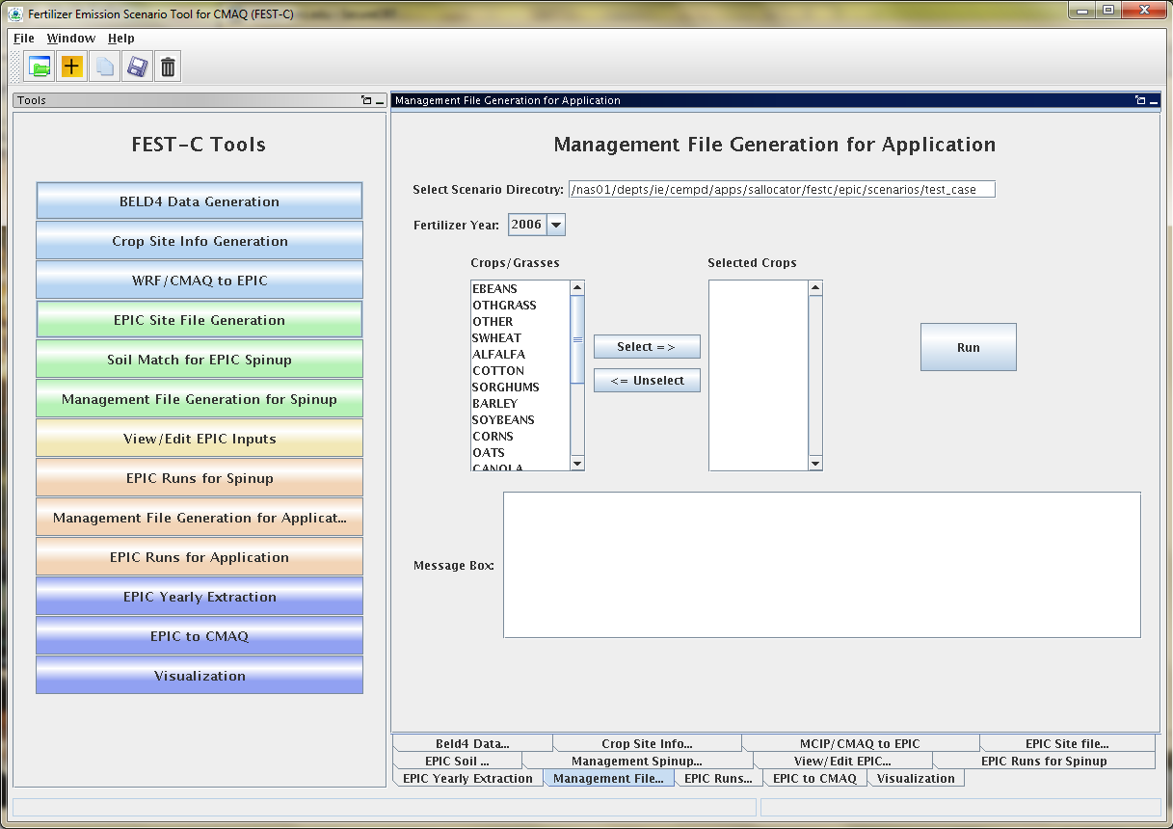

**Figure 16**. The *Management File Generation for Application* tool interface used for the test_case scenario.

The tool will generate many output files under each crop, but many of these are used just for verification. The tool generates the following files under the **”scenario name”/ “crop name”/app/manage** directory:

* EPICRUNFILERAINDW.DAT – EPIC run file for rain-fed application simulation.
* EPICRUNFILEIRRDW.DAT – EPIC run file for irrigated application simulation.
* GRIDS_OPC.DAT – the list of management file names to be used in EPIC modeling.
* **OPC**/”GRIDID”0”BELD3 Crop Number”.OPC – grid cell EPIC management files under the **OPC** directory. Table 1 in Section 4 lists the crop numbers in the BELD3 and BELD4 data.

## 6.2 EPIC Runs for Application

The *EPIC Runs for Application* tool interface is used to run the EPIC model for the simulation year (EPIC0509app.exe) ,which is stored under the directory **${FESTC_HOME}/epic/model/current**. The user already needs to have generated the site daily weather and N deposition files using the tool described in Section 4.3. The *EPIC Runs for Application* tool uses input files stored primarily in the following directories:

* $**{FESTC_HOME}/epic/common_data/EPIC_model/app** – for the common model input files.
* $**{FESTC_HOME}/epic/scenarios/”scenario name”/share_data** – for the EPICCONT.DAT file, site files, and site list file, and daily weather and N deposition files and weather list file.
* $**{FESTC_HOME}/epic/common_data/statWeath** – for observed climate station statistical data.
* $**{FESTC_HOME}/epic/scenarios/”scenario name”/ “crop name” /app/manage** – for the run files, management files, and management list file.
* $**{FESTC_HOME}/epic/scenarios/”scenario name”/ “crop name”/spinup/rainf/SOL** – for the soil files to be used in the rain-fed simulations.
* $**{FESTC_HOME}/epic/scenarios/”scenario name”/ “crop name”/spinup/irr/SOL –** for the soil files to be used in the irrigated simulations.

Figure 17 shows the tool interface used for the test_case scenario. The Simulation Year is defined when the user creates the scenario. Users can select one or multiple crops (except BEANS) for the simulation. After clicking the Run button, a script file is generated to run the rain-fed and irrigated EPIC application simulations for each crop. The EPIC application simulations will run for a two-year period (the previous year and the simulation year) using the same daily weather and N deposition files for the simulation year; the two-year period is needed in order to simulate a full growing season for fall-sown crops. After submitting the script file to the queue (by clicking OK), the user can check the queue job. After the job has finished, users should always check the log file in the “**scenario name”/scripts** directory based on the information in the Message Box (shown in Figure 17) to make sure the runs completed without any errors.

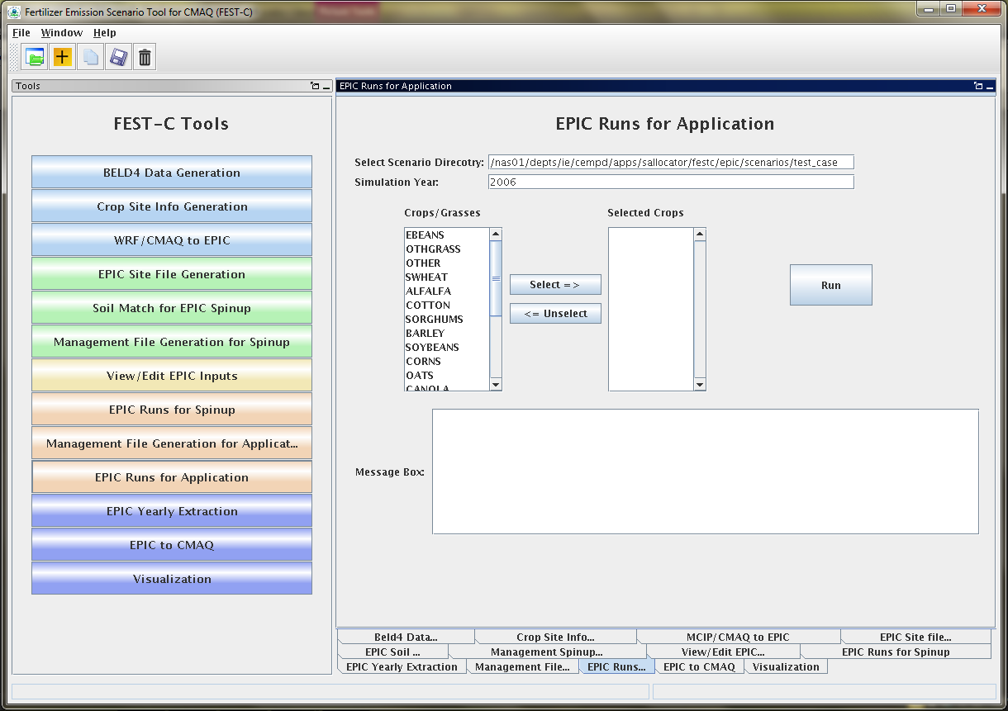

**Figure 17**. The *EPIC Runs for Application* tool interface used for the test_case scenario.

The tool generates many directories and files for each crop. The original EPIC output files are stored under the following two subdirectories in the ”**scenario name”/ “crop name” /app** directory:

* **rainf** – contains output from EPIC rain-fed application simulations for this crop.
* **irr** – contains output from EPIC irrigated application simulations for this crop.

The output data created for CMAQ modeling are stored under the following two subdirectories in the **”scenario name”/output4CMAQ/app** directory:

* **year** – contains average EPIC output data for the simulation year (one year) run for the crops simulated. They are mainly used for QA purposes.
* **daily** – stores daily EPIC output data from EPIC application runs for the crops simulated. They are used to extract the input for the CMAQ bidirectional NH3 modeling.

# 7. Output Processing and Visualizing Tools

EPIC is a site-based model that generates output in formatted text files. In the domain-based EPIC modeling within FEST-C, the crops in each grid cell are modeled individually. Thus, there are many text output files generated for each crop in each grid cell selected for EPIC modeling. In this section we describe two tools that were developed to extract yearly and daily EPIC output variables into NetCDF-format files for QA purposes and for CMAQ modeling. Using the *Visualization* tool interface, users can prepare spatial views of EPIC output variables in the created NetCDF files over their modeling scenario domain.

## 7.1 EPIC Yearly Extraction

The *EPIC Yearly Extraction* tool was developed in the SA Raster Tools. It is used to extract 29 variables into a NetCDF file from the yearly average EPIC output files for all simulated crops within selected grid cells. The output from this tool is primarily used for QA purposes; to make sure that EPIC simulation results appear to be spatially reasonable over the domain area. Figure 18 shows the tool interface used for the test_case scenario. The only item users need to select is one of the two the Output Types:

* EPIC SPINUP – select this if the user wants to extract yearly average variables from the EPIC simulations for spinup. For these simulations, yearly average variables are from the last five years of simulation and are stored under the **”scenario name”/output4CMAQ/spinup/5years** directory.
* EPIC APP – select this if the user wants to extract yearly average variables from the EPIC simulations for the application year. The yearly average variables are from the output stored under the ”**scenario name”/output4CMAQ/app/year** directory.

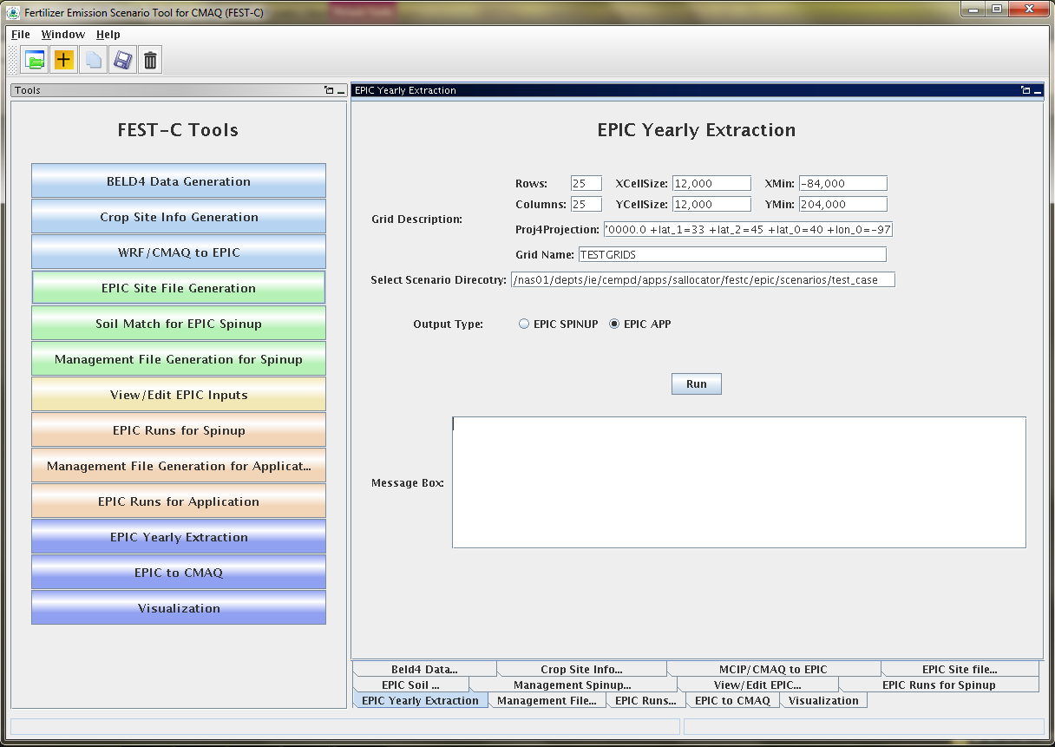

**Figure 18**. The *EPIC Yearly Extraction* tool interface used for the test_case scenario.

Table 3 lists the 29 variables in the EPIC output files that are extracted by the tool. The output file produced by the tool is stored in one of the following two directories as:

* **${FESTC_HOME}/epic/scenarios/”scenario name”/output4CMAQ/spinup/** **toCMAQ/**epic2cmaq_year.nc – if the EPIC SPINUP output type was selected.
* **${FESTC_HOME}/epic/scenarios/”scenario name”/output4CMAQ/app/toCMAQ/** epic2cmaq_year.nc – if the EPIC APP output type was selected.

Table 3. EPIC yearly extraction output variables



If you are using the VERDI tool for visualization, there is no time dimension. Data layers are assigned to individual crops (see Table 1 in Section 4 for BELD4 crop numbers). Users should always check the log file under the scenario’s **scripts** directory to make sure that the tool has run correctly.

## 7.2 EPIC to CMAQ

The *EPIC to CMAQ* tool interface was developed in the SA Raster Tools. It is used to extract 13 variables from EPIC soil output files and 59 variables from EPIC daily output files into NetCDF files for all simulated crops within selected grid cells. The output from this tool is used as input to CMAQ bidirectional NH3 modeling over the domain area. Figure 19 shows the tool interface used for the test_case scenario. The user needs to input only one item on the interface:

* Output File Prefix – this is used as the file prefix for all NetCDF output file names.

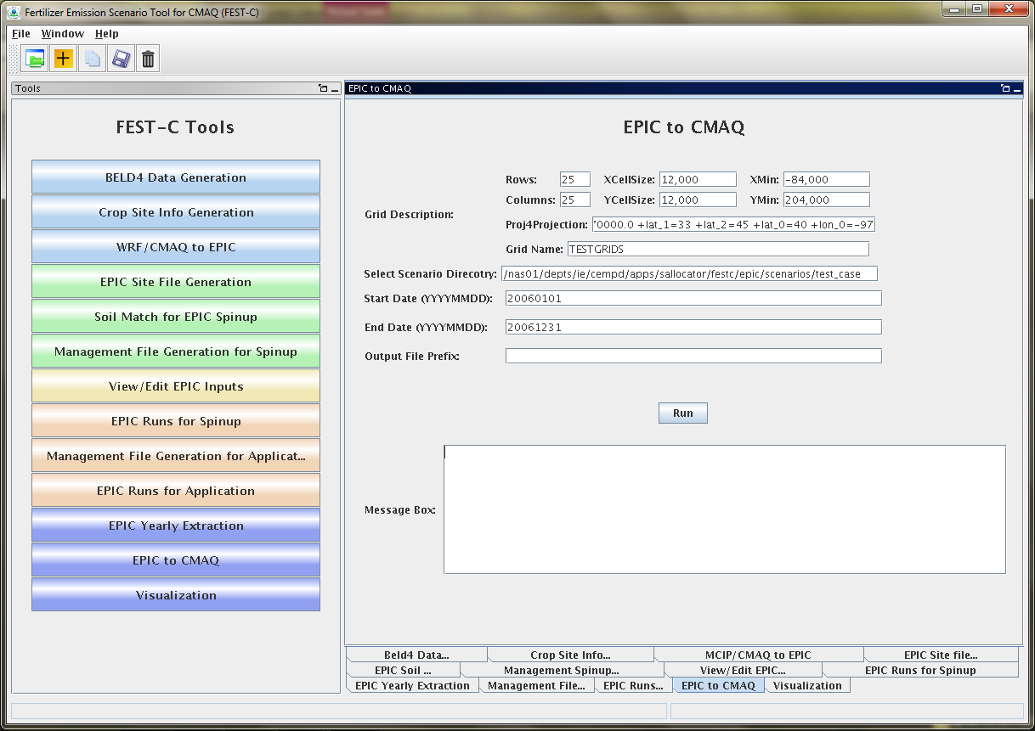

**Figure 19**. The *EPIC to CMAQ* tool interface used for the test_case scenario.

The following output files produced by the tool are stored under the

**${FESTC_HOME}/epic/scenarios/”scenario name”/output4CMAQ/app/toCMAQ** directory:

* **“**Output File Prefix”_soil.nc – soil output file that contains 13 soil variables extracted from EPIC soil output files (**”scenario name”/output4CMAQ /app/daily/“**BELD4 Crop Number”.NCS). The 13 soil variables are listed in Table 4. Layer1 and Layer2 are for the soil depth from 0 to 1 cm and from 1 cm to 100 cm, respectively.
* **“**Output File Prefix”_ timeYYYYMMDD.nc – daily NetCDF files for the simulation year. A daily NetCDF file contains 59 variables extracted from EPIC daily output files (**”scenario name”/output4CMAQ /app/daily/**“BELD4 Crop Number”.NCD”). The 59 variables are listed in Table 5. Layer1, Layer2, and Layert are for the soil depth from 0 to 1 cm, from 1 cm to 100 cm, and from 0 cm to the full Baumer soil profile depth, which can be more than 1 m.

Table 4. “EPIC to CMAQ” soil output variables



Table 5. “EPIC to CMAQ” daily output variables.



*Variable is not used at this time. DN2 is currently under revision, and AVOL is an initial estimate that is revised within the bidirectional CMAQ.

When the Run button is clicked, a script file is generated under the scenario’s **scripts** directory. The script file is submitted to the queue for execution after the user clicks OK. A CMAQ-ready file is generated for each day and is viewable in VERDI. Users should always make sure that there are no error messages in the log file under the **scripts** directory after the queue job has completed.

## 7.3 Visualization

The *Visualization* tool interface is used to invoke the VERDI interface to view the selected NetCDF data set. Figure 20 shows the appearance of the tool interface before an input file has been selected. Users can select the data type on the left side of the interface window and then select a NetCDF file created or used within the FEST-C system (e.g., an EPIC output NetCDF file created by the previous two tools, a BELD4 data set, MCIP and CMAQ data sets, a daily weather and N deposition NetCDF output file) by browsing through the file systems. When the Display button is clicked, the VERDI interface will be invoked to visualize the selected NetCDF file. For this to work properly, the user has to set the VERDI system in the FEST-C configuration file config.properties (described in Section 1). Information on how to use the VERDI system can be obtained from the CMAS VERDI site: <http://www.cmascenter.org/verdi/>.

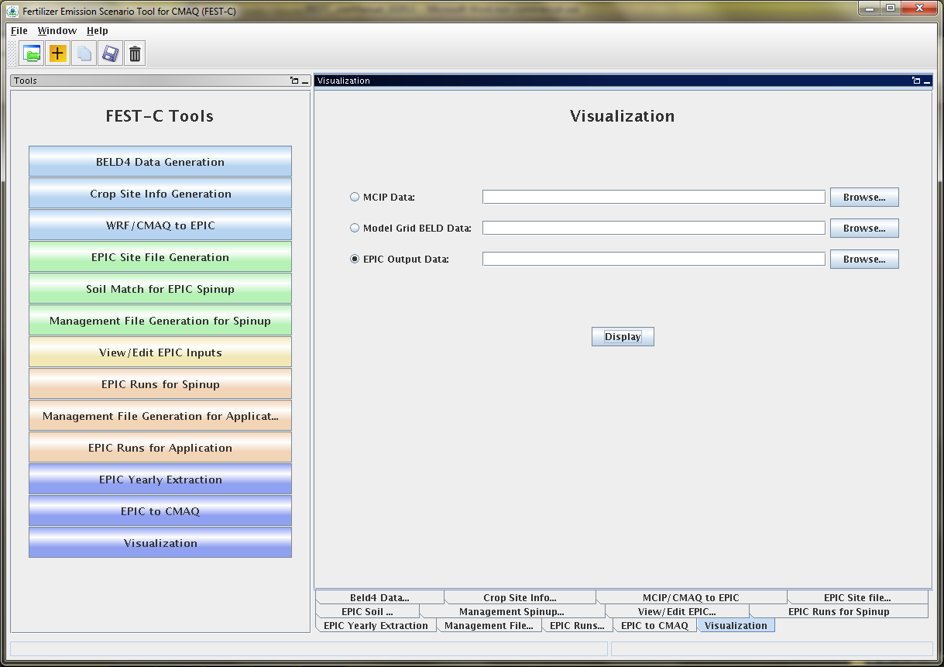

**Figure 20.** The Visualization tool interface.

# 8. Future Work

A newer version of the EPIC model in modular format (EPIC V1102) is being adapted to the EPA application format and will be added into the FEST-C system after thorough testing and evaluation. This new version of EPIC has an improved treatment of N modeling. In addition, we will continue improving the land use data using the 2011 NLCD data that are scheduled to be released by the end of this year. This will be accompanied by an updated fertilizer type scenario, also keyed to 2011. We are exploring a move to computing crop land use data directly from USDA National Agricultural Statistics Service (NASS) Cropland Data Layer (CDL) data. This would provide higher-resolution information, but it does not include critical information such as differentiation between irrigated and rain-fed crops, so further exploration is needed.

In the near-term, we anticipate developing a long-term average daily wet and dry deposition data layer that can be used in spinup or application simulations. A notice will be posted to the CMAS web-site when that data layer is ready for release.

We are also helping the EPA apply the FEST-C system to address multimedia (air, land, water) questions related to biofuels production and climate change. We are exploring using FEST-C to study not only the effects of agricultural practices (e.g., fertilizing and management practices) on air quality (NH3), climate (N2O), and climate change, but also the effects of meteorology and climate on agricultural productivity, soil erosion, water quantity, and water quality.

# Acknowledgments

The development of the FEST-C system is sponsored and directed by the U.S. EPA Atmospheric Modeling and Analysis Division (AMAD) under two U.S. EPA contracts: No. EP-W-09-023, “Operation of the Center for Community Air Quality Modeling and Analysis (CMAS),” and EP‑D-12-044, “Emissions, Air Quality, and Meteorological Modeling Support (EMAQ).” We thank Dr. Ellen Cooter, the EPA Work Assignment Manager for the work described in this document, for her leadership on this project. We also greatly appreciate the continuing and generous intellectual support we received from Dr. Jimmy R. Williams at Texas A&M AgriLife Research, Blackland Research & Extension Center (Temple, TX). We thank Joe Slater, Manager of Fertilizer/AG Lime Control Services, University of Missouri Agricultural Experiment Station at Columbia, MO, for his invaluable insights regarding fertilizer sales and use. Finally, we want to thank Dr. Qun He for his design and support on the FEST-C interface development.