Chapter 10. Using SMOKE: Scripts, Models-3, and EDSS

Contents
- Introduction
- UNIX Scripts
- M3demo case
- Net96 case
- Creating your own scripts
- Changing configurations for different air quality models

Introduction
The current version of SMOKE can be run from three environments: UNIX scripts, the Models-3 system, and the Environmental Decision Support System (EDSS). The current version of this chapter deals only with the first method: UNIX scripts. In the future, this chapter will be expanded to include information about running from Models-3 and from EDSS, as well as from Windows .BAT files.

UNIX Scripts
UNIX scripts are useful for running SMOKE because they provide the ultimate flexibility. Users can manipulate all of the SMOKE options from these scripts, and even write their own scripts to include I/O API utilities and regroup the SMOKE programs into different processing arrangements. For example, although the default SMOKE scripts are grouped by source categories, users are free to create their own scripts that run SMOKE as “inventory steps,” “per-month steps”, and “per-day steps” if desired.
The downside of UNIX scripts is that you have to know something about UNIX to be able to use them most effectively. For those users who are not UNIX savvy, the Models-3 and EDSS options might be the best way to go. Unfortunately, we do not have documentation on these methods at this time.
All SMOKE UNIX scripts can be found in the $SMKROOT/scripts/run directory, or simply the $SCRIPTS/run directory (after having invoked the Assigns file). The sample REPCONFIG files (needed for Smkreport), can be found in $SCRIPTS/configure.

M3demo case
The “m3demo” case was originally designed to be release with Models-3; hence the name “m3demo”. We have also release this case as a stand alone version for users who wish to use SMOKE outside of the Models-3 framework. This case serves as a benchmark for the SMOKE system; users should use the scripts for this case to ensure that SMOKE is running properly on their system. CPU times are given for this case for an SGI and a Sun configuration in Chapter 12: Compiling and Performance.
The m3demo case uses old data, and we therefore no longer recommend that users start with the m3demo Assigns file and scripts when customizing scripts for their own usage. The net96 case (below) is better suited for such usage. The m3demo case is a 1-day case over the Eastern US, using a 36-km Lambert projection covering the domain shown below.
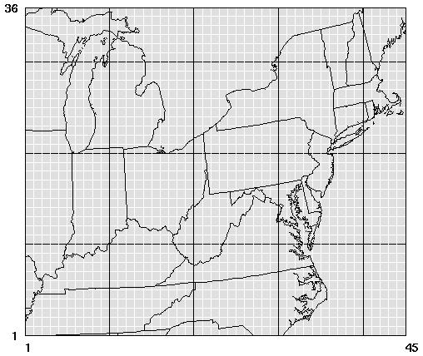
The inventory used for m3demo is pared down to the region covered by the grid, to help the test case run faster. All emission inventory formats are in Inventory Data Analyzer (IDA) format. The output created is for the CMAQ model for CB-IV speciation with PM2.5 speciation as well. However, mobile sources are only run with CO, NOx, and VOC, but not for SO2, NH3, PM10, and PM2.5. Area and point source use all 7 pollutants previously mentioned. Biogenics runs only for NOx and VOC, which is what is available from BEIS-2 (which SMOKE reproduces).
The following steps and scripts are for the m3demo case:
Area emissions 1995 base case: smk_ar_m3demo.run.
This script runs Smkinven (inventory import), Grdmat (grdding), Spcmat (speciation), Temporal (hourly allocation), Smkmerge (merging of SMOKE intermediates), and Smkreport (reporting) for area sources in 1995, the base year for this case. Smkreport is run for the “state” configuration of the example REPCONFIG files, for which state totals are given for each stage of the area-source processing (inventory import, import + gridding, import + speciation, import + hourly allocation, full merge).
Area emissions 2007 projection and 2007 merge: smk_ar_m3demo-07.run.
This script runs Cntlmat (for projection matrix creation), Grwinven (for inventory projection to 2007), Temporal (for 2007 hourly allocation), and Smkmerge (to create model-ready files). This scripts does not rerun Grdmat or Spcmat, because the matrices created from these steps are independent on the future year.
Biogenic emissions: smk_bg_m3demo.run.
This script runs Rawbio (for landuse import), Tmpbio (for temporal allocation and speciation of biogenic emission), and Smkmerge (for biogenic reporting). The landuse for the m3demo case is simply county-total landuse, which is gridded based on the “area” gridding surrogate.
Biogenic emissions: smk_beis3_m3demo.run.
This script runs Normbeis3 (for landuse import), Beis3 (for temporal allocation and speciation of biogenic emission), and Smkmerge (for biogenic reporting). The landuse for the m3demo case is gridded landuse in netCDF.
Mobile VMT and emissions 1995 base case: smk_mb_m3demo_vmt.run.
This script runs Smkinven (for VMT import), Spcmat, Grdmat, Premobl (for temperature preprocessing), Emisfac (for emission factor generation with Mobile5b), Temporal (for combining hourly temperatures, emission factors, and VMT to create hourly emissions), Smkmerge, and Smkreport. Smkreport is run for the “state” configuration, as described for area sources above.
Mobile 2007 projection (without merge): smk_mb_m3demo_vmt-07.run.
This script runs Cntlmat (for project matrix creation for VMT) and Grwinven (for future-year growth of VMT). It does not run Emisfac, Temporal, or Smkmerge for 2007 because the Mobile5b 2007 inputs were not available in time for this release. Unfortunately, mobile speeds are also grown to the future year with the same factor as mobile VMT, making the future-year speeds wrong.
Point emissions 1995 base case: smk_pt_m3demo.run.
This script runs Smkinven, Grdmat, Spcmat, Elevpoint (for identification of the elevated sources), Laypoint (for plume rise computations), Temporal, Smkmerge, and Smkreport. Smkreport is run for the “state” configuration, as described for area sources above. Laypoint takes the place of the Models-3 ECIP step for computing layer fractions for input to CMAQ and MAQSIP.
Point 2007 projection and 2007 merge: smk_pt_m3demo-07.run.
This script runs Cntlmat, Grwinven, Temporal, and Smkmerge to create the 2007 model-ready point source emissions.
All sources merge for CMAQ inputs: smk_mrgall_m3demo_l.run.
This script runs Smkmerge for all source categories at the same time to create the model-ready all-category emission files in units of moles/s for CMAQ. This script duplicates some the Smkmerge processing from the area, mobile, and point scripts, and could be replaced with a script that uses Mrggrid to combine the model-ready files created by the area, biogenic, mobile, and point scripts. To do this, users would have to set MRG_GRDOUT_YN to “Y” in the biogenics script, and ensure that the output units from the biogenic Smkmerge step were moles/s.
All sources merge for state reports: smk_mrgall_m3demo_s.run.
This script runs Smkmerge for all source categories at the same time to recreate state-totals. This script is the only way to get all-category merged emissions reports, and this is why we have included it. Smkreport can only create reports for one source category at a time. This sort of script is useful to ensure that the all-category totals output from Smkmerge include emissions from all source categories.

Net96 case
The “net96” case was designed to provide users with a SMOKE example using the best data available. This case uses the National Emission Inventory (NEI), version 3.11. The ancillary files provided with this case (e.g., profiles, x-refs, and surrogates) have been tested by MCNC to work properly with the NEI, version 3.11. One limitation of the data we have provided is that the mobile emissions data are provided and not the VMT. Future releases will include the VMT data and the ancillary files (MPLIST and MPREF) needed for running the NEI based on VMT and meteorology data. CPU times are given for this case for an SGI configuration only in Chapter 12: Compiling and Performance.
We recommend that users start with the net96 Assigns file and scripts when customizing scripts for their own usage. The net96 case is a 1-day case over the whole US, using a 36-km Lambert projection covering the domain shown below.

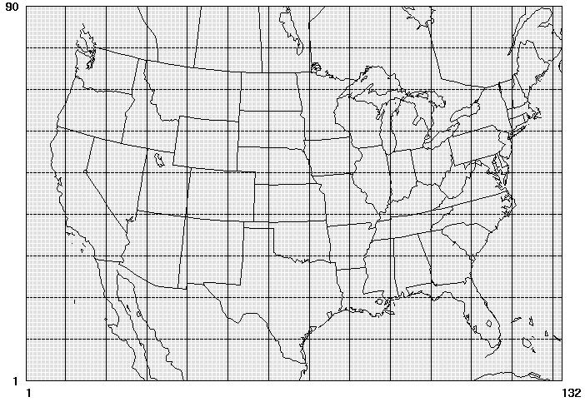
The pollutants available in the NEI are CO, NOx, VOC, SO2, NH3, PM10, and PM2.5. SMOKE computes PMC from the PM10 and PM2.5 values, which is set as an option to the Smkinven program in the scripts. All inventory inputs are in IDA format.
The following steps and scripts are for the net96 case:
Area emissions 1996 base case: smk_ar_net96.run.
This script runs Smkinven (inventory import), Grdmat (grdding), Spcmat (speciation), Temporal (hourly allocation), Smkmerge (merging of SMOKE intermediates), and Smkreport (reporting) for area sources in 1996, the base year for this case. Smkreport is run for the “state” configuration of the example REPCONFIG files, for which state totals are given for each stage of the area-source processing (inventory import, import + gridding, import + speciation, import + hourly allocation, full merge).
Biogenic emissions: smk_bg_net96.run.
This script runs Rawbio (for landuse import), Tmpbio (for temporal allocation and speciation of biogenic emission), and Smkmerge (for biogenic reporting). The landuse for the net96 case is gridded landuse, instead of county-total landuse used with the m3demo case.
Mobile emissions 1996 base case: smk_mb_net96.run.
This script runs Smkinven (for emissions import), Spcmat, Grdmat, Temporal, Smkmerge, and Smkreport. Smkreport is run for the “state” configuration, as described for area sources above. No VMT is run for this case; only the mobile emissions from the NEI are used.
Point emissions 1996 base case: smk_pt_net96.run.
This script runs Smkinven, Grdmat, Spcmat, Temporal, Smkmerge, and Smkreport. Smkreport is run for the “state” configuration, as described for area sources above. Laypoint takes the place of the Models-3 ECIP step for computing layer fractions for input to CMAQ and MAQSIP.
All sources merge for CMAQ inputs: smk_mrgall_net96.run.
This script runs Smkmerge for all source categories at the same time to create the model-ready all-category emission files in units of moles/s for CMAQ.

Creating your own scripts
To create your own scripts, you must typically take the following steps:
- Copy the ASSIGNS.net96.us36 assigns file to your own copy
- Modify the necessary features of the Assigns file for your case. For example, change the scenario names, episode dates, duration, grid name, or speciation name. Some of these changes require additional input files. More details about the steps needed for preparing input files for SMOKE are available in the SMOKE training slides. See the Problem Solving presentation available from the on-line index for more information on these steps.
- Copy the appropriate net96 scripts to your own scripts, change the Assigns file listed in the script to the one that you created in the previous step, and change the options as needed based on Chapter 7: SMOKE Core Programs, as well as based on the information in the next section of this chapter.

Changing configurations for different air quality models
In this section, we attempt to give a basic outline of the considerations for script reconfiguration needed for SMOKE output for various models. This version of SMOKE supports CMAQ, MAQSIP, UAM-IV, UAM-V, CAM_{X} (no toxics), REMSAD (no toxics), and UAM-AERO. We have tested and used SMOKE for all of these configurations, although we are not able to provide all of the scripts for these cases at this time. Furthermore, the SMOKE installation currently provides data for only CMAQ speciation for the CB-IV and RADM2 chemical mechanisms. Look for future data releases for other speciation profiles in SMOKE. It is possible for users to create their own speciation profiles file, or make a request of other SMOKE users for such data.
Most of the options that affect model output format deal with the Elevpoint, Smkmerge, and Smk2emis programs. The input speciation profiles used in Spcmat also impact the final model-ready files, because SMOKE outputs the species that are provided in the GSPRO file. The gridded inputs used by Grdmat as well as the gridded meteorology inputs need to be consistent with the output grid SMOKE grid and grid projection.
All models require Smkmerge to be configured for outputting gridded data, with speciation, and with hourly emissions.

CMAQ
The SMOKE “net96” case is configured to run for CMAQ. CMAQ requires a I/O API NetCDF 3d, gridded, hourly, model-species file, which can contain species for the CB-IV mechanism, the RADM2 mechanism, and can optionally take speciated PM2.5 as well as other primary particulate data such as SO2, NH₃, and PMC. The “net96” scripts provided with SMOKE give output for the CB-IV with speciated PM2.5.
Users can get CMAQ-ready files by:
- Using a CMAQ speciation profile file
- Using a Lambert projection for all gridded input files
- Optionally running Elevpoint if (1) user want to identify specific elevated sources, and/or (2) if user wants to identify plume-in-grid (PinG) sources and output PinG files for CMAQ.
- Run Laypoint for plume rise (takes the place of CMAQ’s ECIP)
- Run Smkmerge with layer-fractions merge, gridded outputs for “moles/s”, and optionally with PinG outputs. SMOKE will automatically output units of “g/s” for PM pollutants that cannot be converted to moles.

MAQSIP
SMOKE outputs for MAQSIP are very similar to those of CMAQ. The major differences to consider are:
- Use a MAQSIP-specific speciation profile
- Smkmerge output units of “moles/hr”.
- Public versions of MAQSIP may not support plume-in-grid.

UAM-IV
To output for UAM-IV, a different approach for elevated point sources is required, and an extra conversion step is needed. Users can get UAM-IV-ready files by:
- Constrain pollutants processed by SMOKE to only those readable by UAM-IV (usually, CO, NO_{x}, and VOC) by editing the sipols.txt file in the $INVDIR directory, or by providing an inventory with only those pollutants. Other pollutants can be used if UAM-IV is configured to accept those data.
- Use a UAM-specific speciation profile. The CB-IV speciation profile provided with SMOKE for CMAQ may be useful, but it does not contain MEOH or ETOH.
- Use a UTM projection for all gridded inputs and meteorology.
- Run Elevpoint with the RISE instruction in the PELVCONFIG file and using a non-zero criteria for plume rise cutoff (user-defined). SMOKE will use a quick calculation based on the Briggs formula for computing plume rise with meteorology assumed. Sources with plume rise greater than the cutoff height will be flagged for elevated processing by Smkmerge. Alternatively, you can use other elevated or PinG criteria in the PELVCONFIG file if you desire some other selection method besides the traditional cutoff method.
- Smkmerge configured to merge without layer fractions, output units of “gm moles/hr”, and to output an elevated ASCII file. There are a large number of options in the Smkmerge documentation that allow users to set the header information in the ASCII elevated file. Smkmerge will also create a 2-d merged emissions file in I/O API NetCDF format.
- Run Smk2emis on the 2-d I/O API NetCDF file. This step can be added the script using a RUN_SMK2EMIS setting and ensuring the Smk2emis input and output environment variables are also set by the script (in the environment variable override section – after the Assigns file is invoked, but before smk_run.scr is called). Smk2emis create the UAM-IV binary “EMISSIONS” file. If the output files are not appearing in the OUTPUT directory, it may be because the environment variable used by Smk2emis is not getting set by the SMOKE scripts. Check the Smk2emis log file to check if this is the case.
- Run the PTSRCE program provided with UAM-IV with the ASCII elevated file from Smkmerge as input.

UAM-V, CAM_{X}
The processing for UAM-V and CAM_{X} is much like that for UAM-IV. The pollutants, grids, layer structures, and chemical mechanisms that these models can use are more varied than for UAM-IV. The SMOKE settings and inputs must be adjusted to accommodate these differences.

REMSAD
The processing for REMSAD is much like that for UAM-IV. REMSAD can input a number of different pollutants, but it has only been tested with SMOKE for PM inputs (not with TOXIC inputs). Additionally, the REMSAD version that is currently available only inputs total VOC (not speciated VOC), and will therefore requires REMSAD-specific speciation profiles file.

UAM-AERO
The processing for UAM-AERO is much like that for UAM-IV. The pollutants expected by UAM-AERO are very different from those of UAM-IV, and in fact, the type of variable names UAM-AERO expects (with plusses, minuses, and periods) are prohibited in the NetCDF library. So, in order to output UAM-AERO format, users must configure as for UAM-IV, plus:
- The Smk2emis program must be configured to use the variable name mapping option and the VNAMMAP file. Users can use this option to map the I/O API variable names from the 2-d Smkmerge output to new names in the EMISSIONS file created by Smk2emis. The ASCII elevated file variable names must be changed manually before running through PTSRCE.

