Visualization Environment for Rich Data Interpretation (VERDI 1.4.1): Developer Instructions

U.S. EPA Contract No. EP-W-05-045, “Operation of the Center for Community Air Quality Modeling and Analysis”

Prepared for: William Benjey and Donna Schwede
U.S. EPA, ORD/NERL/AMD/APMB
E243-04
USEPA Mailroom
Research Triangle Park, NC 27711

Prepared by: Liz Adams and Qun He
Institute for the Environment
The University of North Carolina at Chapel Hill
137 E. Franklin St., CB 6116
Chapel Hill, NC 27599-6116

Date: May 31, 2011

Contents

1 Introduction 1
1.1 Background 1
2 Install developer environment 2
2.1 Download and Install Eclipse 2
2.2 Download and install NSIS Installer (only for windows) 2
2.3 Install Subclipse update 1.2x in Eclipse 3.5 2
2.4 Install Java Development Kit 2
3 Running Eclipse 3
3.1 Import VERDI Source Code 5
3.1.1 Select File→Import 5
3.1.2 Checkout Projects from SVN 6
3.1.3 Create a new repository location 7
3.1.4 Specify location of VERDI SourceForge repository 8
3.1.5 Select Folders for Checkout 9
4 Run VERDI within Eclipse 11
5 Prepare to build Distribution 12
5.1.1 build.properties file 12
5.1.1.1 Microsoft Windows 12
5.1.1.2 Linux 12
5.1.2 Build_dist.xml 13
6 Build VERDI 15
6.1 Build using Ant 15
6.1.1 Microsoft Windows 15
6.1.1 Linux Distribution 17
6.2 Check Console for Error Messages 18
6.3 Add Java Compiler to Ant 18
7 Updating source code from the repository 21
7.1 Open the Synchronization Window 21
7.2 Synchronize with Repository using SVN 23
7.3 Resolve conflicts and Update 25

Figures

Figure 3-1 Select a Workspace 3
Figure 3-2 Eclipse Starting Up 4
Figure 3-3 Eclipse Workbench 4
Figure 3-4 File Import 5
Figure 3-5 Click on Arrow to see workbench 6
Figure 3-6 Checkout Projects from SVN on Windows/Linux 7
Figure 3-7 Checkout Projects from SVN on Mac 7
Figure 3-8 Create new repository location 8
Figure 3-9 Checkout Code 9
Figure 3-10 Select Folders for Checkout 10
Figure 3-11 SVN Checkout includes a meter indicating % completion 10
Figure 3-12 SVN imported code into workspace 11
Figure 4-1 Run VERDI within Eclipse 11
Figure 5-1 Review/Edit build.properties 12
Figure 5-2 build_dist.xml – no editing needed 13
Figure 5-3 build_dist.xml: build Linux distribution section 14
Figure 5-4 dist.xml: nsis installer path section 14
Figure 6-2 Window→Show View→Ant 16
Figure 6-3 Double click on build.win.dist to build VERDI distribution 17
Figure 6-4 Console Error Message 18
Figure 6-5 Open Windows→Preferences 19
Figure 6-6 Expand Ant, Select Runtime, Select Global Entries 20
Figure 6-7 Add tools.tar to Ant Preferences 20
Figure 7-1 Show View → Other 21
Figure 7-2 Expand Team Folder - highlight Synchronize – click ok 22
Figure 7-3 Synchronize Window added to bottom of Workspace 22
Figure 7-4 Click on Synchronize Symbol to bring up Pop-up 23
Figure 7-5 Synchronize Pop-up – select SVN 24
Figure 7-6 Synchronize SVN – select all 24
Figure 7-7 Check for Updates and Conflicts 25
Figure 7-7 Check for Updates and Conflicts 25

Introduction

Background
This manual contains instructions on how developers can set up, run, build, and obtain updates from the software repository for Visualization Environment for Rich Data Interpretation (VERDI). Developers are encouraged to develop and contribute code for VERDI. Developers are requested to submit a bugzilla request for enhancement and to submit test datasets, documentation and proposed code to CMAS for testing prior to committing code to the repository.
Initial development of VERDI was done by the Argonne National Laboratory for the U.S. Environmental Protection Agency (EPA) and its user community. Argonne National Laboratory's work was supported by the EPA though U.S. Department of Energy contract DE-AC02-06CH11357. Further development has been performed by the University of North Carolina Institute for the Environment under U.S. EPA Contract No. EP-W-05-045 and EP-W-09-023, by Lockheed Corporation under U.S. EPA contract No. 68-W-04-005, and Argonne National Laboratory. VERDI is licensed under the Gnu Public License (GPL) version 3, and the source code is available through verdi.sourceforge.net. VERDI is supported by the Community Modeling and Analysis System (CMAS) Center under U.S. EPA Contract No. EP-W-09-023. The CMAS Center is located within the Institute for the Environment at the University of North Carolina at Chapel Hill.

Install developer environment
To install this software on Windows, you may need administrator privileges. You should exit all programs before installing software.

Download and Install Eclipse
  - http://www.eclipse.org/
  - Download and install Eclipse Classic 3.5.1
    - Windows: install to the directory C:\Program Files\
    - Linux/Mac: install to local directory

Download and install NSIS Installer (only for windows)
- http://nsis.sf.net
- Download NSIS installer and install
    - install to the directory C:\Program Files\

Install Subclipse update 1.2x in Eclipse 3.5
- http://subclipse.tigris.org/servlets/ProjectProcess?pageID=p4wYuA
- Follow a link for zipped downloads: http://subclipse.tigris.org/servlets/ProjectDocumentList?folderID=2240
- Download the site-1.2.4.zip, Zipped update Site for Subclipse 1.2.4 (the website states that this is obsolete, but if you use a more recent version, it will not provide the Import>Other>Checkout Projects from SVN functionality that is needed.)
- Extract this zip file and save into the Eclipse Directory.
  - Windows: You may need to authorize the overwriting of files.
  - Linux/Mac: copy files in Plugin directory to Plugin directory under Eclipse.

Install Java Development Kit
- http://java.sun.com/javase/downloads/index.jsp#jdk
- Install the latest release of JDK that is available from the above link.
- For Windows:
  - Add the Java compiler to your path on the Windows Machine.
    - From the desktop, right-click My Computer and click Properties.
    - In the System Properties window, click on the Advanced tab.
    - In the Advanced section, click the Environment Variables button.
    - Finally, in the Environment Variables window (as shown below), highlight the Path variable in the Systems Variable section and click the Edit button.
    - Add the location where the most recent JDK available on your computer. For example: C:\Program Files\Java\jdk1.6.0_17\bin
  - For 32 bit JDK, install JAI, JAI-ImageIO and Java 3D:
    - Download JAI from http://download.java.net/media/jai/builds/release/1_1_3/ and install it into JDK directory
    - Download JAI-ImageIO from http://download.java.net/media/jai-imageio/builds/release/1.1/ and install it into JDK directory
    - Download and install Java 3D: http://java3d.java.net/binary-builds.html
- For Linux
  - Add the compiler to a local directory
  - Install JAI, JAI-ImageIO and Java 3D:
    - Download 32 or 64 bit JAI that matching your JDK from http://download.java.net/media/jai/builds/release/1_1_3/ and install it into JDK directory
    - Download 32 or 64 bit JAI-ImageIO that matching your JDK from http://download.java.net/media/jai-imageio/builds/release/1.1/ and install it into JDK directory
    - Download 32 or 64 bit Java 3D that matching your JDK and install it: http://java3d.java.net/binary-builds.html
    - Note: The 64bit version of Jai-ImageIO is corrupt. Fix it after download and using the fixed version:
sed s/+215/-n+215/ jai_imageio-1_1-lib-linux-amd64-jdk.bin > jai_imageio-1_1-lib-linux-amd64-jdk-fixed.bin
sed s/+215/-n+215/ jai_imageio-1_1-lib-linux-i586-jdk.bin > jai_imageio-1_1-lib-linux-i586-jdk-fixed.bin

- For Mac
- JDK is already installed on OSX. Using Software Update to update it to the latest version.
  - Check version using command: javac –version
  - Check path using command: which javac
- Install Java3D to support the contour plot on Mac for VERDI
  - http://www.downloadjava3d.com/mac.php

Running Eclipse
Start Eclipse by going to the C:\Program Files\eclipse directory and double clicking on eclipse.exe. Specify a location for a new workspace folder, for example, C:\workspace\verdi_1.4 as is shown in Figure 3-1. Eclipse will create the directory automatically.
Figure 3-1 Select a Workspace
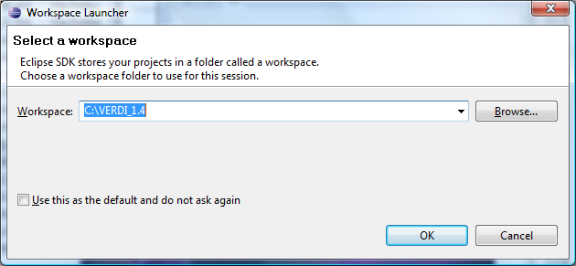

Figure 3-2 Eclipse Starting Up


To enter the developer workspace, click on the arrow at the right hand side of the Welcome screen (Figure 3-3). The Eclipse workbench contains several windows to allow the user to view source code, edit, and build within a single developer environment (Figure 3-4).
Figure 3-3 Eclipse Workbench
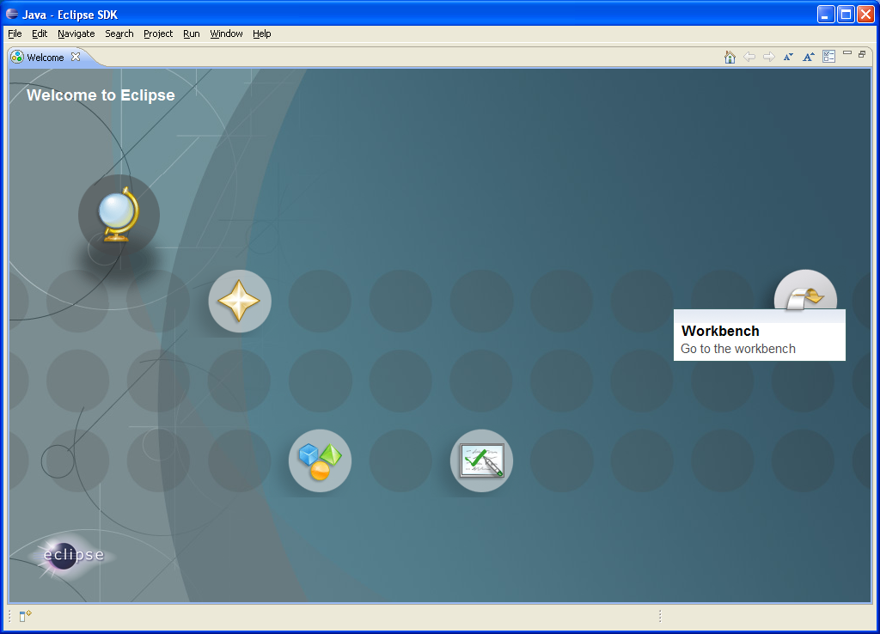

Figure 3-4 File Import
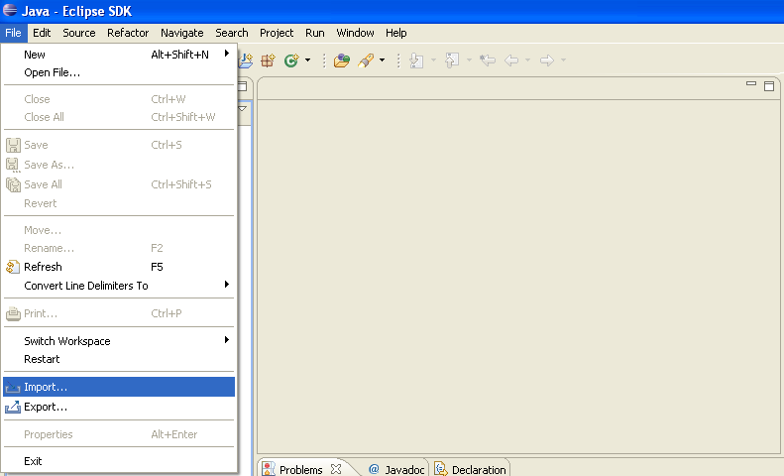

Import VERDI Source Code

Select File→Import
To import the VERDI source code use the mouse to select File→Import (Figure 3-5). This will generate a pop-up window titled Import. Expand the Other Folder by clicking on the plus sign next to the folder titled Other (Figure 3-6). On a Mac, click on and select the SVN wizard (Figure 3-7). Checkout Projects from SVN by clicking on it, and then click next.
Figure 3-5 Click on Arrow to see workbench

Checkout Projects from SVN
Select Checkout Projects from SVN and then click next (Figure 3.6 & Figure 3.7).
Figure 3-6 Checkout Projects from SVN on Windows/Linux | Figure 3-7 Checkout Projects from SVN on Mac
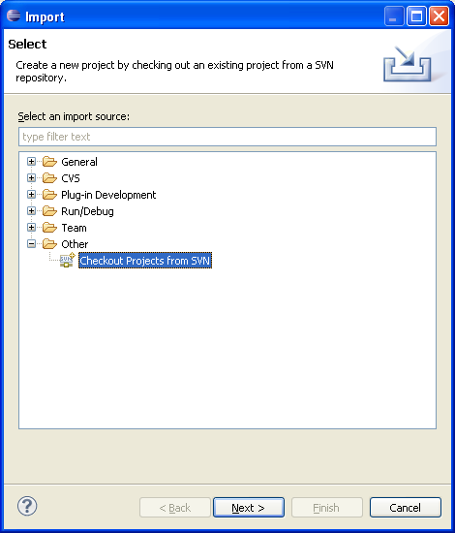 | 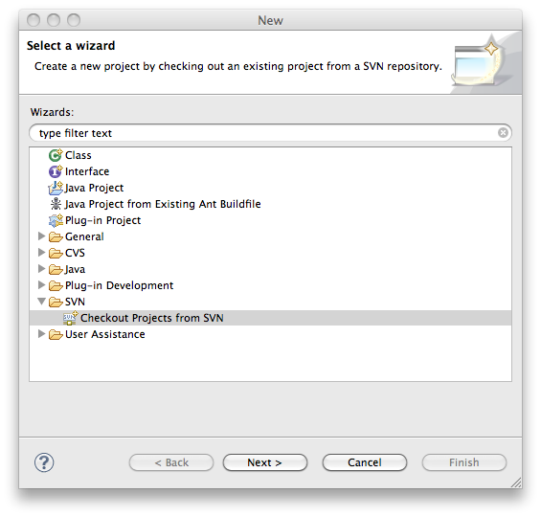

Create a new repository location
Use the mouse to highlight the button next to Create a new repository location (Figure 3-6), then click next.
Figure 3-8 Create new repository location
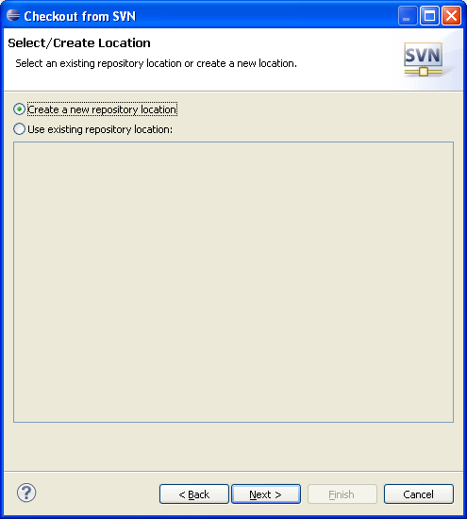

Specify location of VERDI SourceForge repository
Copy and paste the url: https://verdi.svn.sf.net/svnroot/verdi then click next
Figure 3-9 Checkout Code
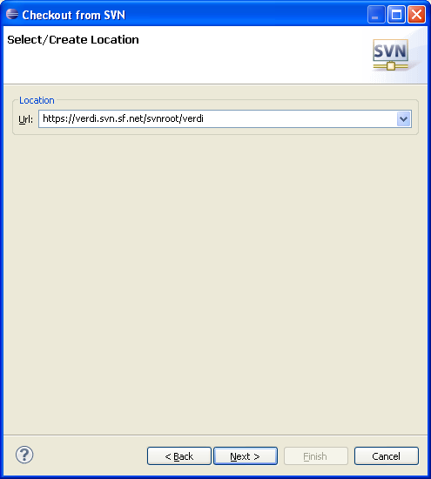

Select Folders for Checkout
Click on Trunk (or Branch/2012_06 for the latest), use the mouse and the shift key to highlight the following group of subfolders: bootstrap, core, saf.core.ui, verdi.data.loaders, and verdi_dist, then click finish (Figure 3-9). Eclipse will checkout the latest version of VERDI from the repository. The SVN checkout routine provides the option to run in the background, and also provides a meter indicating the percentage of completion during the checkout process (Figure 3-10). A message will be displayed in a console window at the bottom of the workspace if there is an error. The console will display an error if you use a directory that already exists, and that may have permission problems in copying files to the workspace directory. The workspace and the directory where the VERDI software has been installed should not share the same location. Figure 3-11 shows the code has been successfully imported into the workspace.
Figure 3-10 Select Folders for Checkout
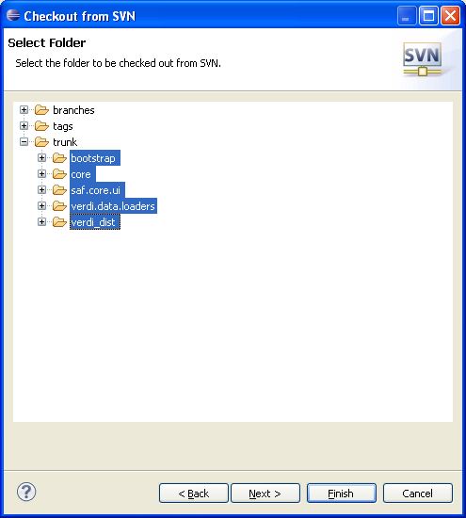

Figure 3-11 SVN Checkout includes a meter indicating % completion
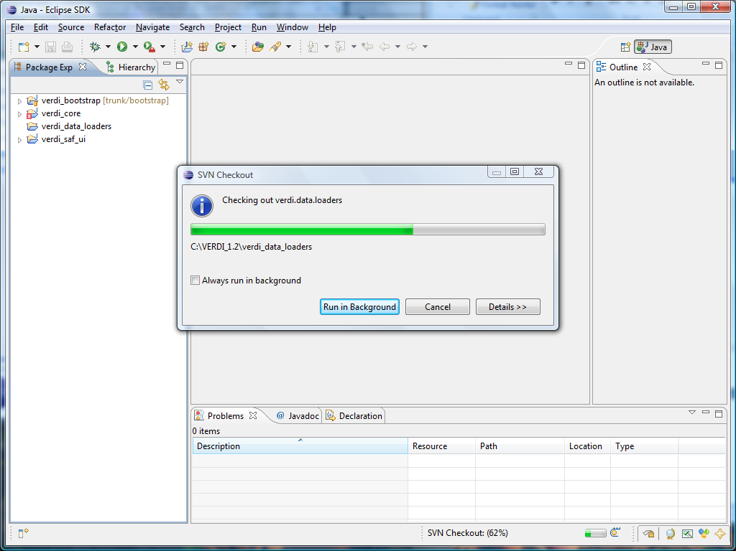
Figure 3-12 SVN imported code into workspace
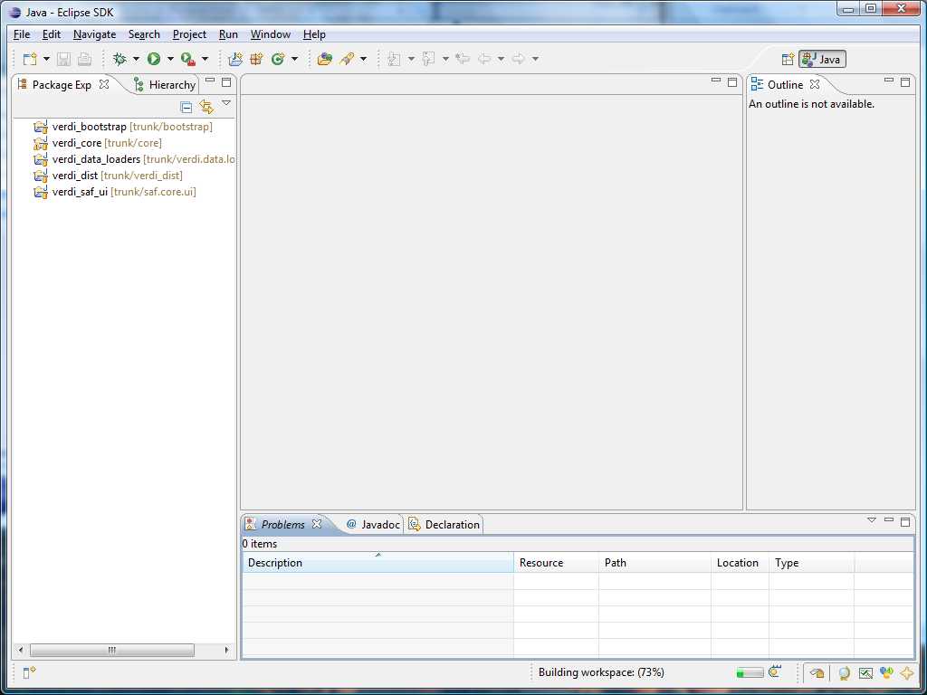

Modify the Source Code

Go to the folder src/anl/Verdi/plot/io, delete the file TIFConvert.java. For 64 bit JDK under windows, rename the TIFConvert.java.Win64 to TIFConvert.java. For any other version of JDK, rename TIFConvert.java.NonWin64 to TIFConvert.java.

Run VERDI within Eclipse
You can run Verdi using the Verdi.launch script in Verdi_bootstrap. Right click on Verdi_launch, select Run As→Verdi (Figure 4-1)
Figure 4-1 Run VERDI within Eclipse
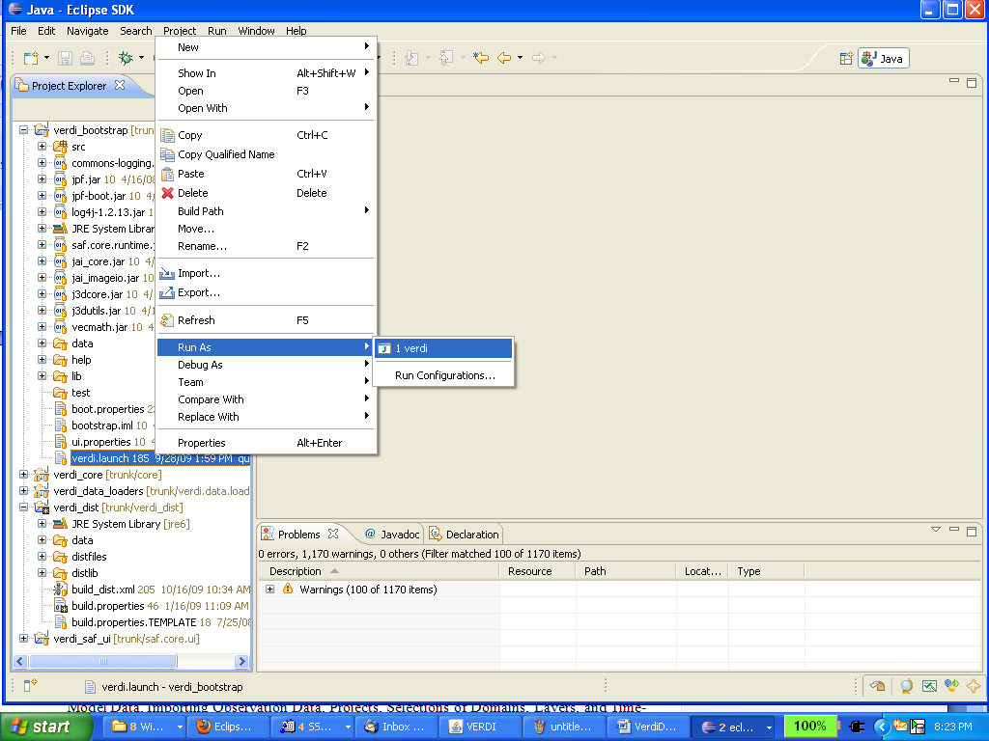

Prepare to build Distribution
Once VERDI has been checked out of the repository, the folders will be displayed in the Project Explorer Window on the Workbench.

build.properties file

Microsoft Windows
If you are building for the Windows platform, open and edit the build.properties.win32 or build.properties.win64 file that matching your JDK by double clicking on the file to open it in the text editor (Figure 5-1). Edit the build properties file to specify the JDK used to compile and the directory where Eclipse will build the VERDI distribution and to specify the directory where the NSIS installer software is on your local computer.

Linux
Edit the build properties file (build.properties.linux32 or build.properties.linux64 that matching your JDK) to specify the JDK used to compile and the local directory where Eclipse will build the distribution. Right click on the build properties file and select Save.

Mac OSX
Edit the build properties file (build.properties.mac) to specify the JDK used to compile and the the local directory where Eclipse will build the distribution. Right click on the build properties file and select Save. Example JDK location: /System/Library/Java/JavaVirtualMachines/1.6.0.jdk/Contents/
Figure 5-1 Review/Edit build properties file
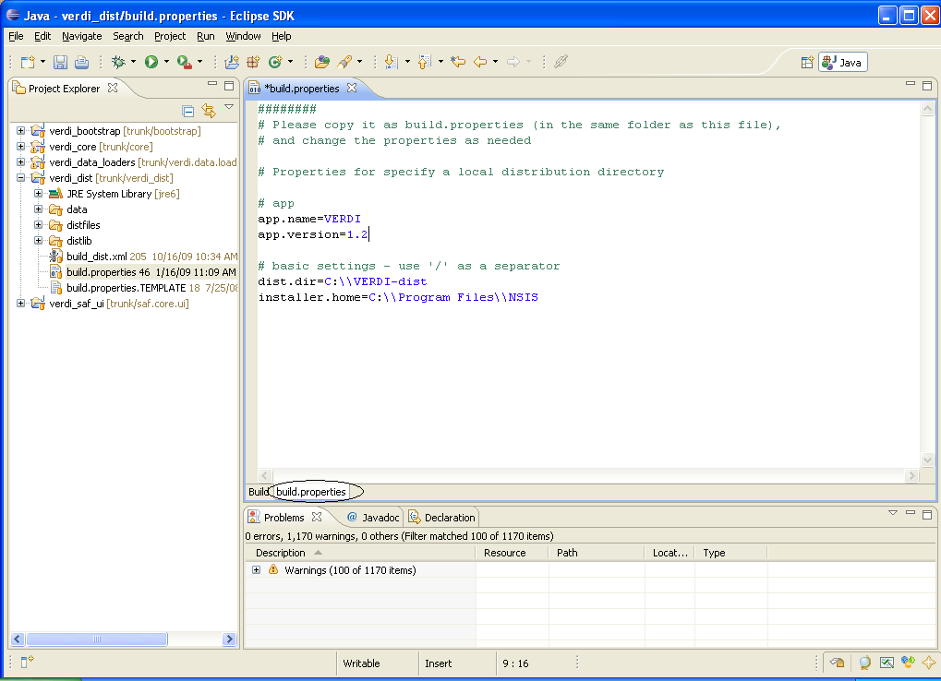

Build_dist xml
There are five build_dist xml files available for ant building: build_dist_linux32.xml, build_dist_linux64.xml, build_dist_win32.xml, build_dist_win64.xml and build_dist_mac.xml, each for a specific version of JDK. The build_dist xml file provides the instructions for how to build both the Mac OSX, Linux and Windows® distributions of VERDI. The build_dist file xml file obtains the local directory settings from the corresponding build properties file. It is also possible to make the changes to specify these directories in the build_dist xml file, but the build properties file has been created to clearly identify what settings are dependent on the local directory configurations, and hopefully will reduce errors that might be incurred by a user editing the build_dist xml file. Figure 5-2 shows the section of the build_dist xml file that provides the paths for the installer used to build the Windows® distribution, if you really want ot edit it in the build file.
Figure 5-2 dist xml: nsis installer path section
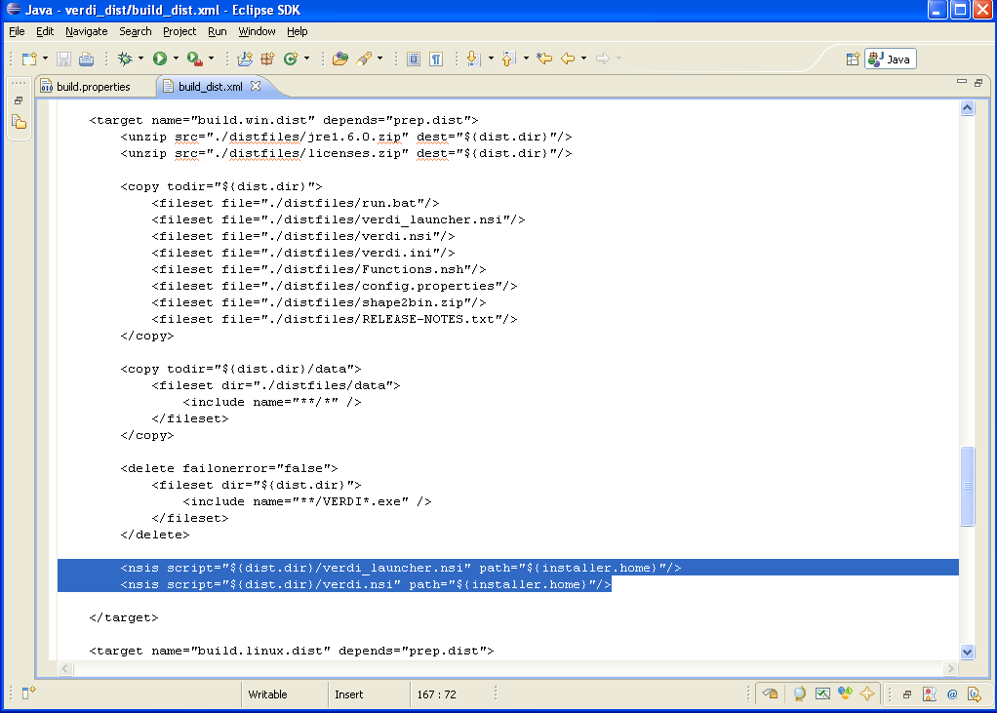

Build VERDI

Build using Ant

Before building the releases, a few settings have to be done through Eclipse menu options Window→Preferences…. Once the Preferences dialog is open (Figure 6.1), select ‘General’ then ‘Workspace’ item. In the ‘Workspace’ panel, select the check boxes for ‘Build automatically’ and ‘Refresh automatically’. Click ‘OK’ button to close the preferences dialog.

Figure 6-1 Window→Preferences

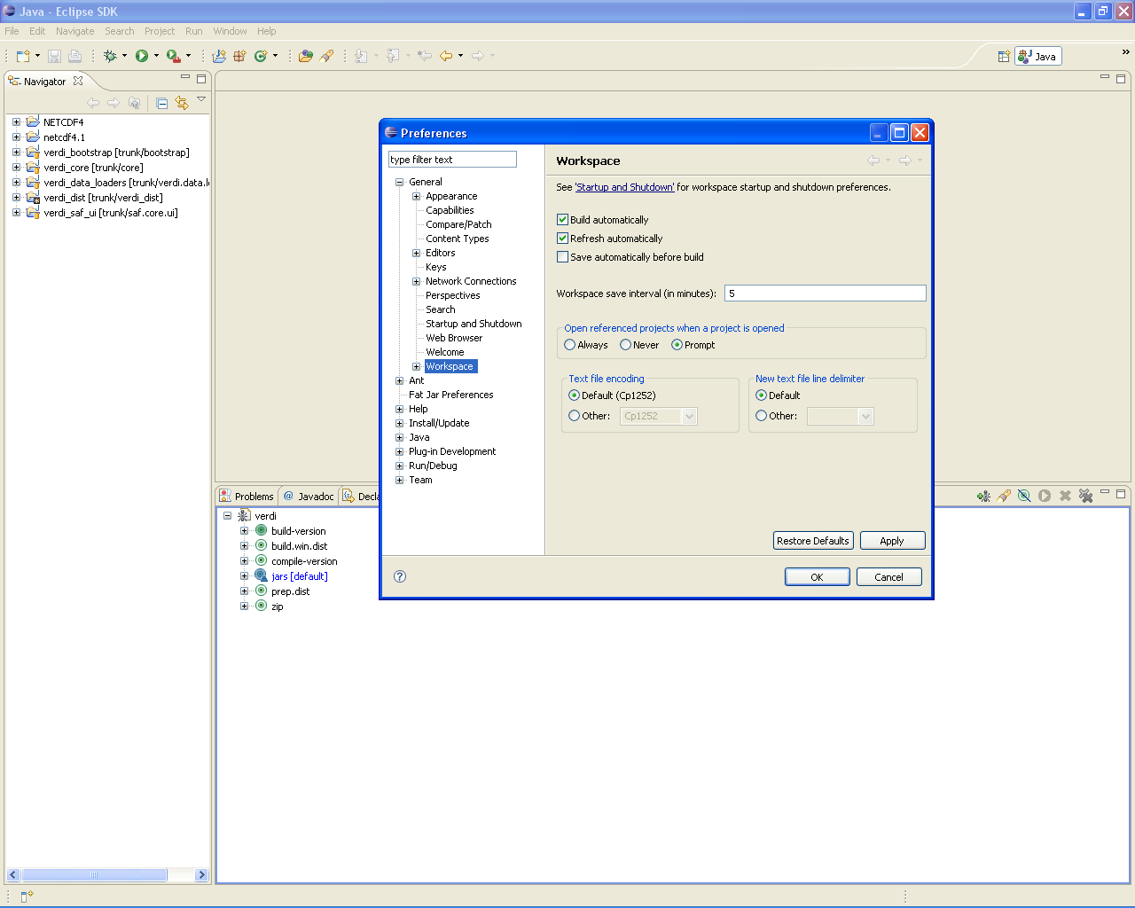

Microsoft Windows
The Windows® distribution can be built using the scripts (build_dist_win32.xml or build_dist_win64.xml) within verdi_dist on a Windows machine. Select the eclipse menu options Window→Show View→Ant to create a subwindow for Ant (Figure 6-2). Then drag the build_dist.xml into the Ant window. Click on the plus button next to verdi to open and display the contents.

- Double click on build.win.dist to build the VERDI distribution for a Windows machine. (Figure 6-3)

Figure 6-2 Window→Show View→Ant
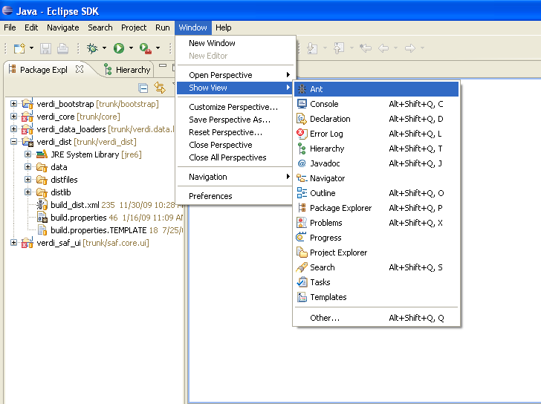
Figure 6-3 Double click on build.win.dist to build VERDI distribution

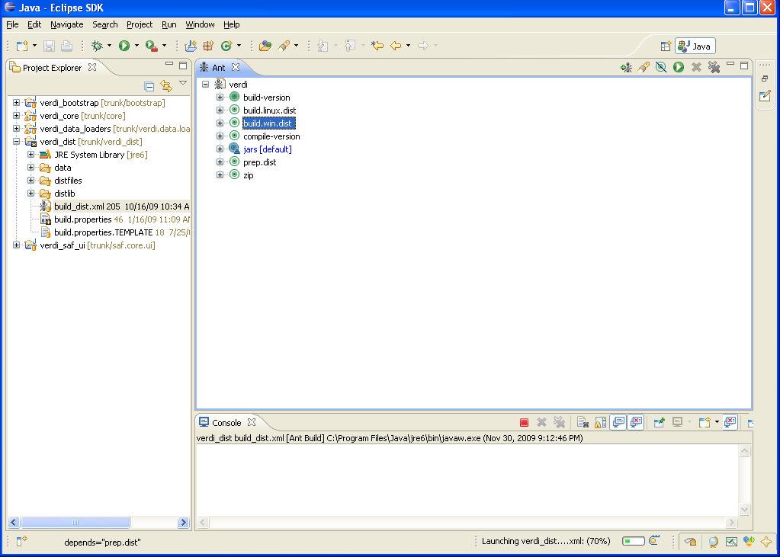

Linux Distribution
Linux distribution can be built by using Ant to run build.linux.dist on a linux machine. The verdi_dist folder contains the build_dist_linx32.xml or build_dist_linx64.xml script. Select the eclipse menu options Window→Show View→Ant to create a subwindow for Ant (Figure 6-2). Then drag the corresponding build_dist xml into the Ant window. Click on the plus button next to verdi to open and display the contents.

- Double click on build.linux.dist to build the VERDI distribution for a linux machine.

Mac Distribution

Mac distribution can be built by using Ant to run build.mac.dist on a Mac OSX machine. The verdi_dist folder contains the build_dist_mac.xml script. Select the eclipse menu options Window→Show View→Ant to create a subwindow for Ant (Figure 6-2). Then drag the corresponding build_dist xml into the Ant window. Click on the plus button next to verdi to open and display the contents.

- Double click on build.mac.dist to build the VERDI distribution for a Mac OSX machine.

Check Console for Error Messages
Error messages will appear in the console underneath the Ant console.
Figure 6-4 Console Error Message
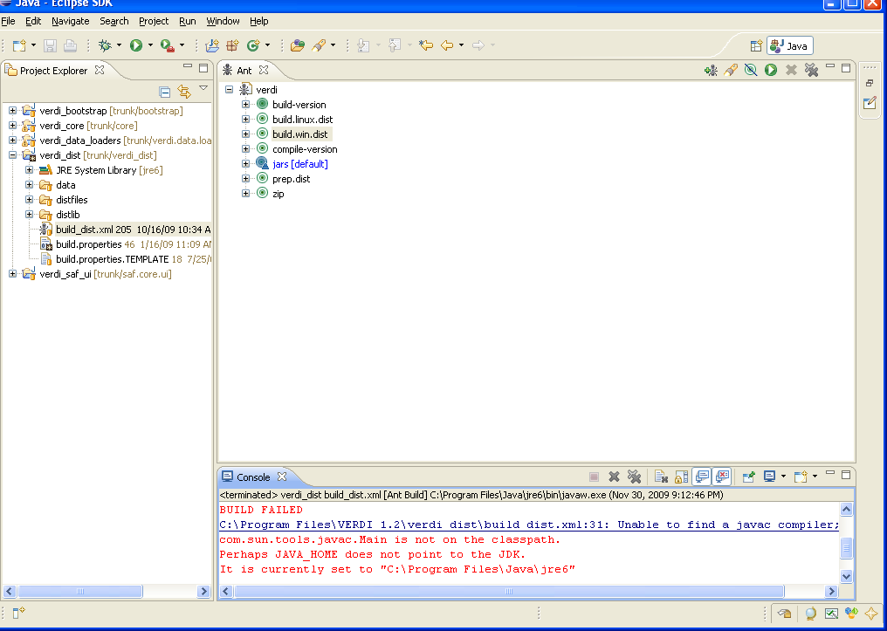
If you obtain this error, add the Java compiler to your path on the Windows Machine (see Section 2.2 and Section 6.2)

Add Java Compiler to Ant
To allow the Ant compiler to find the compiler, you will also need to change the Ant Preferences to add tools.jar as an external jar as follows.
- In Eclipse main menu select Window→Preferences (Figure 6-5)
- In the Preference Window select Ant→Runtime (Figure 6-6)
- Click on the Classpath tab, select Global Entries
- Click on Add External JARs
- Locate the tools.tar under the lib folder on the JDK local installation directory then click OK, and click OK again. (Figure 6-7)
Figure 6-5 Open Windows→Preferences
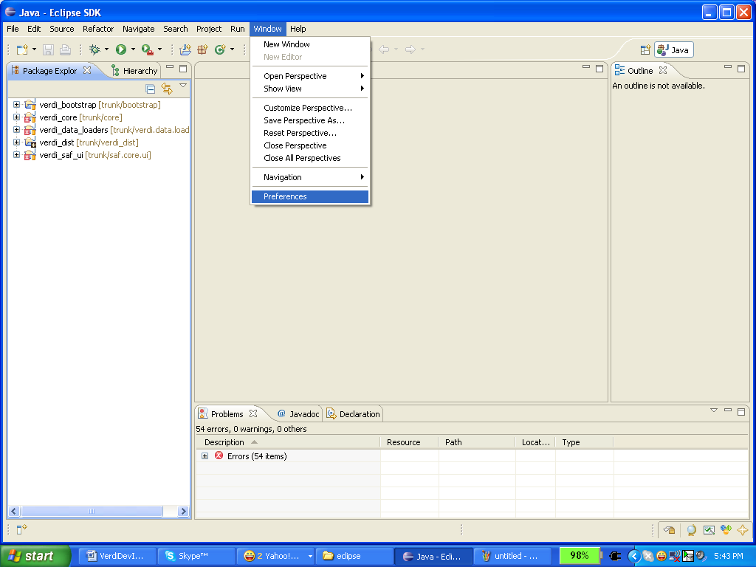
Figure 6-6 Expand Ant, Select Runtime, Select Global Entries
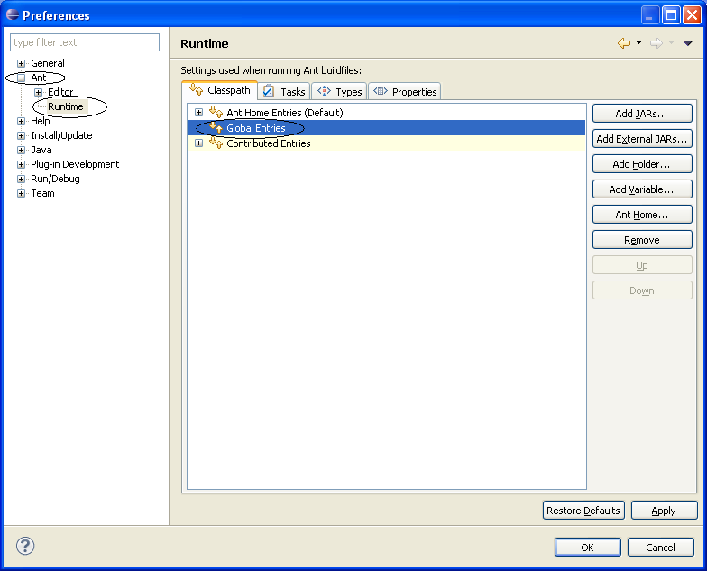

Figure 6-7 Add tools.tar to Ant Preferences
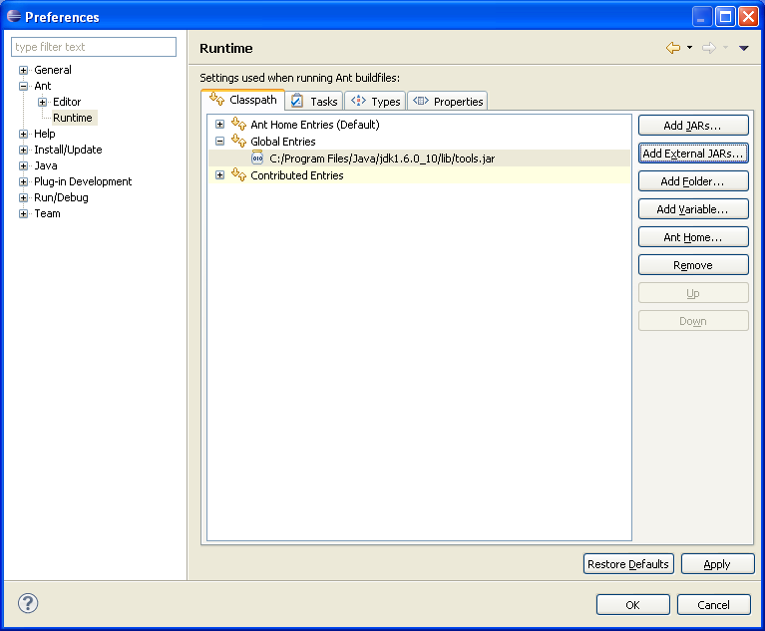

Updating source code from the repository
If you have previously obtained the code from the repository and want to obtain any bug fixes or new features that developers have committed to the repository, the synchronization window allows you to do this.

Open the Synchronization Window
Select Window→Show View→Other to open the Show View Pop-up Window (Figure 5-1). Expand the Team Folder by clicking on the plus symbol and then highlight the word Synchronize and click OK (Figure 7-2).
Figure 8-1 Show View → Other
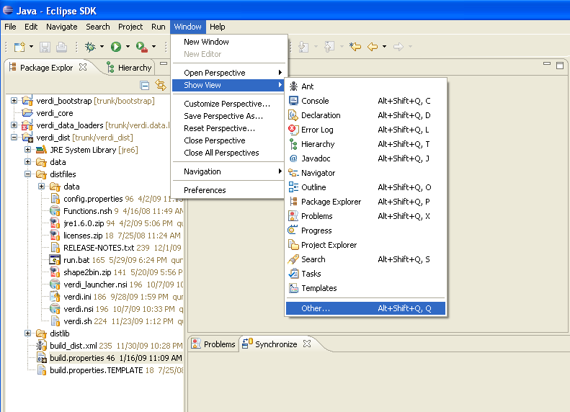
Figure 8-2 Expand Team Folder - highlight Synchronize – click ok
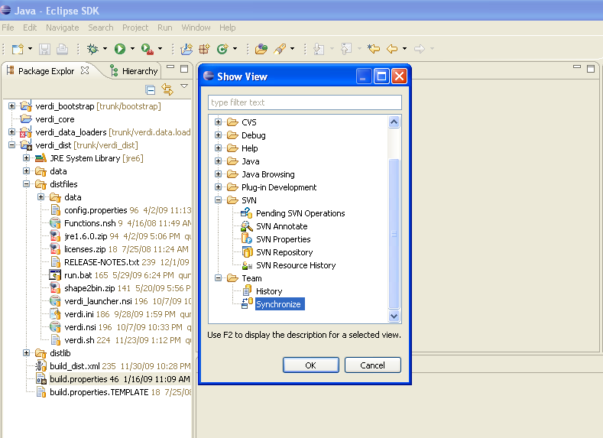
Figure 8-3 Synchronize Window added to bottom of Workspace
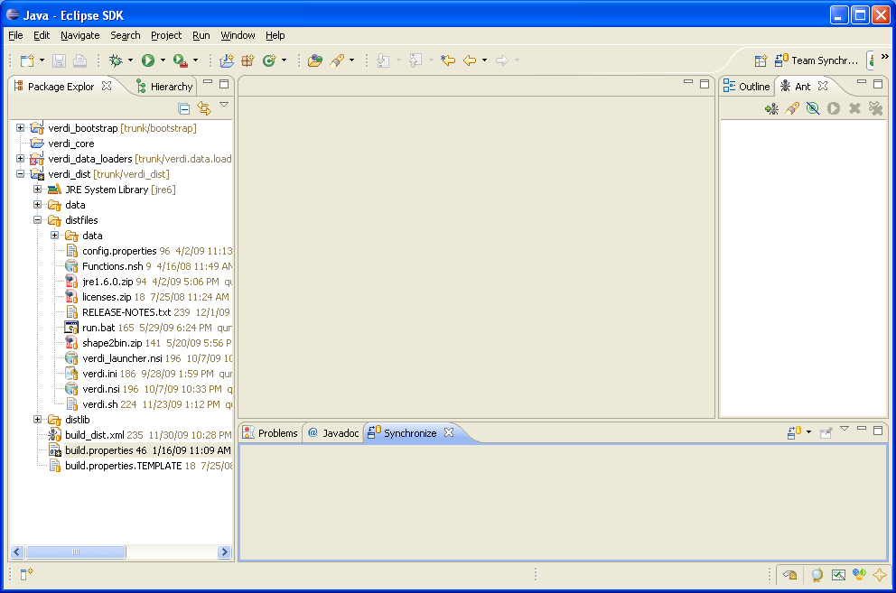

Synchronize with Repository using SVN
The Synchronize window contains a synchronize symbol at the upper right corner. Click on the synchronize symbol to open the Synchronize popup window. Click on SVN to select the subversion software package manager, then click NEXT. A Synchronize SVN pop-up window will appear listing the packages that are available as resources for synchronization. Click the Select All button to select all the packages, then click FINISH. A pop-up window labeled Confirm Open Perspective will ask if you would like to change from the Java Perspective to the Team Synchronization Perspective. If you opt to change perspectives, there is a right arrow button in the upper right hand corner of the workspace to switch back to the Java Perspective once you are finished reviewing the code in the Team Synchronization Perspective.

Figure 8-4 Click on Synchronize Symbol to bring up Pop-up
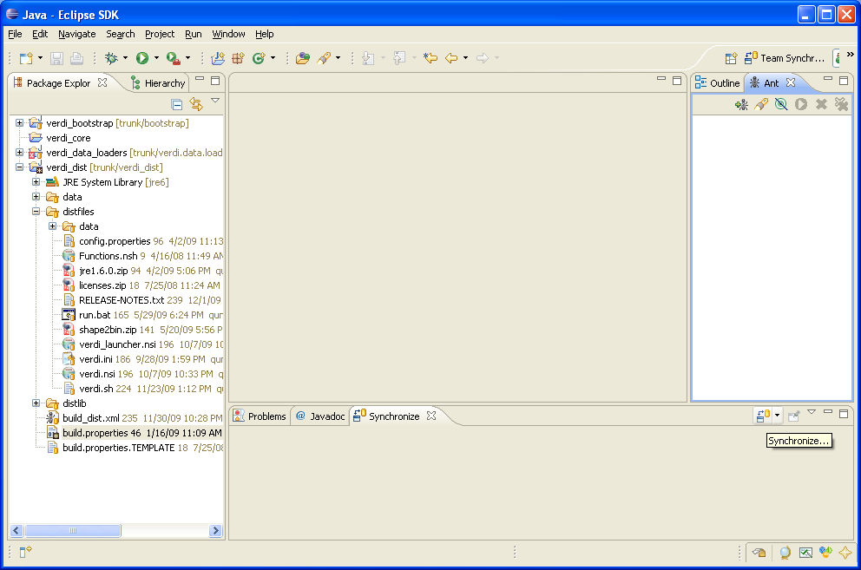

Figure 8-5 Synchronize Pop-up – select SVN
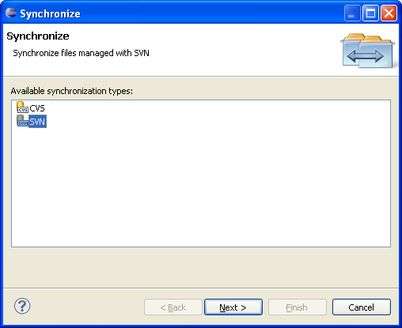
Figure 8-6 Synchronize SVN – select all
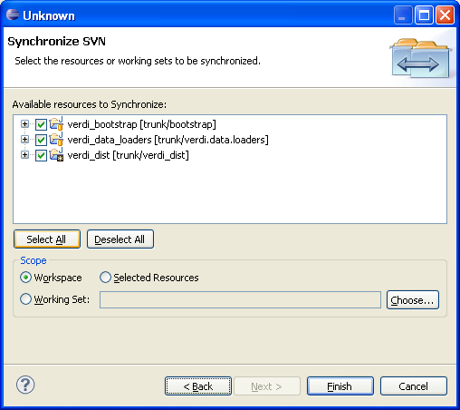

Resolve conflicts and Update
After synchronization, there will be a blue incoming arrow at the bottom of eclipse window that reports the number of files on the repository that are different than your local workspace, a green outgoing arrow, and red double conflict arrow. If you click on the blue arrow, and then right click on the Verdi_core, a pop-up menu will allow you to select update, to bring the updates to the code down to your local workspace (see Figure 7-8).
Figure 8-7 Check for Updates and Conflicts
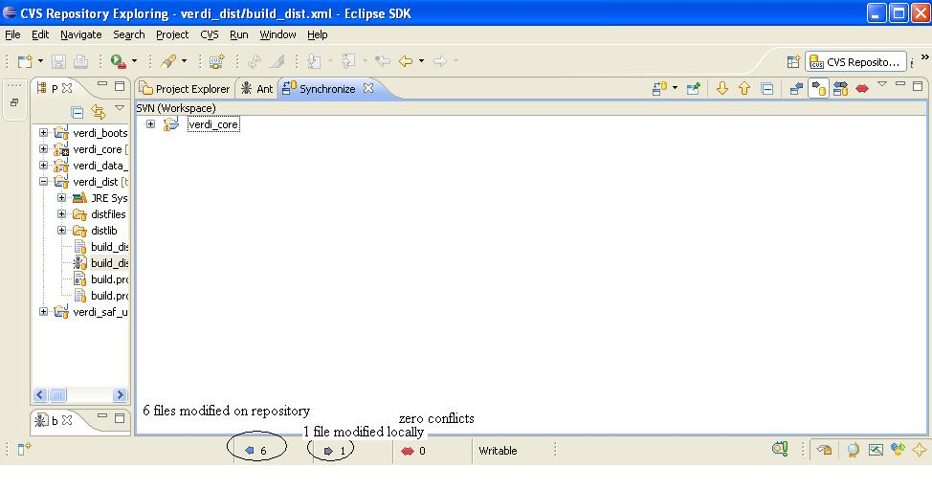

Figure 8-7 Check for Updates and Conflicts

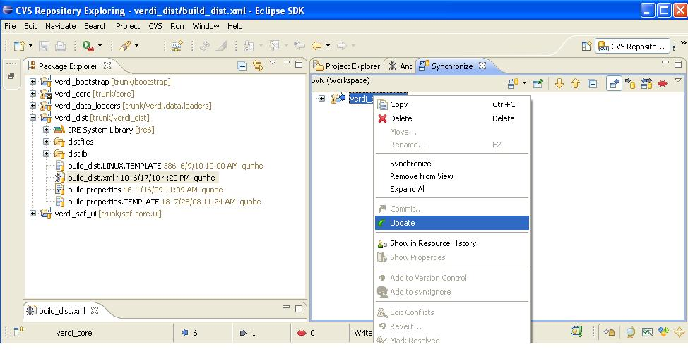

Build netcdf library with our modifications
- Check out the netcdf project from https://verdi.svn.sourceforge.net:/svnroot/netcdf.
- From a command prompt, go to the folder netcdf/nrSrc-4.2/cdm
- Type in ant and hit enter key to build it.
- The final jar file should be in the folder /netcdf/nrSrc-4.2/cdm/target

