Visualization Environment for Rich Data Interpretation (VERDI 1.4.1): Developer Instructions

U.S. EPA Contract No. EP-W-05-045, “Operation of the Center for Community Air Quality Modeling and Analysis”

Prepared for: William Benjey and Donna Schwede
U.S. EPA, ORD/NERL/AMD/APMB
E243-04
USEPA Mailroom
Research Triangle Park, NC 27711

Prepared by: Liz Adams and Darin Del Vecchio
Institute for the Environment
The University of North Carolina at Chapel Hill
137 E. Franklin St., CB 6116
Chapel Hill, NC 27599-6116

Date: March 25, 2013

Contents

1 Introduction 1
1.1 Background 1
2 Install developer environment 2
2.1 Download and Install Eclipse 2
2.2 Download and install NSIS Installer (only for windows) 2
2.3 Install Subclipse update 1.2x in Eclipse 3.5 2
2.4 Install Java Development Kit 2
3 Starting Eclipse 3
4 Import VERDI Source Code 5
4.1.1 Select File→Import 5
4.1.2 Checkout Projects from SVN 5
4.1.3 Create a new repository location 6
4.1.4 Specify location of VERDI SourceForge repository 7
4.1.5 Select Folders for Checkout 8
5 Check out netcdf library with modifications for VERDI 10
6 Build netCDF outside eclipse 10
7 Set Eclipse Preferences 11
7.1 Workspace Preferences 11
7.2 Verdi_core Preferences 11
7.2.1 Java Build Path 11
7.2.2 Java Compiler 11
7.2.3 Project References 11
8 Install JAI, JAI-ImageIO and Java 3D to the JDK: 12
9 Modify TiffConvert.java within verdi_core 15
10 Run VERDI within Eclipse 15
11 Testing VERDI using scripts within eclipse 16
12 Updating source code from the repository 18
12.1 Open the Synchronization Window 18
12.2 Synchronize with Repository using SVN 21
12.3 Resolve conflicts and Update 23
13 Prepare to build VERDI Distribution 24
13.1.1 build.properties file 24
13.1.1.1 Microsoft Windows 24
13.1.1.2 Linux 24
13.1.1.3 Mac OSX 24
13.1.2 Build_dist xml 25
14 Build VERDI 26
14.1 Build using Ant 26
14.1.1 Microsoft Windows 27
14.1.1 Linux Distribution 29
14.1.1 Mac Distribution 30
14.2 Check Console for Error Messages 31
14.3 Add Java Compiler to Ant 31

Figures

Figure 3-1 Select a Workspace 3
Figure 3-2 Eclipse Starting Up 4
Figure 3-3 Eclipse Workbench 4
Figure 4-1 File Import 5
Figure 4-2 Checkout Projects from SVN on Windows/Linux 6
Figure 4-3 Checkout Projects from SVN on Mac 6
Figure 4-4 Create new repository location 7
Figure 4-5 Checkout Code 8
Figure 4-6 Select Folders for Checkout 9
Figure 4-7 SVN Checkout includes a meter indicating % completion 9
Figure 4-8 SVN imported code into workspace 10
Figure 8-1 Select jars for export to dependent projects 14
Figure 10-1 Run VERDI within Eclipse 16
Figure 11-1 Run Configurations> Java Application 17
Figure 11-2 Run Configurations> Java Application> verdi_script 18
Figure 12-1 Show View → Other 19
Figure 12-2 Expand Team Folder - highlight Synchronize – click ok 20
Figure 12-3 Synchronize Window added to bottom of Workspace 20
Figure 12-4 Click on Synchronize Symbol to bring up Pop-up 21
Figure 12-5 Synchronize Pop-up – select SVN 22
Figure 12-6 Synchronize SVN – select all 22
Figure 12-7 Check for Updates and Conflicts 23
Figure 12-8 Check for Updates and Conflicts 23
Figure 13-1 Review/Edit build properties file 25
Figure 13-2 dist xml: nsis installer path section 26
Figure 14-2 Window→Show View→Ant 27
Figure 14-3 Double click on build.win.dist to build VERDI distribution 29
Figure 14-4 Console Error Message 31
Figure 14-5 Open Windows→Preferences 32
Figure 14-6 Expand Ant, Select Runtime, Select Global Entries 33
Figure 14-7 Add tools.tar to Ant Preferences 33

Introduction

Background
This manual contains instructions on how developers can set up, run, build, and obtain updates from the software repository for Visualization Environment for Rich Data Interpretation (VERDI). Developers are encouraged to develop and contribute code for VERDI. Developers are requested to submit a bugzilla request for enhancement and to submit test datasets, documentation and proposed code to CMAS for testing prior to committing code to the repository.
Initial development of VERDI was done by the Argonne National Laboratory for the U.S. Environmental Protection Agency (EPA) and its user community. Argonne National Laboratory's work was supported by the EPA though U.S. Department of Energy contract DE-AC02-06CH11357. Further development has been performed by the University of North Carolina Institute for the Environment under U.S. EPA Contract No. EP-W-05-045 and EP-W-09-023, by Lockheed Corporation under U.S. EPA contract No. 68-W-04-005, and Argonne National Laboratory. VERDI is licensed under the Gnu Public License (GPL) version 3, and the source code is available through verdi.sourceforge.net. VERDI is supported by the Community Modeling and Analysis System (CMAS) Center under U.S. EPA Contract No. EP-W-09-023. The CMAS Center is located within the Institute for the Environment at the University of North Carolina at Chapel Hill.

Install developer environment
To install this software on Windows, you may need administrator privileges. You should exit all programs before installing software.

Download and Install Eclipse
  - http://www.eclipse.org/
  - Download and install Eclipse Classic 3.5.1
    - Windows: install to the directory C:\Program Files\
    - Linux/Mac: install to local directory

Download and install NSIS Installer (only for windows)
- http://nsis.sf.net
- Download NSIS installer and install
    - install to the directory C:\Program Files\

Install Subclipse update 1.2x in Eclipse 3.5
- http://subclipse.tigris.org/servlets/ProjectProcess?pageID=p4wYuA
- Follow a link for zipped downloads: http://subclipse.tigris.org/servlets/ProjectDocumentList?folderID=2240
- Download the site-1.2.4.zip, Zipped update Site for Subclipse 1.2.4 (the website states that this is obsolete, but if you use a more recent version, it will not provide the Import>Other>Checkout Projects from SVN functionality that is needed.)
- Extract this zip file and save into the Eclipse Directory.
  - Windows: You may need to authorize the overwriting of files.
  - Linux/Mac: copy files in Plugin directory to Plugin directory under Eclipse.

Install Java Development Kit
- http://java.sun.com/javase/downloads/index.jsp#jdk
- Install the latest release of JDK that is available from the above link.
- For Windows:
  - Add the Java compiler to your path on the Windows Machine.
    - From the desktop, right-click My Computer and click Properties.
    - In the System Properties window, click on the Advanced tab.
    - In the Advanced section, click the Environment Variables button.
    - Finally, in the Environment Variables window (as shown below), highlight the Path variable in the Systems Variable section and click the Edit button.
    - Add the location where the most recent JDK available on your computer. For example: C:\Program Files\Java\jdk1.6.0_17\bin

Starting Eclipse
Using Windows; go to the C:\Program Files\eclipse directory and double clicking on eclipse.exe. Specify a location for a workspace folder, for example, C:\VERDI_1.4 as is shown in Figure 3-1. Eclipse will create the directory automatically.
Figure 3-1 Select a Workspace
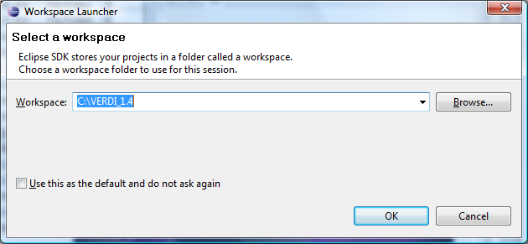
Using a Mac, go to the applications directory, to the eclipse folder, and click on the eclipse icon. Specify a location for a workspace folder.
Using a linux machine, go to the directory where eclipse was installed and run the eclipse executable. Specify a location for a workspace folder.

Figure 3-2 Eclipse Starting Up


To enter the developer workspace, click on the arrow at the right hand side of the Welcome screen (Figure 3-3). The Eclipse workbench contains several windows to allow the user to view source code, edit, and build within a single developer environment (Figure 3-4).
Figure 3-3 Eclipse Workbench
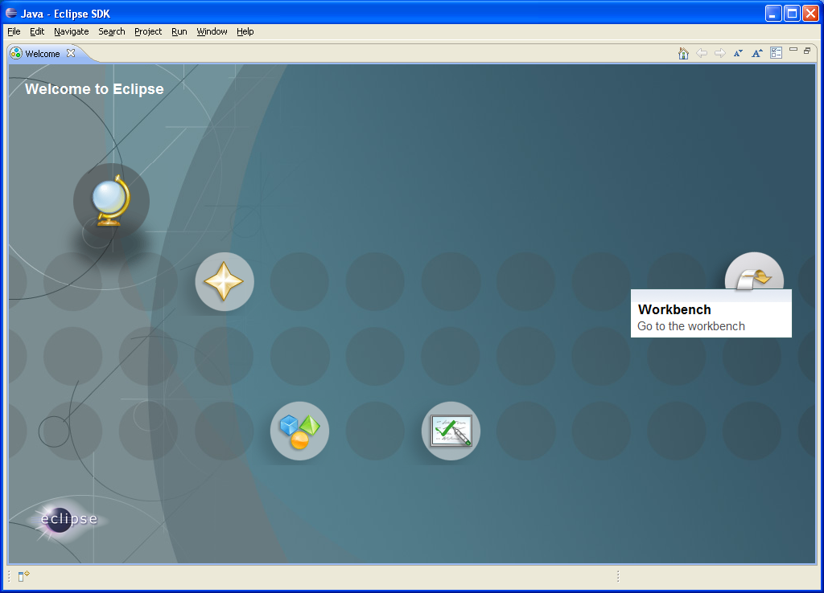

Import VERDI Source Code

Select File→Import
To import the VERDI source code use the mouse to select File→Import (Figure 4-1). This will generate a pop-up window titled Import. Expand the Other Folder by clicking on the plus sign next to the folder titled Other (Figure 4-2). On a Mac, click on and select the SVN wizard (Figure 4-3). Checkout Projects from SVN by clicking on it, and then click next.
Figure 4-1 File Import
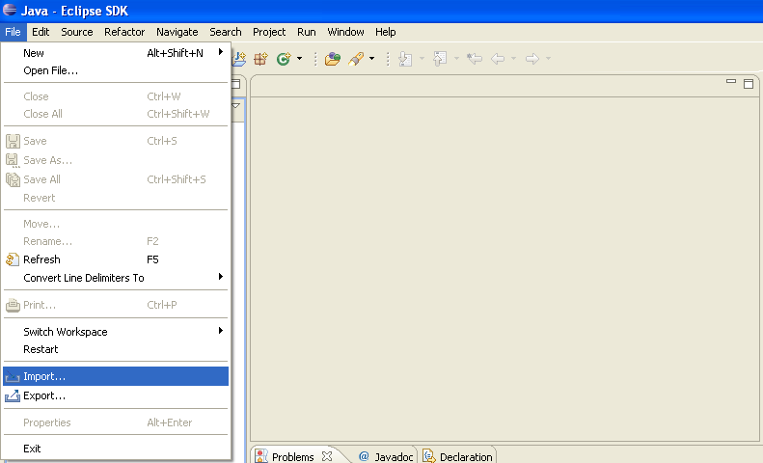

Checkout Projects from SVN
Select Checkout Projects from SVN and then click next (Figure 4- 2 & Figure 4-3).
Figure 4-2 Checkout Projects from SVN on Windows/Linux | Figure 4-3 Checkout Projects from SVN on Mac
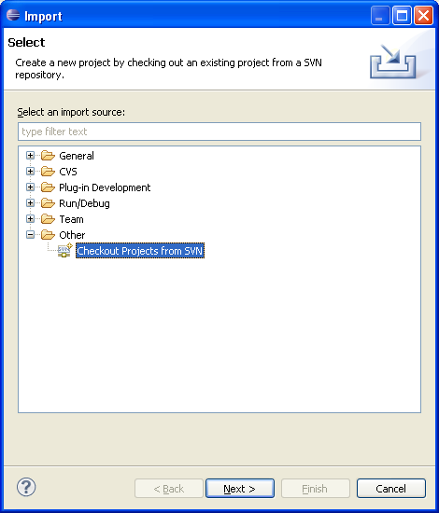 | 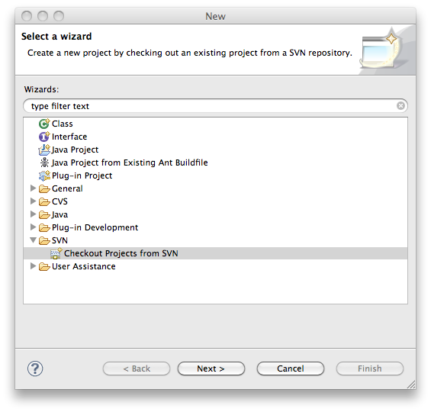

Create a new repository location
Use the mouse to highlight the button next to Create a new repository location (Figure 4-4), then click next.
Figure 4-4 Create new repository location
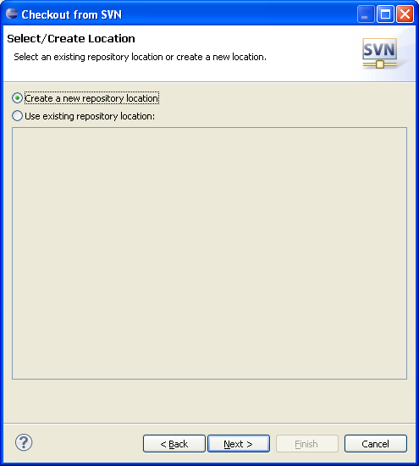

Specify location of VERDI SourceForge repository
Copy and paste the url: https://verdi.svn.sf.net/svnroot/verdi then click next
Figure 4-5 Checkout Code
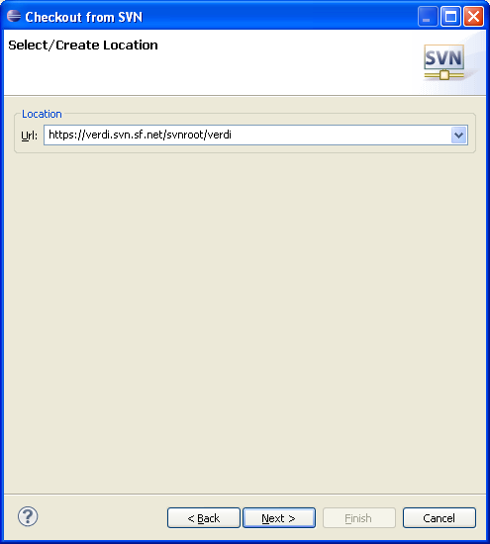

Select Folders for Checkout
Click on Trunk (or Branch/2012_06 for the latest), use the mouse and the shift key to highlight the following group of subfolders: bootstrap, core, saf.core.ui, verdi.data.loaders, and verdi_dist, then click finish (Figure 4-6). Eclipse will checkout the latest version of VERDI from the repository. The SVN checkout routine provides the option to run in the background, and also provides a meter indicating the percentage of completion during the checkout process (Figure 4-7). A message will be displayed in a console window at the bottom of the workspace if there is an error. The console will display an error if you use a directory that already exists, and that may have permission problems in copying files to the workspace directory. The workspace and the directory where the VERDI software has been installed should not share the same location. Figure 4-8 shows the code has been successfully imported into the workspace.
Figure 4-6 Select Folders for Checkout
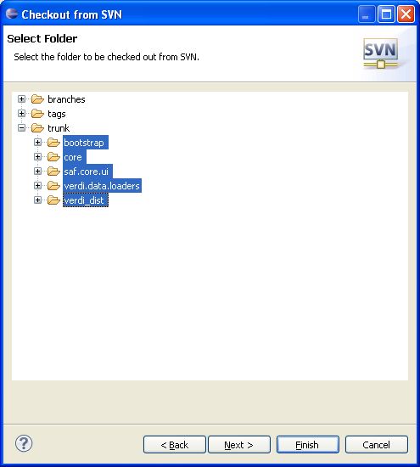

Figure 4-7 SVN Checkout includes a meter indicating % completion
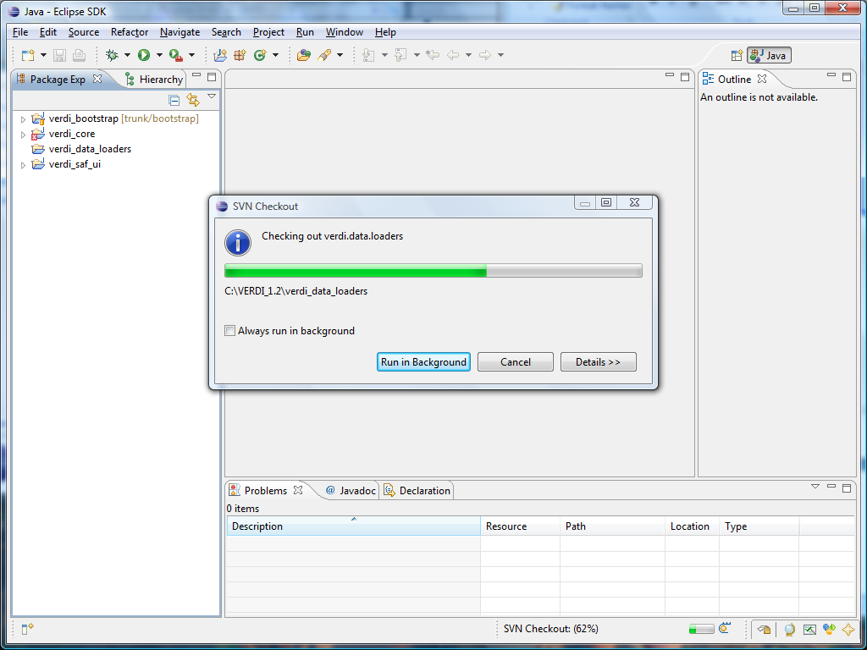
Figure 4-8 SVN imported code into workspace
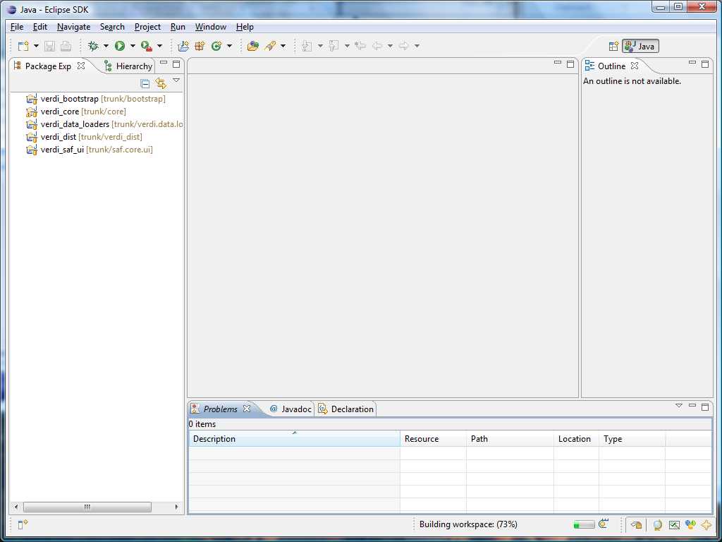

Check out netcdf library with modifications for VERDI
- Check out the netcdf project from http://verdi.svn.sf.net/svnroot/verdi/netcdf.
  - When in eclipse use File> Import> Other> SVN
  - Select Checkout Projects from SVN
  - Select use existing repository location
  - Put Url in the text box, click next
  - Select the netcdf folder

Build netCDF outside eclipse
The netCDF project contains changes to the WRFConvention.java that has not been implemented yet into the netCDF source code from Unidata. To take advantage of this code, build netCDF outside of eclipse, and then copy the netcdf.jar to the location that VERDI looks for it.
From a command prompt, go to the folder netcdf/nrSrc-4.2/cdm
Type in ant and hit enter key to build it.
The final jar file should be in the folder /netcdf/nrSrc-4.2/cdm/target
Copy netcdfAll-4.2.35.jar to /verdi_core/lib/

Set Eclipse Preferences

Workspace Preferences

Eclipse can be set-up to build the projects automatically after a developer makes local changes to the java source code.

To automatically build after source code changes are made, enable this preference using:
Eclipse > Preferences > General > Workspace >
Select the Build Automatically option.

There is also a setting to automatically recognize files that are added to the workspace. To automatically synchronize the workspace with the underlying file system, enable this preference:
Eclipse > Preferences > General > Workspace >
Select the Refresh on Access option.

Verdi_core Preferences

In the Package Explorer view, right click on verdi_core and select the Properties option at the bottom of the pop-up menu. A Pop-up window titled Properties for verdi_core will appear.

Java Build Path
Select Java Build Path, and the window on the right will update showing 4 tabs, containing information on the source folders, the required projects, the JARS and class folders on the build path, and the order and entries that are selected for export to dependent projects.

Java Compiler
Select Java Compiler, and the window on the right will update to show that the 1.6 JDK is currently being used by VERDI, and that a check mark is by the option to enable project specific settings for the Java Compiler.

Project References

Install JAI, JAI-ImageIO and Java 3D to the JDK:
- For Windows 32 bit JDK
  - Download JAI from http://download.java.net/media/jai/builds/release/1_1_3/ and install it into JDK directory. Comprehensive installation instructions are available from http://download.java.net/media/jai/builds/release/1_1_3/INSTALL.html#Windows
    - Download JAI-ImageIO from http://download.java.net/media/jai-imageio/builds/release/1.1/ and install it into JDK directory
    - Download and install Java 3D: http://java3d.java.net/binary-builds.html
- For Linux
  - Add the compiler to a local directory
  - Install JAI, JAI-ImageIO and Java 3D:
    - Download 32 or 64 bit JAI that matching your JDK from http://download.java.net/media/jai/builds/release/1_1_3/ and install it into JDK directory. More comprehensive install instructions are available from http://download.java.net/media/jai/builds/release/1_1_3/INSTALL.html#Linux
    - Download 32 or 64 bit JAI-ImageIO that matching your JDK from http://download.java.net/media/jai-imageio/builds/release/1.1/ and install it into JDK directory
      - Note: The 64bit version of Jai-ImageIO is corrupt. Fix it after download and using the fixed version:
sed s/+215/-n+215/ jai_imageio-1_1-lib-linux-amd64-jdk.bin > jai_imageio-1_1-lib-linux-amd64-jdk-fixed.bin
sed s/+215/-n+215/ jai_imageio-1_1-lib-linux-i586-jdk.bin > jai_imageio-1_1-lib-linux-i586-jdk-fixed.bin

    - Download 32 or 64 bit Java 3D that matching your JDK and install it: http://java3d.java.net/binary-builds.html
    - Extracting the j3d-jre.zip according to the instructions in the README-unzip.html in the downloaded version.
    - In the package explorer in eclipse right click on verdi_core and select Properties. Click on the Libraries tab, and select Add External JARs, navigate to the directory that contains the files that were extracted from j3d-jre.zip, j3dcore.jar, j3dutils.jar and vecmath.jar. Add all of the jars that were extracted from the j3d*.zip files.
    - Click on the Order and Export tab and select the j3dcore.jar, j3dutils.jar and vecmath.jar to add these to the list of exported entries (contributed to dependent projects). Note: all of the jar files in the order and export tab should have check marks next to them, except for the projects and jar files that are shown as unchecked in Figure 7-1.

Figure 8-1 Select jars for export to dependent projects

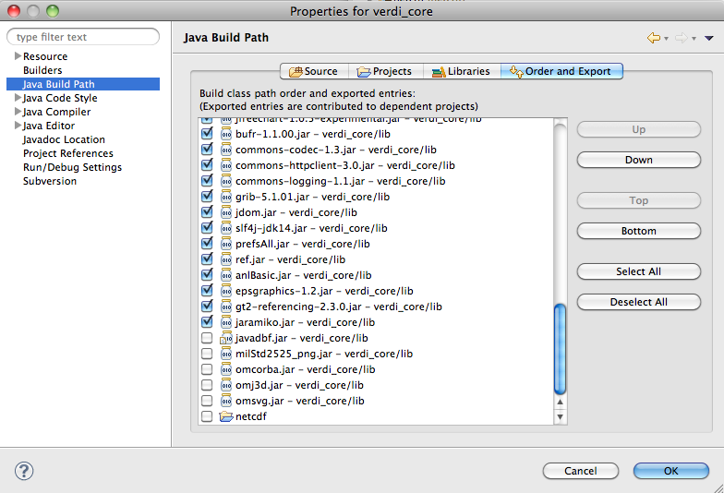

- For Mac
- JDK is already installed on OSX. Using Software Update to update it to the latest version.
  - Check version using command: javac –version
  - Check path using command: which javac
- Need instructions for JAI-ImageIO, on Mac OS X JAI, but not the Image I/O tools has been shipping with Mac OSX
- See the following link: http://gvsigce.sourceforge.net/wiki/index.php/Java_Advanced_Imaging_(JAI)_and_64_bit
- Install Java3D to support the contour plot on Mac for VERDI
  - http://www.downloadjava3d.com/mac.php

Modify TiffConvert.java within verdi_core

VERDI allows the user to save an image in the Tiff format using the following command within the VERDI Plots menu options:
File> Export> File Format: Tiff Image

Currently, the code within VERDI; TiffConvert.java, is platform dependent. There is a Win64 version of TIFConvert.java called TIFConvert.java.Win64 that needs to be copied to TIFConvert.java file when you are building VERDI for the Windows 64 platform. When you are building on all other platforms, ie. Mac, Linux, or Windows 32, the TIFConvert.java.NonWin64 version needs to be copied to the TIFConvert.java file. This allows the following command from the VERDI plots menu to work on all platforms:
File> Export image> File Format: Tiff Image

Go to the folder verdi_core/src/anl/Verdi/plot/io, delete the file TIFConvert.java.

For 64 bit JDK under windows, rename the TIFConvert.java.Win64 to TIFConvert.java.

For any other version of JDK, rename TIFConvert.java.NonWin64 to TIFConvert.java.

Run VERDI within Eclipse
You can run Verdi using the Verdi.launch script in Verdi_bootstrap. Right click on Verdi_launch, select Run As→Verdi (Figure 10-1)
Figure 10-1 Run VERDI within Eclipse
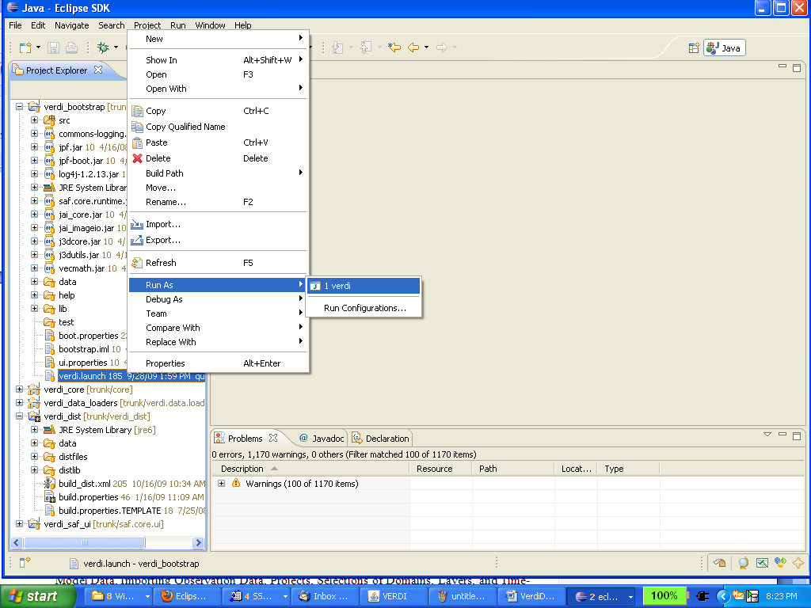

Testing VERDI using scripts within eclipse

Scripts are available for testing VERDI within eclipse for several plot types. Prior to using these scripts, extract the data.zip file under the verdi_dist/distfiles directory using the commands.
cd verdi_dist/distfiles
unzip data.zip.
From the Eclipse Main Menu select either Run>Run Configurations or Run> Debug Configurations (if you want to run the script within the Debugger).
Figure 11-1 Run Configurations> Java Application

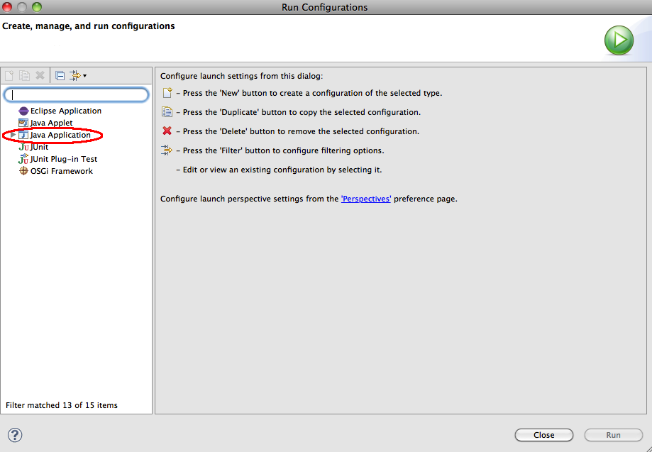

Select Java Application to view the scripts. The script names include verdi_script, verdi_script_batch, verdi_script_camx, verdi_script_two_bars, verdi_script_vertical_crosssection. When you run the script, verdi automatically loads the data and creates plots using the script commands specified in the arguments tab. Setting up and running scripts shortens the time it takes to debug plot issues, as it is easier to quickly reproduce plots.
Figure 11-2 Run Configurations> Java Application> verdi_script

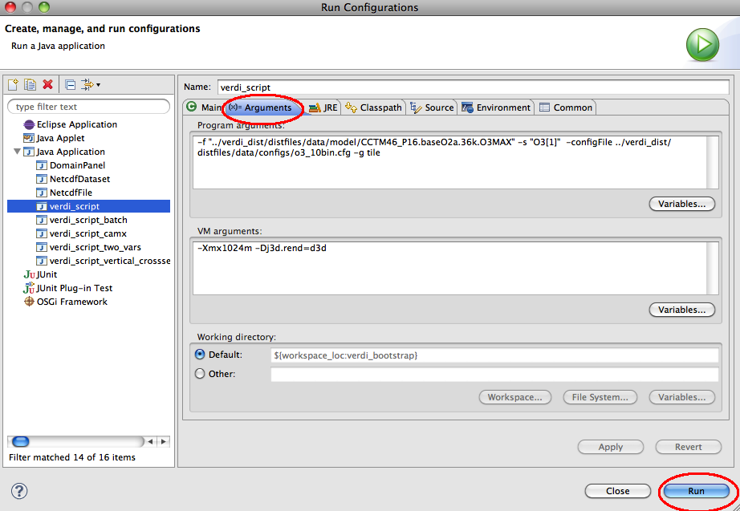

Updating source code from the repository
If you have previously obtained the code from the repository and want to obtain any bug fixes or new features that developers have committed to the repository, the synchronization window allows you to do this.

Open the Synchronization Window
Select Window→Show View→Other to open the Show View Pop-up Window (Figure 12-1). Expand the Team Folder by clicking on the plus symbol and then highlight the word Synchronize and click OK (Figure 12-2).
Figure 12-1 Show View → Other
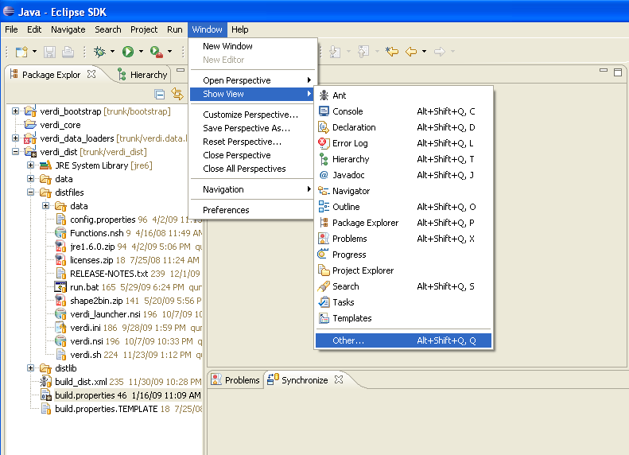
Figure 12-2 Expand Team Folder - highlight Synchronize – click ok
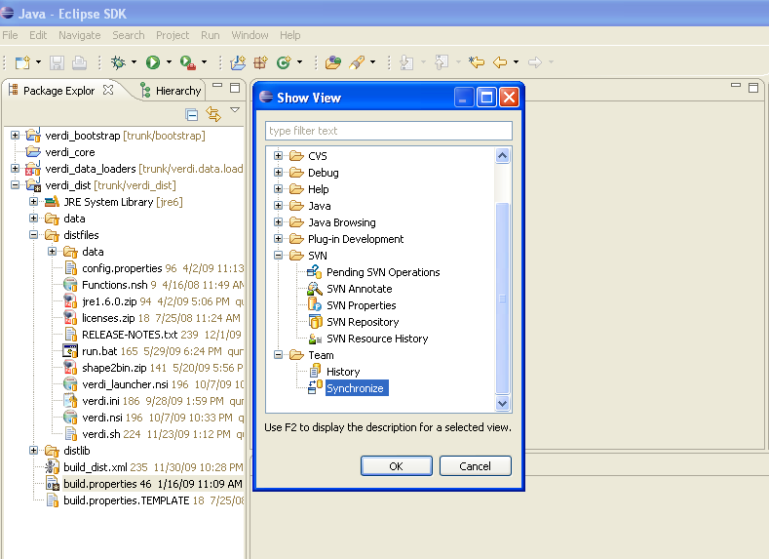
Figure 12-3 Synchronize Window added to bottom of Workspace
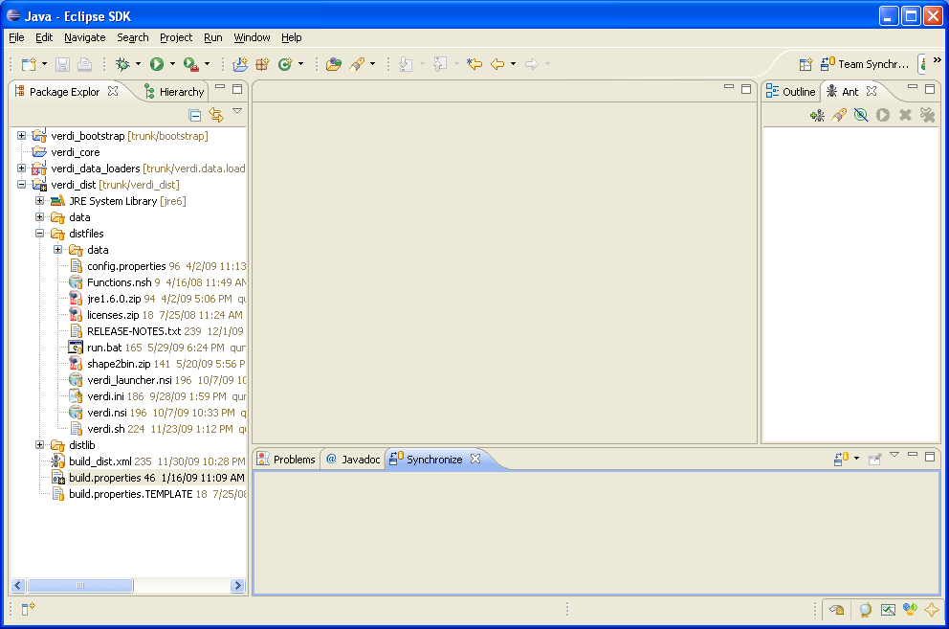

Synchronize with Repository using SVN
The Synchronize window contains a synchronize symbol at the upper right corner. Click on the synchronize symbol to open the Synchronize popup window. Click on SVN to select the subversion software package manager, then click NEXT. A Synchronize SVN pop-up window will appear listing the packages that are available as resources for synchronization. Click the Select All button to select all the packages, then click FINISH. A pop-up window labeled Confirm Open Perspective will ask if you would like to change from the Java Perspective to the Team Synchronization Perspective. If you opt to change perspectives, there is a right arrow button in the upper right hand corner of the workspace to switch back to the Java Perspective once you are finished reviewing the code in the Team Synchronization Perspective.

Figure 12-4 Click on Synchronize Symbol to bring up Pop-up
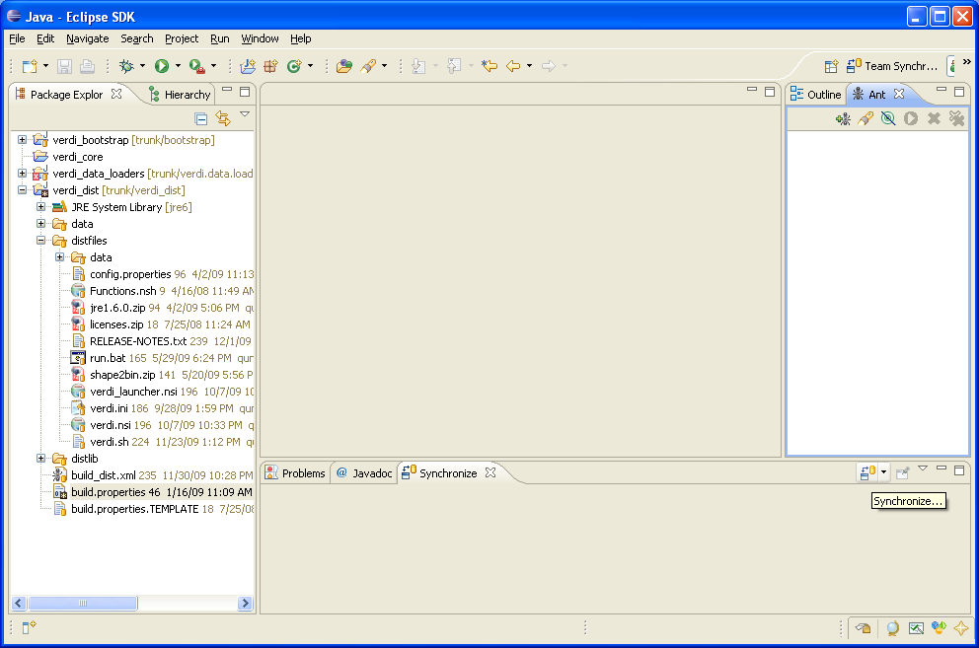

Figure 12-5 Synchronize Pop-up – select SVN
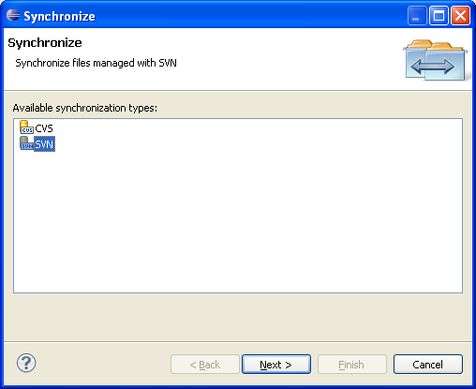
Figure 12-6 Synchronize SVN – select all
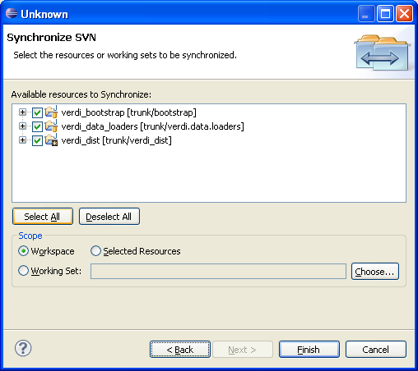

Resolve conflicts and Update
After synchronization, there will be a blue incoming arrow at the bottom of eclipse window that reports the number of files on the repository that are different than your local workspace, a green outgoing arrow, and red double conflict arrow. If you click on the blue arrow, and then right click on the Verdi_core, a pop-up menu will allow you to select update, to bring the updates to the code down to your local workspace (see Figure 12-7).
Figure 12-7 Check for Updates and Conflicts
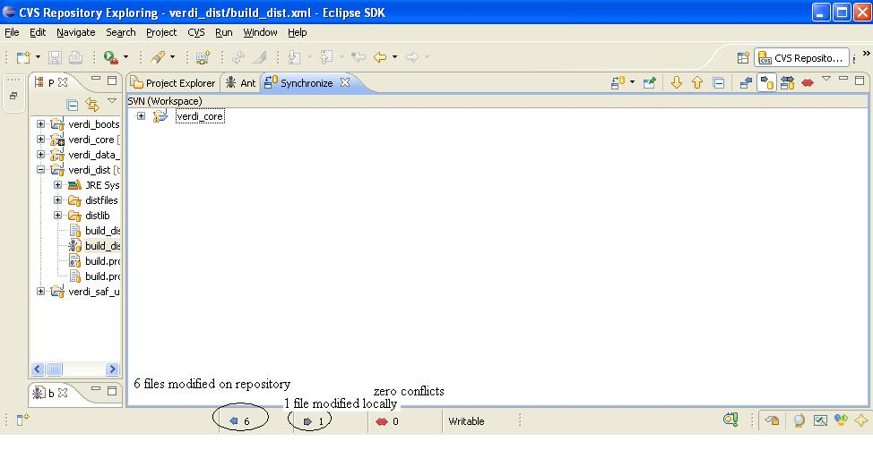

Figure 12-8 Check for Updates and Conflicts

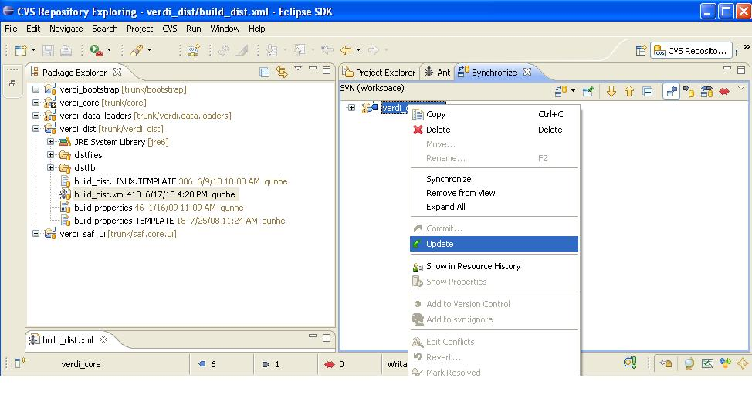

Prepare to build VERDI Distribution
Once VERDI has been checked out of the repository, the folders will be displayed in the Project Explorer Window on the Workbench.

build.properties file

Microsoft Windows
If you are building for the Windows platform, open and edit the build.properties.win32 or build.properties.win64 file that matching your JDK by double clicking on the file to open it in the text editor (Figure 6-1). Edit the build properties file to specify the JDK used to compile and the directory where Eclipse will build the VERDI distribution and to specify the directory where the NSIS installer software is on your local computer.

Linux
Edit the build properties file (build.properties.linux32 or build.properties.linux64 that matching your JDK) to specify the JDK used to compile and the local directory where Eclipse will build the distribution. Right click on the build properties file and select Save.

Mac OSX
Edit the build properties file (build.properties.mac) to specify the JDK used to compile and the the local directory where Eclipse will build the distribution. Right click on the build properties file and select Save. Example JDK location: /System/Library/Java/JavaVirtualMachines/1.6.0.jdk/Contents/
Figure 13-1 Review/Edit build properties file
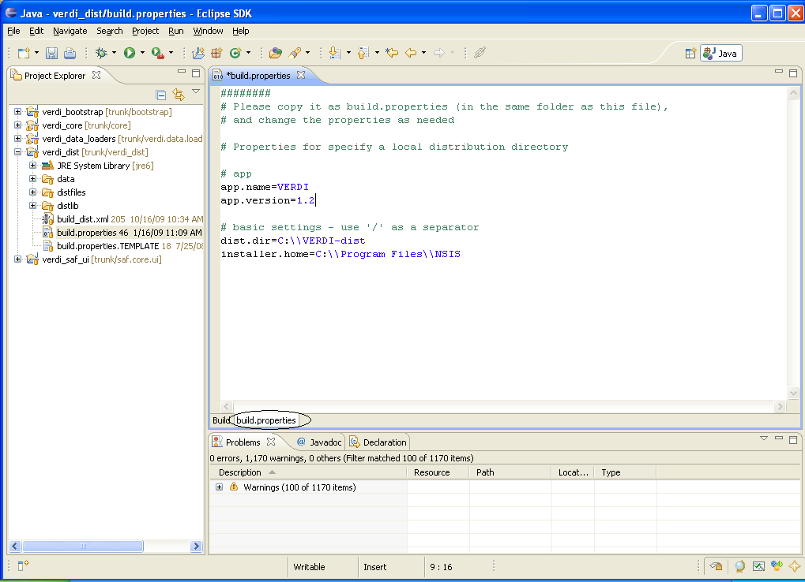

Build_dist xml
There are five build_dist xml files available for ant building: build_dist_linux32.xml, build_dist_linux64.xml, build_dist_win32.xml, build_dist_win64.xml and build_dist_mac.xml, each for a specific version of JDK. The build_dist xml file provides the instructions for how to build both the Mac OSX, Linux and Windows® distributions of VERDI. The build_dist file xml file obtains the local directory settings from the corresponding build properties file. It is also possible to make the changes to specify these directories in the build_dist xml file, but the build properties file has been created to clearly identify what settings are dependent on the local directory configurations, and hopefully will reduce errors that might be incurred by a user editing the build_dist xml file. Figure 6-2 shows the section of the build_dist xml file that provides the paths for the installer used to build the Windows® distribution, if you really want to edit it in the build file.
Figure 13-2 dist xml: nsis installer path section
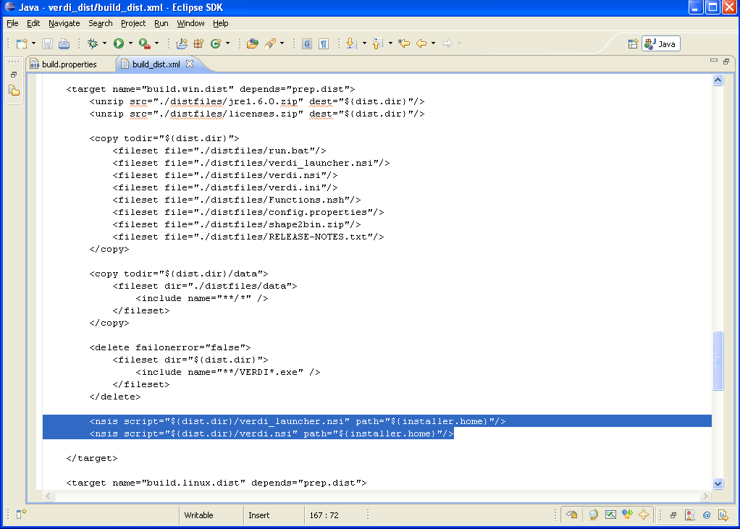

Build VERDI

Build using Ant

Before building the releases, a few settings have to be done through Eclipse menu options Window→Preferences…. Once the Preferences dialog is open (Figure 14-1), select ‘General’ then ‘Workspace’ item. In the ‘Workspace’ panel, select the check boxes for ‘Build automatically’ and ‘Refresh automatically’. Click ‘OK’ button to close the preferences dialog.

Figure 14-1 Window→Preferences

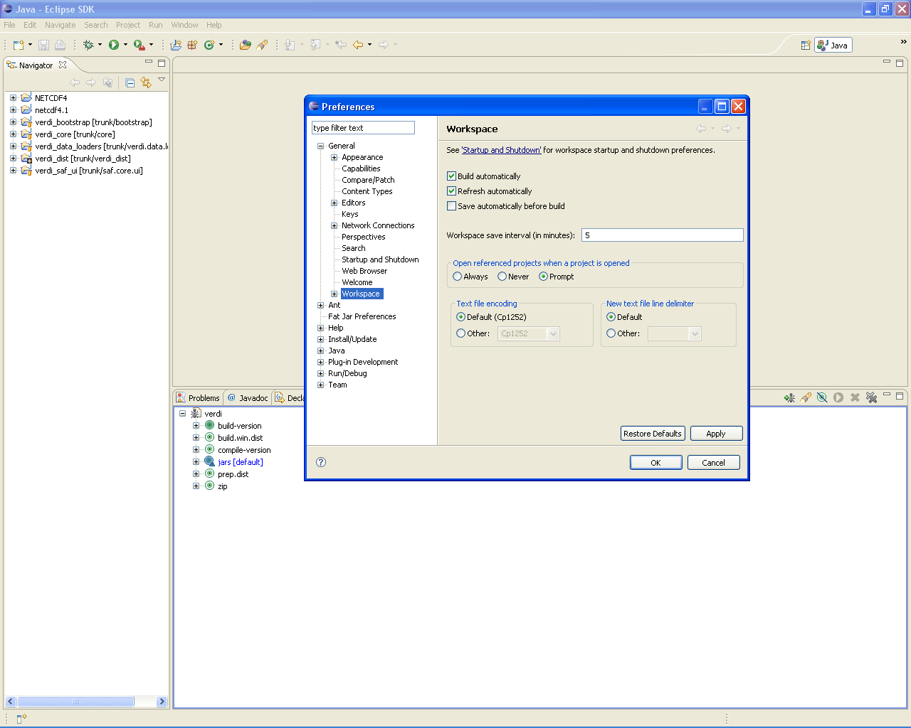

Microsoft Windows
The Windows® distribution can be built using the scripts (build_dist_win32.xml or build_dist_win64.xml) within verdi_dist on a Windows machine. Select the eclipse menu options Window→Show View→Ant to create a subwindow for Ant (Figure 14-2). Then drag the build_dist.xml into the Ant window. Click on the plus button next to verdi to open and display the contents.

- Double click on build-version to update the build version number
- Double click on compile-version to update the compile version number
- Double click on build.win.dist to build the VERDI distribution for a Windows machine. (Figure 7-3)

Figure 14-2 Window→Show View→Ant
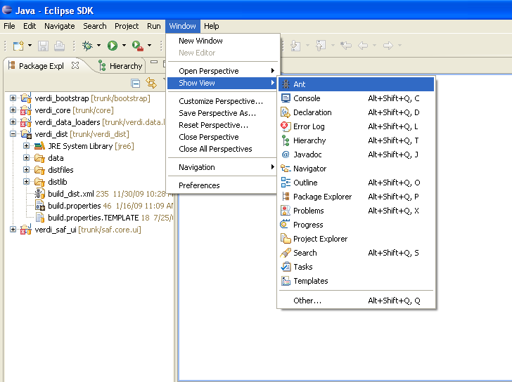
Figure 14-3 Double click on build.win.dist to build VERDI distribution

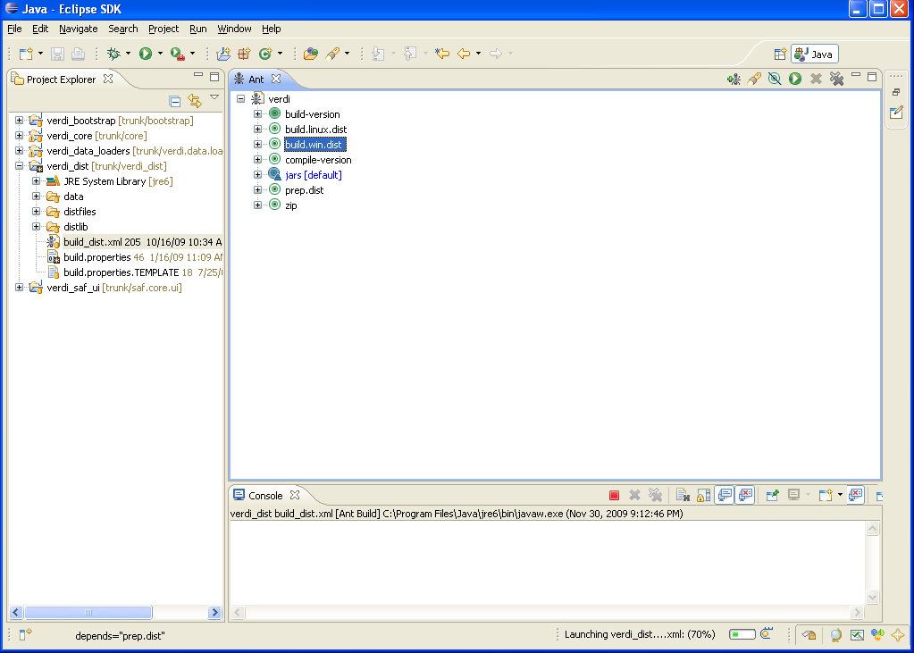

Linux Distribution
Linux distribution can be built by using Ant to run build.linux.dist on a linux machine. The verdi_dist folder contains the build_dist_linx32.xml or build_dist_linx64.xml script. Select the eclipse menu options Window→Show View→Ant to create a subwindow for Ant (Figure 14-2). Then drag the corresponding build_dist xml into the Ant window. Click on the plus button next to verdi to open and display the contents.

- Double click on build-version to update the build version number
- Double click on compile-version to update the compile version number
- Double click on build.linux.dist to build the VERDI distribution for a linux machine.

Mac Distribution

Mac distribution can be built by using Ant to run build.mac.dist on a Mac OSX machine. The verdi_dist folder contains the build_dist_mac.xml script. Select the eclipse menu options Window→Show View→Ant to create a subwindow for Ant (Figure 14-2). Then drag the corresponding build_dist xml into the Ant window. Click on the plus button next to verdi to open and display the contents.

- Double click on build-version to update the build version number
- Double click on compile-version to update the compile version number
- Double click on build.mac.dist to build the VERDI distribution for a Mac OSX machine.

Check Console for Error Messages
Error messages will appear in the console underneath the Ant console.
Figure 14-4 Console Error Message
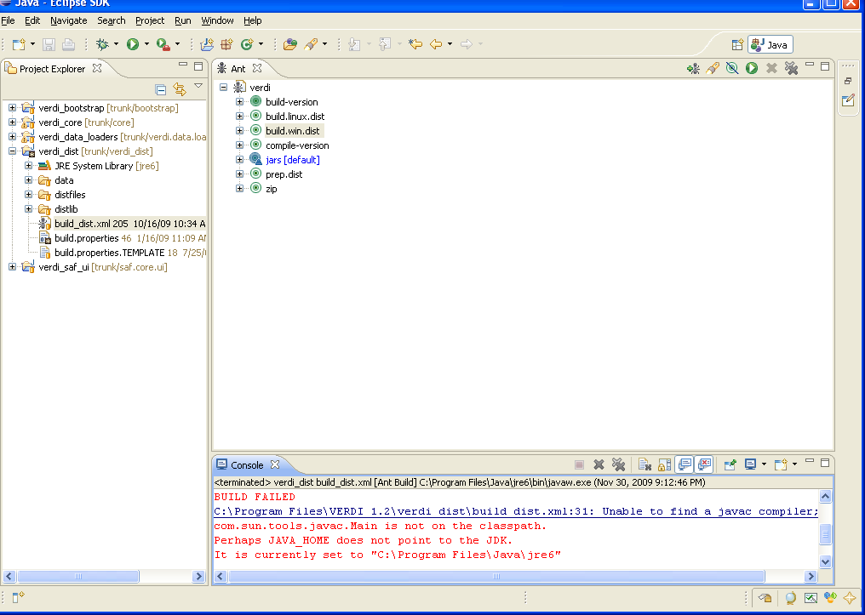
If you obtain this error, add the Java compiler to your path on the Windows or Linux? Machine (see Section 2.2 and Section 6.2)

Add Java Compiler to Ant
To allow the Ant compiler to find the compiler, you will also need to change the Ant Preferences to add tools.jar as an external jar as follows.
- In Eclipse main menu select Window→Preferences (Figure 14-5)
- In the Preference Window select Ant→Runtime (Figure 14-6)
- Click on the Classpath tab, select Global Entries
- Click on Add External JARs
- Locate the tools.tar under the lib folder on the JDK local installation directory then click OK, and click OK again. (Figure 14-7)
Figure 14-5 Open Windows→Preferences
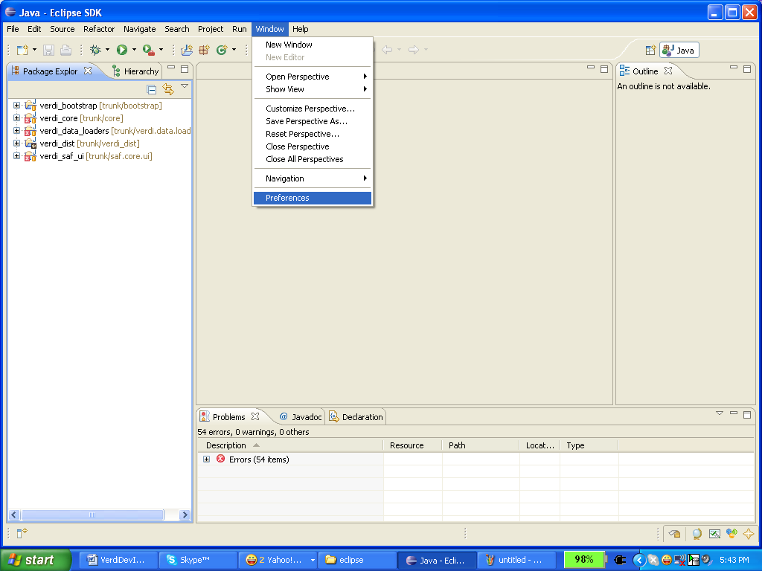
Figure 14-6 Expand Ant, Select Runtime, Select Global Entries
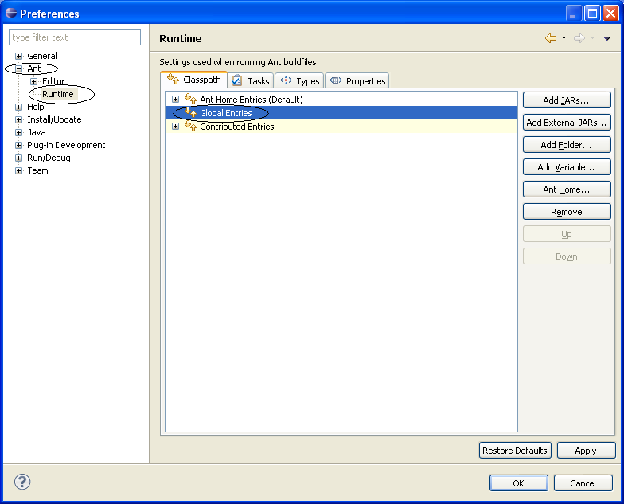

Figure 14-7 Add tools.tar to Ant Preferences
