Two-Temperature Model of Germanium Wedge-Polished TEM Specimens (1D)

Summary: Here, I describe my methodology behind the implementation of the two-temperature model. A majority of this work is based off of the equations provided by Shin *et. al.*, with supporting information by various other authors in successfully inputting material properties.1 These will all be explained in this document.

Two-Temperature Model as Provided by Shin *et. al.*:

The derivation will not be provided here, as it is fully explained in the paper. However, there are some changes made to the model that I will discuss in further detail later. In short, the governing equations correspond to charge carrier movement and recombination, lattice temperature thermal energy, and electron temperature energy.

$$\log\left(10\right){10}^{u}\frac{du}{dt}=D_{e}\log\left(10\right)\left[\log\left(10\right)+1\right]{10}^{u}\frac{d^{2}u}{dx^{2}}-k{10}^{u}+{10}^{\dot{u}}$$

$$n_{L}C_{L}\frac{dT_{L}}{dt}=K_{L}\frac{d^{2}T_{L}}{dx^{2}}+g\left(T_{e}-T_{L}\right)+ξk{10}^{u}(C_{e}T_{e}+E_{g})$$

$${10}^{u}C_{e}\frac{dT_{e}}{dt}=D_{e}C_{e}\log\left(10\right){10}^{u}\frac{du}{dx}\frac{dT_{e}}{dt}-g\left(T_{e}-T_{L}\right)+{10}^{\dot{u}}(hν-E_{g})$$

where *u* is the charge carrier concentration in log-base-10 form, *De* is the electron diffusivity, *x* is the spatial element, *nL*is the density of germanium in atoms, *CL* is the heat capacity of germanium, *TL* is the lattice temperature, *KL* is the thermal conductivity, *g* is the electron-phonon scattering constant, *ξ* is the percentage of non-radiative recombination events, *k* is the rate of charge-carrier recombination events, *Ce* is the electron heat capacity, *Te* is the electron temperature, *Eg* is the band gap, *h* is Planck’s constant, and *ν* is the frequency of incident light. In table form:

|  |  |  |
| --- | --- | --- |
| Symbol | Name | Units |
| *u* | log-base-10 charge carrier concentration | log10(nm-3) |
| *De* | electron diffusivity (ambipolar) | nm2/ps |
| *nL* | atomic density | atoms*nm-3 |
| *CL* | lattice heat capacity | eV/K/atom |
| *TL* | lattice temperature | K |
| *KL* | thermal conductivity | eV/nm/K/ps |
| *g* | electron-phonon coupling constant | eV/ps/K/nm3 |
| *ξ* | non-radiative recombination percentage | % |
| *k* | recombination rate | ps-1 |
| *Ce* | electron heat capacity | eV/K |
| *Te* | electron temperature | K |
| *Eg* | band gap | eV |
| *h* | Planck’s constant | eV*ps |
| *ν* | photon frequency | ps-1 |

On Charge Carrier Concentration and Its Logarithm Form (*u*):

Early on in the simulation work, it was discovered that MATLAB was not good at handling orders of magnitude that spanned from 1013 to >1020 cm-3 in terms of charge carrier concentration. This is compounded with the fact that temperatures are discussed on the order of 102 to 104. Therefore, the following conversion was declared: *ne*, the concentration of charge carriers, was equivalent to 10*u*. In short:

$$u=\log_{10}{n_{e}}$$

This change was propagated across all mentions of *ne* in the original equations posed by Shin *et. al.* and result in the PDEs presented above. If this change was not implemented, then the extremely high diffusivity of the charge carriers would cause MATLAB to think that certain regions of the specimen would have negative concentration. By forcing a logarithmic condition, any drastic swing would at the very least maintain the concentrations of charge carriers above zero, if not above the intrinsic charge carrier concentration.

Electron Diffusivity (*De*):

Charge-carrier diffusion is largely governed by ambipolar diffusion at high charge carrier concentrations in germanium.2 The values for the diffusion constant has been presented as a function of both charge carrier concentration and lattice temperature by Young *et. al.*

Atomic Density:

This was found in a generic chemical handbook.3

Lattice Heat Capacity:

Provided by Flubacher *et. al.*4

Thermal Conductivity:

Provided by Glassbrenner *et. al.*5

Electron-Phonon Coupling Constant:

The equation used to calculate this constant was unfortunately first reported in a Soviet era journal and has been lost. Anisimov *et. al.* is the first mention that I can find.6 The formula was provided by Kaganov *et. al.* in 1957 and is explained in great detail by Lin *et. al.*:7

where *me* is electron mass, *vs* is the speed of sound, and *τ* is the electron-phonon scattering time. This equation is valid for lattice and electron temperatures much higher than the Debye temperature of germanium (374 K) and when the electron temperature is greater than the lattice temperature. In addition, Lin *et. al.* brings up additional studies that have shown this equation applies only when the incident laser fluence is small. However, there is a large difference between the Sommerfeld theory of coupling (linear w.r.t. just carrier concentration and no temperature dependence), which is only valid at low temperatures, and the above equation. Therefore, we will use the above equation knowing that it may give slightly different answers to the actual values.

The only value that is difficult to determine in the equation is the electron-phonon scattering time. Thankfully, there is a study provided by Tandon *et. al.*8 that has provided the scattering rates between electrons and phonons for germanium at two different carrier temperatures. The scattering rate was interpolated with a linear fit and the average scattering rate was found *via* the following calculation:

$${\hat{τ}}_{e,ph}^{-1}=\frac{\int_{E_{C}}^{∞}{f\left(E,T_{e}\right)g\left(E,T_{e}\right)τ_{e,ph}^{-1}dE}}{\int_{E_{C}}^{∞}{f\left(E,T_{e}\right)g\left(E,T_{e}\right)dE}}$$

A linear fit was used for the scattering rate because higher temperatures (the predicted result) would only result in larger values for scattering rates, which is still valid. If the scattering rates dipped below zero, then this would be considered not viable and a log-linear fit would have been chosen instead.

Here is where I ran into a major issue that stymied the development of this model. There is no formulaic description or experimentally plotted graph for the density of states of germanium in the form of counts per energy per volume. Almost all publications are presented in the form of arbitrary units, which for this case become useless, especially if they place the DOS at the band edge at the zero level (of course there are energy states at the band edge). What this means is that I resorted to the good old fashioned free electron model (Drude-Sommerfeld) and took the DOS from that. This means I assume the density of states in the conduction band of germanium resembles that of a free electron gas. Close enough for a rough calculation like this. The density of states of the free electron model begins at zero, so we must offset this by the actual number of states available to germanium at the band edge:

$$N_{C}\left(T_{e}\right)=2{\left(\frac{m_{e}^{*}k_{B}T_{e}}{2πℏ^{2}}\right)}^{3/2}$$

$$g_{FEM}\left(E,T_{e}\right)= N_{C}\left(T_{e}\right)+\frac{m_{e}^{*}}{ℏ^{2}π^{2}}\sqrt{\frac{2m_{e}^{*}\left(E-E_{C}\right)}{ℏ^{2}}}$$

Additionally, the chemical potential is calculated to be, assuming that the charge carriers are in a thermal pseudo-equilibrium (Boltzmann-like):

$$μ\left(T_{e}\right)=\frac{E_{C}+E_{V}}{2}+\frac{k_{B}T_{e}}{2}\ln\left(\frac{N_{V}\left(T_{e}\right)}{N_{C}(T_{e})}\right)$$

where *NV* is analogous to *NC*, but uses the mass of the holes instead of the electrons.

Non-radiative Recombination Percentage:

For germanium, this can be considered to be one (largely due to the indirect bandgap).9-11

Recombination Rate:

This was first calculated as primarily Auger recombination by Huldt and Auston *et. al.* before being expanded in great detail by Dominici *et. al.**9-10**,**12*

The Auger recombination rate is (empirically) presented as:

$$C_{eeh}\left(n_{e}>{10}^{18} cm^{-3}\right)=\frac{{10}^{190.9124}n_{e}^{0.6698\log_{10}{n_{e}}-21.5249-1}}{n_{e}^{2}-n_{i}^{2}}$$

$$C_{hhe}\left(n_{e}>{10}^{18} {cm}^{-3}\right)=\frac{{10}^{120.1814}n_{e}^{0.4574\log_{10}{n_{e}}-13.6881-1}}{{\left({10}^{u}\right)}^{2}-n_{i}^{2}}$$

$$C_{eeh}\left(n_{e}<{10}^{18} {cm}^{-3}\right)=\frac{{10}^{-30.9373}n_{e}^{0.0110\log_{10}{n_{e}}+2.6402-1}}{n_{e}^{2}-n_{i}^{2}}$$

$$C_{hhe}\left(n_{e}<{10}^{18} {cm}^{-3}\right)=\frac{{10}^{-28.9705}n_{e}^{0.0114\log_{10}{n_{e}}+2.6257-1}}{{\left({10}^{u}\right)}^{2}-n_{i}^{2}}$$

$k=\left(C_{eeh}+C_{hhe}\right)n_{e}^{2}$

Electron Heat Capacity:

The heat capacity can be calculated from the energy density as described by Lin *et. al.*:7

where *µ* is the chemical potential. I used the exact same assumption for the density of states here (Drude-Sommerfeld model).

Band Gap:

Provided by Streetman *et. al.*13 Taken to be 0.67 eV with no variation in temperature, as it is difficult to tell if studies mean carrier temperature or lattice temperature.

MATLAB and Material Property Fitting:

Due to the peculiarities with fitting to functions that span across orders of magnitude with curves that are otherwise ill-fitted to traditional fitting functions, a majority of the parameters have been polynomial fit across their relevant ranges. In addition, many of these take the form of log-linear or log-log fits and are converted at the end to their relevant PDE forms. In general, fits that depended on lattice temperature were set between 200K and 1200K, with the assumption being that if the lattice temperature exceeded 1200K the specimen would have melted and the simulation would have (obviously) failed. For charge carriers, the range was from 1013 cm-3, the intrinsic charge carrier concentration, up to ~1020 per Young *et. al.*, with any values beyond acquired through extrapolation. Finally, the electron temperatures were completely unbound, with any values outside provided experimental ranges also acquired through linear or logarithmic extrapolation. The fits are explained in further detail below.

Electron Heat Capacity (*Ce*):

To obtain a good fit, the temperatures were fit in log-base-10 form. Additionally, the values within the range of the fit were centered and scaled such that:

$$T_{e}^{*}=\frac{\log_{10}{T_{e}}-3.876}{0.4073}$$

The polynomial fit is applicable in the range between 78K and 20000K:

$$\log_{10}{C_{e}\left(T_{e}^{*}\right)}=3.765×{10}^{-5}{T_{e}^{*}}^{9}+6.056×{10}^{-4}{T_{e}^{*}}^{8}+4.413×{10}^{-3}{T_{e}^{*}}^{7}+1.654×{10}^{-2}{T_{e}^{*}}^{6}+2.823×{10}^{-2}{T_{e}^{*}}^{5}-3.744×{10}^{-2}{T_{e}^{*}}^{4}-0.1470{T_{e}^{*}}^{3}-0.2213{T_{e}^{*}}^{2}+0.4762T_{e}^{*}+4.234$$

in units of J/K/m3

Ambipolar Diffusion Constant (*De*):

The charge carrier dependence was scaled and centered in log-base-10 form. Two curves at 100K and 300K were provided by Young *et. al.* At 100K:

$$n_{e,100K}^{*}=\frac{\log_{10}{n_{e}}-17.27}{2.215}$$

$$D_{e,100K}^{*}(n_{e,100K}^{*})=21.34{n_{e,100K}^{*}}^{5}+113{n_{e,100K}^{*}}^{4}+218.2{n_{e,100K}^{*}}^{3}+164.1{n_{e,100K}^{*}}^{2}-20.31n_{e,100K}^{*}+246.6$$

At 300K:

$$n_{e,300K}^{*}=\frac{\log_{10}{n_{e}}-17.73}{2.478}$$

$$D_{e,300K}^{*}(n_{e,300K}^{*})=7.81{n_{e,300K}^{*}}^{5}+33.92{n_{e,300K}^{*}}^{4}+49.47{n_{e,300K}^{*}}^{3}+25.18{n_{e,300K}^{*}}^{2}-3.337n_{e,300K}^{*}+62.31$$

with the temperature dependence accounted for as:

$$D_{e}=\exp_{10}\left[\frac{D_{e,300K}^{*}\left(n_{e,300K}^{*}\right)-D_{e,100K}^{*}(n_{e,100K}^{*}) }{300K-100K}\left(T_{L}-100K\right)+ D_{e,300K}^{*}(n_{e,300K}^{*})\right]$$

in units of cm2/s. This fit is valid from 1013 cm-3 to 1020 cm-3 charge carriers. Extrapolation is required for any values beyond this range.

Thermal Conductivity (*Ki*):

The temperature dependence was centered, scaled, and set in log-base-10 form.

$$T_{L}^{*}=\frac{\log_{10}{T_{L}}-1.976}{0.7905}$$

$$K_{i}=\exp_{10}\left[0.01207{T_{L}^{*}}^{7}+0.04158{T_{L}^{*}}^{6}-3.84×{10}^{-3}{T_{L}^{*}}^{5}-0.1541{T_{L}^{*}}^{4}+0.1266{T_{L}^{*}}^{3}+0.0513{T_{L}^{*}}^{2}-1.026T_{L}^{*}+0.3893\right]$$

in units of J/m/K/s. This fit is valid between 3K and 1200K.

Lattice Heat Capacity (*Ci*):

The temperature dependence was centered, scaled, and set in log-base-10 form.

$$T_{L}^{*}=\frac{\log_{10}{T_{L}}-2.08}{0.6879}$$

$$C_{i}=\exp_{10}\left[-0.03258{T_{L}^{*}}^{8}-0.1327{T_{L}^{*}}^{7}+0.1028{T_{L}^{*}}^{6}+0.948{T_{L}^{*}}^{5}+0.326{T_{L}^{*}}^{4}-2.35{T_{L}^{*}}^{3}-1.014{T_{L}^{*}}^{2}+4.331T_{L}^{*}+3.812\right]$$

in units of J/K/mol. The fit is valid from 2.5K to 1200K.

Scattering Time (*τ*):

The temperature dependence was centered and scaled.

$$T_{e}^{*}=\frac{T_{e}-650}{260.2}$$

$$τ=\exp_{10}\left[1.878×{10}^{-3}{T_{e}^{*}}^{4}-7.429×{10}^{-3}{T_{e}^{*}}^{3}+3.456×{10}^{-2}{T_{e}^{*}}^{2}-0.2661T_{e}^{*}-13.51\right]$$

in units of seconds. The fit is valid from 200K to 1100K.

The PDEs were solved in their one-dimensional form using the PDEPE package in MATLAB.

Results:

The results presented here are of the top-most surface of the specimen (where the light is first incident).

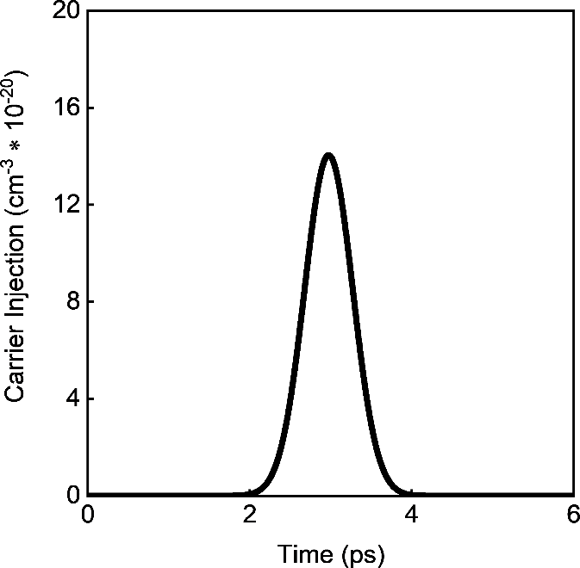 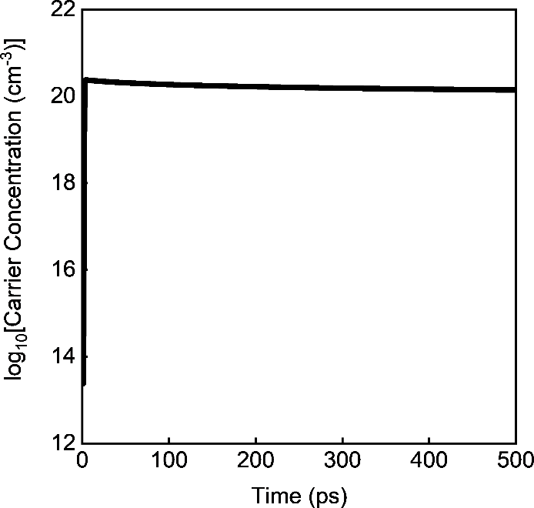

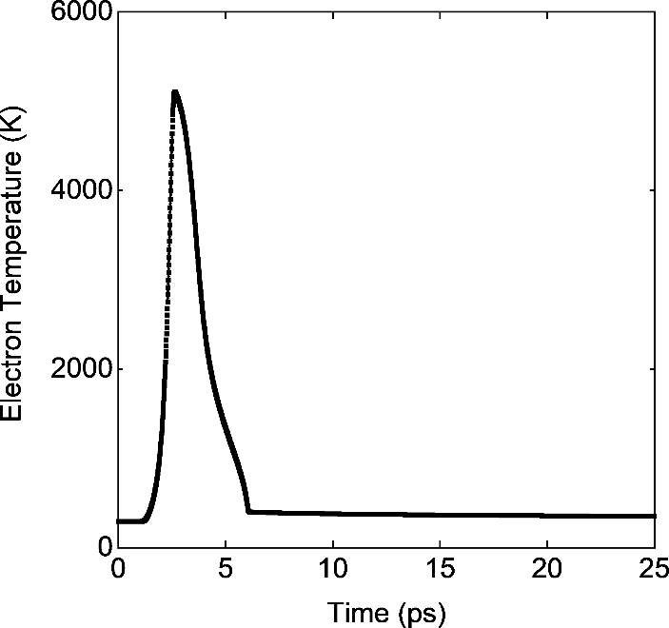 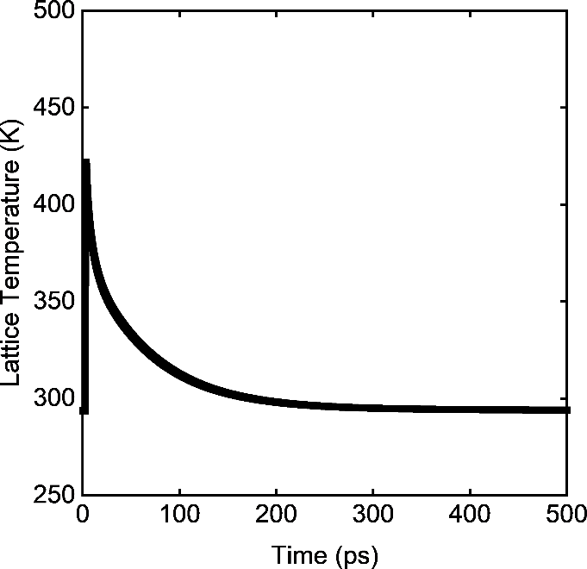

The full 1D solution is:

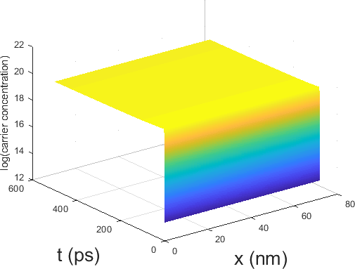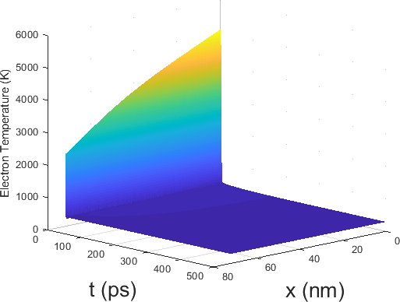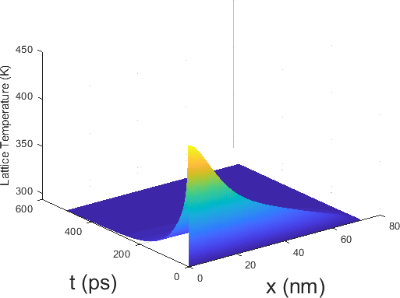

Failure Points:

While the results of this simulation are reasonable enough, I am concerned the constraint to 1D alongside the incredibly small specimen side artificially inflates the resulting electron and lattice temperatures due to a constraint on the charge carrier concentrations. To put it simply, the triple no-flux condition imposed at the boundary within this 72 nm thick specimen causes the charge carriers to stay at 1020 cm-3 in concentration instead of rapidly spreading out through the specimen if the simulation were instead in three dimensions. This would eventually artificially inflate the darkness of any simulated contrast bands and ultimately cause an increase in simulated strain.

I am also worried about the density of states approximation.

1. Shin, T.; Teitelbaum, S. W.; Wolfson, J.; Kandyla, M.; Nelson, K. A. Extended two-temperature model for ultrafast thermal response of band gap materials upon impulsive optical excitation. *The Journal of Chemical Physics* **2015**, *143*, 194705.

2. Young, J. F.; van Driel, H. M. Ambipolar diffusion of high-density electrons and holes in Ge, Si, and GaAs: Many-body effects. *Phys. Rev. B* **1982**, *26*, 2147-2158.

3. Samsonov, G. V., *Handbook of the Physicochemical Properties of the Elements*. Springer Science & Business Media: 2012.

4. Flubacher, P.; Leadbetter, A. J.; Morrison, J. A. The heat capacity of pure silicon and germanium and properties of their vibrational frequency spectra. *The Philosophical Magazine: A Journal of Theoretical Experimental and Applied Physics* **1959**, *4*, 273-294.

5. Glassbrenner, C. J.; Slack, G. A. Thermal Conductivity of Silicon and Germanium from 3K to the Melting Point. *Phys. Rev.* **1964**, *134*, A1058-A1069.

6. Anisimov, S.; Kapeliovich, B.; Perelman, T. Electron emission from metal surfaces exposed to ultrashort laser pulses. *Zh. Eksp. Teor. Fiz* **1974**, *66*, 375-377.

7. Lin, Z.; Zhigilei, L. V.; Celli, V. Electron-phonon coupling and electron heat capacity of metals under conditions of strong electron-phonon nonequilibrium. *Phys. Rev. B* **2008**, *77*, 075133.

8. Tandon, N.; Albrecht, J. D.; Ram-Mohan, L. R. Electron-phonon interaction and scattering in Si and Ge: Implications for phonon engineering. *J. Appl. Phys.* **2015**, *118*, 045713.

9. Auston, D. H.; Shank, C. V.; LeFur, P. Picosecond optical measurements of band-to-band Auger recombination of high-density plasmas in germanium. *Phys. Rev. Lett.* **1975**, *35*, 1022-1025.

10. Dominici, S.; Wen, H.; Bertazzi, F.; Goano, M.; Bellotti, E. Numerical evaluation of Auger recombination coefficients in relaxed and strained germanium. *Appl. Phys. Lett.* **2016**, *108*, 211103.

11. Hall, R. N. Electron-hole recombination in germanium. *Phys. Rev.* **1952**, *87*, 387-387.

12. Huldt, L. Auger recombination in germanium. *Phys. Status. Solidi* **1974**, *24*, 221-229.

13. Streetman, B. G.; Banerjee, S., *Solid state electronic devices*. Prentice hall Englewood Cliffs, NJ: 1995; Vol. 4.