CEN4010 Principles of Software Engineering, Spring 2023

Milestone 1 Project Proposal and High-level description

Team 03, Project name: Overview

Team 03

Aira Torres

George Gordon

Daniel Rovira

Tyler Fasoli

Eric Smith

February 24, 2023

Executive summary

*Overview* is meant to be a simple web-based application for getting a “bird’s eye view” of all posts on all social media platforms that a user is registered with. Key advantages include an efficient, streamlined approach to interacting with multiple web services from a single user interface. Focus of this application compared to others on the market is on ease-of-use and simplicity. Most options on the market today suffer from feature-creep and are aimed more at professionals and larger businesses; *Overview* aims to remedy this by having a streamlined interface that any user can easily pick up and make use of.

*Overview* is aimed more at the casual user of social media that wants a single placed to view all of their social media content as well as offer a way to post onto all social media platforms they are registered with from one place.

Competitive Analysis

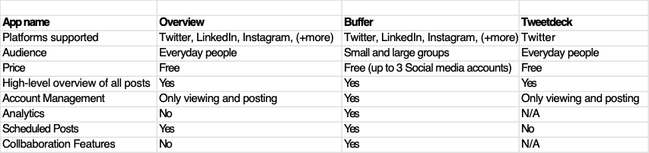

Putting aside the difference in supported platforms between *Buffer* and *Tweetdeck,* the goal for *Overview* is to offer a simple and streamlined interface with minimal but powerful options in easy to see places. In other words, we are aiming for a simpler user interface when compared to *Buffer* and *Tweetdeck*.

Data Definitions

Overview, scenarios, use cases

Initial list of high-level functional requirements

1. Clear and concise overview of all new social media posts for a given day.
2. Ability to quickly reply to a post on a given social media platform.
3. Ability to create a new post on a given social media platform.

List of non-functional requirements

1. Emphasis on usability, should be easier to make post when compared to using the native social media platform for posting
2. Accessibility: user interface items should be distinct and easy to discover
3. Security requirements: no personal data associated with the user or their account should be stored. All relevant data retrieved via an API must only be used for the operation that the user has initiated; there will be no storage of any user-specific data.

High-level system architecture

A tentative list of products, tools, and programming languages that will be used for this project include:

* Visual Studio Code for programming
* Chromium and Firefox web development/debugging tools
* Electron tools
* Electron framework for desktop app support and easy translation to web app
  + JavaScript
  + Node.js
* HTML5, CSS
* Python
* C++

Team

Aira Torres – Frontend Developer

Daniel Rovira

George Gordon – Frontend Developer

Tyler Fasoli - Frontend Developer

Eric Smith – Repository Maintainer, Backend Developer

Checklist

a) ~~Team decided on basic means of communications~~

b) Team found a time slot to meet outside of the class (To do)

c) Front and back end team leads chosen (To do)

d) ~~Github master chosen~~

e) Team ready and able to use the chosen back and front-end frameworks (To do)

f) ~~Skills of each team member defined and known to all~~

g) Team lead ensured that all team members read the final M1 and agree/understand it before submission