**UNITABHUB**

Name:

Date:

**Summary**

This document outlines the specifications, design, and implementation details of the TA Management System. It provides a comprehensive guide for users, department staff, committee members, and instructors involved in the TA management process. The system aims to streamline the TA application, review, matching, TA Selection,enhancing communication and decision-making within the department.

**3. Introduction**

**Background:**

The UNITAHUB is designed to address the challenges and complexities associated with the management of Teaching Assistant (TA) processes within our educational institution. As academic demands increase, the need for an organized, streamlined system for handling TA applications, assignments, and communication becomes crucial.

The current manual processes for TA management often lead to inefficiencies, miscommunications, and delays. Recognizing these challenges, the TA Management System is conceived to provide an integrated and automated solution, optimizing the entire TA lifecycle.

**Purpose of the Document:**

This document serves as a comprehensive guide outlining the key aspects of the TA Management System. It is intended for various stakeholders involved in the system, including TA applicants, department staff, TA committee members, instructors.The document aims to provide clear insights into the system's functionalities, requirements, design, implementation, and testing.

**Scope and Objectives:**

**Scope:**

* The TA Management System will cover the entire lifecycle of TA management, from user registration to TA assignment and performance assessment.
* It will include features for TA applicants, department staff, TA committee members, instructors, and administrators, ensuring a tailored experience for each user role.
* The system will facilitate efficient communication channels and data tracking, enhancing transparency and collaboration.

**Objectives:**

* Streamline the TA application process, making it user-friendly and efficient.
* Enable department staff to manage courses and TA assignments with ease.
* Provide a platform for TA committee members to review applications and make informed assignment decisions.
* Offer instructors tools for assessing TA performance and providing feedback.
* Ensure secure and transparent communication channels within the system.

**4. Requirements and User Cases**

**Functional Requirements:**

**UNITAHUB Home page:**

In this we have option for login or signup by users like TA Applicant, Department Staff, TA Committee Member and Instructor. Please refer below screenshot.

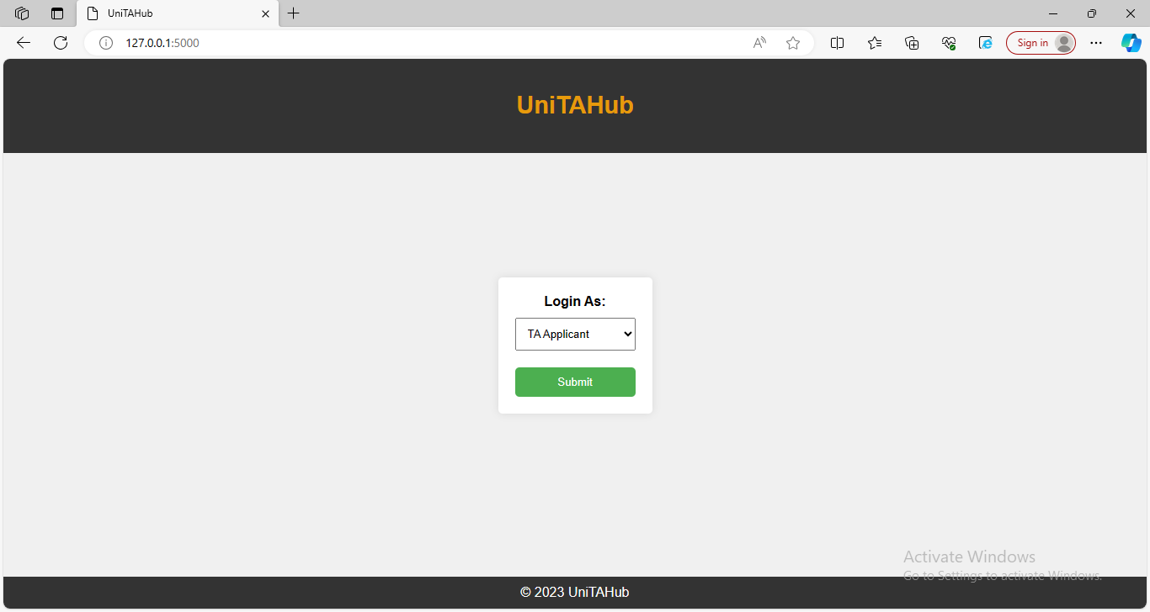

**TA Applicants:**

1. User Registration and Profile Creation

TA applicants can create user accounts and complete profiles.

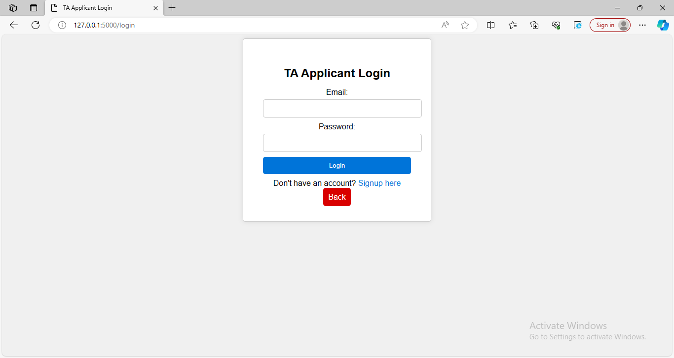

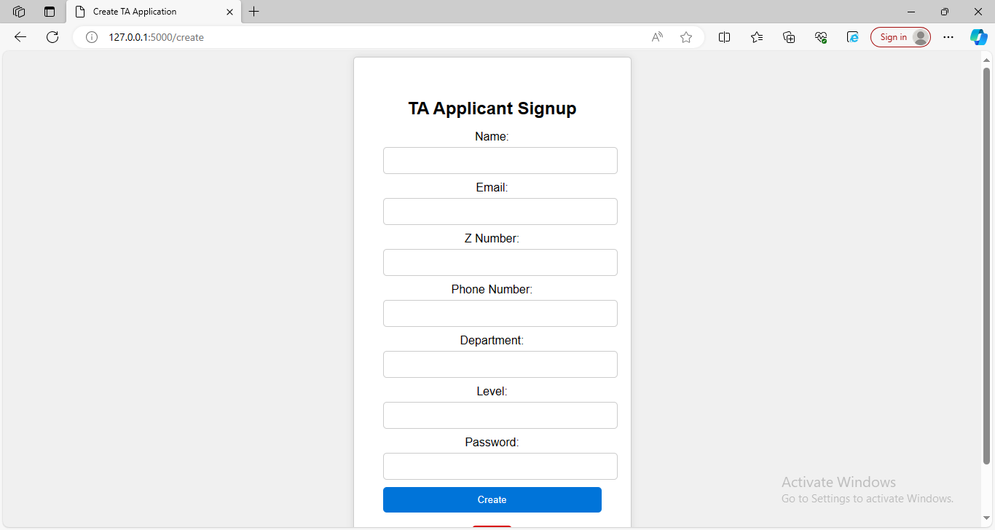

**Profile:**

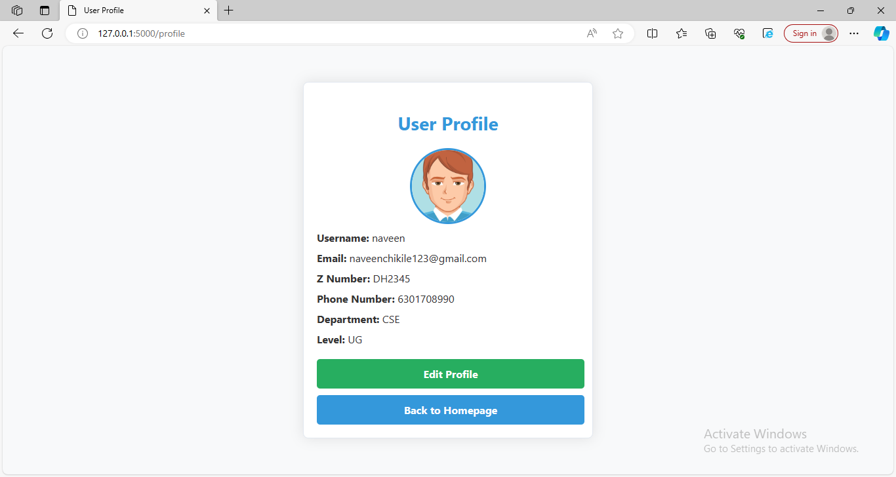

**TA Applicant Home Page:**

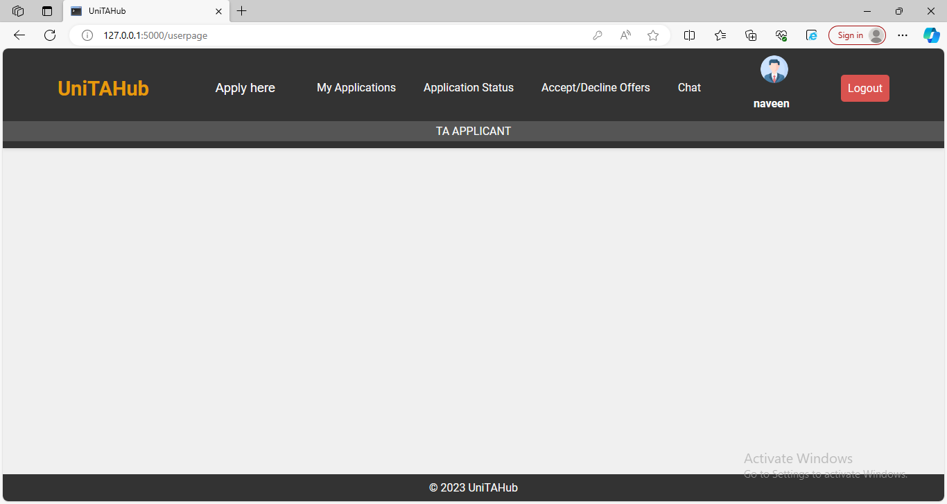

2. Apply Here:

In this section,TA Applicant will send application ,according to their subject.A form will be appear in next page. Fill the form with all details and send it.This application will goto Department Staff and TA Committee Members.

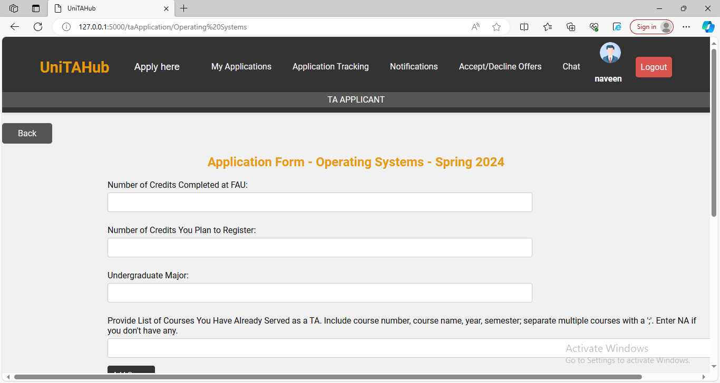

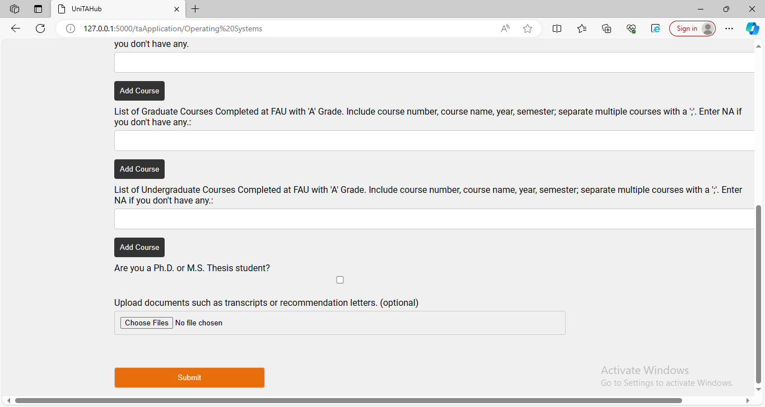

3. My Applications:

In this Section , TA Applicant view their applications which they applied. There is view ,edit and delete option for every subject application.

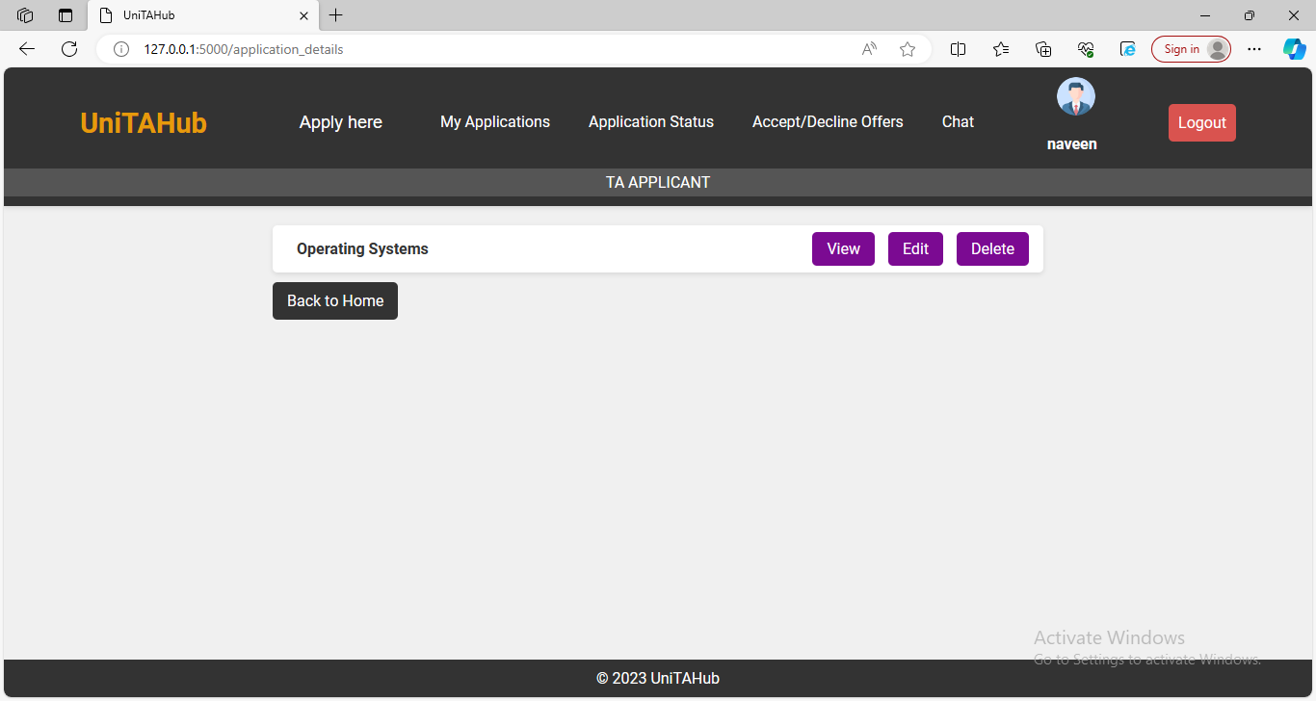

View:

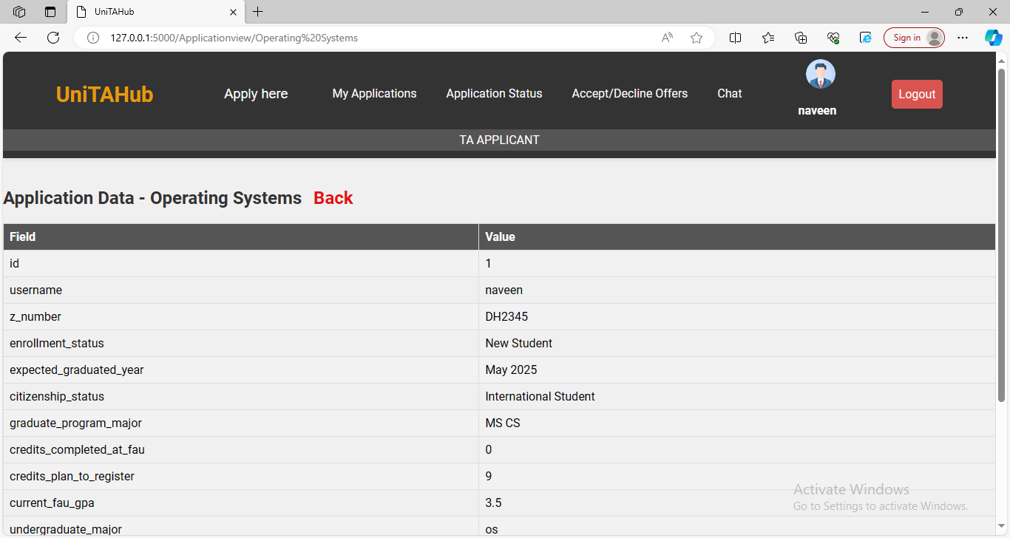

Edit:

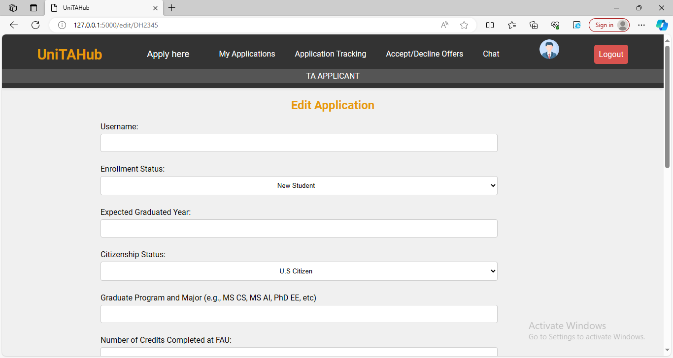

4. Application Status:

In this section TA Applicant know their application status. whether its TA committee member selected or Pending or Accept or decline by you, these type of status were shown in Application status section.

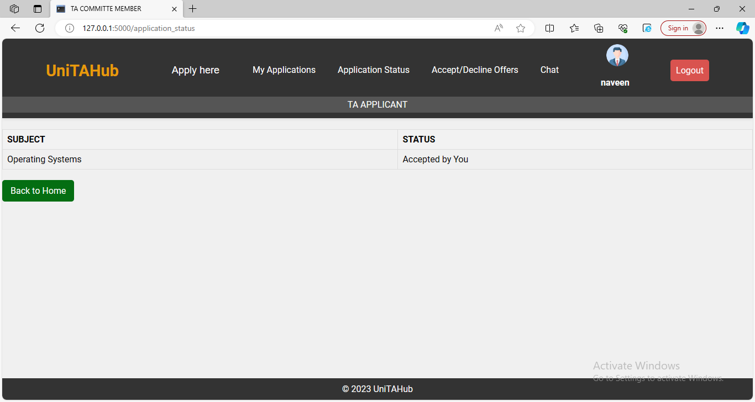

5. Accept/Decline Offers:

In this section TA Applicant accept or decline the offers who the department staff assign the subjects to them. And also displayed accepted offers list and rejected offers list in this page.

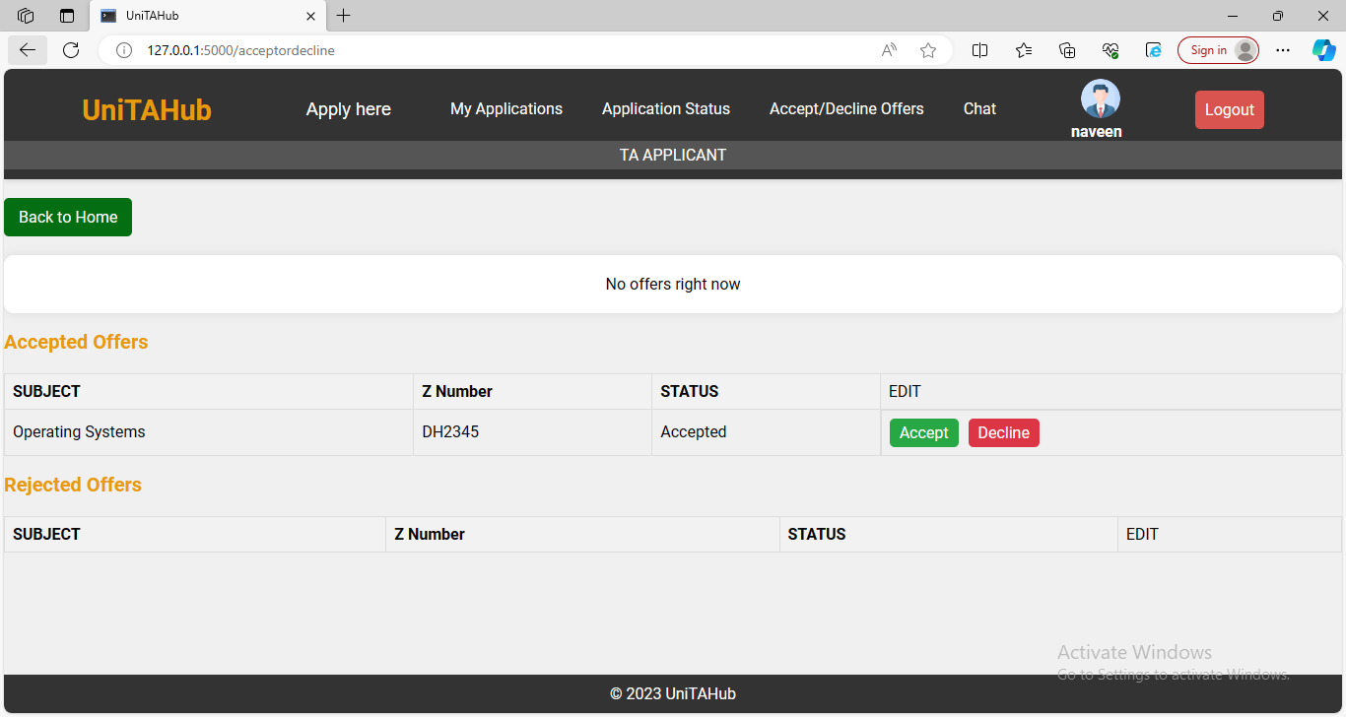

6 Chat:

Its provide a messaging system for communication with department staff and committee members and Instructor. Chat with anyone you want to list of users appears in this page.

