Input
# | Time | Frequency | New Frequency
1 | 15 | 101 | 26.44 %
2 | 30 | 124 | 32.46 %
3 | 45 | 73 | 19.11 %
4 | 60 | 84 | 21.99 %
 | Total | 382 | 100%

Plot
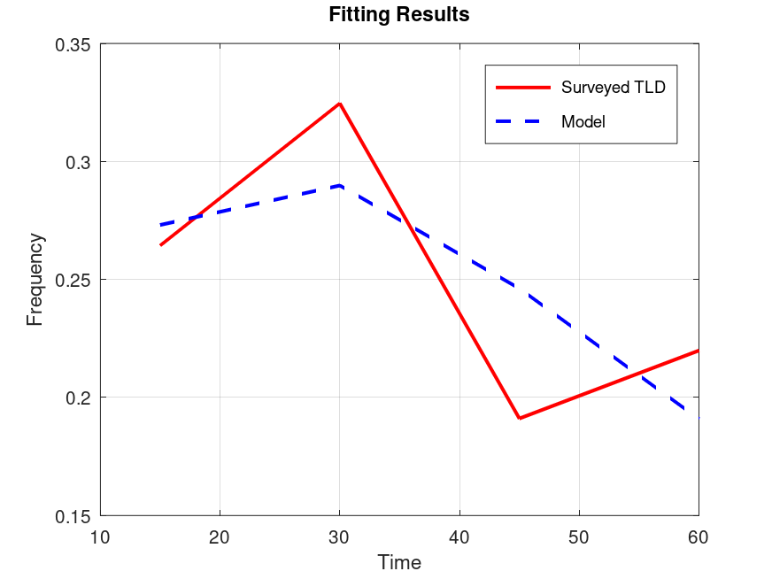

Output
Optimized Parameters
A: 0.6215
B: 0.7736
C: -0.0318
Equation
f(t) = 0.621 t^0.774 e^-0.032 t
Statistics
R²: 0.4915
SSE: 0.0052

