Input
# | Time | Frequency | New Frequency
1 | 5 | 24 | 2.28 %
2 | 10 | 50 | 4.74 %
3 | 15 | 155 | 14.71 %
4 | 20 | 185 | 17.55 %
5 | 25 | 157 | 14.9 %
6 | 30 | 117 | 11.1 %
7 | 35 | 110 | 10.44 %
8 | 40 | 71 | 6.74 %
9 | 45 | 60 | 5.69 %
10 | 50 | 34 | 3.23 %
11 | 55 | 26 | 2.47 %
12 | 60 | 12 | 1.14 %
13 | 65 | 8 | 0.76 %
14 | 70 | 17 | 1.61 %
15 | 75 | 12 | 1.14 %
16 | 80 | 5 | 0.47 %
17 | 85 | 6 | 0.57 %
18 | 90 | 3 | 0.28 %
19 | 95 | 2 | 0.19 %
20 | 100 | 0 | 0 %
 | Total | 1054 | 100%

Plot
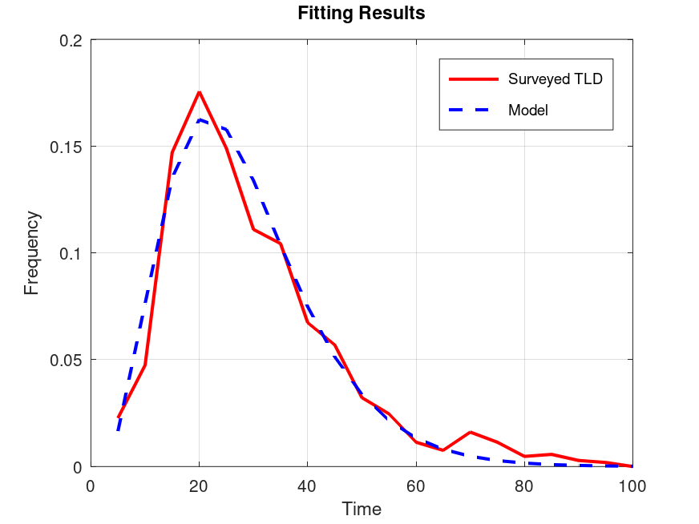

Output
Optimized Parameters
A: -3.2651
B: 3.2986
C: -0.1531
Equation
f(t) = -3.265 t^3.299 e^-0.153 t
Statistics
R²: 0.9649
SSE: 0.0021

