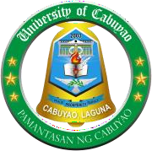Republic of the Philippines

University of Cabuyao

(Pamantasan ng Cabuyao)

*College of Education*

Katapatan Mutual Homes, Brgy. Banay-banay, City of Cabuyao, Laguna, Philippines 4025

**RIZ101 Special Task- Prelim**

Direction. Answer the question:

1. Among the siblings of Dr. Jose Rizal, who resonates with you the most? How does this person affect your perspective in the life and works of Rizal?

***Note****: Using AI Generated answer is strictly prohibited!*

Format

Handwritten (Yellow Paper) 250 words minimum.

**Submission**: September 26, 2024

**Submit here:** [almonterde@pnc.edu.ph](mailto:almonterde@pnc.edu.ph)

*Prepared by Arjane Mae L. Monterde, RPm Course Instructor*