CENTRO DE ENSEÑANZA TÉCNICA Y SUPERIOR

SCHOOL OF ENGINEERING
MACHINE LEARNING

PROFESSOR CESAR ALAN TORRES QUIROZ

“U1_H1”

PRESENTS:
MANUEL DE LA TORRE SALAZAR, 34258

B5

TIJUANA, B.C., AUGUST 27 2026
1. Female survivors older than 50
- Answer: 16 survivors
- Code:
df[(df["Sex"] == "female") & (df["Survived"] == 1) & (df["Age"] > 50)].shape[0]

2. Median fare of passengers who did not survive
- Answer: Median is 10.5
- Code:
print(df[df["Survived"] == 0]["Fare"].median())

3. Third-class survival rate
- Answer: 24.24%
- Code:
print(round(df[df["Pclass"] == 3]["Survived"].mean() * 100, 2), "%")

4. Passengers by embarkation port
- Answer:
  - Port S: 644 passengers
  - Port C 168 passengers
  - Port Q 77 passengers
  - Missing value 2
- Code:
print(df["Embarked"].value_counts(dropna=False))

5. Average age of survivors by sex
- Answer:
  - Female: 28.84
  - Male: 27.27
On average female passengers were older.
- Code:
print(df[df["Survived"] == 1].groupby("Sex")["Age"].mean())

6. Missing cabin and survival status
- Answer: 481 passengers
- Code:
print(df[df["Cabin"].isna() & (df["Survived"] == 0)].shape[0])

7. Traveling alone and survival
- Answer:
  - Alone 30.35%
  - With family: 50.56%
Passengers with family on board had a higher survival rate by 20 points
- Code:
alone = df[(df["SibSp"] == 0) & (df["Parch"] == 0)]["Survived"].mean() * 100
print("Alone: ", alone, "%")

family = df[(df["SibSp"] > 0) | (df["Parch"] > 0)]["Survived"].mean() * 100
print("With family: ", family, "%")

8. Average fare by passenger class
- Answer:
  - 1st class: 84.15
  - 2nd class: 20.66
  - 3rd class: 13.67
- Code:
print(df.groupby("Pclass")["Fare"].mean())

9. Passengers younger than 18
- Answer:
  - Under 18: 113 passengers
  - Survival rate: 53.98%
- Code:
print("Under 18:",df[df["Age"] < 18].shape[0])
print("Survival rate:", df[df["Age"] < 18]["Survived"].mean() * 100, "%")

10. Correlation between fare and passenger class
- Answer:
The correlation between fare and class is how much passengers paid to be put into their class.
The correlation is “-0.54” because it is natural that higher class passengers will pay more than those in lower classes.
- Code:
print(df["Fare"].corr(df["Pclass"]))

11. Age distribution plot
- Answer:
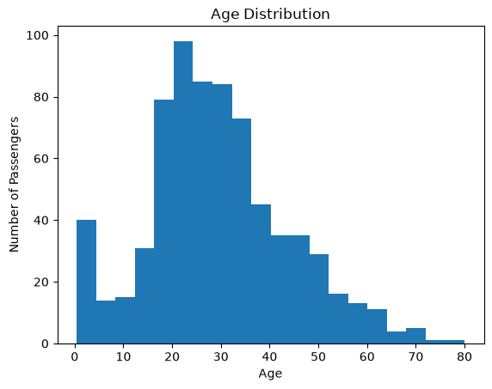
Highest concentration of passenger is found in the average age that being people in their 20s to 30s.
- Code:
import matplotlib.pyplot as plt

df["Age"].plot(kind="hist", bins=20)
plt.xlabel("Age")
plt.ylabel("Number of Passengers")
plt.title("Age Distribution")
plt.show()
- Graphic interpretation: Shows how the age was distributed among all the titanic passengers, x-plot being the age and the y-plot being the amount of passengers.

12. Survival by sex or passenger class
- Answer:
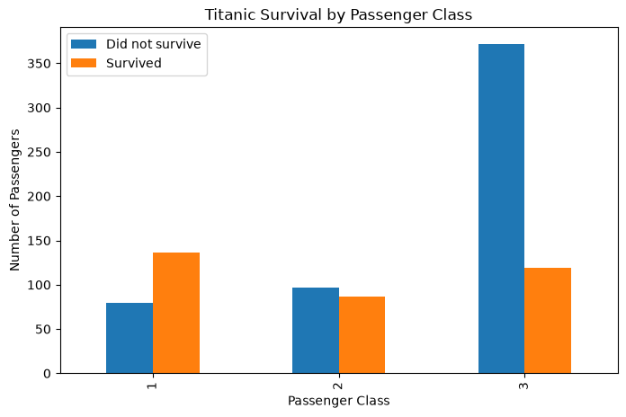
HIghest group of survivors came from passengers of 3rd class.
- Code:
df.groupby(["Pclass", "Survived"]).size().unstack().plot(kind="bar", figsize=(8, 5))

plt.xlabel("Passenger Class")
plt.ylabel("Number of Passengers")
plt.title("Titanic Survival by Class")
plt.legend(["Did not survive", "Survived"])
plt.show()
- Graphic interpretation: The passengers have been separated depending on class showing the survivors and those who did not survive from each class.

13. Fare distribution by survival status
- Answer:
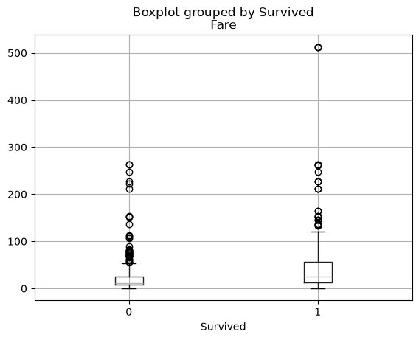
- Code:
- df.boxplot(column="Fare", by="Survived")
- plt.show()
- Graphic interpretation: The boxplot shows the amount of survivors depending on the fare paid.

