Access to ROMS code repository on bitbucket.com

Repository access

Jeroen and Devin are the account admins and will give you access to the code hosting service bitbucket.com.

You will then receive an email from Bitbucket, please follow the link to activate your access. It may require creating an account on Bitbucket if you have not done so before, but it will prompt you as required.

Cloning the code

On your machine, make a directory to store the code (typically ~/repos/).
You should be able to clone the code to your machine through the terminal with the following command, but editing for your bitbucket username.
git clone https://username@bitbucket.org/nmolem/ucla-roms.git

If that did not work, as per the image below, go to the bitbucket webpage from your email link and click on 'clone' on the top right.

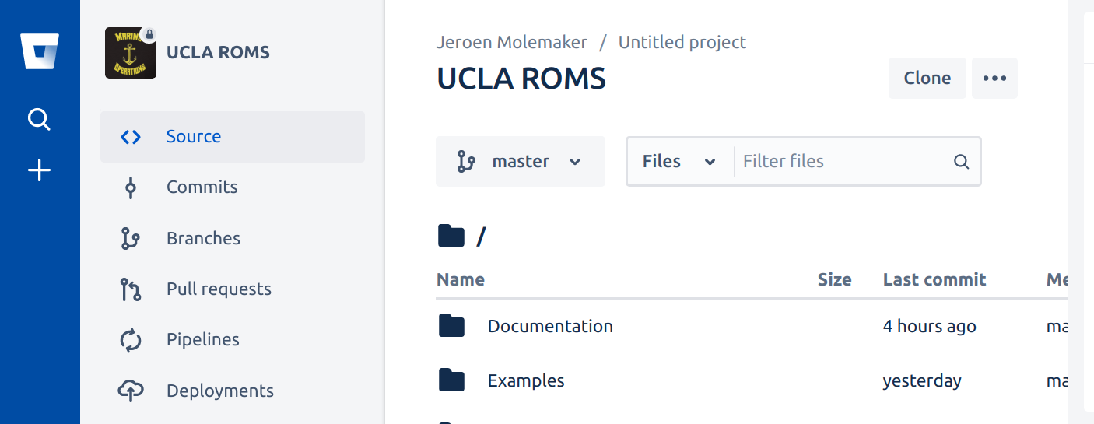

Copy the terminal command it displays 'git clone .....'

On your machine, make a directory to store the code (typically ~/repos/).

Then enter the copied command in a terminal at that directory 'git clone .....'

It will then download the latest code into a ‘ucla-roms’ directory (this may take a few minutes as the download is about 0.5GB due to example netcdf input files).

Running ROMS

Open the first readme (i.e. ~/repos/ucla-roms/readme) for further instructions for getting the new code to compile, running a quick practice example, and details about the new roms.

