Read me

Name of application/Project: Bowling AR Game

Name: Cieran Evan Upton

Student ID: 22135022

Controls:

Touch screen: interact with UI (this includes all buttons on main menu and pause button and bowl button)

Rotate phone: makes ball move left or right or speed up or slow down depending on its rotation

Documentation of design and building process of Game (In chronological order):

Inspirations from Google Play store:

PBA bowling challenge:

Bowling Crew -3D bowling game:

AR Sports: augmented reality:

Target platform: android on mobile

Game Engine used to make it: Unity

Plans:

Move the ball by rotating phone using accelerometer​

Click screen or button to throw the ball ​

Still able to move ball by rotating phone but also backwards and forwards to slow and speed up the ball

Free to play as all of the games I looked at were​

To return back to the main menu you have to watch an add

Concept art for game solo:

Design 1:

Design 2:

Design 3:

Whit boxing game:

Pictures of AR implementation:

Ball script implementation (accelerometer):

Play testing: After playtesting it, I realised the Game was too easy, so I thought of the idea of adding more difficulty

Concept art for game Difficulty:

Easy mode: the ones seen above

Classic Mode:

Arcade Mode:

Concept art for menu:

Design 1 moving up​:

Design 2 Settings Music​:

Design 3 moving sideways:

Whit boxing for menu(Moving sideways was chosen) and game modes:

Adding assets to the game modes and adding setting options:

Implementation of UI manager and persistent data for the music to be turned on and off:

Implementation of ads (specifically video ads as banner was done later):



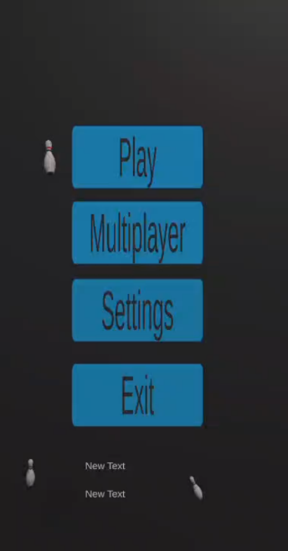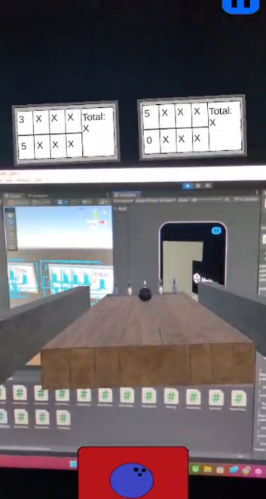

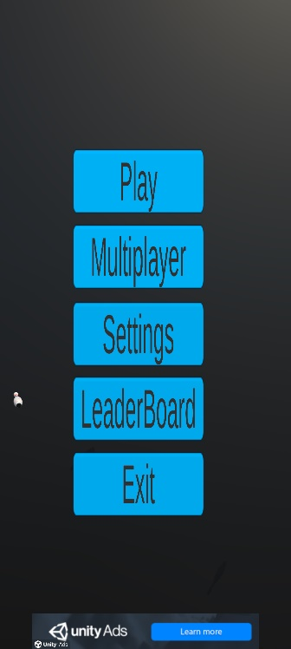

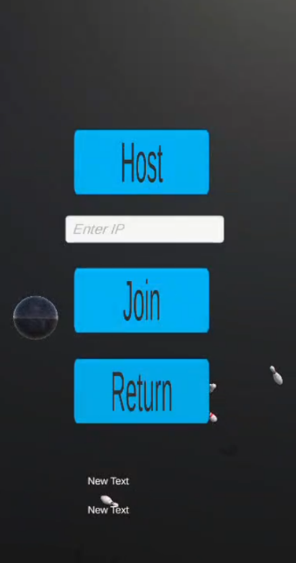

Implementation of Multiplayer

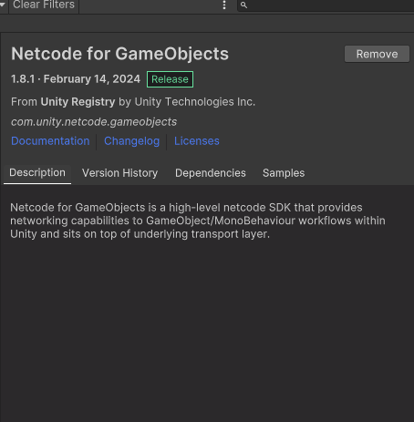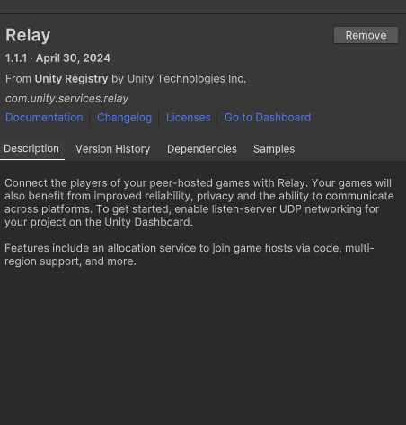

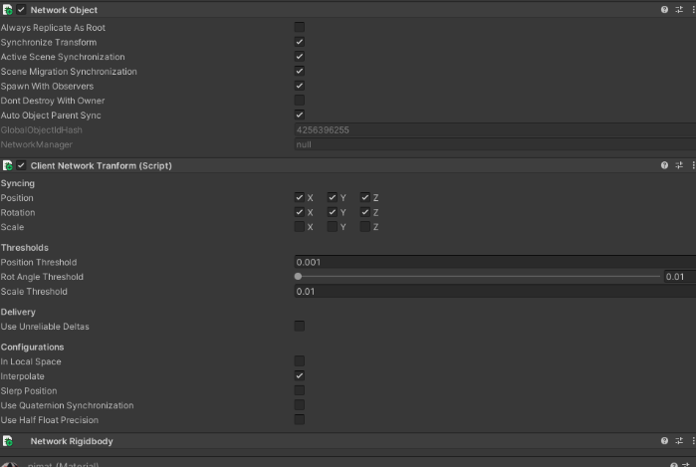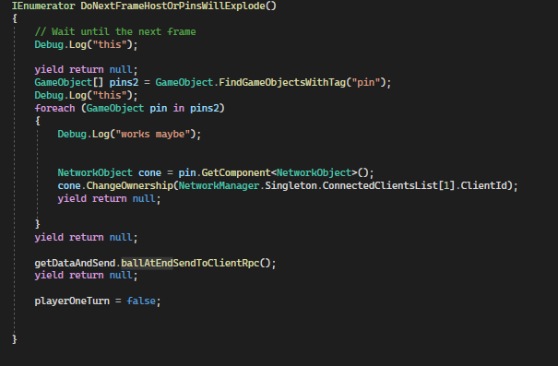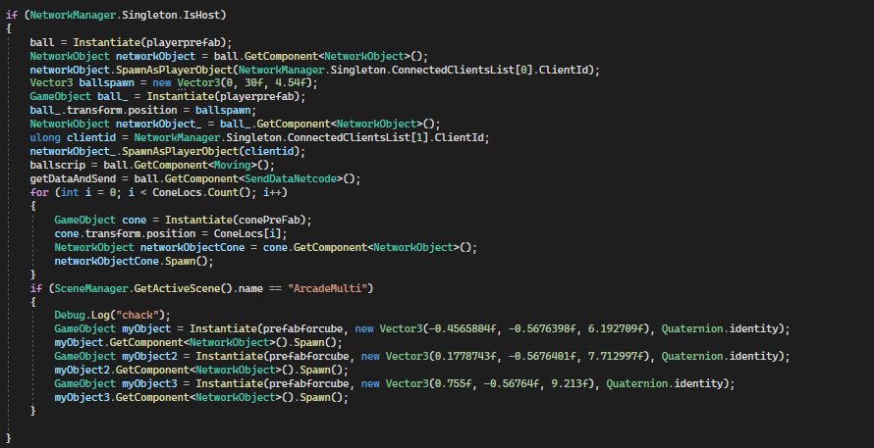

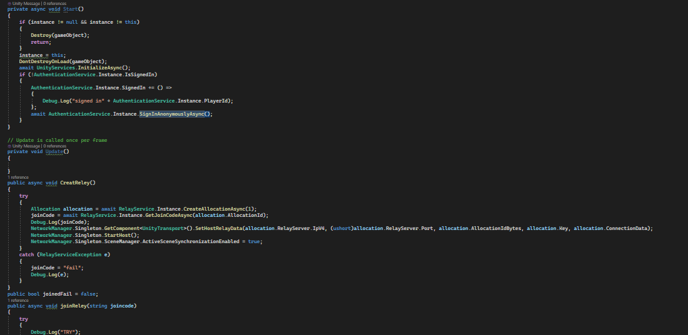

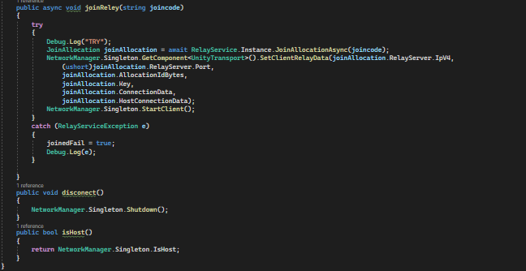

References:

Bowling ball model:

<https://sketchfab.com/3d-models/bowling-ball-5d31d395e0e24138900065b642ac8299#download> ​

Bowling pin model:

<https://sketchfab.com/3d-models/bowling-pin-old-low-poly-b2f373e81e0448fda16771ef62ea2c1b> ​

Wood Texture 1:

<https://polyhaven.com/a/wood_planks> ​

Wood Texture 2:

<https://polyhaven.com/a/dark_wooden_planks> ​

TV model:

<https://sketchfab.com/3d-models/screen-tv-f0cdf527d9154bd8a8e4cd32d3855710>

Music for Game:

Music by <a href="https://pixabay.com/users/alba_mac-40740995/?utm_source=link-attribution&utm_medium=referral&utm_campaign=music&utm_content=176807">Alba MacKenna</a> from <a href="https://pixabay.com//?utm_source=link-attribution&utm_medium=referral&utm_campaign=music&utm_content=176807">Pixabay</a>

Unity JSON tutorial:

<https://www.youtube.com/watch?v=CkBvrC0wZMU>

Unity Ads tutorial:

<https://www.youtube.com/watch?v=seTvVkaU2dk&t=903s>

Play games plugin for unity tutorial:

<https://www.youtube.com/watch?v=lCZd_URHVK8&t=435s>

Play games plugin for unity tutorial used for incremental achievements:

<https://www.youtube.com/watch?v=cYeK09O3xgI&t=965s>