Lab 3: Depth-Damage Models
DataFrames and Distributions
JIAYUE YIN
Fri., Feb. 2
using CSV
using DataFrames
using DataFramesMeta
using Distributions
using Interpolations
using Plots
using StatsPlots
using Unitful
Plots.default(; margin=6Plots.mm)

Site information
Site：The site of Galveston Pier 21, TX The definetion of near：within 1 km building： Fisherman’s Wharf（which is about 150m away from this cite） Elevation: 3.98 feet
haz_fl_dept = CSV.read("data/haz_fl_dept.csv", DataFrame)
include("depthdamage.jl")
DepthDamageData

Depth-Damage
row = @rsubset(
haz_fl_dept, :Description == "Cafeteria Restaurant, structure"
)[
1,:,
]
dd = DepthDamageData(row)
fieldnames(typeof(dd))
(:depths, :damages, :occupancy, :dmg_fn_id, :source, :description, :comment)
scatter(
dd.depths,
dd.damages;
xlabel="Flood Depth at House",
ylabel="Damage (%)",
label="$(dd.description) ($(dd.source))",
legend=:bottomright,
size=(750, 500),
)

itp = let
depth_ft = ustrip.(u"ft", dd.depths)
damage_frac = dd.damages
Interpolations.LinearInterpolation(
depth_ft,
damage_frac;
extrapolation_bc=Interpolations.Flat(),
)
end
29-element extrapolate(interpolate((::Vector{Float64},), ::Vector{Float64}, Gridded(Linear())), Flat()) with element type Float64:
0.0
0.0
0.0
0.0
0.0
15.0
18.0
20.0
23.0
25.0
27.0
28.0
30.0
⋮
58.0
64.0
68.0
72.0
76.0
80.0
84.0
88.0
92.0
96.0
100.0
100.0
let
dmg_fn(x) = itp(ustrip.(u"ft", x))
dmg_fn.([3.1u"ft", 2.2u"m", 91.4u"inch"])
end
3-element Vector{Float64}:
20.3
28.435695538057743
29.23333333333333
function get_depth_damage_function(
depth_train::Vector{<:T}, dmg_train::Vector{<:AbstractFloat}
) where {T<:Unitful.Length}
# interpolate
depth_ft = ustrip.(u"ft", depth_train)
interp_fn = Interpolations.LinearInterpolation(
depth_ft,
dmg_train;
extrapolation_bc=Interpolations.Flat(),
)
damage_fn = function (depth::T2) where {T2<:Unitful.Length}
return interp_fn(ustrip.(u"ft", depth))
end
return damage_fn
end
damage_fn = get_depth_damage_function(dd.depths, dd.damages)
p = let
depths = uconvert.(u"ft", (-7.0u"ft"):(1.0u"inch"):(30.0u"ft"))
damages = damage_fn.(depths)
scatter(
depths,
damages;
xlabel="Flood Depth",
ylabel="Damage (%)",
label="$(dd.description) ($(dd.source))",
legend=:bottomright,
size=(800, 400),
linewidth=2,
)
end
p

Expected annual damages
gauge_dist = GeneralizedExtremeValue(5, 1.5, 0.1)
p1 = plot(
gauge_dist;
xlabel="Water Level (ft)",
ylabel="Probability Density",
legend=:topright,
linewidth=2,
)
offset = 3.15 # house is 2.5 feet above gauge
house_dist = GeneralizedExtremeValue(gauge_dist.μ - offset, gauge_dist.σ, gauge_dist.ξ)
plot!(p1,house_dist,linewidth=2)
N=1000000
samp = rand(house_dist, N) .* 1.0u"ft"
res = damage_fn.(samp)
mean(res)
18.83293448086365
The result is 18.83% # Discussion The
If we chose a different buliding type for one story, Contents, fresh water, short duration(as it is on the example), the result will look like this (I didn’t include the code here as it is just a slight change of above):
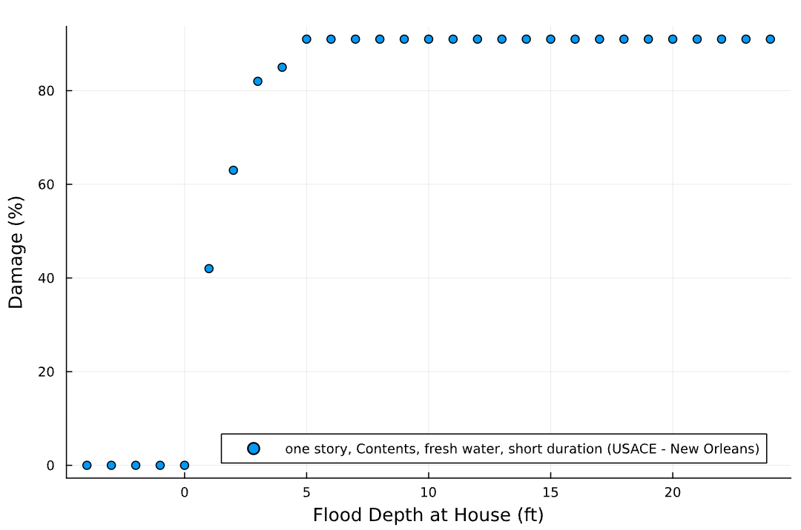
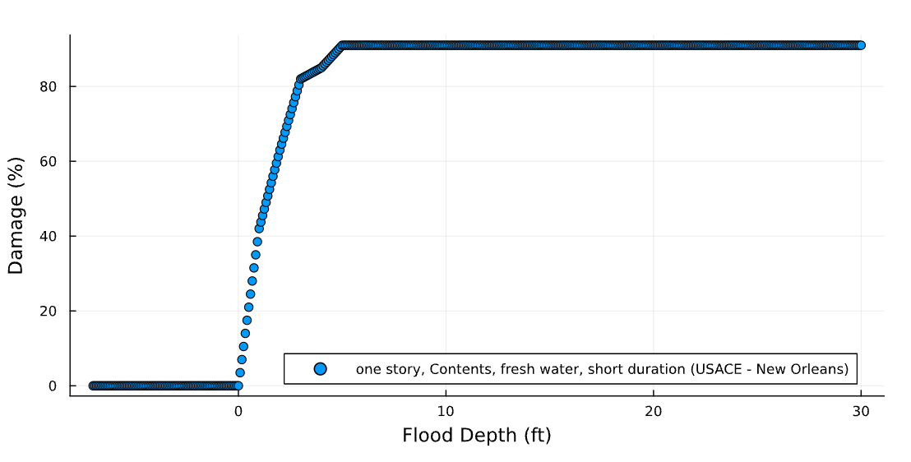
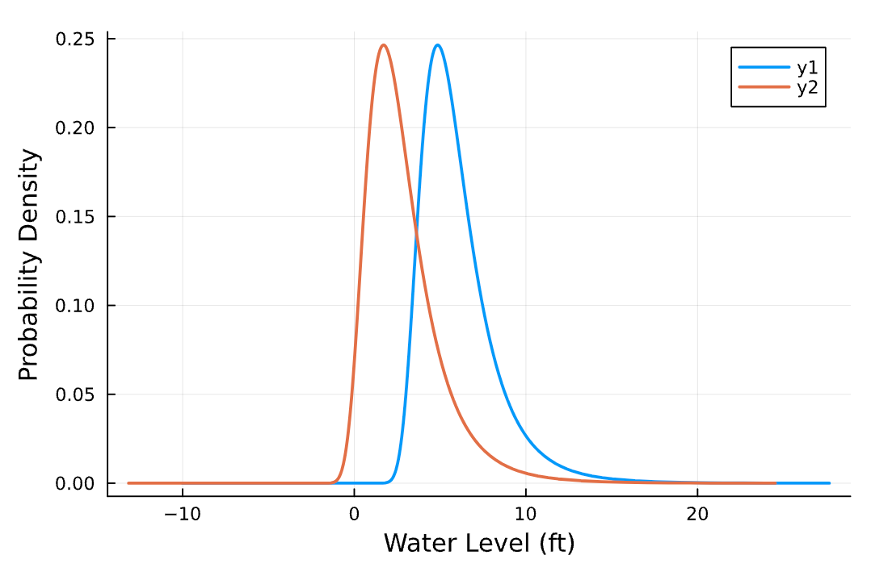

The result will be 64.712%

