Lab 5: Sea-Level Rise

Jonathan Gan wg18

Fri., Feb. 16

# Setup

## The usual

As always:

1. Clone the lab repository to your computer
2. Open the lab repository in VS Code
3. Open the Julia REPL and activate, then instantiate, the lab environment
4. Make sure you can render: quarto render template.qmd in the terminal.
   * If you run into issues, try running ] build IJulia in the Julia REPL (] enters the package manager).
   * If you still have issues, try opening up blankfile.py. That should trigger VS Code to give you the option to install the Python extension, which you should do. Then you should be able to open a menu in the bottom right of your screen to select which Python installation you want VS Code to use.

## Load packages

using CSV  
using DataFrames  
using DataFramesMeta  
using Distributions  
using Plots  
using StatsPlots  
using Unitful  
  
Plots.default(; margin=5Plots.mm)

## Local package

using Revise  
using HouseElevation

## House

house = let  
 haz_fl_dept = CSV.read("data/haz_fl_dept.csv", DataFrame) # read in the file  
 id = 140  
 row = @rsubset(haz_fl_dept, :DmgFnId == id)[1, :] # select the row I want  
 area = 1200u"ft^2"  
 height_above_gauge = 2u"ft"  
 House(  
 row;  
 area=area,  
 height_above_gauge=height_above_gauge,  
 value_usd=400_000,  
 )  
end

House{Int64}(1200, 400000, 2, DepthDamageFunction{Interpolations.Extrapolation{Float64, 1, Interpolations.GriddedInterpolation{Float64, 1, Vector{Float64}, Interpolations.Gridded{Interpolations.Linear{Interpolations.Throw{Interpolations.OnGrid}}}, Tuple{Vector{Float64}}}, Interpolations.Gridded{Interpolations.Linear{Interpolations.Throw{Interpolations.OnGrid}}}, Interpolations.Flat{Nothing}}}(29-element extrapolate(interpolate((::Vector{Float64},), ::Vector{Float64}, Gridded(Linear())), Flat()) with element type Float64:  
 0.0  
 0.0  
 0.0  
 0.0  
 5.0  
 21.0  
 27.0  
 31.0  
 34.0  
 37.0  
 39.0  
 40.0  
 40.0  
 ⋮  
 52.0  
 55.0  
 58.0  
 60.0  
 62.0  
 65.0  
 67.0  
 69.0  
 71.0  
 73.0  
 75.0  
 77.0), String7("RES1"), "140", String31("USACE - Galveston"), "two story, no basement, Structure", "missing")

I obtained the house value and area from Zillow, where a 1500sqft house in the vicinity of the gauge had a value of approximately $400k. I used a depth damage function from the USACE Galveston data set to ensure that the function would be most appropriate for the locality that my chosen house is located in, and the structure of the house also matches the description of the depth damage function (two stories, no basement).

## Depth Damage Curve

let  
 depths = uconvert.(u"ft", (-7.0u"ft"):(1.0u"inch"):(30.0u"ft"))  
 damages = house.ddf.(depths) ./ 100  
 damages_1000_usd = damages .* house.value_usd ./ 1000  
 scatter(  
 depths,  
 damages_1000_usd;  
 xlabel="Flood Depth",  
 ylabel="Damage (Thousand USD)",  
 label="$(house.description)\n($(house.source))",  
 legend=:bottomright,  
 size=(800, 400),  
 yformatter=:plain, # prevents scientific notation  
 )  
end

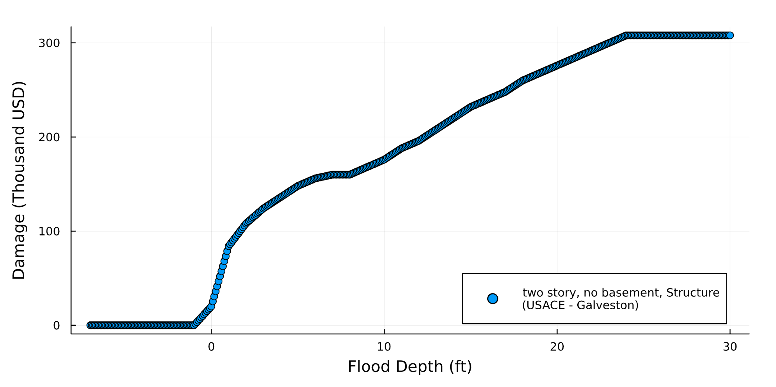

## Elevation Cost

let  
 elevations = 0u"ft":0.25u"ft":14u"ft"  
 costs = [elevation_cost(house, eᵢ) for eᵢ in elevations]  
 scatter(  
 elevations,  
 costs ./ 1_000;  
 xlabel="Elevation",  
 ylabel="Cost (Thousand USD)",  
 label="$(house.description)\n($(house.source))",  
 legend=:bottomright,  
 size=(800, 400),  
 yformatter=:plain, # prevents scientific notation  
 )  
   
end

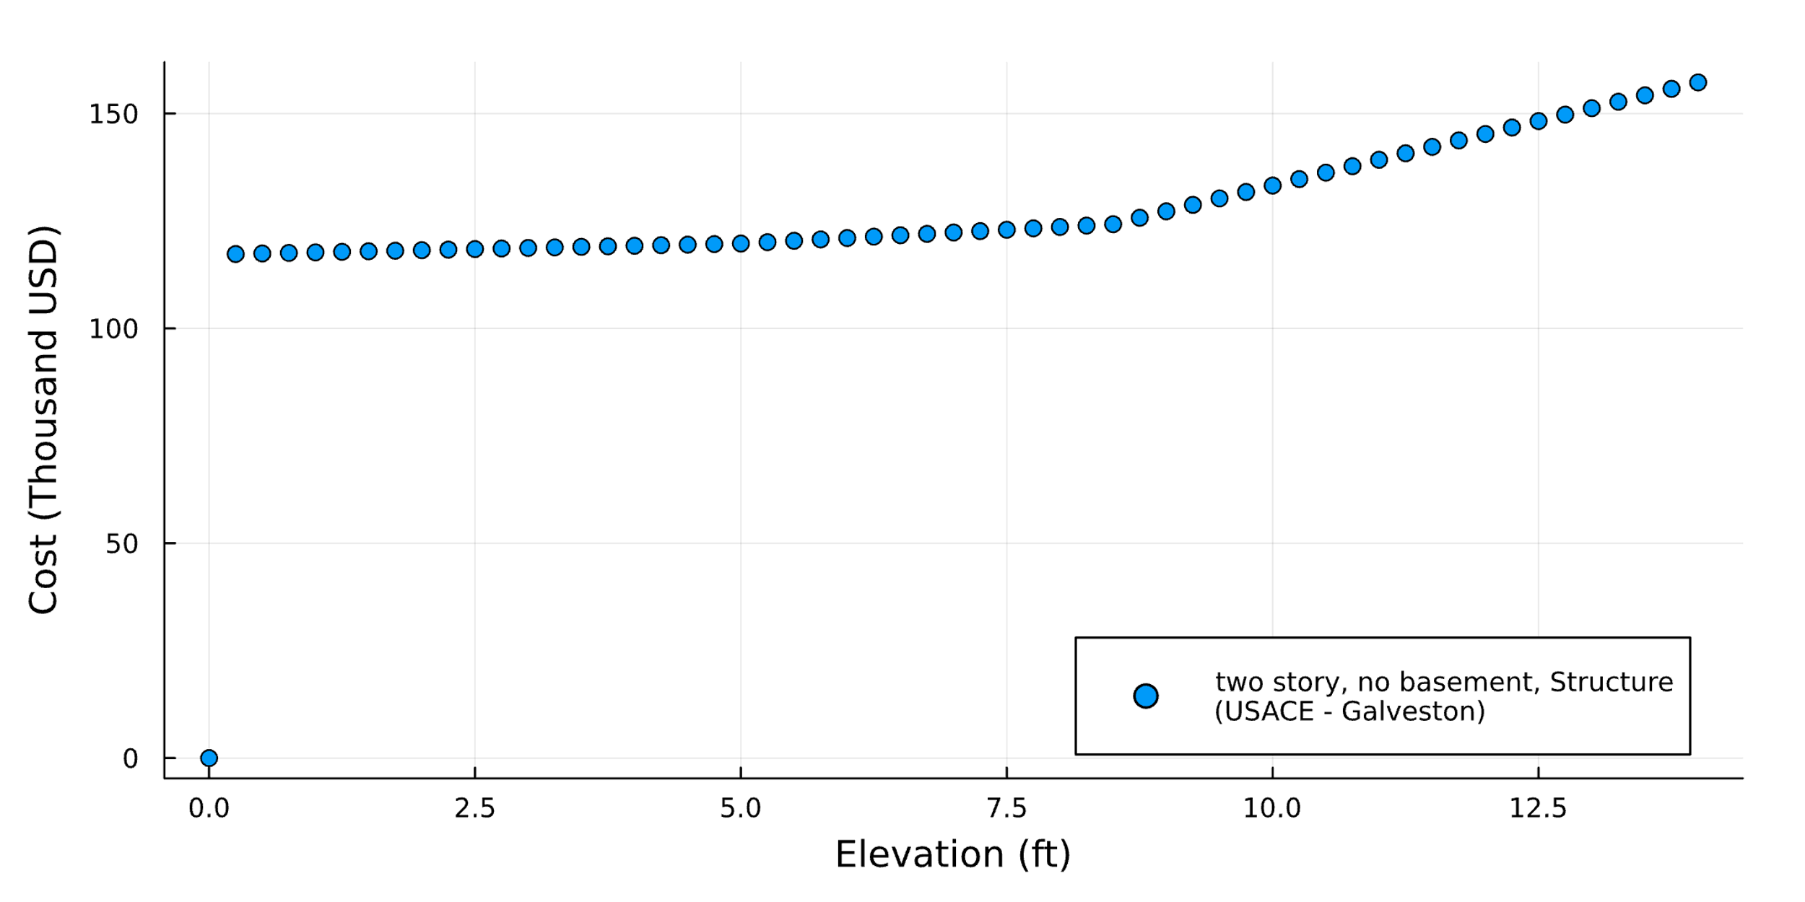

## Sea Level Data

slr_scenarios = let  
 df = CSV.read("data/slr_oddo.csv", DataFrame)  
 [Oddo17SLR(a, b, c, tstar, cstar) for (a, b, c, tstar, cstar) in eachrow(df)]  
end  
println("There are $(length(slr_scenarios)) parameter sets")

There are 34895 parameter sets

## Storm Surge and Discount Rate

function draw_surge_distribution()  
 μ = rand(Normal(5, 1))  
 σ = rand(Exponential(1.5))  
 ξ = rand(Normal(0.1, 0.05))  
 GeneralizedExtremeValue(μ, σ, ξ)  
end  
  
[draw_surge_distribution() for _ in 1:1000]  
  
function draw_discount_rate()  
 return rand(Normal(0.04, 0.02))  
end

draw_discount_rate (generic function with 1 method)

## Single simulation

p = ModelParams(  
 house=house,  
 years=2024:2100  
)  
  
sow = SOW(  
 rand(slr_scenarios),  
 draw_surge_distribution(),  
 draw_discount_rate()  
)  
  
a = Action(5.0u"ft")  
  
res = run_sim(a, sow, p)

-203908.2058666424

## Large simulations

sows = [SOW(rand(slr_scenarios), draw_surge_distribution(), draw_discount_rate()) for _ in 1:11]   
range = 0u"ft":1u"ft":10u"ft"  
actions = [Action(height) for height in range]   
results = [run_sim(a, s, p) for (a, s) in zip(actions, sows)]  
  
df = DataFrame(  
 npv=results,  
 Δh_ft=[a.Δh_ft for a in actions],  
 slr_a=[s.slr.a for s in sows],  
 slr_b=[s.slr.b for s in sows],  
 slr_c=[s.slr.c for s in sows],  
 slr_tstar=[s.slr.tstar for s in sows],  
 slr_cstar=[s.slr.cstar for s in sows],  
 surge_μ=[s.surge_dist.μ for s in sows],  
 surge_σ=[s.surge_dist.σ for s in sows],  
 surge_ξ=[s.surge_dist.ξ for s in sows],  
 discount_rate=[s.discount_rate for s in sows],  
)

I chose to sample a range of actions from 0ft to 10ft to determine the elevation at which would bring the greatest benefit to the house.

## Analysis

From my analysis, it appears that there is no noticable correlation between the height of elevating my house to gaining benefit. In fact, all the NPVs that I’ve calculated are negative. However, it seems that elevating the house to 9 feet is the best case scenario with an NPV of -127245, and the worst case scenario is elevating the house to 6 feet.

The most important parameters other than the height of elevating our houses is the distribution of storm surges. With this model, it is not very sophisticated and we’re just using standard distributions to attempt to model a typical storm surge without accounting for the actual weather and storm conditions at our house location.

If I had unlimited computing power, I would try to run more simulations, but not before refining the model to include better distributions of storm surges and discount rates to ensure that the distributions that are used can accurately depict conditions at my chosen house.

These results, particularly in my case of having negative NPVs, suggest that sometimes inaction might make the mose sense on the individual level, since it would not make financial sense to spend money on elevating houses that are already at high risk of being damaged by future storm surges due to their location and geography. Rather, we should explore developing zoning policies and making choices that would have us build in locations that do not have these weather risks, and thus we are able to build cities that would become more resillient to climate change.