|  |
| --- |
| Project Name : BearDboys |
| March 16,2023 |

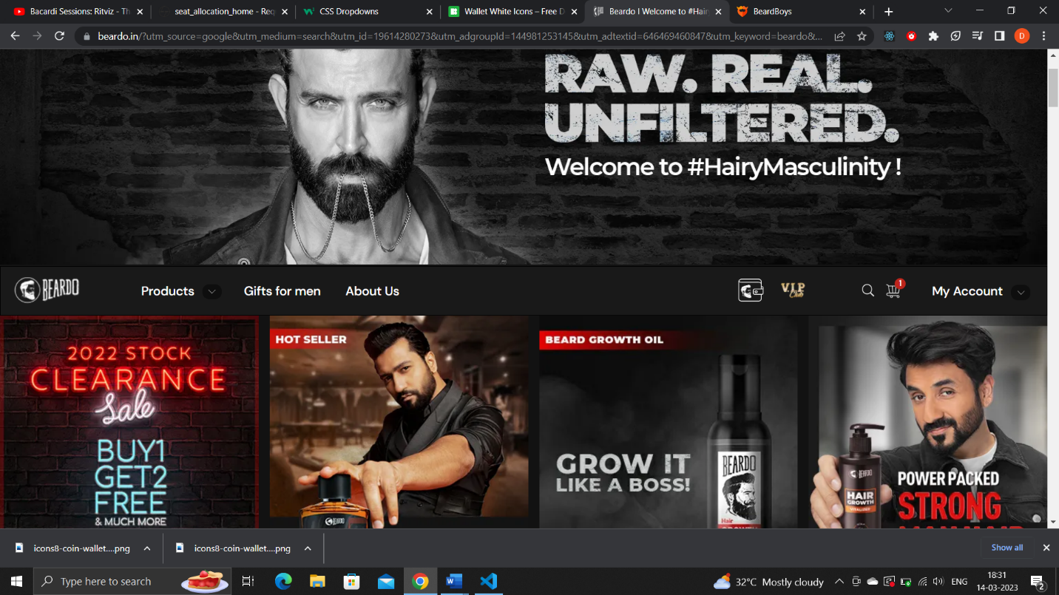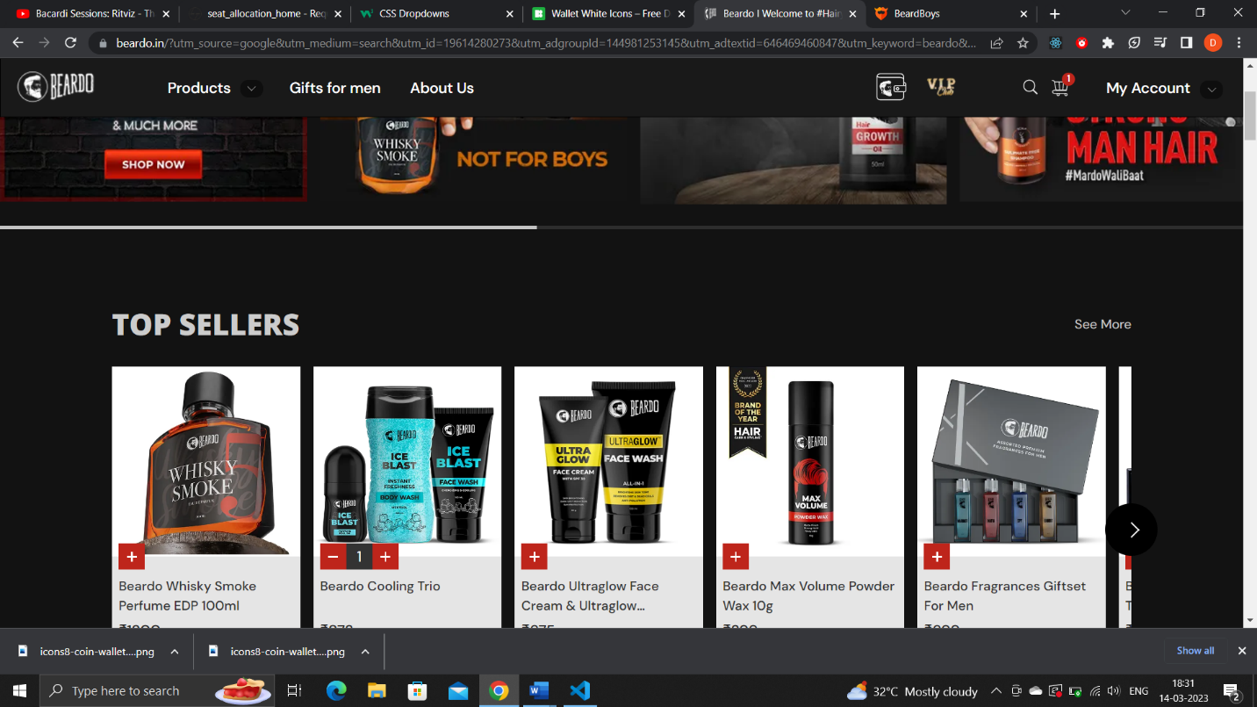

# Overview

## Project background and description

|  |  |
| --- | --- |
| Badge Tick1 with solid fill | BeardBoys website is a platform designed to provide products related to men's facial hair care. This website typically cater to men who are looking to grow, maintain, and style their beards. In addition to that it is an online store where visitors can purchase body care products, perfumes, waxes, and tshirt (merchandises). A well-designed beard website can be an excellent resource for men looking to improve their facial hair grooming game. |

## Home Page Navigation Bar

* Logo
* Products Dropdown (Beards,Face,Body)
* Gift for Men
* About Us
* Wallet
* Cart
* Account Signup/Login

## Image Slider Top Seller Advertisement Trending Products Category Wise Products Most Searched Footer

|  |  |
| --- | --- |
|  |  |

## Gift For Men Page

Customized page for gift packs of men’s grooming kit

## Account Signup/Login Page

|  |  |
| --- | --- |
|  | * E-mail Address * D.O.B * Username * Password |

## Cart PopUp

* Products and quantity
* Cart Value
* Checkout

## Payment Page

|  |  |
| --- | --- |
|  | * Address Selection * Order Summary * Payment Method( UPI, COD, Credit/Debit Card) |