**Task 1.1**

1. **Read your brief form PDF and create a sample timeline for achieving key project milestones with a deadline of X weeks (your personal goal for completing the Achievement). You can use the template attached or a project management tool of your choice.**
2. **Reflect on what challenges you might encounter while working on this project as a freelancer.**
   * **What are the pros and cons of working on your own timeline?**
   * **What strategies will you use to hold yourself accountable?**
   * **Write 150 to 200 words about your thoughts on this Exercise’s content in a text document.**

**What are the pros and cons of working on your own timeline?**

**Pros**:

**Flexibility:** Working on your own timeline provides significant advantages in terms of flexibility. You have the freedom to choose when to work, allowing you to accommodate personal commitments, family time, or other activities without strict adherence to fixed working hours.

**Work-Life Balance:** Having control over your own timeline allows you to create a better work-life balance. You can structure your day according to your preferences and needs, leading to increased job satisfaction and overall well-being.

**Productivity:** Some individuals find that they are more productive when working on their own timeline. They can align their work hours with their peak productivity periods, leading to better concentration and higher quality results.

**Creativity:** Working on your own timeline can enhance creativity and innovation. You can take breaks whenever necessary to clear your mind or find inspiration, which can lead to more creative problem-solving and ideation.

**Autonomy:** The sense of autonomy and empowerment that comes with setting your own timeline can be highly motivating. You have the freedom to make decisions and take ownership of your work, leading to a greater sense of responsibility and satisfaction.

**Reduced Commuting:** For remote workers or freelancers, working on your own timeline eliminates the need for daily commuting. This not only saves time but also reduces stress associated with travel and traffic.

**Cons:**

**Self-Discipline:** Working on your own timeline requires a high level of self-discipline. Without external oversight or a fixed schedule, it's easy to get distracted or procrastinate, potentially leading to missed deadlines and reduced productivity.

**Isolation:** Independent work, especially if done from home, can be isolating. The lack of regular social interaction and collaboration with colleagues may lead to feelings of loneliness or disconnection.

**Time Management Challenges:** Setting your own schedule can be challenging for individuals who struggle with time management. Without external structure, it's essential to prioritize tasks effectively to ensure timely completion.

**Inconsistent Income:** For freelancers and self-employed individuals, income can be unpredictable. Earnings may vary from month to month depending on the amount of work available, leading to financial uncertainty.

**Difficulty Disconnecting:** Working on your own timeline may make it challenging to establish clear boundaries between work and personal life. As a result, you may find yourself working longer hours and having difficulty disconnecting from work-related tasks during personal time.

**Limited Support:** Independent work may lack the support and resources available in a traditional workplace. For example, you may not have access to IT support, HR assistance, or professional development opportunities typically offered in a company setting.

**What strategies will you use to hold yourself accountable?**

Accountabliltiy is crucial for maintaining productivity and achieving goals, particularly when working on a self-determined timeline. Here are several strategies that I would employ to stay accountable:

**Clear and Specific Goals:** Define clear, specific, and achievable goals. Using the SMART criteria (Specific, Measurable, Achievable, Relevant, Time-bound) ensures that my goals are well-defined and measurable.

**Action Plan:** Create a detailed action plan with specific steps and deadlines for each task. Breaking down larger goals into smaller actionable items makes them more manageable.

**Task Tracking:** Use tools like task management apps or project boards to track progress on each task. Regularly updating the status of completed tasks helps to visualize progress.

**Deadline Reminders:** Set reminders for important deadlines to avoid any last-minute rush and to stay on top of time-sensitive tasks.

**Time Management:** Allocate specific time slots for each task and prioritize them based on their importance and urgency. Time blocking can help in maintaining focus and preventing time wastage.

**Review and Adjust:** Regularly review progress against the set timelines and goals. If needed, adjust the plan based on any unforeseen challenges or changes in priorities.

**Accountability Partner:** Share my goals and progress with a trusted friend, family member, or mentor who can provide encouragement and hold me accountable.

**Reward System:** Establish a reward system for achieving milestones. Celebrating small victories can boost motivation and reinforce positive behavior.

**Reflect and Learn:** Take time to reflect on both successes and setbacks. Learning from mistakes and making improvements ensures continued growth.

**Maintain Focus:** Avoid multitasking and stay focused on one task at a time. Concentrated effort on individual tasks improves efficiency and quality of work.

**Self-Motivation Techniques:** Use motivational techniques like positive affirmations or visualization to stay focused and enthusiastic about the project.

**Learn to Say No:** Be realistic about the number of commitments and projects I can take on. Learning to say no to additional tasks helps in avoiding overwhelm and maintaining quality.

**Breaks and Self-Care:** Schedule regular breaks and prioritize self-care. Taking care of physical and mental well-being is crucial for sustained productivity.

**Continuous Improvement:** Regularly seek feedback from others and seek opportunities for skill development and growth.

By employing these strategies, I can effectively hold myself accountable and stay on track to achieve my goals within the set timeline.

**Write 150 to 200 words about your thoughts on this Exercise’s content in a text document.**

The exercise content offers a diverse and engaging set of tasks designed to enhance proficiency in data analysis, data scraping, and natural language processing. Each task is thoughtfully structured to address specific aspects of the data science workflow.

**Task 2** guides learners through setting up a GitHub profile, managing repositories, and using version control with notebooks—a fundamental skill for collaborative coding.

**Task 3** introduces the concept of virtual environments and demonstrates how to activate and utilize them effectively. Installing libraries and performing data manipulation in JupyterLab notebooks further solidifies these skills.

**Task 4** explores web scraping to collect data from web pages, teaching learners how to save and manage information from online sources efficiently.

**Task 5** delves into text analysis using NLP techniques such as tokenization, sentiment analysis, and part-of-speech tagging. These skills are invaluable for processing and extracting insights from unstructured text data.

**Task 6** takes learners to a more advanced level by introducing Named Entity Recognition (NER) and relationship extraction, paving the way for understanding complex relationships within the data.

**Task 7** focuses on network analysis, empowering learners to build and analyze networks based on country relationships. The application of the Leiden algorithm for community detection adds depth to the exploration.

Overall, the exercise content is well-rounded and engaging, providing hands-on experience in diverse areas of data science. By completing these tasks, learners will gain practical knowledge and expertise that can be applied to real-world data analysis projects, enhancing their problem-solving abilities and analytical skills. The bonus tasks offer an extra challenge, encouraging learners to go beyond the basics and explore additional concepts, making this exercise an enriching and rewarding learning journey.

1. **Install JupyterLab and explore its functionalities. Reflect on what you notice in terms of differences (good or bad) compared to Jupyter Notebook. Take a screenshot of a JupyterLab session and paste it into your text document.**

**JupyterLab**

JupyterLab is an open-source web-based interactive development environment (IDE) designed for data science, scientific computing, and general-purpose programming. It provides an intuitive and flexible user interface for creating, editing, and executing code, as well as visualizing and analysing data.

**Jupyter Notebook**

Jupyter Notebook is an open-source web application that allows you to create and share documents called notebooks. It provides an interactive computing environment that combines code, text, visualizations, and other media into a single document.

**Advantages of JupyterLab:**

**Integrated Environment:** JupyterLab offers a comprehensive integrated development environment with a multi-tab interface, allowing users to work with various components within a single window.

**Flexible Layout:** Users can customize the layout and arrange components like notebooks, code editors, and terminals according to their preferences, providing a more personalized working environment.

**Enhanced Text Editing:** JupyterLab provides robust text editing features such as syntax highlighting, code linting, and auto-completion, enhancing the coding experience.

**Native Jupyter Notebook Support:** JupyterLab seamlessly supports Jupyter Notebook files (.ipynb) and provides a notebook interface within the IDE, making it easy to work with existing notebooks.

**Extension Ecosystem:** JupyterLab has a wide range of extensions available, expanding its capabilities by adding features like version control, interactive visualizations, and support for additional programming languages.

**Disadvantages of JupyterLab:**

**Learning Curve:** JupyterLab's more complex interface may require some time for users to get familiar with its features and customization options, especially for those transitioning from Jupyter Notebook.

**Resource Intensive:** Due to its additional features and flexibility, JupyterLab may require more system resources compared to the simpler Jupyter Notebook, potentially posing a challenge in resource-constrained environments.

**Less Streamlined for Simplicity:** Some users may find JupyterLab's multiple components and layout options more complicated, especially if they prefer a more streamlined and minimalistic experience.

**Overall Assessment:**

JupyterLab is an ideal choice for users who require advanced functionality, customization options, and a highly integrated development experience. It offers an extensive ecosystem of extensions, making it versatile for a wide range of tasks. However, users should be prepared for a steeper learning curve and the potential for increased resource consumption.

On the other hand, Jupyter Notebook is more straightforward and lightweight, making it preferable for users who prioritize simplicity and quick setup. It remains a popular choice for beginners and those working on simpler projects.

**Screenshot for Jupyter Lab Session**

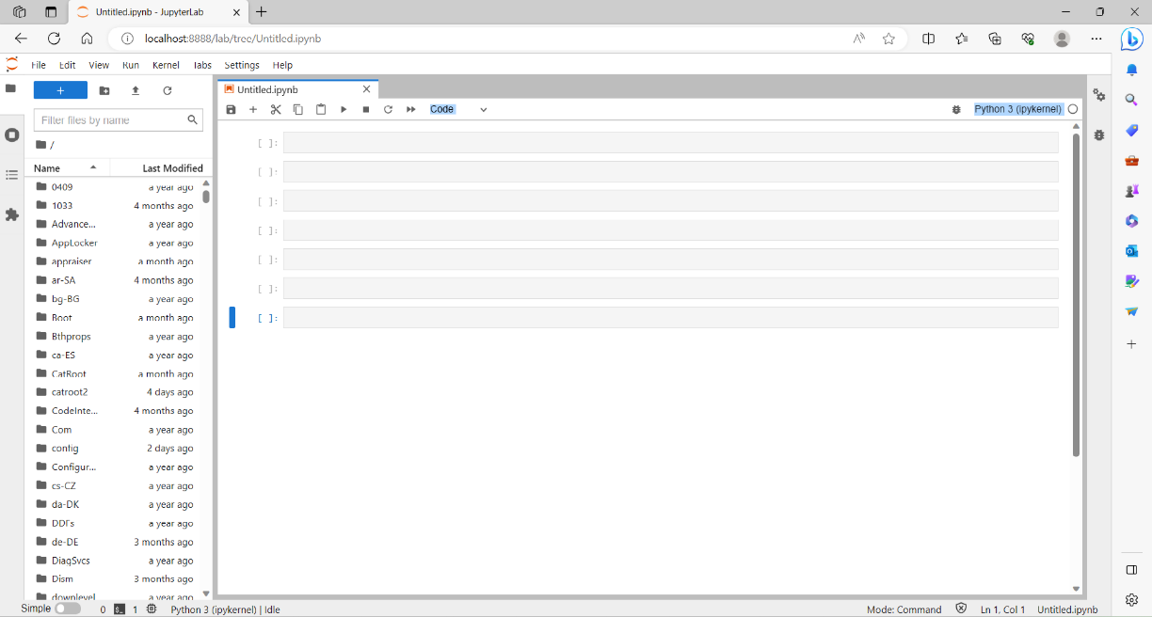

1. **Get started with Google Colab and try executing some basic code, for example, some basic addition and division between numbers. Take a screenshot of the notebook and paste it into your text document.**

**Screenshot for Google Colab Session with basic code for addition and division**

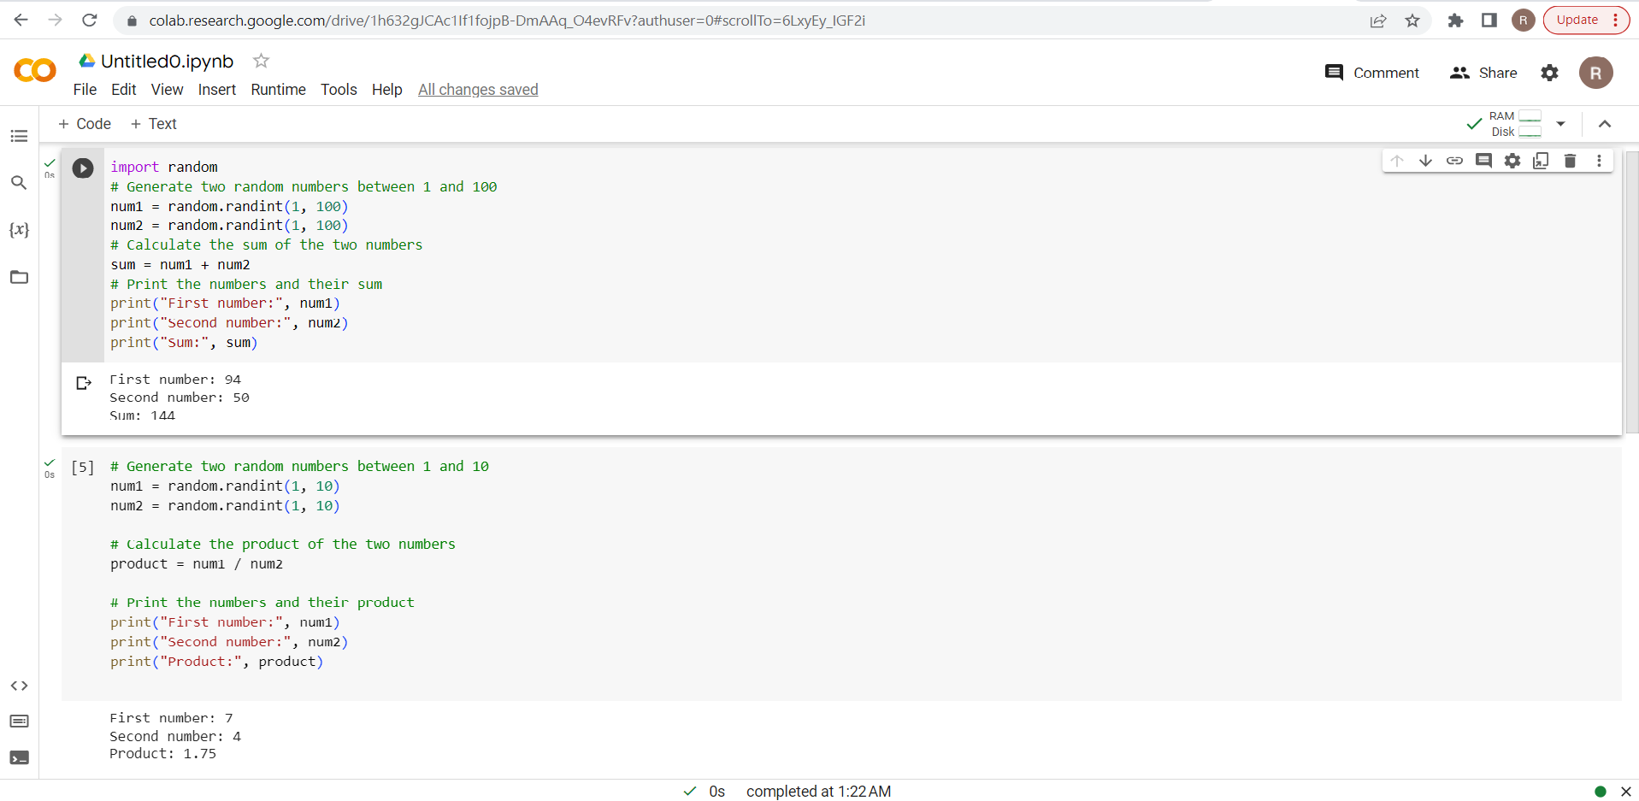

1. **Write 150 to 200 words about the pros and cons of using JupyterLab and Google Colab in your text document. Create a scenario where you think JupyterLab would be the best tool to use, then do the same for Google Colab.**

**JupyterLab**:

**Pros**:

**Flexibility and Customization**: JupyterLab provides a highly flexible and customizable interface, allowing users to arrange and organize components according to their preferences and workflows.

**Extensive Ecosystem**: JupyterLab has a vast ecosystem of extensions that enhance its functionality. Users can easily add features like version control, interactive visualizations, and more.

**Notebook Compatibility**: JupyterLab seamlessly supports Jupyter Notebook files (.ipynb), enabling users to work with existing notebooks and leverage the interactive and narrative-driven nature of Jupyter notebooks.

**Rich Text Editing**: JupyterLab offers enhanced text editing capabilities with features like syntax highlighting, code linting, and auto-completion, enhancing the code writing and editing experience.

**Cons**:

**Learning Curve**: JupyterLab's extensive features and customization options may require some time to fully grasp, making the initial learning curve steeper for new users.

**Resource Intensive**: The additional features and flexibility of JupyterLab may require more system resources compared to simpler tools, which can be a concern for resource-constrained environments.

**Complexity for Simplicity**: JupyterLab's interface, with multiple components and layout options, may introduce additional complexity, potentially overwhelming users who prefer a more streamlined and minimalistic experience.

**Google Colab**:

**Pros**:

**Cloud-based and Collaboration-friendly**: Google Colab is cloud-based and enables seamless collaboration by allowing multiple users to work on the same notebook simultaneously.

**Integrated Environment**: Colab provides an integrated environment with pre-installed libraries and packages, reducing the need for local setup and configuration.

**Easy Access to Resources**: Colab offers easy access to various resources, including datasets, machine learning libraries, and GPU/TPU accelerators, making it convenient for data science and machine learning tasks.

**Google Drive Integration**: Colab integrates with Google Drive, allowing users to easily import and export data, notebooks, and other files.

**Cons**:

**Internet Dependency**: Colab requires an internet connection to access and use the platform, which may limit its usability in offline scenarios.

**Limited Customization**: Compared to JupyterLab, Colab has limited customization options, limiting users' ability to tailor the interface to their specific needs.

**Resource Constraints**: Colab may have limitations on computational resources, including runtime session duration and GPU availability, which can impact resource-intensive tasks.

In conclusion, JupyterLab and Google Colab both have their strengths and weaknesses. JupyterLab offers extensive customization, notebook compatibility, and rich text editing, while Google Colab provides cloud-based collaboration, integrated environment, and easy access to resources. The choice between them depends on individual needs, preferences, and specific use cases.

**Scenario: Exploratory Data Analysis and Machine Learning Model Development**

Let's consider a scenario where a data scientist is working on exploratory data analysis and developing a machine learning model. In this scenario, JupyterLab would be an excellent tool to use due to its flexibility, interactive environment, and rich capabilities for data analysis and model development.

**Data Exploration**: JupyterLab's ability to combine code, visualizations, and explanatory text in notebooks makes it ideal for exploring and analysing datasets. With JupyterLab, the data scientist can use Python libraries like Pandas, NumPy, and Matplotlib to load, clean, and visualize the data. They can document their analysis steps, create interactive plots, and iterate on data transformations, all within the notebook environment.

**Model Development**: JupyterLab provides an interactive and iterative environment for developing machine learning models. Using libraries like scikit-learn, TensorFlow, or PyTorch, the data scientist can write and execute code in notebook cells, experiment with different algorithms and model configurations, and evaluate model performance. JupyterLab's ability to display rich visualizations directly within the notebook facilitates model interpretation and analysis.

**Collaboration and Documentation**: JupyterLab's notebook format allows the data scientist to document their analysis process, including code, visualizations, and explanations. They can share the notebooks with colleagues or stakeholders, enabling collaboration, review, and reproducibility of the analysis. Notebooks can also serve as self-contained documentation, providing a clear record of the data exploration, model development, and findings.

**Extension Ecosystem**: JupyterLab's extensive extension ecosystem offers additional functionalities for data analysis and model development. Data scientists can leverage extensions like interactive widgets, version control integration, code linting, or code formatting to enhance their workflow and productivity.

In this scenario, JupyterLab's flexibility, interactivity, and ability to integrate code, visualizations, and documentation make it a powerful tool for exploratory data analysis and machine learning model development. It provides an environment that encourages experimentation, collaboration, and reproducibility, enabling data scientists to efficiently explore, analyze, and develop models on a single platform.

**Scenario: Collaborative Machine Learning Project**

Let's consider a scenario where a team of data scientists and machine learning engineers is working on a collaborative machine learning project. In this scenario, Google Colab would be the best tool to use due to its cloud-based nature, collaboration features, and easy access to resources.

**Cloud-Based Collaboration**: Google Colab allows team members to work on the same notebook simultaneously, making it ideal for collaborative projects. Multiple team members can edit and run code cells, share insights, and collaborate in real-time, enhancing teamwork and productivity.

**Integrated Environment**: Google Colab provides an integrated environment with pre-installed libraries and packages, eliminating the need for local setup and configuration. The team members can start working immediately, focusing on developing and fine-tuning machine learning models without spending time on environment setup.

**Easy Resource Access**: Google Colab offers easy access to resources required for machine learning tasks. It provides built-in support for popular machine learning frameworks like TensorFlow and PyTorch, along with GPU and TPU accelerators. The team members can leverage these resources without worrying about hardware setup or maintenance, enabling faster experimentation and model training.

**Google Drive Integration**: Colab seamlessly integrates with Google Drive, allowing team members to import and export data, notebooks, and other files. The integration makes it convenient to share and collaborate on datasets, trained models, and project artifacts.

**Notebook Publishing and Sharing**: Google Colab provides the ability to publish notebooks, allowing team members to share their work with stakeholders or the wider community. The published notebooks can be accessed and run by others, enabling easy dissemination of project findings, experiments, and model results.

**Easy Deployment**: Google Colab facilitates the deployment of machine learning models through its integration with other Google Cloud services. The team members can export trained models from Colab and deploy them on services like Google Cloud AI Platform or Google Kubernetes Engine, ensuring seamless transition from development to production.

In this collaborative machine learning project scenario, Google Colab's cloud-based nature, collaboration features, and easy resource access make it an excellent tool. It allows team members to collaborate, leverage pre-installed libraries and resources, and easily share their work. With Google Colab, the team can streamline their workflow, accelerate development, and effectively work together on machine learning projects.