**Task 1.2**

1. **If you haven’t already, install Git on your computer.**
2. **Create a repo in GitHub called “20th century”.**
3. **Clone this remote repo to your local machine.**
4. **Run git status to make sure everything is going well. Take a screenshot of the result and add it to a word processing document.**

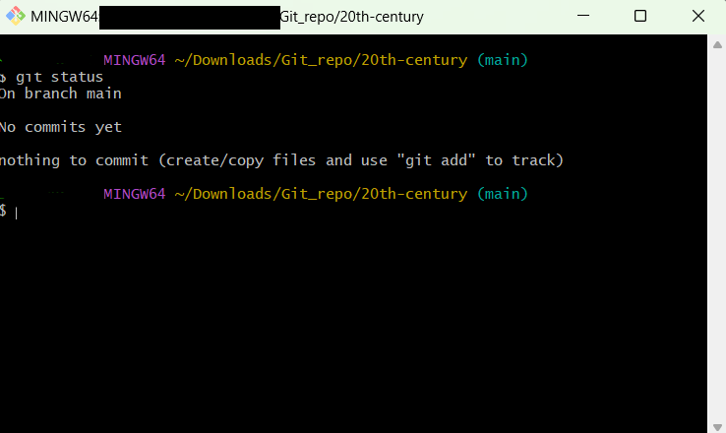

1. **Set up an SSH key and share a screenshot of the SSG and GPG page of your GitHub account Settings page to verify that the SSH key exists and is linked to your profile. Add this screenshot to the word processing document.**

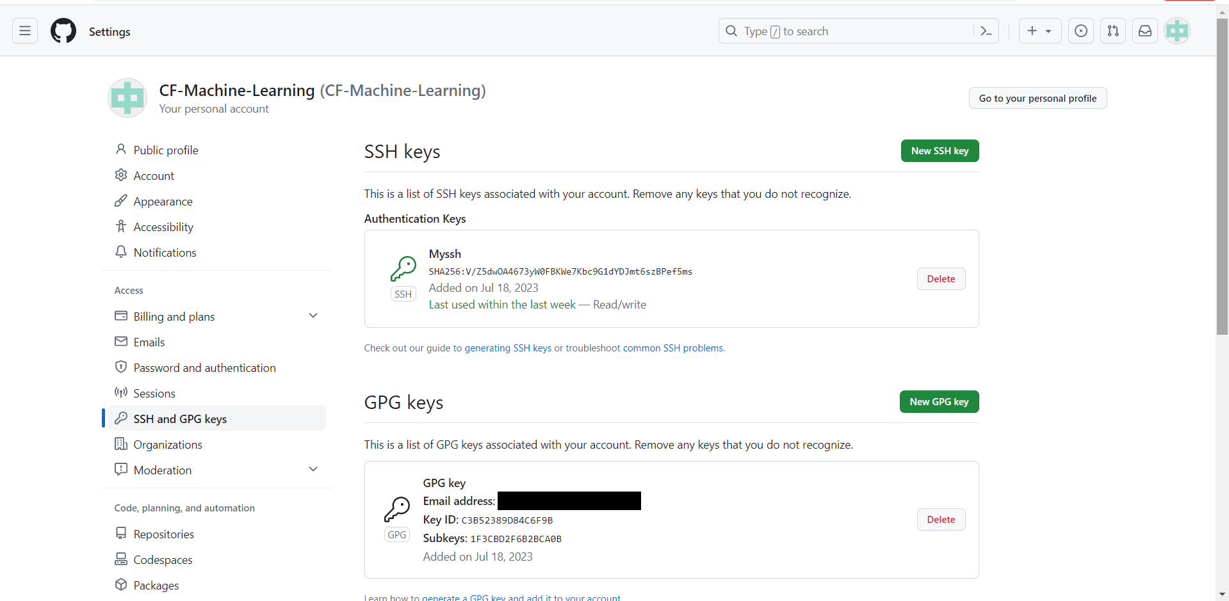

1. **Create a notebook with some text or simple code (for example, 1+1) for testing purposes and push it into the remote repo. Don’t forget to stage and commit to the local repo first! Attach a screenshot of the notebook that appeared in the GitHub remote repo to your word processing document.**

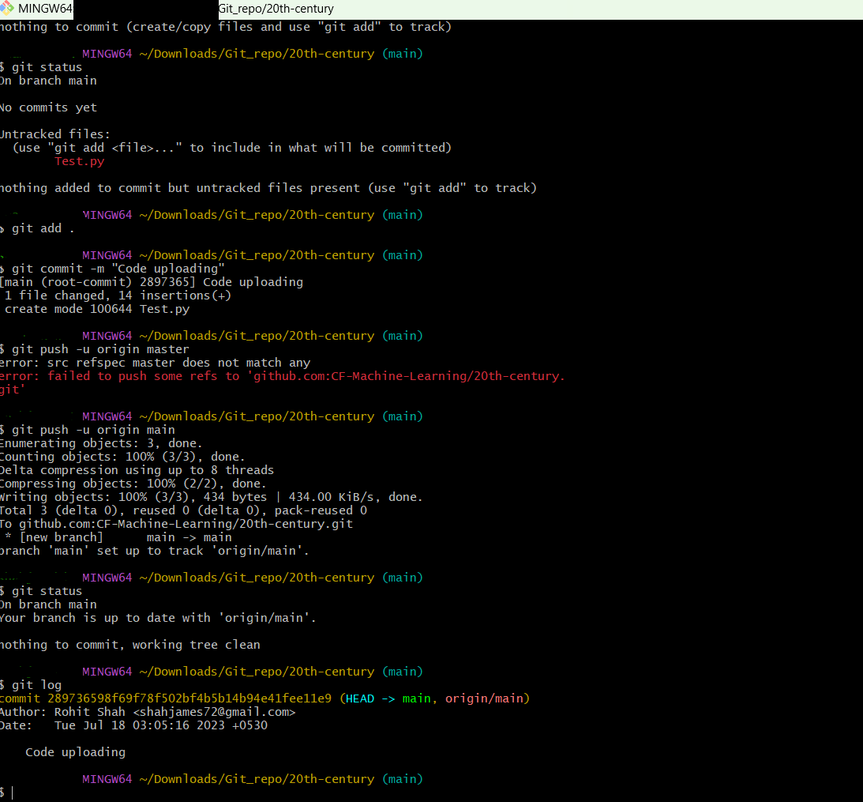

1. **In a new folder outside of the folder containing “20th century” local repo, use git init to create a new local repo called “Test” from your local machine. Create a dummy file, then push this repo to a new remote repo on GitHub. Take a screenshot of the repo on GitHub and add it to your word processing file.**

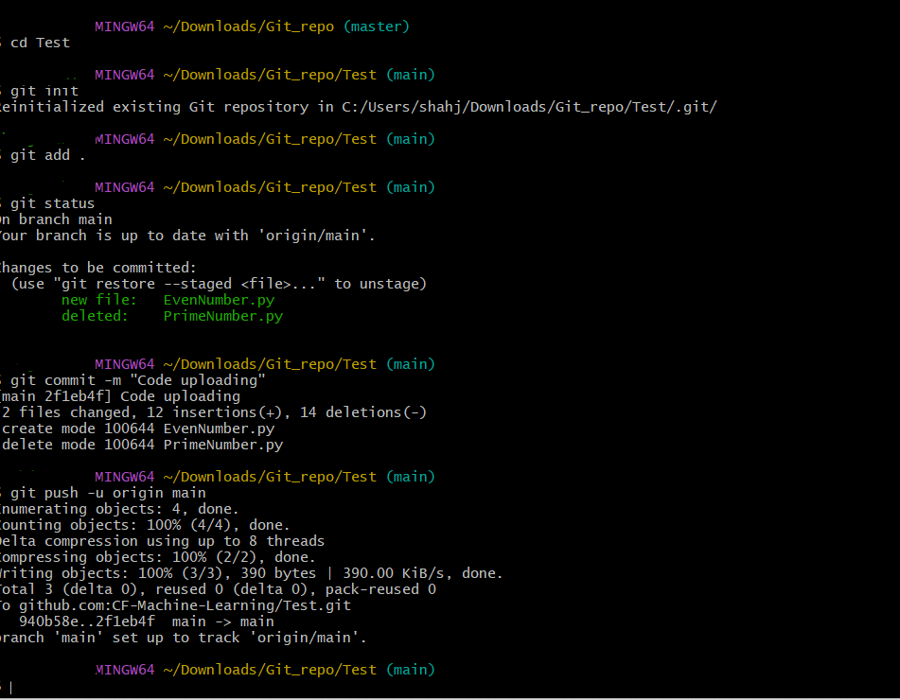

**Links for GitHub Repos:**

**20th Century:** <https://github.com/CF-Machine-Learning/20th-century>

**Test:** <https://github.com/CF-Machine-Learning/Test>