**Manual Page: lseek**

**Name:**

lseek - reposition read/write file offset

**Synopsis:**

lseek(int fd, int offset)

**Description:**

Lseek is a system call that is used to change the location of the pointer of a file descriptor. It takes a file descriptor and an integer offset as arguments. It sets the current offset of the open file to the specified offset upon success. Lseek should work with both extend-based and pointer-based files.

**Return value:**

1 - Success

-1 - Error

**Author:**

Chen En Lee

**Error:**

1.Fd not exist

2. Offset not exist

3. Offset need to be an integer or 0

4. Offset cannot be greater than the file size

**Example:**

lseek(fd, 10) - set file descriptor to offset 10

lseek(-1, 10) - error 1, Fd not exist

lseek(-1) - error 2, Offset not exist

lseek(fd, -1) - error 3, Offset need to be an integer or 0

lseek(fd, 1000) - error4, Offset cannot be greater than the file size

**Changed file**

Sysfile.c:

Get the file by using getFile method which is a modified method from argfd.

Get offset by using argint method. If offset is less than 0 or greater than the file size return -1 and print out the error message. Set the off of the file to n.

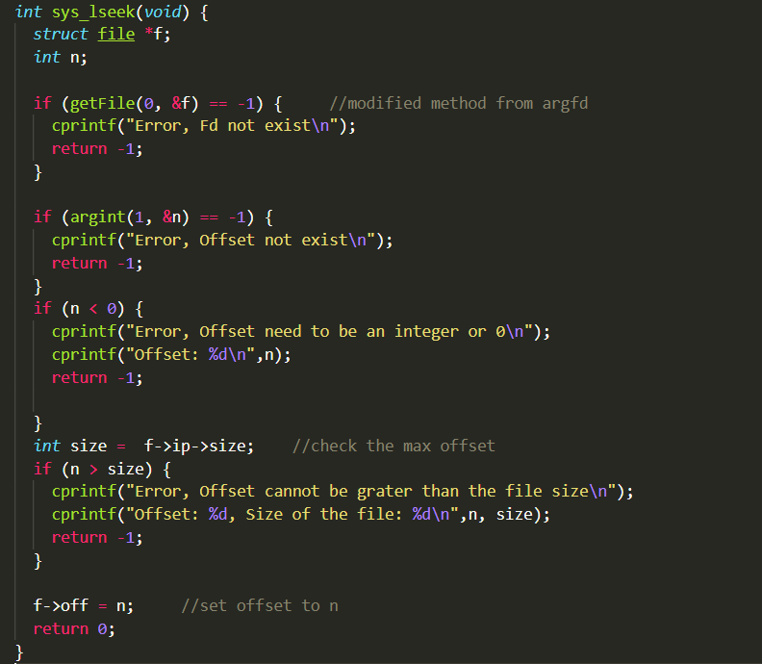

GetFile method is a modified method from argfd.

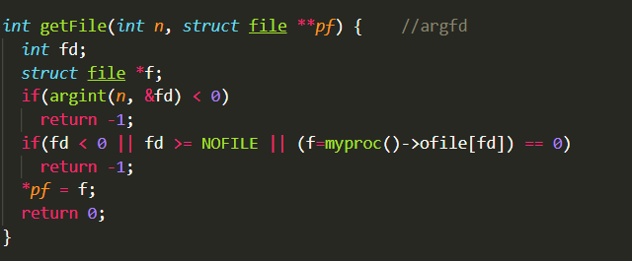

**Test Data**

To test the system call, we write a program called “lseekTest” which contains lseek system call.

First, we create two text file which contain a long string “A long string for testing the normal/extent file”. One is for normal file; another is for extent file. Then we create 8 test cases to test these files and lseek system call

**Test1: Negative offset**

Expect: Error message

**Test2: Empty file descriptor**

Expect: Error message

**Test3: A very large offset**

Expect: Error message

**Test4: Normal file/ Read**

Expect: g string for testing the normal file.

**Test5: Normal file/ Write**

Expect: A lon writingTest testing the normal file.

**Test6: Extent file/ Read**

Expect: g string for testing the extent file.

**Test7: Extent file/ Write**

Expect: A lon writingTest testing the extent file.

**Test8: fork**

Expect: child: lon parent: writingTest

**Output:**

