Module 2: Donor integration, cell-class composition, and pathway analysis
Instructional time: 45 min | Bloom: Apply, Analyze | Notebook: notebooks/02_integration_de_pathways.ipynb

1. Overview
Module 2 stays inside HuBMAP. It concatenates the four Module 1 QC objects, asks whether Harmony improves donor mixing without erasing biology, maps coarse cell_class labels, separates composition change from expression change, and runs Wilcoxon marker detection plus local gene-set enrichment (Hallmark / Reactome / GO Biological Process).
Key components. Donor concatenation and Harmony; mixing metrics; composition tables and dual pseudobulk summaries; marker DE; ORA / prerank enrichment from shipped GMT files under data/genesets/.
Learning objectives.
- Integrate multi-donor snRNA-seq and quantify whether batch correction increases foreign-donor neighborhood mixing.
- Distinguish "is this population larger?" (composition) from "are these cells different?" (markers / pathways).
- Run and read local enrichment without treating top terms as automatically true biology.
Measured peak RSS on the DE leg sets the course RAM floor: 16 GB recommended, 8 GB minimum (outputs/reports/module2_de_run_params.json).

2. Before you begin
Prerequisites. Module 1 (QC-preprocessed teaching blocks for Donor_1, Donor_2, Donor_3, Donor_4)
Time. Instructional: 45 min. Compute (measured): integration ~32 s, DE/pathways ~24 s; peak RSS ~7.6 GB on DE (16 GB recommended; 8 GB minimum).
Data required.
Run order. Run the analysis sections in order; the notebook carries state between cells.

Biological question
After QC, do the four HuBMAP lung donors form a usable joint embedding, and what cell-state and pathway differences appear across coarse lineages once donor identity is reduced?

Data used here
Input | Path pattern | Role
Module 1 QC objects | data/processed/hubmap/module1_*_qc_preprocessed.h5ad | Per-donor nuclei
Azimuth labels | cached TSV and/or remote range-read | cell_class mapping
Gene sets | data/genesets/*.gmt (~2.17 MB shipped) | Enrichment libraries
GTEx is intentionally absent until Module 4. Module 2 does not download new primary matrices beyond what Module 1 verified.
Cohort and ages are unchanged from Module 1 (Donor_1 to Donor_4). The age split remains n=2 vs n=2 illustration only.

3. Methods
Parameters below are live values under module2 in config/paths.yaml. Integration scripts are scripts/nb03_integration/; DE and enrichment are scripts/nb04_de/. Module 2 stays inside HuBMAP; GTEx is off (module2.gtex_context: false).
Each Methods step below corresponds to a numbered section of notebooks/02_integration_de_pathways.ipynb, so the document and the notebook can be read side by side:
Methods step | Notebook section
1. Load and concatenate Module 1 QC objects | 1. Load, concatenate, and compute the joint embedding
2. Joint embedding (recomputed HVG / PCA) | 1. Load, concatenate, and compute the joint embedding
3. Harmony batch correction | 2. Harmony batch correction and mixing diagnostics
4. Mixing and silhouette diagnostics | 2. Harmony batch correction and mixing diagnostics
5. Coarse cell_class mapping, composition, and pseudobulk | 3. Coarse cell_class mapping; 4. Composition, markers, and weighted pseudobulk
6. Intron exclusion on the DE path, Wilcoxon markers | 5. Differential expression and pathway enrichment
7. Local GMT enrichment (ORA and prerank) | 5. Differential expression and pathway enrichment
Where two steps share a notebook section, one call performs both. Notebook section 0 is environment setup, covered in Module 0. Notebook section 6, composition versus expression, is reported under Results below rather than as a Methods step.

1. Load and concatenate Module 1 QC objects
Script. scripts/nb03_integration/concatenate.py (load_module2_inputs, concatenate_donors); path resolve via scripts/nb02_qc/export.py (resolve_qc_h5ad).
What. Load the four Module 1 QC-preprocessed AnnData objects listed in module2.inputs (post-QC, possibly subsampled teaching objects). Ensure donor metadata (donor_id, donor_label, block_id), uniquify observation names across donors, intersect on shared genes (prefer versionless Ensembl gene_id_no_version), and concatenate with an inner join. Outer-join fill is avoided so missing genes are not invented as zeros. Intron-feature exclusion does not happen here. Salmon intron-tagged features (*-I) remain in the integrated object until the DE load path (step 6) when module2.exclude_intron_features is true.
Parameters: see Appendix, section 1.
Why. A joint embedding requires a shared feature space built from the same QC policy. Concatenating Module 1 objects (not raw portal matrices) keeps filters and the teaching subsample explicit. Using post-QC subsampled objects means Module 2 composition is not interchangeable with the Module 1 pre-QC secondary_analysis airway gate.

2. Joint embedding (recomputed HVG / PCA)
Script. scripts/nb03_integration/integrate.py (recompute_pca_umap).
What. On the concatenated object, recompute highly variable genes, scale, and PCA, then neighbors and UMAP on X_pca (pre-Harmony view). Module 1 per-donor PCA/UMAP is not reused. Teaching defaults use n_pcs=40 (not Module 1's 50) so the joint basis is defined at integration time.
Parameters: see Appendix, section 2.
Why. Joint HVG/PCA puts all donors in one feature basis before batch correction. Reusing Module 1 embeddings would mix incompatible PCA spaces and hide the integration step learners are meant to inspect.

3. Harmony batch correction
Script. scripts/nb03_integration/integrate.py (run_harmony).
What. Run harmonypy on X_pca with batch key donor_id, store corrected embedding in obsm['X_pca_harmony'], then recompute neighbors (key harmony) and UMAP (X_umap_harmony) using the same embedding neighbor/UMAP knobs. theta defaults to null (harmonypy default); max_iter_harmony=20.
Parameters: see Appendix, section 3.
Why. Donor is a technical factor in multi-donor atlases. Harmony adjusts the PCA embedding so neighborhoods mix donors while preserving local structure better than regressing donor as a linear covariate in expression space. Mixing metrics (next step) are required; a prettier UMAP is not evidence.

4. Mixing and silhouette diagnostics
Script. scripts/nb03_integration/integrate.py (harmony_mixing_metrics, harmony_silhouette_by_celltype).
What. When module2.diagnostics.enabled is true, score mean foreign-donor kNN fraction on X_pca versus X_pca_harmony (k=knn_k, optional subsample to max_cells), and donor silhouette within coarse cell_class. These are learner diagnostics, not gates that block DE.
Parameters: see Appendix, section 4.
Why. Foreign-donor kNN rising after Harmony is the quantitative mixing claim. Within-class donor silhouette becoming more negative usually agrees. Read both with marker coherence so overmixing is visible.

5. Coarse cell_class mapping, composition, and pseudobulk
Script. scripts/nb03_integration/integrate.py (assign_coarse_cell_class, assert_azimuth_mapping_coverage, donor_composition, cell_class_membership_frame); scripts/nb03_integration/compare.py (composition_weighted_pseudobulk, max_across_labels_pseudobulk, label_fractions); export in scripts/nb03_integration/export.py.
What. Map Azimuth fine labels to exactly four coarse buckets: epithelial, endothelial, stromal, immune. Airway secretory and gland labels (Club, Goblet, SMG, Deuterosomal, transitional Club-AT2, Tuft, and related) fold into epithelial. There is no fifth coarse airway class. Both Unicode and ASCII macrophage keys map to immune (Azimuth Monocyte-derived M + Greek phi, and ASCII Monocyte-derived Mphi; likewise interstitial macrophage variants with phi / Mphi). Unmapped labels are listed loudly and never silently bucketed; unlabeled nuclei are dropped before DE group sizes are quoted.
Build donor-by-label crosstabs and cell-type fractions on the post-QC subsampled integrated object. When module2.export_pseudobulk is true, export composition-weighted and max-across-labels linear-scale pseudobulk vectors for Module 4's HuBMAP-GTEx bridge (plus fractions).
Parameters: see Appendix, section 5.
Why. Four-bucket labels keep classroom DE interpretable and force airway biology into epithelial rather than inventing a fifth DE group. Two pseudobulks answer different questions: composition-weighted tracks tissue-level bulk when abundances differ; max-across asks for the strongest class program. Module 4 compares them explicitly.

6. Intron exclusion on the DE path, Wilcoxon markers
Script. scripts/nb04_de/load.py (load_integrated, exclude_intron_features); scripts/nb04_de/markers.py (run_rank_genes, run_rank_genes_for_prerank, marker filtering helpers).
What. Load the integrated h5ad for DE. When module2.exclude_intron_features: true, drop Salmon intron-tagged features (*-I) on this DE object only; the on-disk integrated embedding object retains them unless rewritten. Record pre/post feature-space descriptions in adata.uns['module2_feature_space']. Run Wilcoxon rank-sum markers per cell_class (reference rest) with configured n_genes, min_cells_per_group, and later filter by min_logfoldchange / max_padj. Optionally exclude ribosomal genes from marker tables. A separate full-universe rank supports prerank GSEA.
Parameters: see Appendix, section 6.
Why. Intron exclusion is a DE-path decision so embedding feature space stays comparable to Module 1 gene intersection while marker ranks avoid intron-duplicate inflation. Wilcoxon on log-normalized X is the teaching default; counts remain in layers['counts'].

7. Local GMT enrichment (ORA and prerank)
Script. scripts/nb04_de/enrich.py (resolve_gmt_paths, run_enrichment_for_groups, run_prerank_gsea).
What. Over-representation enrichment per cell_class against local GMT files (Hallmark 2020, Reactome 2022, GO Biological Process 2023; ****), with background equal to genes measured in the DE object (enrichment.mode: local_gmt). Take top top_genes_per_group markers passing padj cutoff. Separately run preranked GSEA on Wilcoxon scores with min_size=15, max_size=500, permutation_num=100. Enrichr online remains opt-in only.
Parameters: see Appendix, section 7.
Why. Local GMTs keep teaching offline and license-clear. Enrichment is hypothesis-generating: inspect gene membership and n_input_genes before claiming a pathway story. Prefer terms that recur across libraries and that match known lung markers in the dotplots.
Production coarse group sizes on the integrated object are epithelial 6,928, endothelial 6,205, stromal 3,190 and immune 2,556 nuclei. A fifth group, unlabeled, holds 5 nuclei, falls below the min_cells_per_group floor of 50, and is dropped and reported rather than merged into a neighbor.

4. Results

Donor composition after concatenation
donor_label | donor_id | block_id | n_nuclei | n_genes | source_h5ad
Donor_1 | HBM943.SCQQ.877 | HBM347.VDHS.379 | 3884 | 45859 | data/processed/hubmap/module1_HBM347.VDHS.379_qc_preprocessed.h5ad
Donor_2 | HBM994.NXZC.854 | HBM473.NKMR.872 | 5000 | 49754 | data/processed/hubmap/module1_HBM473.NKMR.872_qc_preprocessed.h5ad
Donor_3 | HBM643.KCCK.866 | HBM484.RGWP.797 | 5000 | 53014 | data/processed/hubmap/module1_HBM484.RGWP.797_qc_preprocessed.h5ad
Donor_4 | HBM428.GRPJ.489 | HBM379.QCJT.435 | 5000 | 47770 | data/processed/hubmap/module1_HBM379.QCJT.435_qc_preprocessed.h5ad
Source: module2_donor_composition_summary.tsv
Concatenation keeps 18,884 nuclei: 3,884 from Donor_1 and 5,000 each from Donor_2, Donor_3, and Donor_4, at the module1.max_nuclei teaching cap. Coarse mapping sorts them into four uneven cell_class buckets: 6,928 epithelial, 6,205 endothelial, 3,190 stromal, and 2,556 immune. A fifth group of 5 unlabeled nuclei falls under the min_cells_per_group floor of 50 and is dropped, leaving 18,879 nuclei for DE.

Harmony mixing
embedding | k | n_cells_scored | mean_foreign_donor_knn_fraction | median_foreign_donor_knn_fraction
X_pca | 30 | 8000 | 0.394337 | 0.4
X_pca_harmony | 30 | 8000 | 0.685058 | 0.7
Source: module2_harmony_mixing_metrics.tsv
Mean foreign-donor kNN fraction rises from 0.394 on X_pca to 0.685 on X_pca_harmony at k=30 across 8,000 scored cells, and the median moves from 0.40 to 0.70. That is the mixing claim, and it is a global average.
label | embedding | n_cells | n_donors | silhouette_donor
endothelial | X_pca | 6205 | 4 | 0.004068
endothelial | X_pca_harmony | 6205 | 4 | -0.014194
epithelial | X_pca | 6928 | 4 | -0.007476
epithelial | X_pca_harmony | 6928 | 4 | -0.039982
immune | X_pca | 2556 | 4 | -0.029976
immune | X_pca_harmony | 2556 | 4 | -0.023069
stromal | X_pca | 3190 | 4 | 0.011961
stromal | X_pca_harmony | 3190 | 4 | -0.027011
Source: module2_harmony_silhouette_by_celltype.tsv
Per compartment, agreement is not unanimous. Donor silhouette falls after Harmony in three: endothelial 0.004 to -0.014, stromal 0.012 to -0.027, epithelial -0.007 to -0.040. Immune moves the opposite way, from -0.030 up to -0.023, toward zero. Immune is the smallest compartment and was already the best mixed before correction. Quote the exception rather than averaging it into the global number.
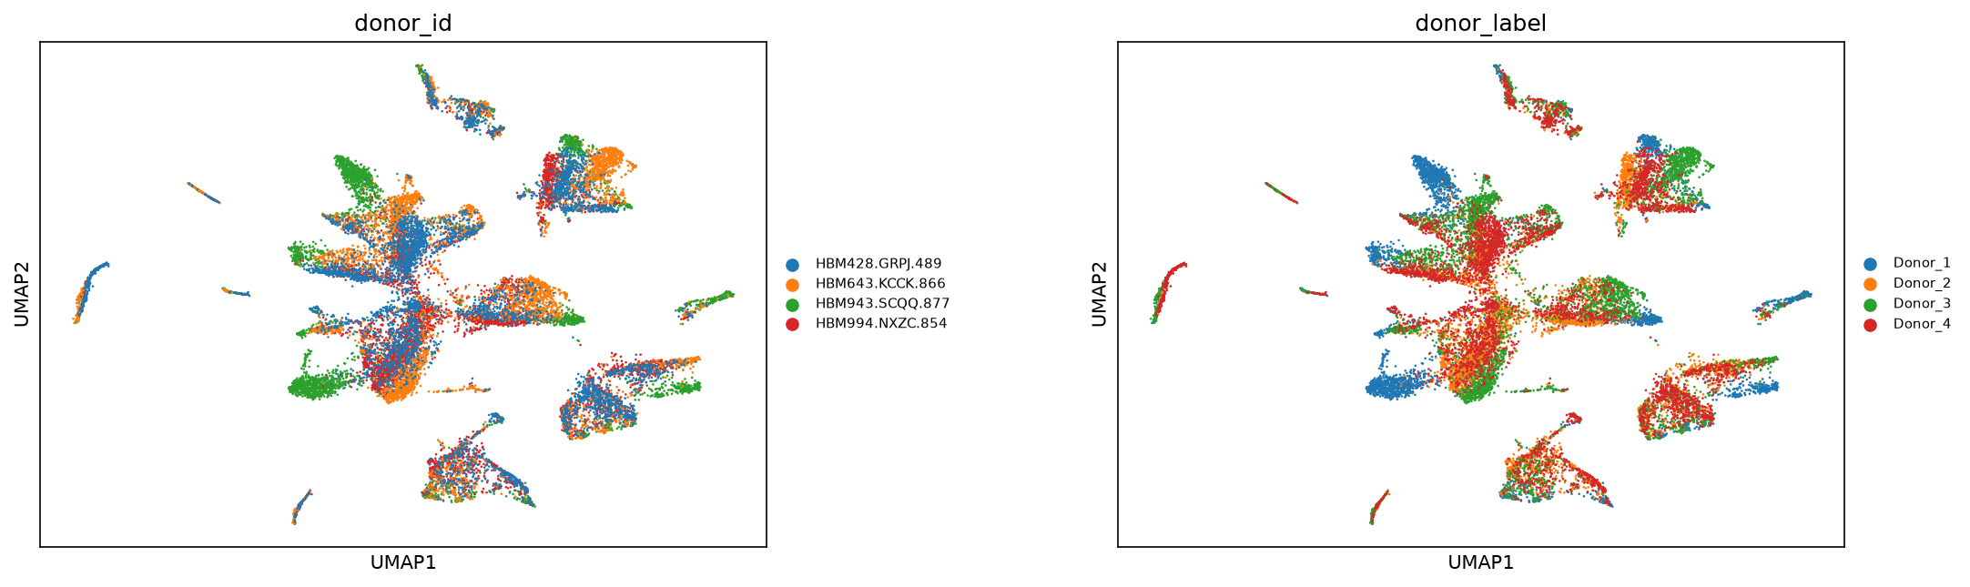
UMAP before Harmony colored by donor
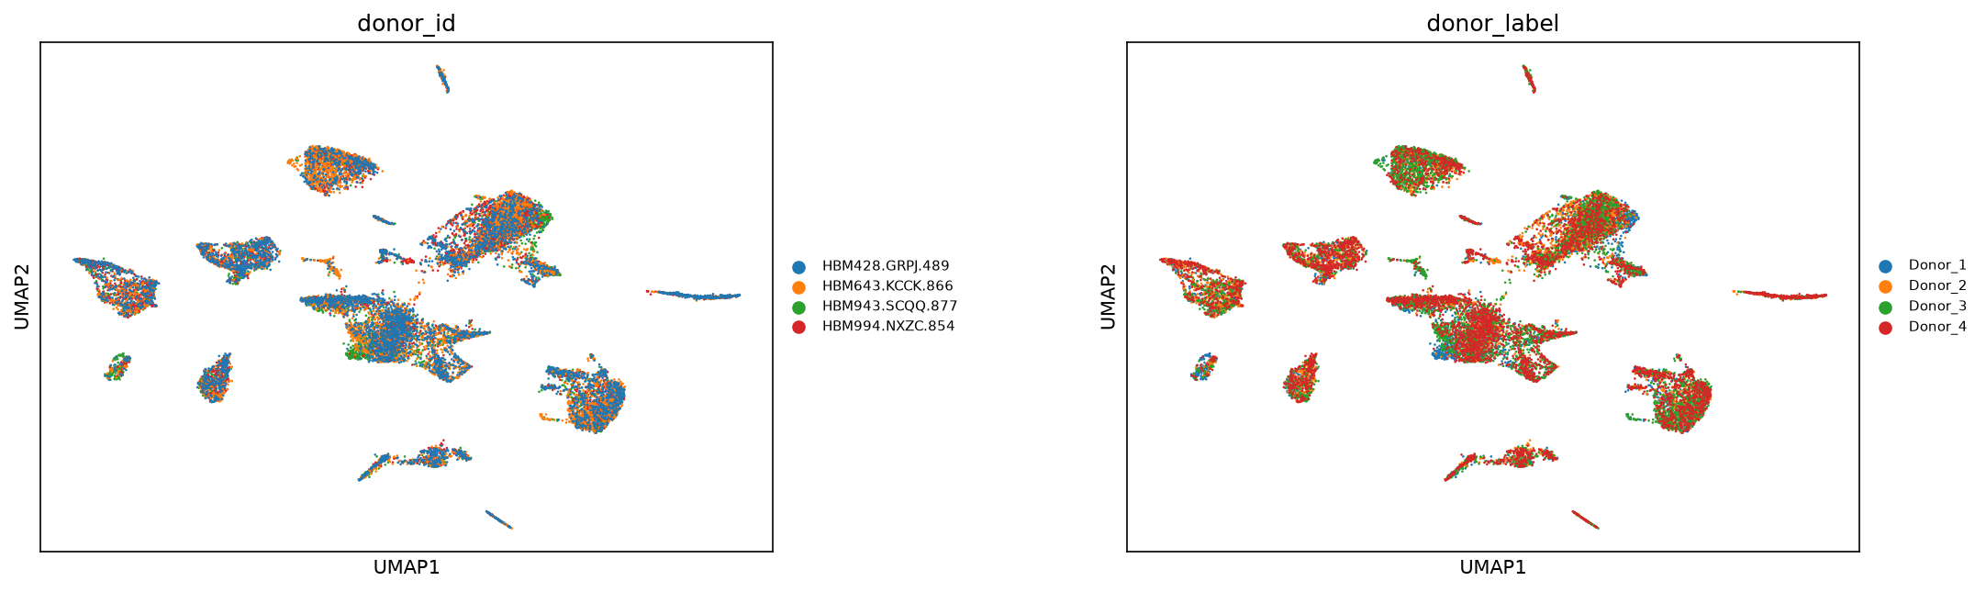
UMAP after Harmony colored by donor, the same view as the figure above
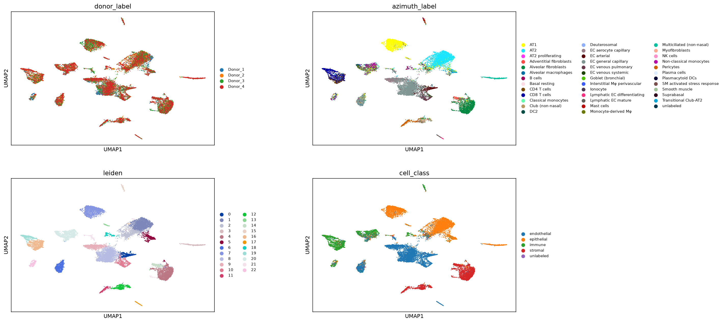
Side-by-side UMAP comparison of label views after Harmony

Composition versus markers
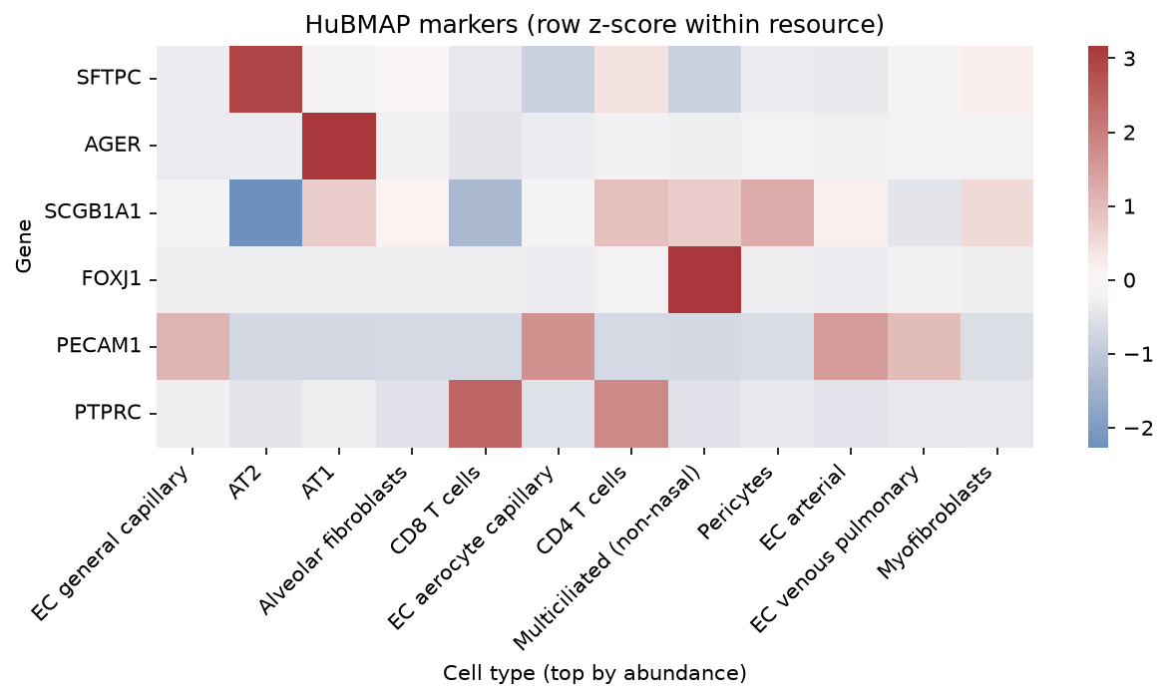
Mean expression heatmap of known lung markers across coarse cell classes
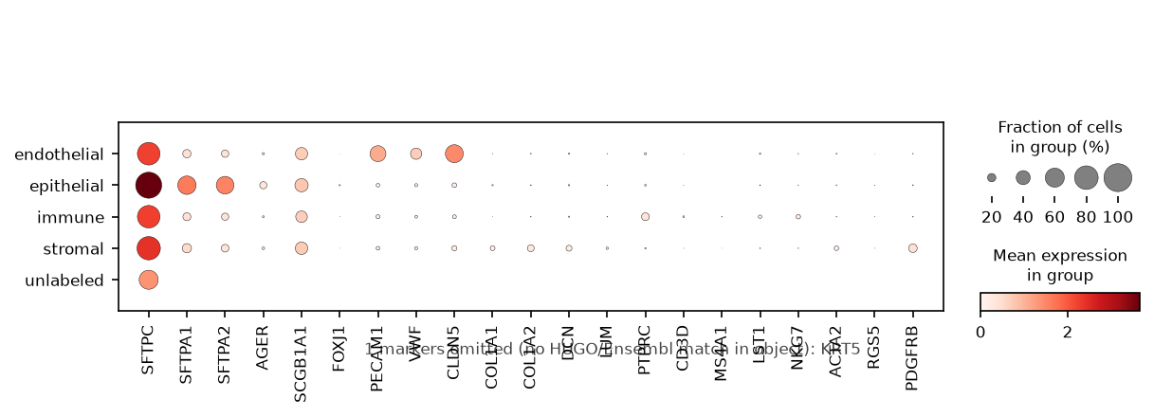
Dotplot of known lung marker genes by cell_class
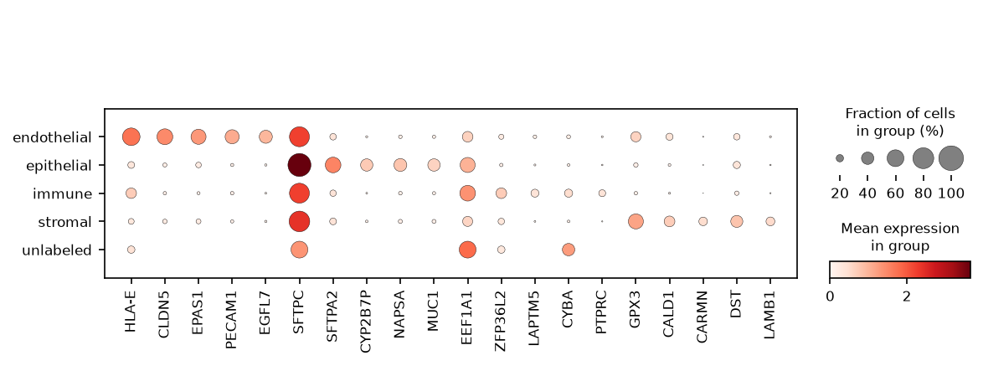
Dotplot of top Wilcoxon markers by cell_class
Wilcoxon ranking returns 9,921 rows. Under the module gates, adjusted p below 0.05 and log fold change above 0.25, 907 epithelial, 456 endothelial, 185 stromal, and 139 immune markers survive. Top ranks are lineage-appropriate but uneven: CLDN5 leads endothelial at log fold change 4.06, detected in 55.4 percent of endothelial nuclei versus 9.1 percent elsewhere, while SFTPC leads epithelial at 2.10 yet appears in 76.2 percent of the non-epithelial reference, which is ambient surfactant. Of 22 panel genes, 13 resolve by symbol and 21 by Ensembl ID; only KRT5 is missing from both.
Local ORA on 100 input genes per class returns 724 terms at adjusted p below 0.05 (endothelial 259, stromal 238, immune 190, epithelial 37); prerank GSEA returns 225 at FDR below 0.05. Some read as biology: Epithelial Mesenchymal Transition tops stromal at 19 of 143 genes. Two do not. Hallmark Estrogen Response Early is a top epithelial term at 9 of 143, adjusted p 6.5e-06, and Hallmark Allograft Rejection tops immune at 14 of 127, adjusted p 8.7e-13, in lung with no transplant anywhere. Both are real output of this run and both are gene-overlap artifacts.
Full tables: outputs/tables/module2_marker_genes.tsv, module2_pathway_enrichment.tsv, module2_prerank_gsea.tsv, module2_celltype_fractions.tsv, module2_donor_by_label_crosstab.tsv.
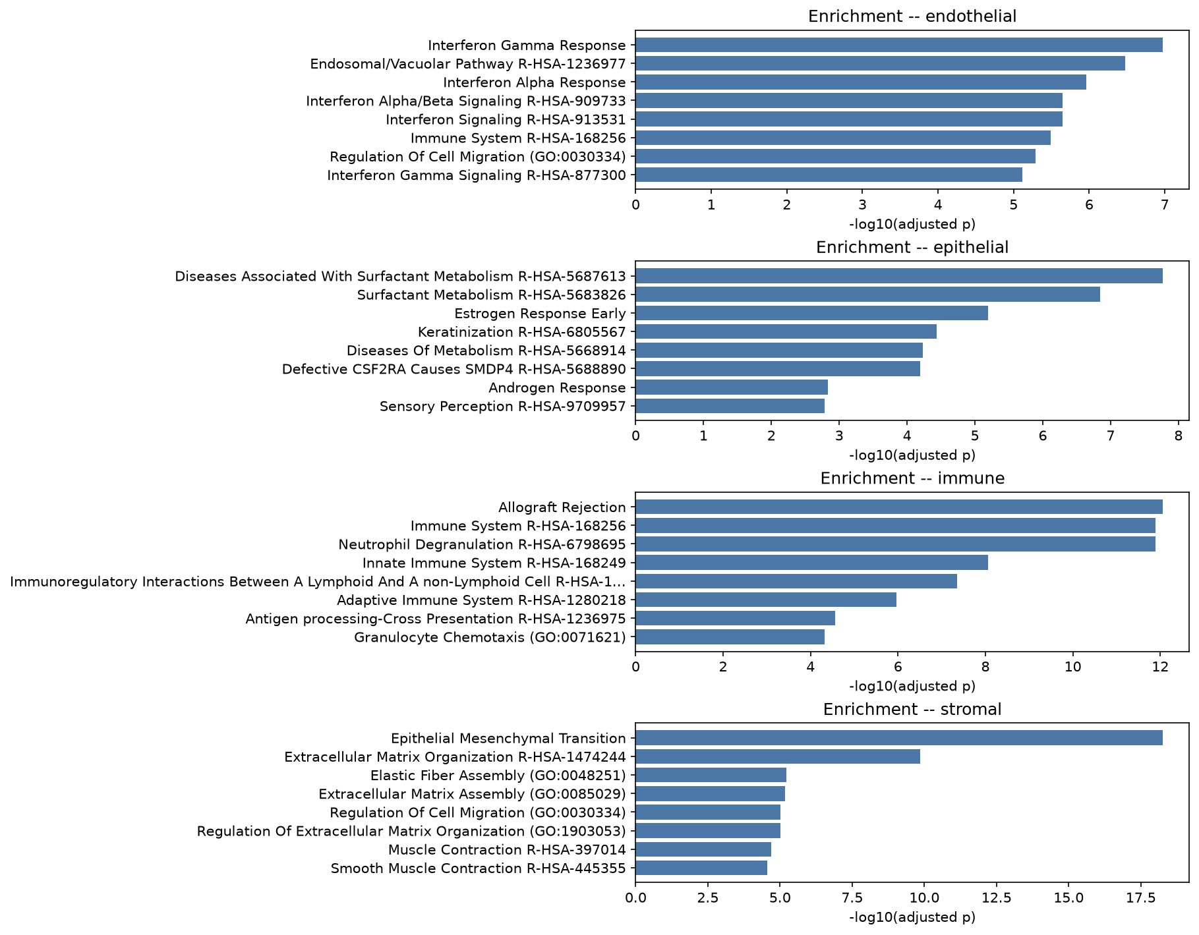
Summary of local GMT enrichment results by cell_class

5. Interpretation
Module 2 shows that the four QC'd HuBMAP donors can be embedded jointly, that Harmony increases donor mixing by a measurable neighborhood metric, and that coarse lineages yield markers and enrichment tables suitable for classroom interpretation.
What the results support.
- Integration is usable for teaching composition and marker analyses within one DCC.
- Composition tables and marker tables answer different questions; both are required to avoid attributing abundance shifts to cell-state programs.
- Foreign-donor kNN fraction is a concrete mixing statistic learners can recompute after changing Harmony or PCA settings.
How to read markers and enrichment together. A large epithelial compartment will dominate many global summaries. Class-stratified Wilcoxon markers ask what distinguishes each coarse class inside the joint object. Enrichment then summarizes those ranked lists against gene sets. When n_input_genes is small, ORA terms become brittle: the same course packages Hallmark (broad) and Reactome/GO BP (finer). Prefer terms that recur across libraries and that match known lung marker biology in the dotplots before elevating a pathway to a claim.

6. Extending this analysis
Each item below states what a stronger version of this analysis would require. The requirement is the boundary of what the Module 2 tables currently license.
- Cross-ecosystem agreement needs a second ecosystem. Establishing that these lineage programs recur in GTEx, GEO, or spaceflight tissue requires a second source measured independently and a bridge between the two feature spaces. Module 4 builds exactly that from the composition-weighted pseudobulk exported here; until then every number in this module comes from four HuBMAP donors and describes only them.
- Confirming an enriched pathway requires evidence outside the ranked list. The standard is term-by-term inspection of gene membership, recurrence across Hallmark and Reactome and GO Biological Process, and an orthogonal assay of the implicated program. Estrogen Response Early and Allograft Rejection both clear the adjusted p gate in this run and neither would survive that standard, which is why the check is run rather than assumed.
- A donor-age contrast that carries weight requires donors, not a split. The n=2 vs n=2 comparison demonstrates the mechanics of setting up a covariate contrast. Powering it would require a cohort sized against between-donor variance, which is a cohort design problem rather than a parameter change.
- Showing that Harmony removed batch, rather than rearranged the embedding, would require a matched re-prep. The same donor processed across protocols is what separates donor identity from technical batch. Foreign-donor kNN fraction and within-class donor silhouette are the two metrics this module chose to monitor; they are diagnostic of the embedding, not causal about its source.
- Trusting a mixing verdict per compartment requires per-compartment reporting. The immune silhouette moving toward zero while three compartments move negative is visible only because the silhouette table is stratified by cell_class. A single global mixing number would require a stratified companion metric before anyone reads it as uniform improvement.
Forward link. Module 3 interprets paired RNA+ATAC for Donor_2 (HBM828.GPVG.252), matched to the Donor_2 10x snRNA teaching block. Module 4 reuses composition-weighted pseudobulk in the HuBMAP-GTEx bridge and compares cross-ecosystem contrasts.

7. Open questions
- Which cell population or cluster was analyzed?
- What are the top marker genes, and do they match known lung identities?
- What pathways are enriched, and are they biologically coherent for that population?
- What biological interpretation is supported by markers + pathways together?
- What limitations remain (label transfer uncertainty, enrichment bias, small input lists)?
- Did Harmony change donor mixing in a way that matches the silhouette story, or do the two metrics disagree?
- Where does composition change stop and cell-state change begin in these tables?

Appendix A: Analysis parameters
Live values under module2 in config/paths.yaml. Section numbers match the Methods subsections.

1. Load and concatenate Module 1 QC objects
Config key | Default | Definition | If modified | Impact on results
module2.inputs | four donor blocks | Cohort of Module 1 h5ads to concat | Drop/add donor | Every composition fraction and DE n changes
module2.input_h5ad | data/processed/integrated/module2_hubmap_lung_integrated.h5ad | Written integrated path (DE input) | Relocate | Downstream DE must point at new path
module1.max_nuclei | 5000 | Upstream teaching cap (per donor) | Raise/lower | Nucleus counts entering concat
module2.random_seed | 0 | Seed for later embedding / diagnostics | Change | Stochastic neighbors/UMAP/Harmony draws

2. Joint embedding (recomputed HVG / PCA)
Config key | Default | Definition | If modified | Impact on results
module2.embedding.n_top_genes | 2000 | Joint HVG count (Seurat flavor) | Raise/lower | Changes PCA basis and all neighbors
module2.embedding.n_pcs | 40 | PCA components recomputed jointly | Raise | Can reintroduce donor-driven variance into neighbors
module2.embedding.n_pcs_neighbors | 40 | PCs used for kNN | Lower | Smoother neighborhoods; may lose fine structure
module2.embedding.n_neighbors | 20 | kNN size | Raise | More global mixing in UMAP
module2.embedding.umap_min_dist | 0.25 | UMAP min_dist | Lower | Tighter visual clusters
module2.embedding.umap_spread | 1.2 | UMAP spread | Raise | More dispersed layout
module2.embedding.scale_max_value | 10 | Scale clip before PCA | Lower | Compresses outlier gene leverage
module2.embedding.leiden_resolution | 0.8 | Default Leiden for teaching | Change | Cluster grain; default label still Azimuth-driven
module2.embedding.leiden_resolutions | [0.4, 0.8, 1.2] | Exploratory sweep stored as leiden_r* | Edit list | Extra cluster columns only

3. Harmony batch correction
Config key | Default | Definition | If modified | Impact on results
module2.harmony.enabled | true | Whether Harmony runs | Set false | No X_pca_harmony; mixing comparison collapses
module2.harmony.key | donor_id | Obs column for batch | Use donor_label | Same biological batches if IDs align
module2.harmony.max_iter_harmony | 20 | Harmony iterations | Raise | Longer runtime; usually small geometry change
module2.harmony.theta | null | Diversity penalty (null = package default) | Raise | Stronger correction; risk of overmixing rare states
module2.random_seed | 0 | Passed to Harmony / neighbors | Change | Stochastic differences in corrected space

4. Mixing and silhouette diagnostics
Config key | Default | Definition | If modified | Impact on results
module2.diagnostics.enabled | true | Run mixing / silhouette | Set false | No mixing tables; RAM floor may omit diagnostic peak
module2.diagnostics.log_matrix_memory | true | Log matrix RSS notes | Set false | Reporting only
module2.diagnostics.knn_k | 30 | Neighbors for foreign-donor fraction | Change k | Numeric mixing score scale changes
module2.diagnostics.max_cells | 8000 | Subsample cap for scoring | Raise | Higher RAM; stabler estimate
module2.diagnostics.random_seed | null | Null falls back to module2.random_seed | Set explicit | Controls diagnostic subsample only

5. Coarse cell_class mapping, composition, and pseudobulk
Config key | Default | Definition | If modified | Impact on results
module2.label_column | azimuth_label | Fine label source for mapping | Switch column | Remaps every cell_class
module2.labels.fetch_remote | false | Remote range-read for labels | Set true | Join coverage may change
module2.labels.cache | outputs/tables/module2_azimuth_labels.tsv | Local label cache | Refresh | Same as join change
module2.groupby | cell_class | Default DE grouping | Use fine labels | Marker tables explode in groups
module2.export_pseudobulk | true | Write bridge vectors for Module 4 | Set false | Module 4 level bridge lacks HuBMAP side
module2.markers | lung panel list | Genes for teaching heatmaps/dotplots | Edit list | Figure content only
module2.known_markers | lineage panels | Named marker sets for dotplots | Edit | Figure content only

6. Intron exclusion on the DE path, Wilcoxon markers
Config key | Default | Definition | If modified | Impact on results
module2.exclude_intron_features | true | Drop *-I features at DE load | Set false | Intron tags compete in ranks; markers change
module2.de.method | wilcoxon | rank_genes_groups method | Change | Rank statistics differ
module2.de.n_genes | 3000 | Genes reported per group (prerank-friendly) | Lower | Shorter ranked lists for GSEA
module2.de.min_cells_per_group | 50 | Minimum nuclei to keep a group | Raise | Rare classes may drop from DE
module2.de.min_logfoldchange | 0.25 | Filter for ORA input markers | Raise | Fewer ORA genes; brittle enrichment
module2.de.max_padj | 0.05 | Adjusted p filter for markers | Stricter | Same direction as LFC filter
module2.de.exclude_ribosomal_genes | true | Drop ribosomal symbols from marker tables | Set false | Ribosomal genes dominate ranks
module2.azimuth_focus | AT2/AT1/... | Fine labels highlighted in plots | Edit | Figure focus only

7. Local GMT enrichment (ORA and prerank)
Config key | Default | Definition | If modified | Impact on results
module2.enrichment.enabled | true | Run enrichment half | Set false | No pathway tables
module2.enrichment.mode | local_gmt | Offline GMT vs Enrichr HTTP | enrichr_online | Needs network; different background
module2.enrichment.gene_sets | Hallmark, Reactome, GO BP | GMT basenames under data/genesets | Swap release | Term names/sizes change
module2.enrichment.geneset_dir | data/genesets | GMT directory | Relocate | Path resolution
module2.enrichment.top_genes_per_group | 100 | ORA input list size | Lower | Unstable ORA
module2.enrichment.cutoff_padj | 0.05 | ORA marker padj gate | Stricter | Fewer input genes
module2.enrichment.prerank.enabled | true | Run prerank GSEA | Set false | No NES table for Module 2
module2.enrichment.prerank.min_size | 15 | Min overlapping genes in set | Raise | Drops small sets
module2.enrichment.prerank.max_size | 500 | Max set size | Lower | Drops large sets
module2.enrichment.prerank.permutation_num | 100 | Prerank permutations | Raise | Stabler FDR; slower
module2.enrichment.exclude_ribosomal_genes | null | Null inherits DE ribosomal policy | Override | Changes ranked inputs

References
- Korsunsky I, et al. Fast, sensitive and accurate integration of single-cell data with Harmony. Nat Methods. 2019;16(12):1289-1296. PMID: 31740819.
- Subramanian A, et al. Gene set enrichment analysis: a knowledge-based approach for interpreting genome-wide expression profiles. Proc Natl Acad Sci U S A. 2005;102(43):15545-15550. PMID: 16199517.
- Wolf FA, Angerer P, Theis FJ. SCANPY: large-scale single-cell gene expression data analysis. Genome Biol. 2018;19(1):15. PMID: 29409532.
- Liberzon A, et al. The Molecular Signatures Database (MSigDB) hallmark gene set collection. Cell Syst. 2015;1(6):417-425. PMID: 26771021.

