Module 3: Paired multiome interpretation with MOFA
Instructional time: 30 min. Bloom: Analyze. Notebook: notebooks/03_multiome.ipynb

1. Overview
Module 3 interprets a fitted MOFA model on HuBMAP SNARE-seq2 data from Donor_2 (HBM828.GPVG.252). That multiome shares a block and a section with the Donor_2 10x snRNA teaching block used in Modules 1-2, so the two assays can be compared as a matched pair (different nuclei; no per-nucleus join). The lesson asks whether RNA and ATAC share latent structure, whether MOFA found cell identity at all, what the ATAC gene-activity view actually encodes, and whether a second integrator (WNN) does better.
Key components. multiome_mofa.hdf5 as the default download; a committed Azimuth / WNN label cache in the package; variance and dominance tables; cluster concordance; QC association; factor versus label association; genome-wide and focus-gene bridges.
Learning objectives.
- Explain what paired multiome adds beyond Module 1/2 snRNA-seq, and what a matched block licenses.
- Read MOFA variance tables and recognize modality-private factors.
- Tell a broken model from an absent ATAC signal using cell-type and QC diagnostics.
- Separate ATAC gene activity from RNA expression when interpreting correlations.
Default compute stays inside the course RAM floor of 8 GB, with 16 GB recommended (load_h5mu: false). Learners do not download the ~14.7 GiB MuData file.

2. Before you begin
Prerequisites. Module 1 (QC objects) and Module 2 (integrated HuBMAP object / pseudobulk exports). Conda env CFDE_lung_env (or the pinned pip venv). Default path uses the fitted MOFA HDF5 plus the committed label cache; full MuData is not a learner download.
Time. Instructional: 30 min. Compute is short on the default path. Measured peak RSS 7.1 GB; 16 GB recommended, 8 GB is the minimum.

Biological question
In Donor_2 SNARE-seq2 nuclei, do RNA and ATAC share latent structure in the shipped MOFA model? If not, did the method fail, or is the ATAC gene-activity view empty of cell-type information?

Data used here
File | Local path | Role
multiome_mofa.hdf5 | data/source/HUBMAP/Donor_2/SNAREseq/HBM828.GPVG.252/multiome_mofa.hdf5 | Default interpretation object
Label cache | outputs/tables/module3_label_cache_HBM828.GPVG.252.tsv | Committed Azimuth labels, WNN Leiden, WNN UMAP
secondary_analysis.h5mu (optional) | same SNARE directory | Full MuData if module3.params.load_h5mu: true (~14.7 GiB; not a learner download)
Portal: HBM828.GPVG.252. Modules 1-2 use 10x snRNA-seq on Donor_2 block HBM473.NKMR.872, which shares a block and a section with this multiome.
SNARE folders are named by the public processed dataset ID, not by a distinct primary block ID. That is the exception relative to the 10x snRNA teaching folders.

3. Methods
Parameters below are live values under module3 in config/paths.yaml, collected in the Appendix. Scripts live in scripts/nb05_multimodal/. Default compute is interpretation-only from the shipped MOFA HDF5 plus the committed cache; full MuData is optional and is not required.
Each Methods step below corresponds to a section of notebooks/03_multiome.ipynb. The notebook is organized by the question each diagnostic answers rather than by step, so several Methods steps feed one notebook section:
Methods step | Notebook section
0. The MOFA model and variance explained per view | conceptual, no notebook section
1. Default path: interpret shipped MOFA | 1. Object composition and barcode pairing
2. Barcode pairing check | 1. Object composition and barcode pairing
3. Variance explained and factor dominance | 2. Variance explained across modalities
4. Factor association with cell identity | 3. Factor association with cell identity
5. Content of the ATAC gene-activity view | 4. Content of the ATAC gene-activity view
6. Weighted nearest neighbor as a second integration | 5. Weighted nearest neighbor concordance
7. Genome-wide RNA-ATAC gene bridge | 6. Gene bridge and focus genes
8. Focus-gene correlations, global and within cell type | 6. Gene bridge and focus genes
Notebook section 0 is environment setup, covered in Module 0.

0. The MOFA model and variance explained per view
MOFA (Multi-Omics Factor Analysis) is an unsupervised factor model. Given two or more matrices measured on the same cells, it learns a small set of latent factors and, for each factor, a set of weights per feature in each modality. A factor is a direction of variation; its weights say which genes or which chromatin features move along it.
The quantity that matters for interpretation is variance explained per factor per view. For each factor MOFA reports how much of the variance in the RNA view it accounts for, and how much of the variance in the ATAC view. That decomposition is what distinguishes the two outcomes this module asks you to tell apart:
- A shared factor explains a substantial share of variance in both views. It represents coordinated variation, where the same biological axis is visible in transcription and in chromatin accessibility.
- A modality-private factor explains variance in one view and close to none in the other. It represents structure confined to a single assay.
Applied to this dataset, RNA is a count matrix over genes and ATAC is summarized as gene-level accessibility, so both views are indexed by gene and a shared factor is biologically plausible: a gene whose promoter opens might be expected to rise in expression. Whether that coupling is actually present in these nuclei is the empirical question, and the variance decomposition answers it directly rather than by inference.
Two properties of the method are worth carrying into the interpretation. MOFA is unsupervised, so factors are not labeled by cell type or condition and any biological meaning has to be argued from the weights. And the number of factors is set in advance, so factors beyond the informative ones carry near-zero variance and should be read as absent rather than as weak effects.

1. Default path: interpret shipped MOFA
Script. scripts/nb05_multimodal/load.py (multiome_paths, load_mofa); inventory helpers in scripts/nb05_multimodal/inventory.py.
What. Load multiome_mofa.hdf5 with views configured as rna and atac_cbg (module3.modalities). Do not refit MOFA in the lesson (module3.params.interpretation_only: true, load_h5mu: false). Optional ATAC bin view atac_cbb exists in config but use_atac_bin defaults false. The teaching product is HuBMAP SNARE-seq2 for Donor_2 (HBM828.GPVG.252), matched to the Donor_2 10x snRNA teaching block.
Parameters: see Appendix, section 1.
Why. Refitting is slow, non-identical across environments, and unnecessary for teaching how to read a DCC-provided multiome factor model. The HDF5 plus the committed cache keep the module inside the course download budget.
Modules 1-2 and 4 are unaffected unless the multiome file is part of the learner download manifest.

2. Barcode pairing check
Script. scripts/nb05_multimodal/bridge.py (barcode_overlap_table, barcode_overlap_from_mofa); optional MuData barcode sets in scripts/nb05_multimodal/load.py (barcode_sets).
What. Report RNA and ATAC barcode counts and overlap (module3_barcode_overlap.tsv). With MuData unloaded, overlap is asserted by MOFA's shared sample list rather than an independent MuData crosstab. State that basis explicitly in results.
Parameters: see Appendix, section 2.
Why. Paired multiome claims require shared nuclei. Stating the basis of the overlap avoids implying a stronger check than was run on the default path.

3. Variance explained and factor dominance
Script. scripts/nb05_multimodal/bridge.py (mofa_factor_dominance); variance export in scripts/nb05_multimodal/export.py; plots in scripts/nb05_multimodal/plots.py (plot_mofa_variance).
What. Summarize total R2 by view, per-factor R2, and dominance (which view owns each factor). Gate stored R2 units (percent vs fraction) before quoting totals. Config module3.analysis.mofa_variance_max_factor marks trailing factors as numerically dead on this object (note: this key lives under `analysis`, not params).
Parameters: see Appendix, section 3.
Why. Shared latent biology would show factors with substantial R2 in both views. Modality-private factors mean stacked single-modality structure. Dead trailing factors are a first-class result, not a plotting inconvenience. Misreading percent-scale R2 as fractions invents impossible totals.

4. Factor association with cell identity
Script. scripts/nb05_multimodal/load.py (load_label_cache, assemble_nucleus_frame); scripts/nb05_multimodal/bridge.py (factor_label_association); scripts/nb05_multimodal/plots.py (plot_factor_label_heatmap).
What. Join the committed cache (Azimuth labels, WNN Leiden, WNN UMAP) onto MOFA sample order. For every factor score, compute eta squared against Azimuth, WNN, RNA Leiden, and ATAC Leiden. Write module3_factor_label_association.tsv. Cache generation from the MuData file is an authoring step (scripts/nb05_multimodal/cache.py); learners read the committed TSV.
Parameters: see Appendix, section 4.
Why. A modality-private MOFA fit can still have found biology in one view. Eta squared against cell identity is how you tell "the method worked on RNA" from "the object is noise."

5. Content of the ATAC gene-activity view
Script. scripts/nb05_multimodal/load.py (mofa_sample_metadata); scripts/nb05_multimodal/bridge.py (cluster_concordance, qc_association); scripts/nb05_multimodal/plots.py (plot_cluster_concordance, plot_qc_association).
What. MOFA samples_metadata/group1 already carries RNA Leiden, ATAC Leiden, ArchR Clusters, and the ATAC QC panel, so these diagnostics do not need the MuData file. Compute pairwise adjusted Rand index and normalized mutual information. Compute eta squared of QC metrics under each clustering, log10-transforming fragment and TSS count columns and recording that transform.
Parameters: see Appendix, section 5.
Why. If ATAC Leiden is chance-level against cell type and strongly associated with sequencing depth, the ATAC gene-activity matrix is not a legitimate basis for integration. That is a property of this representation, not a proof that chromatin is uninformative in lung.

6. Weighted nearest neighbor as a second integration
Script. scripts/nb05_multimodal/bridge.py (cluster_concordance); scripts/nb05_multimodal/plots.py (plot_wnn_umap).
What. The cache supplies WNN Leiden and WNN UMAP from the portal MuData object. Compare WNN to RNA Leiden, ATAC Leiden, and Azimuth. Plot the WNN embedding colored by Azimuth and by ATAC Leiden.
Parameters: see Appendix, section 6.
Why. A joint embedding can look successful while still leaning on one modality. WNN is the portal's second integrator; it is the control for "maybe MOFA was the wrong method."

7. Genome-wide RNA-ATAC gene bridge
Script. scripts/nb05_multimodal/bridge.py (rna_atac_gene_bridge); metric configured as module3.analysis.bridge_metric.
What. Join RNA and ATAC features by HUGO symbol on MOFA inputs; summarize dispersion relationships with metric feature_std_on_mofa_inputs. Report genome-wide Pearson/Spearman on those paired dispersions.
Parameters: see Appendix, section 7.
Why. ATAC gene activity is not RNA expression. Weak global correlation is an expected scientific result for this object, not a pipeline failure.

8. Focus-gene correlations, global and within cell type
Script. scripts/nb05_multimodal/bridge.py (focus_gene_bridge, focus_gene_correlations, focus_gene_correlations_by_cell_type, combine_focus_correlations, focus_gene_availability).
What. Correlate configured focus genes in RNA and ATAC spaces. Joining the cache supplies Azimuth labels, so within-cell-type rows are emitted on the default path. Config module3.thresholds.min_nuclei_correlation: 50 flags correlations with n below this threshold. focus_gene_cell_types was re-checked against the Azimuth labels present in this Donor_2 object. focus_genes_not_in_both_modalities (e.g. EPCAM) documents genes that cannot support a paired claim.
Parameters: see Appendix, section 8.
Why. Focus genes connect Module 3 to lung programs taught in Modules 1-2 without pretending ATAC gene activity equals RNA abundance. Explicit low-n and missing-modality rows prevent silent empty correlations.
MOFA inputs or cache changed.

4. Results

Object composition and barcode pairing
rna_n_barcodes | atac_n_barcodes | n_exact_overlap | overlap_fraction_of_rna | overlap_fraction_of_atac | paired_multiome | interpretation
21978 | 21978 | 21978 | 1.0 | 1.0 | True | NOT independent pairing evidence from a barcode crosstab. Pairing is asserted by MOFA file construction: one shared sample barcode list is written once for rna + atac_cbg views. n_exact_overlap equals that list length by definition (MuData barcode crosstab skipped because load_h5mu=false).
Source: module3_barcode_overlap.tsv
azimuth_label | n_nuclei | fraction
EC general capillary | 8339 | 0.379425
AT1 | 2210 | 0.100555
EC arterial | 2030 | 0.092365
Alveolar fibroblasts | 1620 | 0.07371
CD8 T cells | 1509 | 0.06866
Multiciliated (non-nasal) | 1109 | 0.05046
AT2 | 849 | 0.03863
Pericytes | 676 | 0.030758
Ionocyte | 601 | 0.027346
EC venous pulmonary | 523 | 0.023797
EC venous systemic | 474 | 0.021567
CD4 T cells | 441 | 0.020066
Non-classical monocytes | 343 | 0.015607
EC aerocyte capillary | 222 | 0.010101
Showing 14 of 34 rows. Source: module3_azimuth_composition.tsv
RNA and ATAC barcode overlap equals the shared MOFA sample list. That is construction, not an independent MuData crosstab: load_h5mu is false. The cache row count and Azimuth label count are stamped in outputs/reports/module3_label_cache_provenance.json. The matched 10x snRNA block is HBM473.NKMR.872 (same block and section; different nuclei).

Variance explained across modalities
view | r2_total | units
rna | 1.312837 | percent
atac_cbg | 0.914476 | percent
Source: module3_mofa_variance_total.tsv
factor | rna | atac_cbg | dominant_view | nondominant_r2 | rna_minus_atac
Factor1 | 0.000244 | 0.795037 | atac_cbg | 0.000244 | -0.794793
Factor2 | 0.516283 | 0.000179 | rna | 0.000179 | 0.516104
Factor3 | 0.171526 | 0.000263 | rna | 0.000263 | 0.171263
Factor4 | 0.145588 | 0.000222 | rna | 0.000222 | 0.145366
Factor5 | 0.128056 | 0.000189 | rna | 0.000189 | 0.127867
Factor6 | 0.11177 | 0.000194 | rna | 0.000194 | 0.111576
Factor7 | 0.079673 | 0.000191 | rna | 0.000191 | 0.079482
Factor8 | 0.00035 | 0.058451 | atac_cbg | 0.00035 | -0.058101
Factor9 | 0.000415 | 0.055252 | atac_cbg | 0.000415 | -0.054837
Factor10 | 0.04313 | 0.000134 | rna | 0.000134 | 0.042996
Factor11 | 0.03681 | 0.000115 | rna | 0.000115 | 0.036695
Factor12 | 0.025438 | 6.39e-05 | rna | 6.39e-05 | 0.025374
Factor13 | 0.025268 | 6.85e-05 | rna | 6.85e-05 | 0.0252
Factor14 | 0.000127 | 0.023684 | atac_cbg | 0.000127 | -0.023557
Showing 14 of 18 rows. Source: module3_mofa_factor_dominance.tsv
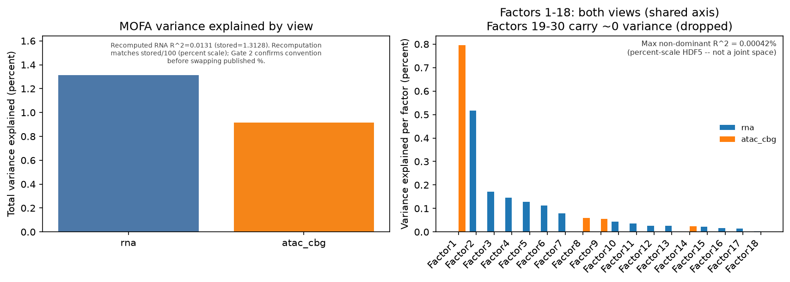
MOFA variance explained per factor for RNA and ATAC views
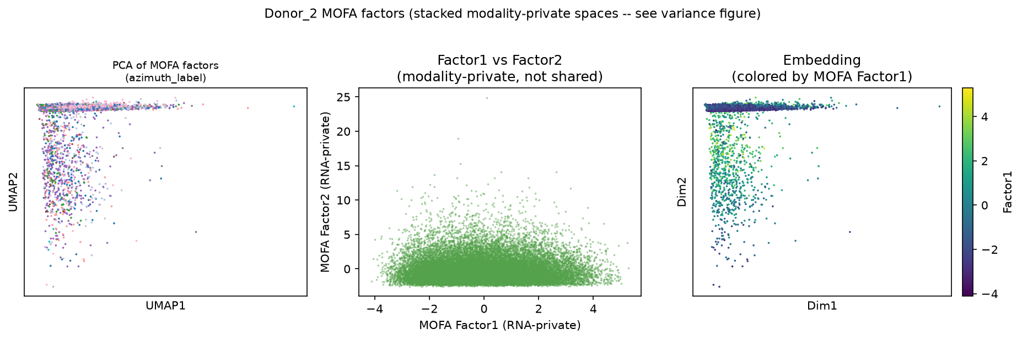
MOFA latent embedding for teaching inspection
Units first. The units column reads percent. Stored totals near 1.3 and 0.91 mean about 1.3 percent of RNA variance and about 0.91 percent of ATAC gene-activity variance, not fractions above 1. The recomputation in outputs/reports/module3_run_params.json confirms the percent convention.
Finding. Every active factor is modality-private. Trailing factors beyond mofa_variance_max_factor are numerically dead. This is two stacked single-modality spaces, not a joint latent space.

Factor association with cell identity
factor | labelling | eta_squared | n_groups | n_nuclei
Factor1 | azimuth_label | 0.001423 | 34 | 21978
Factor1 | leiden_wnn | 0.487874 | 23 | 21978
Factor1 | rna_leiden | 0.000317 | 20 | 21978
Factor1 | atac_leiden | 0.001658 | 30 | 21978
Factor2 | azimuth_label | 0.073788 | 34 | 21978
Factor2 | leiden_wnn | 0.421429 | 23 | 21978
Factor2 | rna_leiden | 0.266424 | 20 | 21978
Factor2 | atac_leiden | 0.178713 | 30 | 21978
Factor3 | azimuth_label | 0.437111 | 34 | 21978
Factor3 | leiden_wnn | 0.632004 | 23 | 21978
Factor3 | rna_leiden | 0.623223 | 20 | 21978
Factor3 | atac_leiden | 0.019384 | 30 | 21978
Factor4 | azimuth_label | 0.416625 | 34 | 21978
Factor4 | leiden_wnn | 0.577355 | 23 | 21978
Showing 14 of 120 rows. Source: module3_factor_label_association.tsv
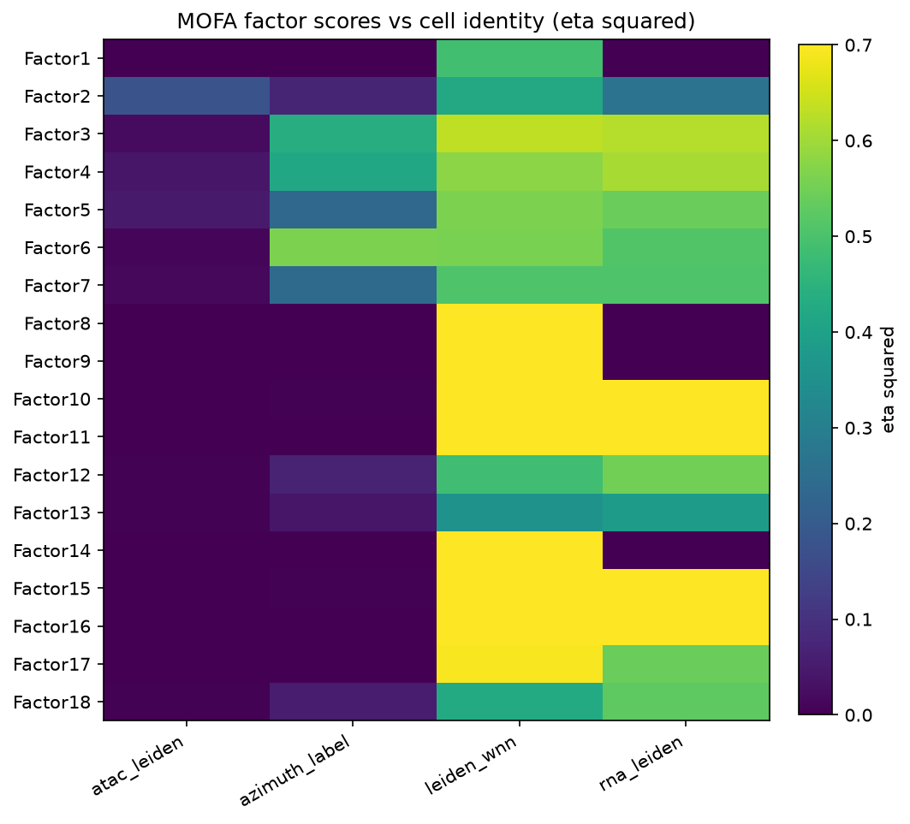
Eta squared of MOFA factor scores against Azimuth, WNN, RNA Leiden, and ATAC Leiden
Finding. RNA-dominant factor scores track Azimuth, WNN, and RNA Leiden. The same factors are near floor against ATAC Leiden. MOFA found cell identity, in RNA only.

Content of the ATAC gene-activity view
pair | col_a | col_b | n_nuclei | k_a | k_b | ari | nmi
atac_leiden vs azimuth_label | atac_leiden | azimuth_label | 21978 | 30 | 34 | 0.011747 | 0.028309
atac_clusters vs azimuth_label | atac_clusters | azimuth_label | 21978 | 25 | 34 | 0.006943 | 0.01062
leiden_wnn vs rna_leiden | leiden_wnn | rna_leiden | 21978 | 23 | 20 | 0.246892 | 0.443028
leiden_wnn vs atac_leiden | leiden_wnn | atac_leiden | 21978 | 23 | 30 | 0.020134 | 0.039789
rna_leiden vs azimuth_label | rna_leiden | azimuth_label | 21978 | 20 | 34 | 0.180146 | 0.26221
leiden_wnn vs azimuth_label | leiden_wnn | azimuth_label | 21978 | 23 | 34 | 0.065516 | 0.200672
atac_leiden vs rna_leiden | atac_leiden | rna_leiden | 21978 | 30 | 20 | 0.029988 | 0.040883
1 further column in the source file. Source: module3_cluster_concordance.tsv
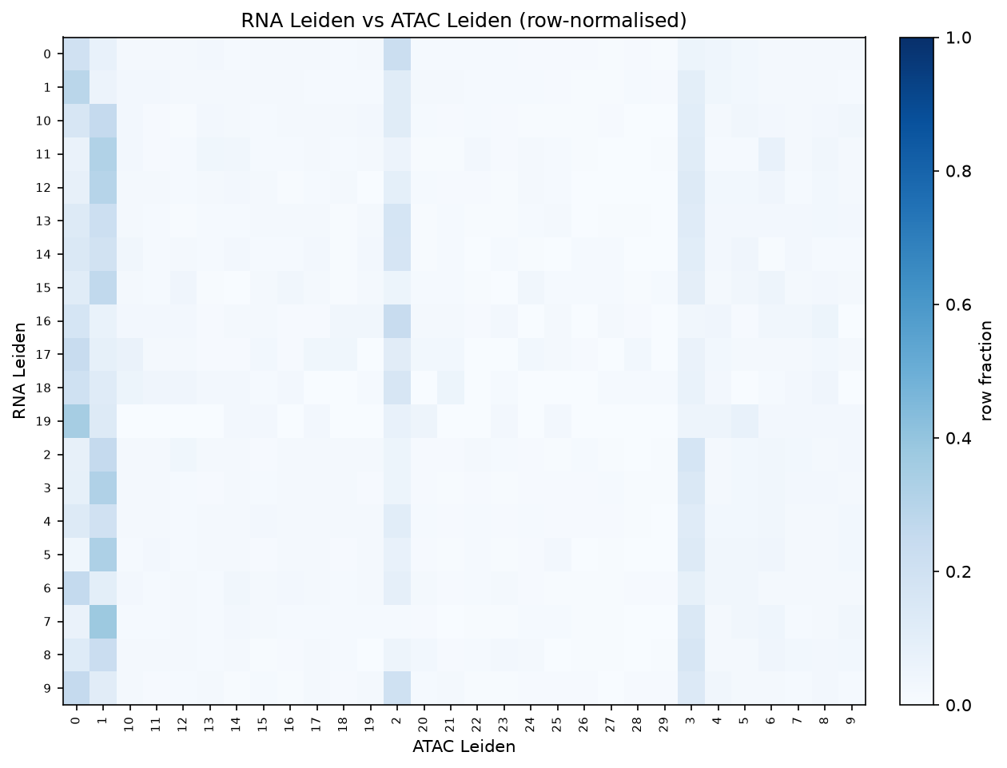
RNA Leiden versus ATAC Leiden, row-normalized
qc_metric | qc_column | labelling | eta_squared | transform | n_nuclei | n_groups
log10 nFrags | nFrags | atac_leiden | 0.554629 | log10 | 21978 | 30
log10 nFrags | nFrags | rna_leiden | 0.10157 | log10 | 21978 | 20
log10 ReadsInTSS | ReadsInTSS | atac_leiden | 0.498693 | log10 | 21978 | 30
log10 ReadsInTSS | ReadsInTSS | rna_leiden | 0.174031 | log10 | 21978 | 20
DoubletEnrichment | DoubletEnrichment | atac_leiden | 0.161544 | none | 21978 | 30
DoubletEnrichment | DoubletEnrichment | rna_leiden | 0.051957 | none | 21978 | 20
PromoterRatio | PromoterRatio | atac_leiden | 0.141002 | none | 21978 | 30
PromoterRatio | PromoterRatio | rna_leiden | 0.094058 | none | 21978 | 20
Source: module3_qc_association.tsv
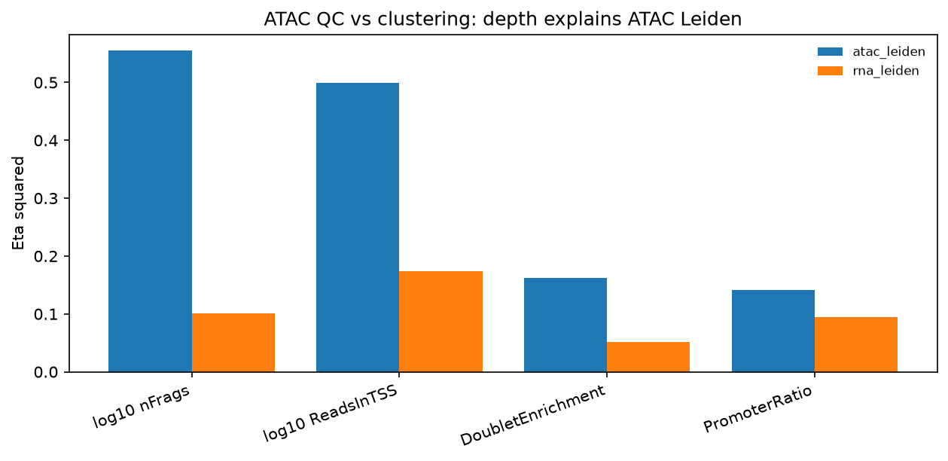
Eta squared of ATAC QC metrics under ATAC Leiden versus RNA Leiden
Finding. ATAC Leiden is near chance against Azimuth cell type. The same clustering tracks sequencing depth (log10 fragment counts and log10 reads in TSS). RNA Leiden does not. On this product the ATAC gene-activity view encodes depth, not cell identity.

Weighted nearest neighbor concordance
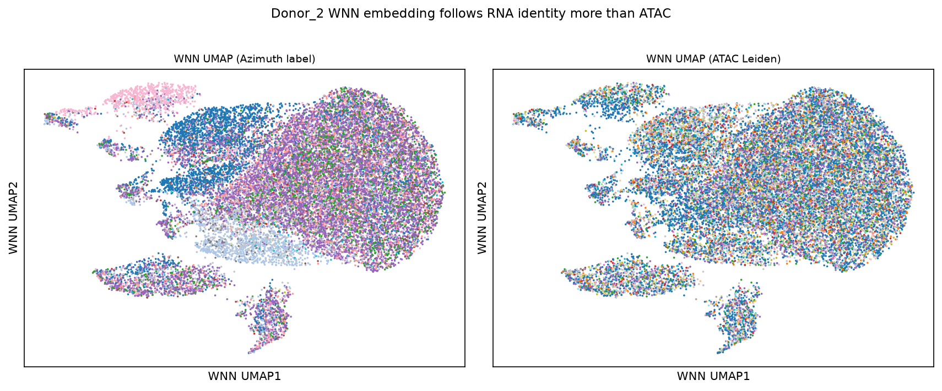
WNN UMAP colored by Azimuth label and by ATAC Leiden
Read the WNN rows of module3_cluster_concordance.tsv. WNN agrees with RNA Leiden more than with ATAC Leiden, and it agrees with Azimuth less than RNA Leiden does. The joint embedding that looks successful is leaning on RNA.

Gene bridge and focus genes
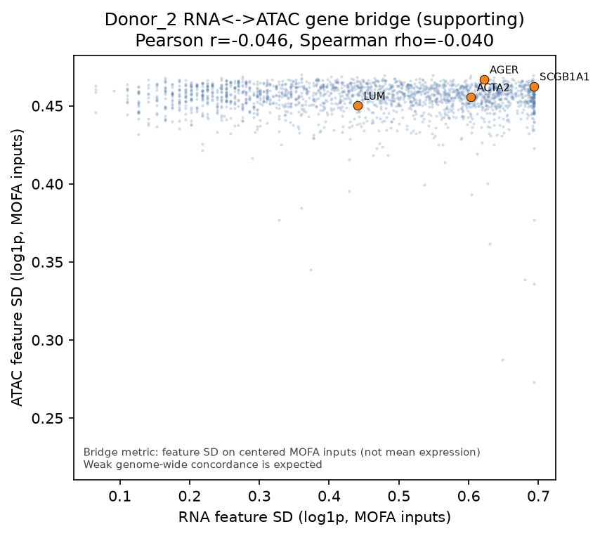
Scatter of RNA vs ATAC feature dispersion for shared genes in the MOFA input space
gene_symbol | scope | n_nuclei | pearson_r | note
AGER | global | 21978 | -0.006238
SCGB1A1 | global | 21978 | 0.001598
LUM | global | 21978 | -0.007713
ACTA2 | global | 21978 | 0.002102
AGER | within_cell_type | 2210 | -0.030638
SCGB1A1 | within_cell_type | 37 | 0.108276 | n_nuclei=37 below threshold 50; correlation not interpretable
LUM | within_cell_type | 1750 | -0.035931
ACTA2 | within_cell_type | 343 | 0.04819
5 further columns in the source file. Source: module3_focus_gene_correlations.tsv
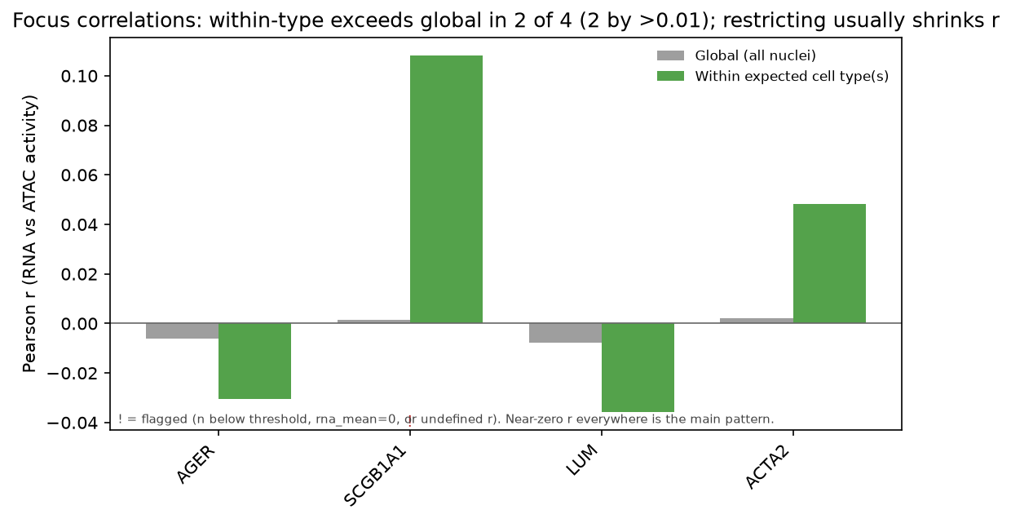
Focus-gene RNA vs ATAC correlations, global and within cell type
Shared HUGO symbols and genome-wide correlations are in module3_rna_atac_gene_bridge.tsv (row count) and its figure caption. Within-cell-type rows are now populated because the cache supplies Azimuth labels. Low-n groups are flagged rather than reported as bare missing values.

5. Interpretation
Module 3 teaches how to interrogate a real multiome product without forcing a shared-factor story the object does not support.
This object is a legitimate multiome: paired RNA and ATAC in the same nuclei, with a matched 10x snRNA block from the same section. The ATAC gene-activity representation is not a legitimate basis for integration on this product. Those two statements are not in conflict.
What the results support.
- MOFA did not fail as a method. RNA factors track cell identity.
- The ATAC gene-activity view carries no detectable cell-type information, and its clustering tracks sequencing depth.
- WNN produces a joint embedding by following RNA, and it matches Azimuth less well than RNA alone.
- Factor dominance and dead factors remain first-class results: they constrain claims about joint latent biology.
Success here means the files pair, the factor model loads, the variance tables are interpretable, and the diagnostics distinguish method failure from empty ATAC structure. It does not mean RNA and ATAC share a latent axis. If a manuscript claimed shared MOFA factors for this object without showing dual-view R2 and a cell-type check, Module 3 is the counterexample.
Two limits to name explicitly. Azimuth labels are transferred predictions rather than ground truth. WNN and Azimuth diagnostics are measured on Donor_2 only.

6. Extending this analysis
Each item below names a claim a learner may want to make and the work that would license it.
- Whether the depth confound is block-specific. HBM285.MWNX.593 is a Donor_3 multiome from a different block, ten libraries against ten. Repeating the QC association there would test whether ATAC gene-activity clustering is depth-driven outside Donor_2.
- Peak-level ATAC. Differentially accessible regions, motif enrichment, and chromVAR need peak-level data. The shipped ATAC view is gene activity, and that tooling is not in the pinned environment.
- The bin-level modality. atac_cbb is present in the MuData object with chromosome and bin coordinates. It is not in the MOFA object and is not on the teaching path (use_atac_bin: false).
- Refitting MOFA. The lesson reads a DCC fit (interpretation_only: true). A refit changes the object under discussion and cannot be reproduced identically across environments.
- Independent pairing evidence. A barcode crosstab from MuData obs would confirm shared nuclei independently. The default path asserts pairing from MOFA file construction.
- Donor_3 as a second arm. Stated as an extension, not run. Donor_3 cannot support a matched snRNA/multiome comparison at any download size, because none of its 10x blocks share a block with its SNARE products.
Forward link. Module 4 leaves single-DCC multiome and compares bulk and snRNA-derived contrasts across HuBMAP, GTEx, GEO, and OSDR.

7. Open questions
- What evidence shows this is true multiome rather than unpaired same-donor assays, and what does the matched 10x block license that Donor_3 could not?
- Why is this MOFA space not a joint latent space? Quote the max non-dominant R2 from the table.
- What result shows that MOFA still found biology? Quote an eta squared for an RNA factor against Azimuth.
- Why is the ATAC gene-activity view not a legitimate basis for integration on this object?
- WNN looks like a joint embedding. What comparison shows that it is leaning on RNA?
- When a within-cell-type focus-gene row is flagged for low n, what claim is still licensed?
- Factor1 carries the largest single share of ATAC variance yet tracks no cell-type label, no cluster assignment and no recorded QC metric, while sitting at eta squared 0.488 against the WNN clustering. WNN takes the ATAC representation as an input. What does that shared input explain, and what does it leave open?

Appendix A: Analysis parameters
Live config values under module3 in config/paths.yaml, in Methods order.

1. Default path: interpret shipped MOFA
Config key | Default | Definition | If modified | Impact on results
module3.params.load_h5mu | false | Load full secondary_analysis.h5mu | Set true | Enables MuData UMAP/layers; large RAM/download; not required
module3.params.interpretation_only | true | Skip MOFA refit; read shipped factors | Set false | Out of scope for class; non-identical refits
module3.files.mofa_hdf5 | multiome_mofa.hdf5 | Filename under multiome dir | Point elsewhere | Different factor object
module3.multiome_dir | data/source/HUBMAP/Donor_2/SNAREseq/HBM828.GPVG.252 | Local product directory | Relocate | Path resolution
module3.donor_label | Donor_2 | Teaching donor | Change donor | Every Module 3 claim is donor-specific
module3.dataset_id | HBM828.GPVG.252 | Public SNARE product ID (folder name) | Change product | Different object
module3.modalities.rna | rna | MOFA/MuData RNA view name | Rename | Load fails if view missing
module3.modalities.atac_gene | atac_cbg | ATAC gene-activity view | Switch | Bridge uses different ATAC features
module3.modalities.use_atac_bin | false | Whether to use atac_cbb | Set true | Adds bin-level ATAC path

2. Barcode pairing check
Config key | Default | Definition | If modified | Impact on results
module3.params.load_h5mu | false | Whether independent MuData barcode sets are available | Set true | Overlap can be recomputed from MuData obs
module3.files.secondary_h5mu | secondary_analysis.h5mu | MuData filename when loaded | Missing file | Blocks MuData path only

3. Variance explained and factor dominance
Config key | Default | Definition | If modified | Impact on results
module3.analysis.mofa_variance_max_factor | 18 | Last factor treated as active for teaching | Raise | May present near-zero factors as active
module3.analysis.random_seed | 0 | Seed for any stochastic preview draws | Change | Preview subsample only
module3.analysis.max_nuclei_preview | 5000 | Cap when MuData preview embeddings are drawn | Raise | Higher RAM on MuData path

4. Factor association with cell identity
Config key | Default | Definition | If modified | Impact on results
module3.files.label_cache | outputs/tables/module3_label_cache_HBM828.GPVG.252.tsv | Committed Azimuth / WNN cache | Rebuild cache | All labeled diagnostics change
module3.thresholds.min_label_prediction_score | 0.0 | Azimuth score floor (off) | Raise | Drops low-confidence labels

5. Content of the ATAC gene-activity view
Config key | Default | Definition | If modified | Impact on results
module3.thresholds.min_cluster_size | 20 | Recorded cluster-size floor | Raise | Does not change default ARI; reserved for extensions

6. Weighted nearest neighbor as a second integration
Config key | Default | Definition | If modified | Impact on results
module3.files.label_cache | see section 4 | Supplies leiden_wnn and WNN UMAP | Rebuild | WNN comparisons and UMAP change
module3.matched_snrna.primary_id | HBM473.NKMR.872 | Matched 10x snRNA teaching block | Change | Cross-assay language only; no barcode join

7. Genome-wide RNA-ATAC gene bridge
Config key | Default | Definition | If modified | Impact on results
module3.analysis.bridge_metric | feature_std_on_mofa_inputs | Summary used for genome-wide scatter | Change metric | Correlation magnitudes redefine
module3.analysis.rna_layer | spliced_unspliced_sum | Preferred MuData RNA layer | Use spliced only | Layer-resolved values change on MuData path
module3.analysis.rna_layer_fallback | spliced | Fallback if preferred layer absent | N/A if preferred exists | Contingency only
module3.thresholds.noise_delta_r | 0.01 | Within-type vs global margin treated as noise | Raise | More correlations flagged as noise

8. Focus-gene correlations and low-n guards
Config key | Default | Definition | If modified | Impact on results
module3.analysis.focus_genes | SFTPC, AGER, ... | Genes plotted/correlated | Edit list | Which rows appear; not genome-wide stats
module3.analysis.focus_gene_cell_types | per-gene Azimuth lists | Expected cell types for within-type n | Edit | Changes within-type n and flags
module3.analysis.focus_genes_not_in_both_modalities | [EPCAM] | Genes known unpaired | Edit | Documentation of impossible pairs
module3.thresholds.min_nuclei_correlation | 50 | Flag low-n correlations | Raise | More rows flagged unreliable
module3.thresholds.noise_delta_r | 0.01 | Noise margin vs global r | Raise | Stricter "real within-type" calls

Optional MuData extension
Config key | Default | Definition | If modified | Impact on results
module3.params.load_h5mu | false | Whether MuData extension runs | Set true | Large download/RAM; extra panels
module3.params.secondary_h5mu_size_note | ~14.7 GiB; optional... | Human-readable size warning | Editorial | Docs only
module3.interpretation | true | Write interpretation markdown | Set false | Skips narrative export
module3.assay | SNARE-seq2 [Salmon + ArchR + Muon] | Assay label for reports | Editorial | Provenance text

References
- Duong TE, Diep D, Conklin KY, et al. A Multimodal Spatial and Epigenomic Atlas of Human Adult Lung Topography. bioRxiv. 2025. DOI: 10.1101/2025.05.23.655666. Preprint; the source publication for the SNARE-seq2 and snRNA-seq data this course uses. Its own analysis labels SNARE-seq2 nuclei from the RNA modality alone and reports no joint RNA-ATAC factor model, so the MOFA object interpreted here is a product of the HuBMAP central pipeline rather than of that paper.
- Argelaguet R, et al. MOFA+: a statistical framework for comprehensive integration of multi-modal single-cell data. Genome Biol. 2020;21(1):111. PMID: 32393329.
- HuBMAP Consortium. The human body at cellular resolution: the NIH Human Biomolecular Atlas Program. Nature. 2019;574(7777):187-192. PMID: 31597973.
- Dataset: HuBMAP HBM828.GPVG.252 (SNARE-seq2 Salmon + ArchR + Muon). Portal: browse dataset.
- Matched 10x snRNA teaching block: HuBMAP HBM473.NKMR.872. Portal: browse dataset.

