Module 4: Cross-ecosystem contrast comparison
Instructional time: 30 min | Bloom: Evaluate | Notebook: notebooks/04_cross_ecosystem.ipynb

1. Overview
Module 4 compares independently generated lung transcriptomic contrasts after methods calibration. Native expression levels are shown only to demonstrate incomparability. What can travel is within-resource log fold-change and the pathway normalized enrichment score (NES), the per-pathway statistic gene set enrichment analysis returns after correcting for gene-set size. The headline analysis is shared-mechanism concordance against chance; global NES Spearman is supporting context only.
Key components. Four within-resource contrasts (GEO idiopathic pulmonary fibrosis (IPF), GTEx aging, OSD-248 spaceflight, HuBMAP aging illustration); a HuBMAP to GTEx level bridge; pathway NES comparison across contrast pairs; and shared-mechanism concordance tested against permutation nulls. Calibration checks on the flight contrast establish that the pipeline is sound before any biology is read from it.
Learning objectives. After this module you will be able to:
- Explain why expression levels produced by independent pipelines cannot be merged, and identify which quantities can be compared across resources instead.
- Judge whether a contrast is fit to interpret, using spike-in calibration and agreement with an independently produced differential-expression table as the evidence.
- Test whether pathway programs agree in direction beyond chance using a permutation null, and explain why a global correlation across all pathways cannot answer the same question.
- Distinguish a null result from an uninterpretable one, and state which of the two a given contrast produced and what would be needed to resolve it.
No CFDE program supplies fibrotic human lung; the disease arm is external GEO GSE150910 (NIH, not CFDE).

2. Before you begin
Prerequisites. Modules 1 to 3 complete; conda env CFDE_lung_env (or the pinned pip venv); Module 2 integrated object and pseudobulk tables present.
Time. Instructional: ~30 min. Compute (measured from module4_run_params.json, sensitivity gated off): notebook wall ~5 min / ~301 s compute; peak RSS ~5.5 GB. Course RAM: 16 GB recommended, 8 GB minimum (Module 2 DE peaks at ~7.6 GB). Free disk: several GB for tables/figures.
Data required.
Run order. Run the analysis sections in order; the notebook carries state between cells.

Biological question
When disease, aging, and spaceflight lung contrasts are each analyzed in their own resource, which pathway programs agree in direction beyond chance, and which contrasts are uninterpretable given the data?
Spaceflight belongs in that comparison rather than sitting beside it as an unrelated third condition. The combination of microgravity and space radiation is studied explicitly as a model of accelerated aging, producing the inflammation, cellular senescence and fibrotic remodeling signatures that characterize aged tissue, and a genomic radiation-age association derived for spaceflight has already been carried into lung disease (references 6 and 7). That is what makes a flight contrast worth testing against a chronological aging contrast and against a fibrotic disease contrast: if the accelerated aging framing holds at the pathway level, the three should share directional programs. Whether they do in these particular datasets is the empirical question this module answers.

Data used here
Resource | Accession | Contrast | Local role
GEO | GSE150910 | H_DISEASE IPF vs control | Bulk counts
GTEx v10 lung | gene_reads / gene_tpm | H_AGING_GTEX older vs younger | Bulk counts + TPM bridge
NASA OSDR | OSD-248 | M_FLIGHT ISS-T flight vs GC | Mouse bulk counts (+ ERCC)
HuBMAP | teaching donors | H_AGING_HUBMAP older vs younger | 2 vs 2 illustration
Orthologs | Ensembl one2one | mouse to human symbols | data/reference/
Gene sets | Hallmark / Reactome / GO BP | NES | data/genesets/
Module 1 introduced the download map; Module 2 supplied composition-weighted HuBMAP pseudobulk for the GTEx bridge. Sample sizes:
resource | contrast_id | arm | n | notes
GSE150910 | H_DISEASE | IPF | 103 | CHP excluded from teaching contrast
GSE150910 | H_DISEASE | control | 103 | CHP excluded from teaching contrast
OSD-248 | M_FLIGHT | ground | 10 | ISS-T ~60 Carcass; duration-matched GC (not hindlimb unloading)
OSD-248 | M_FLIGHT | flight | 10 | ISS-T ~60 Carcass; duration-matched GC (not hindlimb unloading)
OSD-248 | M_FLIGHT | flight_qa_below_threshold | 1 | Mmus_C57-6T_LNG_FLT_ISS-T_Rep7_F7
GTEx | H_AGING_GTEX | younger_brackets | 100 | brackets=['20-29', '30-39']; samples=257; DE uses one sample/subject capped at 40/arm
GTEx | H_AGING_GTEX | older_brackets | 269 | brackets=['60-69', '70-79']; samples=655; DE uses one sample/subject capped at 40/arm
HuBMAP | H_AGING_HUBMAP | older | 2 | illustration only; donors=Donor_3,Donor_4; ages=56.8,52.96
HuBMAP | H_AGING_HUBMAP | younger | 2 | illustration only; donors=Donor_1,Donor_2; ages=37.0,25.0
HuBMAP | bridge | composition_weighted_genes | 42258 | linear-scale pseudobulk from Module 2 (levels only)
GTEx | bridge | lung_mean_tpm_genes | 59033 | mean TPM for levels/bridge only; age DE uses gene_reads
Source: module4_sample_counts.tsv

3. Methods
Parameters below are live values under module4 in config/paths.yaml. Scripts live in scripts/nb06_crossres/. Native expression levels never travel across ecosystems; within-resource log fold-change and pathway NES do. The headline analysis is shared-mechanism concordance against chance; global NES Spearman is supporting context only.
Each Methods step below corresponds to a section of notebooks/04_cross_ecosystem.ipynb. The notebook is ordered by the question each result answers rather than by the order the steps run, so the two sequences do not track each other:
Methods step | Notebook section
1. Within-resource DE (pydeseq2) | 2. Four within-resource contrasts and calibration
2. Calibration of the flight contrast | 2. Four within-resource contrasts and calibration
3. Ortholog mapping (mouse to human) | 3. Ortholog mapping and pathway concordance
4. HuBMAP-GTEx level bridge | 4. HuBMAP to GTEx level bridge
5. Pathway NES and configured pairs | 3. Ortholog mapping and pathway concordance
6. Shared-mechanism concordance | 3. Ortholog mapping and pathway concordance
The notebook runs in the order the questions are asked rather than the order the steps execute, so step 4 appears after steps 5 and 6. Notebook section 1, on whether native expression levels can be compared across resources, is reported under Results as "Native levels do not travel" rather than as a Methods step.

1. Within-resource DE (pydeseq2)
Script. scripts/nb06_crossres/contrasts.py (contrast_h_disease, contrast_h_aging_gtex, contrast_h_aging_hubmap, contrast_m_flight, _pydeseq2_contrast); loaders in scripts/nb06_crossres/load.py and scripts/nb06_crossres/hubmap_donor_counts.py.
What. Fit negative binomial DE separately in each resource with explicit reference levels (Treatment(reference)). Never concatenate counts across studies or species. Four contrasts only:
- H_DISEASE: GEO GSE150910 IPF vs control (~ condition)
- H_AGING_GTEX: GTEx v10 lung older vs younger brackets
- H_AGING_HUBMAP: HuBMAP teaching donors older vs younger (2 vs 2 illustration from summed counts)
- M_FLIGHT: OSD-248 ISS-T flight vs ground control
Filter genes with low total counts (de_min_count_sum). Round RSEM expected counts to integers before pydeseq2 where required.
Parameters: see Appendix, section 1.
Why. Units differ (TPM, rounded sums, RSEM counts). Alphabetical factor orders would invert several contrasts; references are set deliberately. HuBMAP aging is illustration-only: ages sit inside GTEx middle brackets and power differs by an order of magnitude from H_AGING_GTEX.

2. Calibration of the flight contrast
Script. scripts/nb06_crossres/ercc_calib.py (ercc_calibration_frame, ercc_calibration_summary, plot_ercc_calibration); GeneLab subset in scripts/nb06_crossres/genelab_subset.py; size-factor policy in contrast_m_flight.
What. ExFold spike-in calibration for OSD-248 (flight Mix1 vs GC Mix2) against Thermo Fisher expected fold changes. Cross-check endogenous logFC against a committed GeneLab ISS-T DE subset (osd248_genelab_isst_de_subset). Estimate size factors on endogenous genes only (module4.osd248.exclude_ercc_from_size_factors: true) while keeping ERCC rows for calibration plots. Optional RIN/QA sensitivity uses rin_sensitivity / rin_sensitivity_threshold 6.0.
Parameters: see Appendix, section 2.
Why. Spike-ins can dominate ranks when mixes differ by arm. Calibration asks whether the flight contrast is methodologically usable before biology claims. Putting ERCC back into size factors was tested and rejected (ground ERCC fraction was higher; pathway p_up stayed 0). Adult globin share was checked and was not a material flight-specific driver: 1.33 percent of the non-ERCC library in flight against 0.96 percent in ground, a difference of 0.36 percentage points. Even when methods checks pass, flight pathway passers that are unanimously down remain uninterpretable, not null, for cross-ecosystem concordance.

3. Ortholog mapping (mouse to human)
Script. scripts/nb06_crossres/orthologs.py (load_ortholog_table, ortholog_loss_record, align_logfc_by_ortholog).
What. Map mouse genes to human symbols with Ensembl one-to-one orthologs (data/reference/human_mouse_orthologs_one2one.tsv; BioMart download metadata under module4.orthologs_meta). Record loss in module4_ortholog_loss.tsv. Leading-edge overlaps for cross-species mechanism pairs restrict both sides to the mappable human-symbol subspace.
Parameters: see Appendix, section 3.
Why. Many-to-many orthologs would double-count. Loss is part of the result and must travel with any human-space NES comparison that includes mouse flight.

4. HuBMAP-GTEx level bridge (demonstration only)
Script. scripts/nb06_crossres/compare.py (hubmap_gtex_bridge_table, plot_pseudobulk_vs_gtex); inputs from Module 2 pseudobulk exports and GTEx TPM means via scripts/nb06_crossres/load.py.
What. Compare Module 2 composition-weighted and max-across-labels HuBMAP pseudobulk vectors to GTEx lung mean TPM on shared symbols. This demonstrates that native levels do not travel; it is not a DE input. Production runs favor composition-weighted over max-across for bulk-like tracking.
Parameters: see Appendix, section 4.
Why. Showing incomparability of native levels is the pedagogical point before NES concordance. Levels never enter the headline mechanism test.

5. Pathway NES and configured pairs
Script. scripts/nb06_crossres/compare.py (prerank_contrast, nes_comparison, compare_configured_nes_pairs, resolve_nes_sensitivity).
What. Prerank GSEA on each contrast's ranked logFC against local Hallmark + Reactome GMTs (no KEGG; GO BP is sensitivity-only). Prerank defaults: min_size=15, max_size=500, permutation_num=100. Compare exactly four NES pairs from module4.nes_pairs (H_AGING_HUBMAP only vs H_AGING_GTEX). Global Spearman on overlapping gene sets is recorded as supporting context with an independence caveat; it is not the headline. GO BP sensitivity prerank is gated: module4.sensitivity.enabled: false loads the committed TSV (module4_nes_sensitivity.tsv) to keep RAM near ~5.5 GB instead of recomputing (~12 GB peak).
Parameters: see Appendix, section 5.
Why. Global Spearman is not independent evidence across overlapping gene sets. Mechanism concordance (next step) uses pass/fail and sign agreement with permutation nulls and is the correct headline object.

6. Shared-mechanism concordance (headline)
Script. scripts/nb06_crossres/mechanisms.py (run_mechanism_analysis, pass_mask, permute_concordant_count, analytic_null, leading_edge_overlap, cluster_mechanisms).
What. Define pathway passers with FDR q < 0.25 and absolute NES >= 1.5 in each contrast; concordant pathways agree in sign. Compare observed concordant counts to analytic and permutation nulls (n_permutations=2000, random_seed=0) that preserve observed marginals (including flight's all-down pathway passers). All pathways ship as tier 3 (concordance only): leading-edge Jaccard on this run (~0.21-0.48) has no natural tier 1/2 cut. Suspect OxPhos / translation terms are flagged, never auto-excluded. Cross-species leading edges restrict to ortholog-mappable human symbols. Flight-involving pairs with unanimous down passers are labeled uninterpretable, not null.
Parameters: see Appendix, section 6.
Why. Permutation preserves polarity marginals so enrichment is not automatic from "everything is down" alone. Tier 3-only labeling prevents overclaiming shared leading-edge mechanisms when Jaccard stays moderate. The clustering result is binding on the prose: where it declines to merge, the pathways are reported separately. Disease-aging concordance does not rise above the null; ECM direction inferred from global rho is corrected by the pathway screen; aging-flight exceeds permutation while remaining biologically suspect.

4. Results

Ortholog loss
metric | n
genes_in_human_contrast | 18401
genes_in_mouse_contrast | 15429
one2one_orthologs_available | 17041
retained_after_intersection | 13577
dropped_human_side | 4824
dropped_mouse_side | 1852
Source: module4_ortholog_loss.tsv

Methods checks that pass
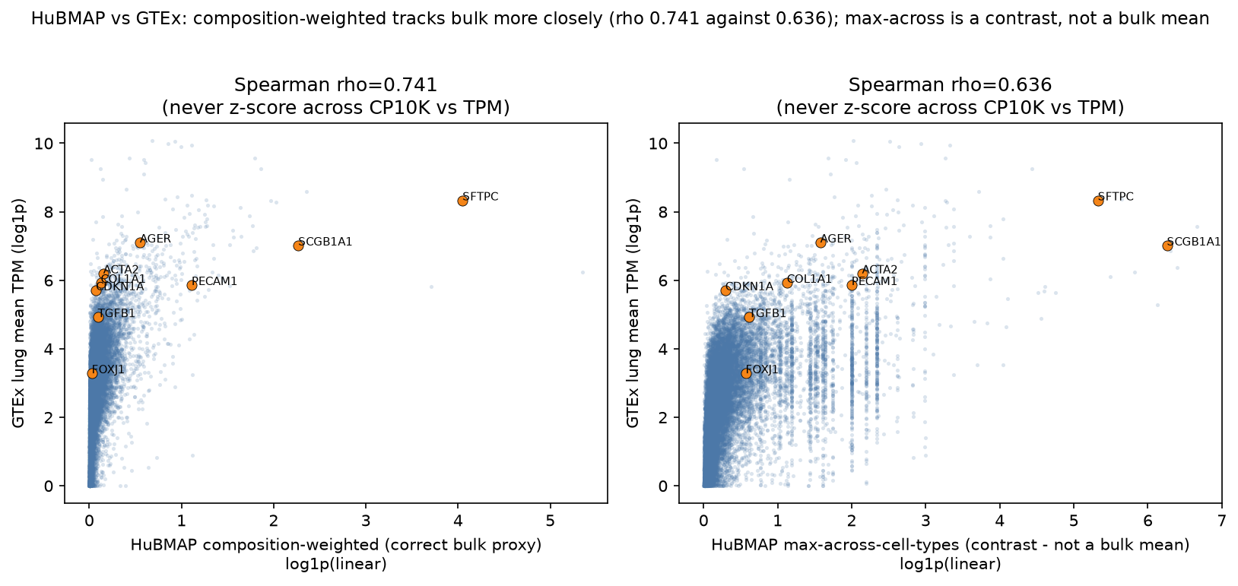
HuBMAP pseudobulk versus GTEx lung mean TPM bridge
ERCC calibration on the production run: slope 0.98884, R2 0.8817. The flight contrast computed here also agrees with GeneLab's independently produced differential expression across shared symbols, which is what that cross-check is for: two pipelines run on the same samples should rank genes the same way, and a disagreement would indicate a processing error rather than biology. The HuBMAP-GTEx bridge favors composition-weighted over max-across vectors: Spearman rho 0.741 against 0.636 across 18,055 shared genes.

Native levels do not travel
gene_symbol_human | gtex_lung_mean_tpm | gse150910_mean_counts_ipf | osd248_mean_counts_flight | units_note
SFTPC | 4156.258313 | 627510.165049 | 280904.5 | TPM vs linear CP10K-pseudobulk vs raw counts; human vs mouse -- not comparable
AGER | 1214.833166 | 4364.708738 | 29046.4 | TPM vs linear CP10K-pseudobulk vs raw counts; human vs mouse -- not comparable
SCGB1A1 | 1113.153419 | 426.776699 | 698380.1 | TPM vs linear CP10K-pseudobulk vs raw counts; human vs mouse -- not comparable
FOXJ1 | 25.705356 |  | 1519.6 | TPM vs linear CP10K-pseudobulk vs raw counts; human vs mouse -- not comparable
PECAM1 | 350.185872 | 1236.68932 | 24226.5 | TPM vs linear CP10K-pseudobulk vs raw counts; human vs mouse -- not comparable
COL1A1 | 374.837595 | 20970.009709 | 3038.4 | TPM vs linear CP10K-pseudobulk vs raw counts; human vs mouse -- not comparable
ACTA2 | 492.614129 | 35195.407767 | 6660.552 | TPM vs linear CP10K-pseudobulk vs raw counts; human vs mouse -- not comparable
CDKN1A | 301.076699 | 10327.038835 | 2325.2 | TPM vs linear CP10K-pseudobulk vs raw counts; human vs mouse -- not comparable
TGFB1 | 136.778551 |  | 944.8 | TPM vs linear CP10K-pseudobulk vs raw counts; human vs mouse -- not comparable
5 further columns in the source file. Source: module4_native_levels_panel.tsv
One row carries the module title. SFTPC reads about 56 in the composition-weighted HuBMAP pseudobulk (linear CP10K), about 4,156 in GTEx lung mean TPM, about 1,286,872 in GSE150910 mean control counts, and about 204,863 in OSD-248 mean ground counts for mouse Sftpc. Four units and two species, with no shared scale: the spread across those columns is a units artifact, not biology. This panel is why the module compares within-resource log fold-change and pathway NES and never native levels.

Contrast volcanoes
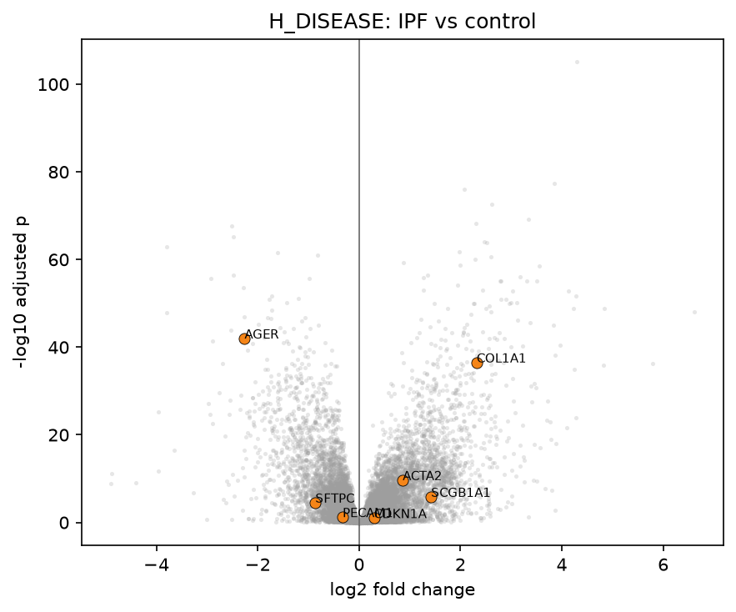
Volcano plot for H_DISEASE (IPF vs control)
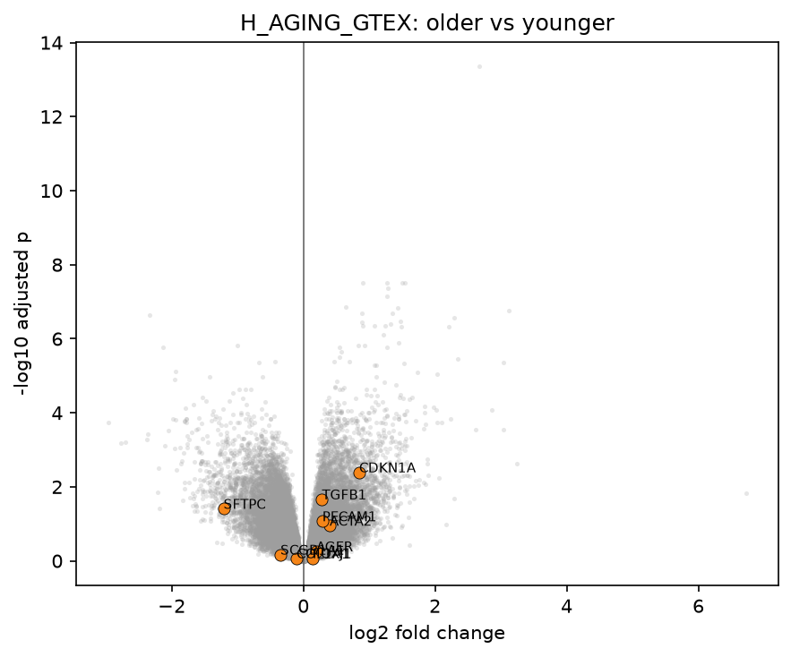
Volcano plot for H_AGING_GTEX (older vs younger)
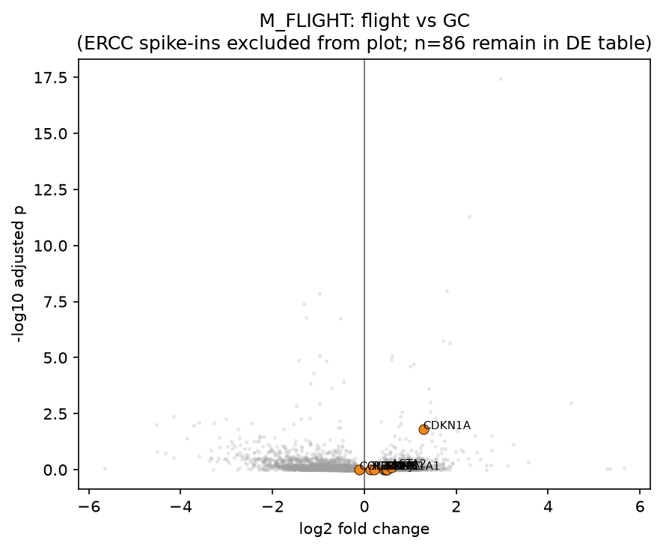
Volcano plot for M_FLIGHT (ISS-T flight vs ground control)
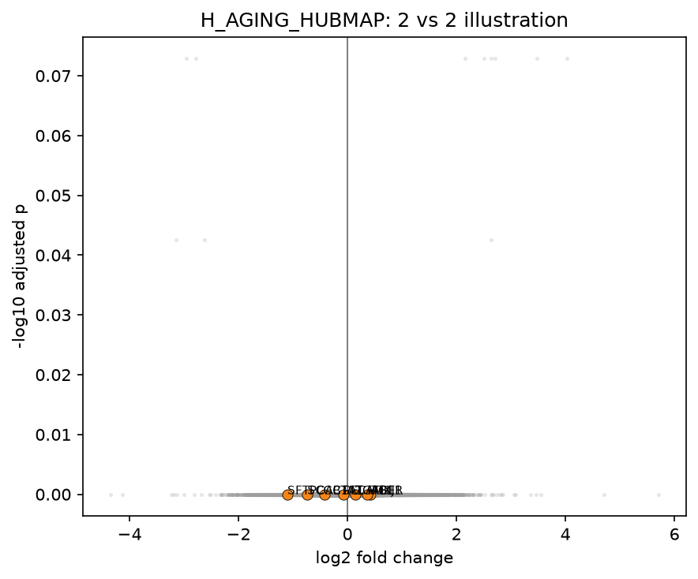
Volcano plot for H_AGING_HUBMAP (older vs younger), the 2 vs 2 teaching illustration

Global NES pairs (supporting)
contrast_x | contrast_y | frame | n_shared_pathways | spearman_rho | sign_agreement | spearman_p | spearman_p_note
H_DISEASE | H_AGING_GTEX | biology_best_case | 1185 | -0.197008 | 0.395781 | 7.82e-12 | gene-set overlap violates independence; spearman_p is not a valid evidence claim for the headline
H_DISEASE | M_FLIGHT | cross_ecosystem | 1136 | -0.10913 | 0.484155 | 0.000229 | gene-set overlap violates independence; spearman_p is not a valid evidence claim for the headline
H_AGING_GTEX | M_FLIGHT | cross_ecosystem | 1158 | -0.021858 | 0.462867 | 0.457419 | gene-set overlap violates independence; spearman_p is not a valid evidence claim for the headline
H_AGING_HUBMAP | H_AGING_GTEX | method | 945 | 0.190643 | 0.582011 | 3.48e-09 | gene-set overlap violates independence; spearman_p is not a valid evidence claim for the headline
Source: module4_nes_pair_summary.tsv
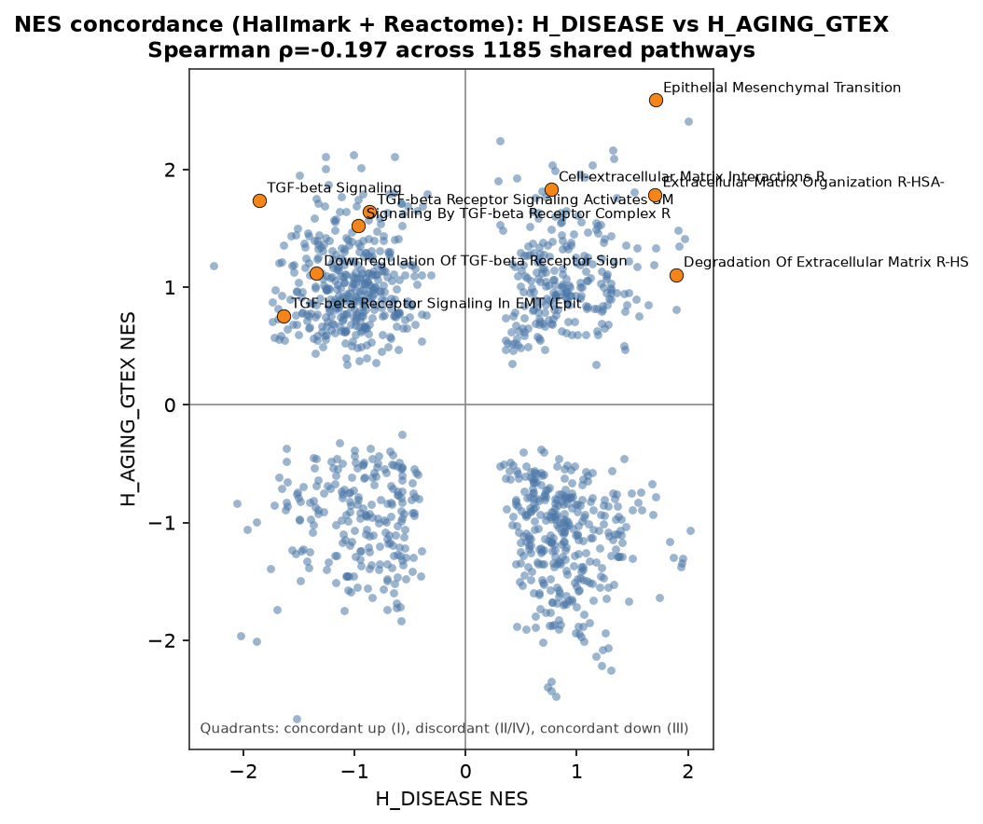
Headline NES panel: normalized enrichment scores for H_DISEASE versus H_AGING_GTEX, with selected pathway terms labeled
Open the panel above first. It is the canonical headline NES figure, module4_nes_scatter.png, and it carries the configured headline pair H_DISEASE vs H_AGING_GTEX; the explicitly named per-pair file directly below holds the same content under its pair name.
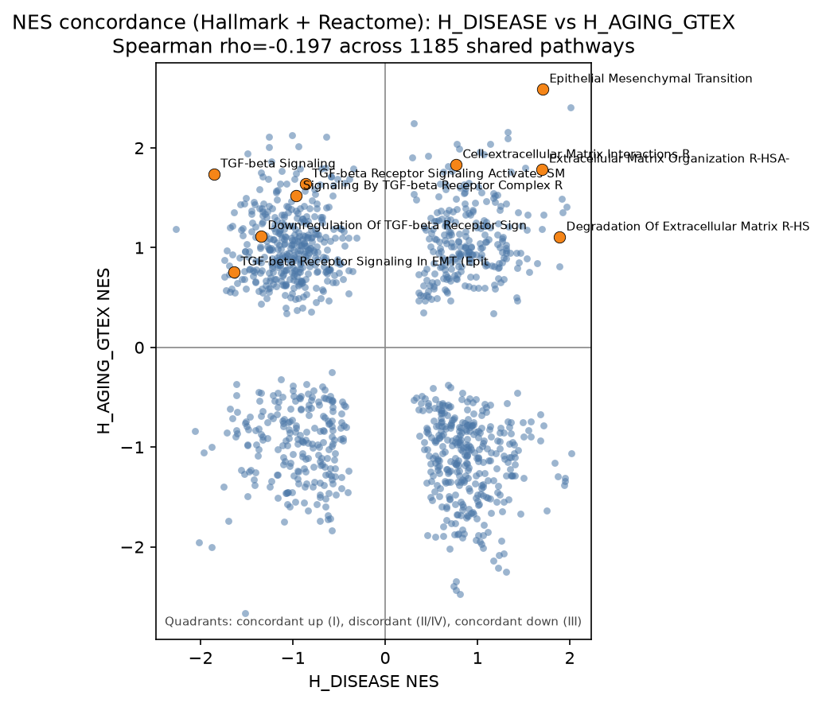
NES scatter for H_DISEASE versus H_AGING_GTEX
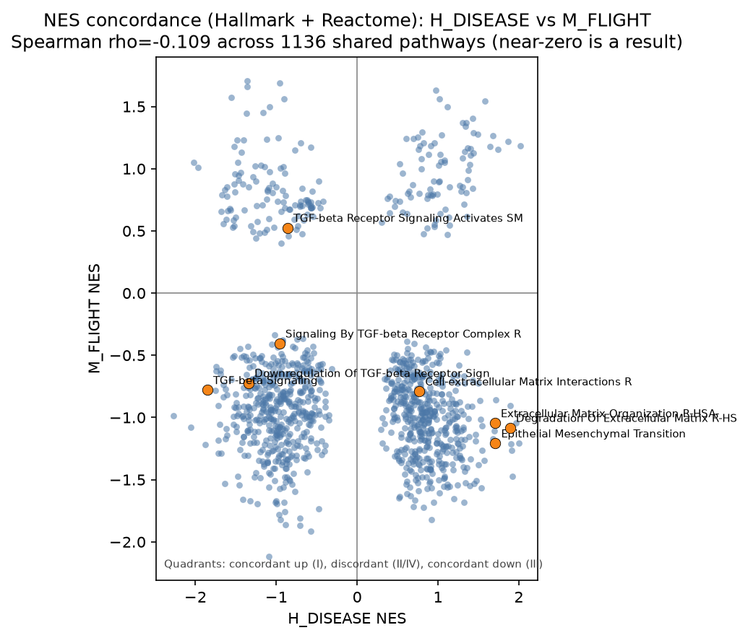
NES scatter for H_DISEASE versus M_FLIGHT
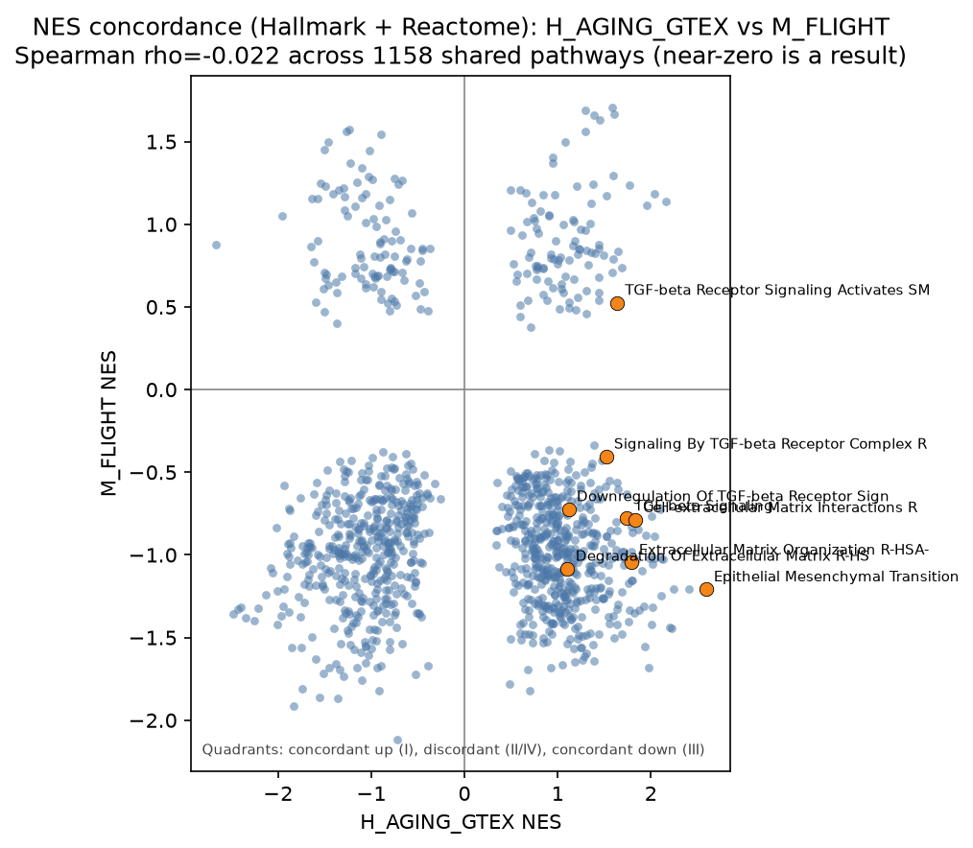
NES scatter for H_AGING_GTEX versus M_FLIGHT, the aging-flight pair
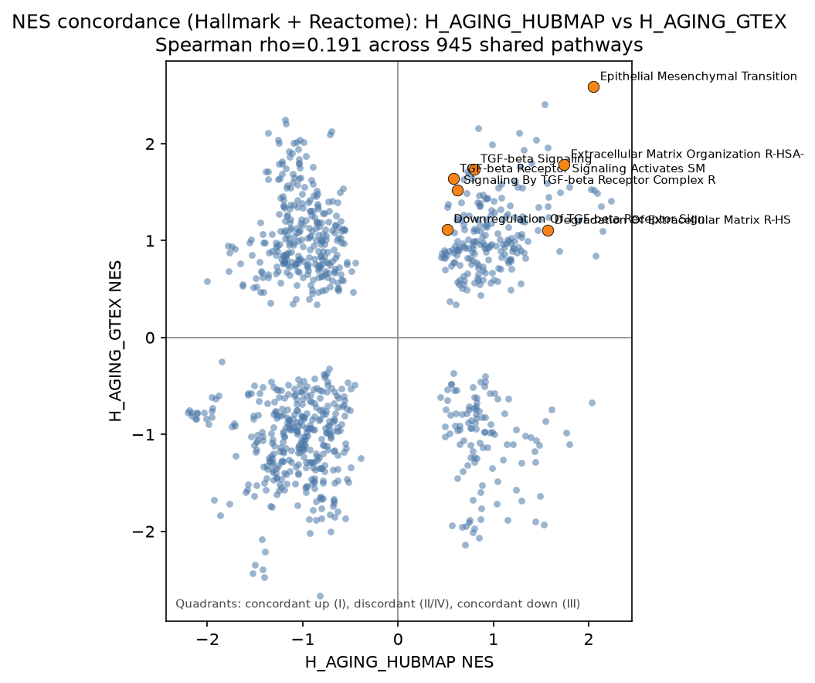
NES scatter for H_AGING_HUBMAP versus H_AGING_GTEX, a method-frame pair rather than a biology pair
Biology pairs are near-null to negative on global Spearman. That is context, not the headline. Aging-flight is the flattest of the four on this axis, rho -0.022 over 1,158 shared sets, and it is still the only pair whose pathway concordance clears its permutation null; global correlation and mechanism concordance answer different questions. The fourth scatter is the method frame pair (H_AGING_HUBMAP vs H_AGING_GTEX, rho 0.191 over 945 shared sets), a pipeline check on the 2 vs 2 illustration rather than a biology result.
Gene-set library sensitivity.
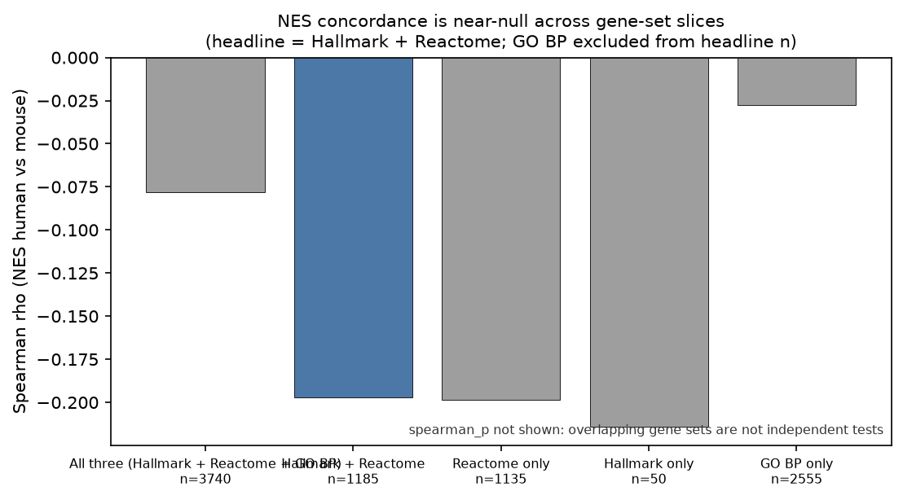
Bar chart of Spearman rho for the disease-aging NES pair across five gene-set library slices
The headline coefficient moves with the library it is computed on. For H_DISEASE vs H_AGING_GTEX, module4_nes_sensitivity.tsv reports Spearman rho -0.197 on the headline Hallmark plus Reactome universe (n = 1,185), -0.078 once GO BP is added to make all three libraries (n = 3,740), and -0.027 on GO BP alone (n = 2,555); Reactome alone gives -0.199 (n = 1,135) and Hallmark alone gives -0.214 (n = 50). A coefficient that ranges from -0.214 to -0.027 depending on which annotation happens to be loaded is describing the annotation at least as much as the biology. That instability, not modesty about effect size, is why the global correlation is supporting context and the permutation-tested pathway concordance is the headline.

Shared-mechanism concordance (headline)
set_id | n_mechanisms_total | n_mechanisms_unflagged | n_concordant_pathways | n_concordant_unflagged | perm_mean | perm_p_ge_obs
disease_aging | 5 | 5 | 5 | 5 | 3.0075 | 0.169
disease_flight | 0 | 0 | 0 | 0 | 0.42 | 1.0
aging_flight | 5 | 3 | 6 | 3 | 2.483 | 0.0255
three_way | 0 | 0 | 0 | 0 | 0.0345 | 1.0
Source: module4_mechanism_summary.tsv
The full null table module4_concordance_null.tsv carries 27 columns and does not fit a portrait page. The compact view below keeps the nine needed to read the close; the analytic null columns (E_both_pass, P_agree, E_concordant, analytic_ratio_obs_over_E), the unflagged and q<0.05 concordant counts, the permutation spread (perm_median, perm_sd, perm_ratio_obs_over_mean, n_permutations), the threshold stamps (fdr_q, nes_abs_min), and the third-contrast columns (contrast_c, k_c, p_c_up) used by the three-way row stay in the TSV.
set_id | N_shared_pathways | k_a | k_b | p_a_up | p_b_up | observed_concordant | perm_mean | perm_p_ge_obs
disease_aging | 1185 | 45 | 160 | 0.644 | 0.456 | 5 | 3.01 | 0.169
disease_flight | 1136 | 38 | 32 | 0.605 | 0.000 | 0 | 0.42 | 1.000
aging_flight | 1158 | 168 | 34 | 0.494 | 0.000 | 6 | 2.48 | 0.026
three_way | 1135 | 38 | 155 | 0.605 | 0.458 | 0 | 0.03 | 1.000
Passer counts (k_a, k_b) are computed inside each row's own shared-pathway universe, so the same contrast can show different k across rows. On the three-way row k_a and k_b are H_DISEASE and H_AGING_GTEX; flight sits in the k_c and p_c_up columns of the TSV.
pair_id | Term | NES_a | NES_b | FDR_a | FDR_b | direction | le_jaccard | suspect_flag
disease_aging | Cholesterol Biosynthesis R-HSA-191273 | -2.021249 | -1.957994 | 0.012417 | 0.00959 | down | 0.47619 | False
disease_aging | Keratinization R-HSA-6805567 | 2.004068 | 2.407191 | 0.0 | 0.0 | up | 0.214286 | False
disease_aging | Activation Of Gene Expression By SREBF (SREBP) R-HSA-2426168 | -1.878254 | -2.006322 | 0.124168 | 0.004359 | down | 0.3125 | False
disease_aging | Epithelial Mesenchymal Transition | 1.706697 | 2.589803 | 0.013321 | 0.0 | up | 0.344595 | False
disease_aging | Extracellular Matrix Organization R-HSA-1474244 | 1.701873 | 1.786559 | 0.036193 | 0.035369 | up | 0.267442 | False
aging_flight | Myc Targets V2 | -1.848522 | -1.559738 | 0.0 | 0.049132 | down | 0.346939 | False
aging_flight | Oxidative Phosphorylation | -1.835324 | -1.915239 | 0.0 | 0.0 | down | 0.469512 | True
aging_flight | Mitochondrial Fatty Acid Beta-Oxidation R-HSA-77289 | -1.743523 | -1.810352 | 0.044174 | 0.069165 | down | 0.423077 | False
aging_flight | Respiratory Electron Transport R-HSA-611105 | -1.6002 | -1.628869 | 0.107809 | 0.179397 | down | 0.454545 | True
aging_flight | Mitochondrial Protein Import R-HSA-1268020 | -1.559344 | -1.85967 | 0.121895 | 0.059439 | down | 0.480769 | False
aging_flight | Respiratory Electron Transport, ATP Synthesis By Chemiosmotic Coupling, Heat Production By Uncoupling Proteins R-HSA-163200 | -1.513786 | -1.716195 | 0.147571 | 0.155622 | down | 0.425532 | True
14 further columns in the source file. Source: module4_concordant_pathways.tsv
module4_concordant_pathways.tsv is the only artifact that names the pathways the close discusses. All 11 concordant rows are shown, 5 for disease-aging and 6 for aging-flight, with per-contrast NES and FDR, direction, tier, the q<0.05-in-both flag, the suspect flag, and the leading-edge Jaccard and intersection genes.
How to read the close.
- Disease-aging: five separate concordant pathways, grouped only by direction. Down: cholesterol biosynthesis, SREBF activation. Up: EMT, ECM organization, keratinization. Leading-edge clustering at Jaccard 0.5 merged none of them, so they are reported as five and not as blocks. The set is not above chance: 5 observed against a permutation null mean of 3.0, p 0.169. It does not survive as a shared-mechanism claim. Four of the five also pass q<0.05 in both contrasts; SREBF activation does not.
- ECM correction: global correlation invited an "ECM opposite" story; the pathway screen shows ECM terms passing up in both IPF and aging. That is why the coefficient is not the headline.
- Flight pairs: pathway passers are unanimously down (p_up = 0). Treat disease-flight and three-way as uninterpretable, not null, while that polarity holds. Spike-in size-factor and globin accounts were tested and rejected.
- Aging-flight: six concordant pathways, five after clustering merged the two Respiratory Electron Transport terms. Oxidative phosphorylation, mitochondrial fatty-acid beta-oxidation and mitochondrial protein import stay distinct. Myc Targets V2 is adjacent and reported separately. The six together exceed the permutation null, 6 observed against 2.48, p 0.026, and this is the only set that does. Three of the six carry a suspect flag (oxidative phosphorylation and both Respiratory Electron Transport terms), so the result stays suspect on composition and circadian grounds.
- HuBMAP aging: 2 vs 2 illustration; gene-level padj < 0.05 count can be zero.

5. Interpretation
Module 4's teaching point is epistemic: cross-ecosystem comparison is a contrast-level problem, not a matrix merge. Methods assets can pass while biology pairs stay near-null or uninterpretable.
What the results support.
- Calibration (ERCC, GeneLab, bridge) can succeed independently of concordance claims.
- Shared-mechanism tables with permutation p-values are the correct headline objects.
- Several popular overclaims (shared fibrotic flight program; ECM opposition from rho; one aging-IPF mechanism) are contradicted by the committed tables.
Two of these results are easy to overstate, and the distance between what the tables show and what a reader will assume is where the interpretation has to be careful.
For disease and aging, the tables show a small set of same-sign pathway hits spanning sterol and remodeling programs, and permutation testing does not place that set above chance. The supported claim is therefore a labeled hypothesis rather than a validated shared mechanism. Neither "IPF recapitulates aging" nor "aging recapitulates fibrosis" follows from these tables alone, and the accelerated-aging framing that motivates the comparison is what makes those readings tempting enough to need stating explicitly.
For flight, every pathway passer moves in the same direction. Until that polarity is explained, any cross-ecosystem concordance involving flight is uninterpretable rather than null. That distinction matters in both directions: "no shared pathways" is not available as a positive biological finding while p_up = 0 dominates the passer set, because an unexplained artifact and a true absence of shared signal are not the same result.

6. Extending this analysis
- Resolve the unanimous flight polarity first. p_up = 0 across M_FLIGHT pathway passers is the one result that stalls every flight-involving pair, and the spike-in size-factor and globin accounts are already excluded. A follow-up should test the remaining candidates directly: library composition by arm (module4_library_composition_by_arm.tsv is already exported), RNA integrity through the RIN sensitivity contrast, and collection-time and circadian confounding, with replication in a second independent flight dataset. Until one of those explains the polarity, disease-flight and three-way stay uninterpretable rather than null.
- Combining native levels needs a shared quantification, not a rescaling. Any claim that merges levels across these resources would require raw reads reprocessed through one pipeline, one annotation and one unit, in one species. That work is outside this package, and the native-levels panel in Results shows what the merge would be papering over.
- A powered HuBMAP aging statement needs a powered cohort. H_AGING_HUBMAP is a 2 vs 2 illustration whose gene-level padj < 0.05 count can be zero; supporting an aging claim from HuBMAP would need donor arms sized like the GTEx brackets and non-overlapping age ranges, since the teaching donors sit inside the GTEx middle brackets. Treat the current contrast as a method check.
- Lifting disease-aging above chance needs more signal or a narrower universe. On this run 5 observed against a permutation null mean of 3.0 gives p 0.169. A stronger analysis would raise per-contrast passer counts (deeper cohorts, more prerank permutations than the current 100) or pre-register a narrower pathway universe so the null is not diluted by 1,185 shared sets. Reporting the five as a labeled hypothesis is what the current numbers support.
- Clearing the suspect flag on aging-flight needs controls, not a smaller p. Three of the six concordant pathways are flagged (oxidative phosphorylation and both Respiratory Electron Transport terms). p 0.026 does not address whether those terms track cell-composition shifts or circadian state; matched composition estimates and collection-time metadata on both sides would.
- Stabilizing the global coefficient needs a fixed annotation. The disease-aging rho ranges from -0.214 to -0.027 across gene-set slices, so any future use of a global NES correlation as evidence should pre-commit to one library and report the sensitivity panel alongside it.
Forward link. Module 5 (no notebook) is a scientific communication assessment on these outputs, authored separately for the course package.

7. Open questions
- If methods calibration succeeds and biology concordance stays weak, what claim is still licensed?
- Why is global NES Spearman the wrong headline for shared mechanisms?
- Disease-aging gives five separate pathways, not above chance. What would promote that from hypothesis to claim?
- Flight pathway passers are all down after ERCC and globin checks failed to explain it. What confound remains on the table?
- Why keep flagged OxPhos / RET terms in the aging-flight set instead of dropping them?
- What does an empty three-way intersection mean for "spaceflight as accelerated aging" rhetoric?
- HuBMAP aging has zero genes at padj < 0.05. How should a learner read its NES passers?
- When should module4.sensitivity.enabled be turned on, and what does it cost?

Appendix A: Analysis parameters
Live values under module4 in config/paths.yaml. Section numbers match the Methods subsections.

1. Within-resource DE (pydeseq2)
Config key | Default | Definition | If modified | Impact on results
module4.thresholds.de_min_count_sum | 10 | Min count sum to keep a gene | Raise | Fewer genes in each DE table
module4.geo.include_diagnoses | [ipf, control] | GSE150910 diagnoses kept | Add diagnoses | Redefines disease cohort
module4.gtex.young_age_brackets | ["20-29","30-39"] | Young arm brackets | Narrow/widen | Redefines H_AGING_GTEX
module4.gtex.old_age_brackets | ["60-69","70-79"] | Old arm brackets | Narrow/widen | Same
module4.gtex.one_sample_per_subject | true | One lung sample per subject | Set false | Pseudo-replication
module4.gtex.max_subjects_per_arm | 40 | Cap per arm for runtime | Raise | More power; longer DE
module4.gtex.random_seed | 0 | Subject subsample seed | Change | Different GTEx draws
module4.hubmap_aging.older_donors | [Donor_3, Donor_4] | Older illustration arm | Swap donors | Tiny-n DE identity changes
module4.hubmap_aging.younger_donors | [Donor_1, Donor_2] | Younger illustration arm | Swap donors | Same
module4.osd248.* sample filters | ISS-T carcass ~60d; no LAR/baseline | Flight cohort definition | Loosen filters | Different M_FLIGHT n

2. Calibration of the flight contrast
Config key | Default | Definition | If modified | Impact on results
module4.osd248.exclude_ercc_from_size_factors | true | Omit ERCC- from size factors | Set false | Spike-in mass confounds arm scaling
module4.data.ercc_exfold_expected | data/reference/ercc_exfold_expected_fc.txt | Expected Mix1/Mix2 FC table | Replace file | Calibration slope/R2 change
module4.data.osd248_genelab_isst_de_subset | outputs/tables/module4_osd248_genelab_isst_de_subset.tsv | Committed GeneLab subset | Refresh subset | Spearman vs GeneLab changes
module4.thresholds.rin_sensitivity | 6.0 | QA/RIN threshold for sensitivity drop | Change | Optional filtered flight DE
module4.osd248.rin_sensitivity_threshold | 6.0 | Same threshold under osd248 block | Change | Same

3. Ortholog mapping (mouse to human)
Config key | Default | Definition | If modified | Impact on results
module4.data.orthologs | data/reference/human_mouse_orthologs_one2one.tsv | One2one table path | Replace table | Loss rates and mapped DE change
module4.orthologs_meta.orthology_type | ortholog_one2one | Declared mapping class | Use many2many | Double-counting risk (not teaching default)
module4.orthologs_meta.download_date | 2026-08-10 | Provenance stamp | Refresh table | Should match file bytes

4. HuBMAP-GTEx level bridge (demonstration only)
Config key | Default | Definition | If modified | Impact on results
module4.data.hubmap_pseudobulk | outputs/tables/module2_composition_weighted_pseudobulk.tsv | Composition-weighted vector | Rebuild Module 2 | Bridge scatter changes
module4.data.hubmap_max_across | outputs/tables/module2_max_across_labels_pseudobulk.tsv | Max-across vector | Rebuild Module 2 | Same
module4.data.gtex_tpm | data/source/GTEX/gene_tpm_v10_lung.gct.gz | GTEx TPM for means | Replace release | Bridge y-axis changes

5. Pathway NES and configured pairs
Config key | Default | Definition | If modified | Impact on results
module4.enrichment.prerank.min_size | 15 | Min overlapping genes | Raise | Drops small sets
module4.enrichment.prerank.max_size | 500 | Max set size | Lower | Drops large sets
module4.enrichment.prerank.permutation_num | 100 | GSEA permutations | Raise | Stabler FDR; slower
module4.enrichment.comparison_gene_sets | Hallmark, Reactome | Headline NES libraries | Add GO BP | Changes shared-term universe
module4.enrichment.sensitivity_gene_sets | Hallmark, Reactome, GO BP | Sensitivity-only libraries | Edit | Sensitivity table only
module4.sensitivity.enabled | false | Recompute GO BP sensitivity | Set true | Large RAM; regenerates sensitivity TSV
module4.sensitivity.table | outputs/tables/module4_nes_sensitivity.tsv | Committed sensitivity asset | Replace file | Sensitivity panel only
module4.nes_pairs | four pairs | Which NES scatters/summaries ship | Edit | Pair tables and figures
module4.params.nes_headline_pair | [H_DISEASE, H_AGING_GTEX] | Pair attached to sensitivity narrative | Switch | Which pair sensitivity comments target

6. Shared-mechanism concordance (headline)
Config key | Default | Definition | If modified | Impact on results
module4.mechanisms.fdr_q | 0.25 | Passer FDR threshold | Stricter | Smaller concordance sets
module4.mechanisms.nes_abs_min | 1.5 | Absolute NES gate | Raise | Fewer passers
module4.mechanisms.fdr_q_strict | 0.05 | Stricter annotation threshold | Change | Secondary labels only
module4.mechanisms.cluster_jaccard_min | 0.5 | Mechanism clustering Jaccard | Lower | Larger merged clusters
module4.mechanisms.n_permutations | 2000 | Null permutations | Raise | Stabler permutation p
module4.mechanisms.random_seed | 0 | Permutation RNG | Change | Null draws differ slightly
module4.mechanisms.top_intersection_genes | 40 | Genes listed from LE intersection | Raise | Wider gene lists in tables

References
- GTEx Consortium. The GTEx Consortium atlas of genetic regulatory effects across human tissues. Science. 2020;369(6509):1318-1330. PMID: 32913098.
- Furusawa H, et al. Chronic Hypersensitivity Pneumonitis, an Interstitial Lung Disease with Distinct Molecular Signatures. Am J Respir Crit Care Med. 2020;202(10):1430-1444. PMID: 32602730. (GSE150910)
- Love MI, Huber W, Anders S. Moderated estimation of fold change and dispersion for RNA-seq data with DESeq2. Genome Biol. 2014;15(12):550. PMID: 25516281.
- Muzellec B, et al. PyDESeq2: a python package for bulk RNA-seq differential expression analysis. Bioinformatics. 2023;39(9):btad547. PMID: 37669147.
- Subramanian A, et al. Gene set enrichment analysis: a knowledge-based approach for interpreting genome-wide expression profiles. Proc Natl Acad Sci U S A. 2005;102(43):15545-15550. PMID: 16199517.
- Hayslip N, et al. Space radiation and microgravity as models of accelerated aging: modulation of hepatic miRNA-TGF-beta networks associated with senescence and fibrosis. GeroScience. 2026. PMID: 42337157.
- Ruprecht NA, et al. Establishing a genomic radiation-age association for space exploration supplements lung disease differentiation. Front Public Health. 2023;11:1161124. PMID: 37250098.
- NASA Open Science Data Repository / GeneLab. OSD-248 (GLDS-248), rodent spaceflight lung RNA-seq resource.

