**LakeConditionService Web Service:**

This documentation is used to help anyone who wants to make some change in the web service source code and recompile it. They also need to ask Mark for the permission to deploy the app into the tomcat.

The source code, the compiled war and the dependency lib has been pushed into GitHub along this documentation.

Source code structure:

database: Those classes help establish the connection and send the queries

model: The model for Lake Condition. If you need to add fields for lake condition, add it here

resources: Try to map the url to this file

services: The main class for the program

utils: it sets the connection by reading dbDrive and connection from db.properties

LakeCondition Web Service Brief overview:

API: http://localhost:8080/LakeConditionService/

Host: [thalassa.limnology.wisc.edu:8080](http://thalassa.limnology.wisc.edu:8080). (Argyon has been dead for a long time)

Tools: Eclipse, Tomcat, My SQL

Technologies: Java 7, JAX-RS (Jersey Implementation)

Dependency: jdbc, common-langs, javax

You can find the data table in the original documentation

**Make Change in Source Code:**

What I did is to replace the class in the war file (you can see the inside by extracting file from war) with the new compiled class, and then make war with this command “ jar -cvf my_web_app.war *” in the directory. It can avoid some dependency problems.

For recompilation the code, I suggest you to have a eclipse which can help you. In the eclipse, create a new project, and move the sources code into the project by dragging the file into the src in package explorer. With the help of eclipse mistake fix system, make the structure look like this.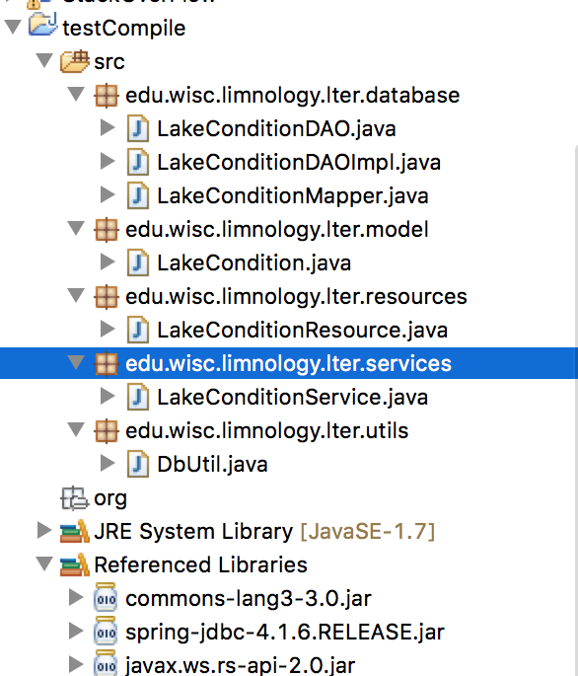 Don’t forget to add the dependences as the referenced libraries

Try to build it, not run. Just build, and find the corresponding .class file in the project bin. Now you have the compiled classes

**Deployment:**

SSH into thalassa, and go to this directory:

/var/lib/tomcat7/webapps/

You will see the old LakeConditionService.war.

Save this war to some place, don’t delete it. If you delete it or replace it, you can’t redo it….

SCP your war to this directory, and you will see the war get extracted by Tomcat automatically.

Now you can go to [thalassa.limnology.wisc.edu:8080](http://thalassa.limnology.wisc.edu:8080) to check whether your code works. I highly recommend to build the test environment (apache, tomcat) on your workstation.

This documentation might contain something wrong, as a developer you probably know that almost nothing can get done in its first time. Please be patient and try you best! This took me 2 weeks to figure out.