Gun deaths

2020-05-06

# Gun deaths by age

We have data about 100798 individuals killed by guns. Only 15687 are older than 65. The distribution of the remainder is shown below:

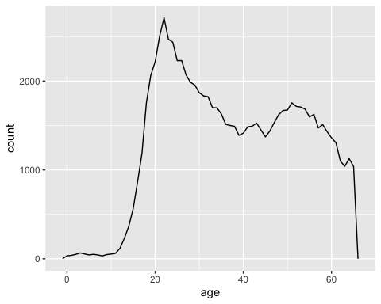

The peak of the distribution is around 22 years of age, with a second smaller peak around 50 years of age.

# Gun deaths by race

