Collin Fabian

Analysis Notes

1. Sources:
   1. “Provisional COVID-19 Death Counts by County and Race” - <https://data.cdc.gov/NCHS/Provisional-COVID-19-Death-Counts-by-County-and-Ra/k8wy-p9cg>
   2. “Annual County Resident Population Estimates by Age, Sex, Race, and Hispanic Origin: April 1, 2010 to July 1, 2019 (CC-EST2019-ALLDATA)” - <https://www.census.gov/data/tables/time-series/demo/popest/2010s-counties-detail.html>
   3. “COVID-19 Case Surveillance Public Use Data” - <https://data.cdc.gov/Case-Surveillance/COVID-19-Case-Surveillance-Public-Use-Data/vbim-akqf>
2. Notes on Data:
   1. “Provisional COVID-19 Death Counts by County and Race”
      1. Variable Descriptions

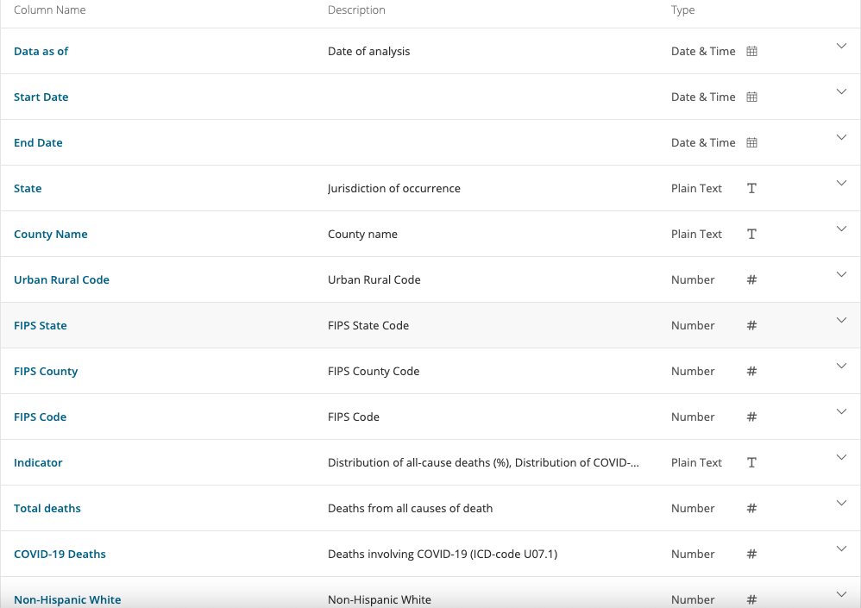

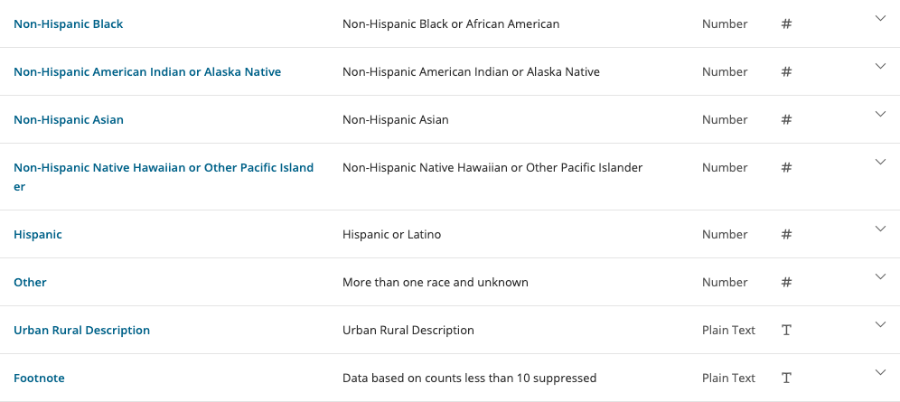



1. KNN
   1. Identify likelihood that an average county will be over national death average based on minority population as a proportion of total population.
2. ANOVA – Multi factoring (race and income)
   1. Compare number of deaths / 100k
3. Naïve Bayes
   1. Identify conditional probabilities of death based on Race

$H0: \hat{μ_{Main}}=\hat{μ_{Interact}}$

$$HA: \hat{μ_{Main}}≠\hat{μ_{Interact}}$$