As real-world example two packages from Symfony were taken: symfony/process [4] and symfony/routing [5]. These packages are part of Drupal/PHPBB3 and other projects. Packages are installed from Composer manager [6].
Create composer.json file:
$ cat composer.json
{
"require": {
"symfony/process": "v3.4.47",
"symfony/routing": "v3.4.47"
}
}
Run composer installer:
$ composer install
Installer creates vendor/ directory with PHP source files.

Search for code line to rewrite zval:
$this->exitcode = $this→processInformation['exitcode'];
This line located in method of class Process and very possible can be reached from __destruct method.

Search for class that implements Serializable
./routing/Route.php:class Route implements \Serializable
It has unserialize method with another unserialize function call.
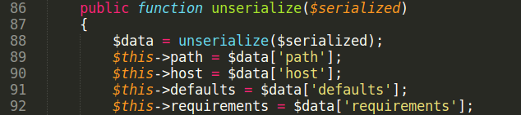

Let us run exploit and understand how it works.
Set two breakpoints in gdb. First, when GMP object is created.

gdb-peda$ b gmp.c:640
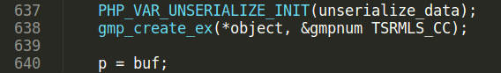

Another breakpoint, where type confusion bug happens.
gdb-peda$ b gmp.c:661
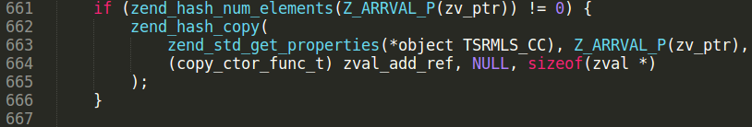
Rub gdb, unserialization of GMP object properties starts.
Stop on line 640 and print object zval. It is GMP object with handle = 0x3
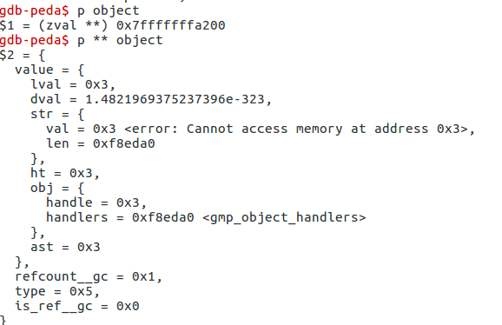

Set breakpoint on unserialize call.
gdb-peda$ b var.c:967
Continue execution.

Execution reaches second unserialize function call, located in unserialize method of Route class.
Because of invalid serialization string (it hash “A” char instead of closing bracket at the end), php_var_unserialize call returns false and zval_dtor(return_value) is called. If the zval_dtor argument has object type, it’s __destruct method executes.
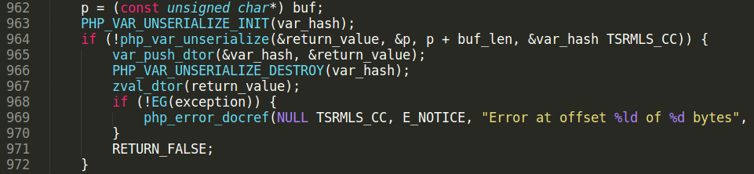
Output return_value using printzv macros. It is object of Process class with unserialized properties.

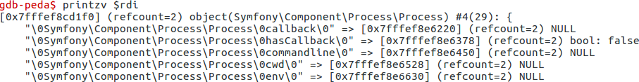
Start POI chain from __destruct method of Process class:
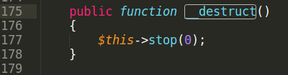

Code line to rewrite zval is located in close() method.
$this->exitcode = $this→processInformation['exitcode'];

Execution reaches updateStatus method:

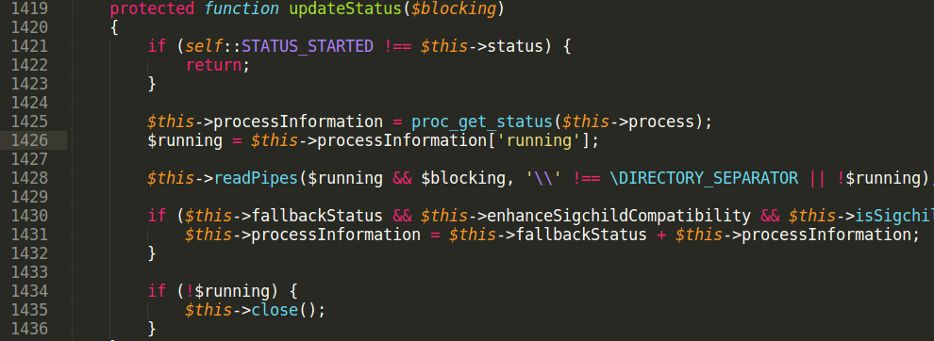
Another problem is that proc_get_status returns false because $this→process is not resource.
$this->processInformation property is assigned to false. So we can’t set $this->processInformation right in serialized string.

There is some code after proc_get_status called:
if ($this->fallbackStatus && $this->enhanceSigchildCompatibility && $this->isSigchildEnabled()) {
$this->processInformation = $this->fallbackStatus + $this->processInformation;
}

To pass $this→isSigchildEnabled() condition PHP needs to be compiled with “–enable-sigchild” option.
If processInformation is false, addition of false and array gives Fatal error and script stops. But we need to write into processInformation by somehow.
In PHP language, variable is deleted from memory, when it’s refcount becomes 0. If a variable is an object, it’s __destructor method executes. Look closer on this line:
$this->processInformation = proc_get_status($this→process);

Rewrite of processInformation property can lead to __destruct execution because refcount becomes 0. We can use reference (R:) again to rewrite processInformation in called __destruct method. ProcessInformation needs to have an array type not to throw Fatal error. There is another class in symfony/process that has empty array assignment.

abstract class AbstractPipes implements PipesInterface
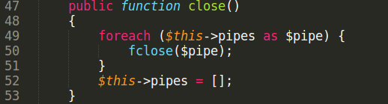

Make $this->pipes reference to $this→processInformation. They point into same zval in memory.
When $this→pipes is assigned an empty array, then $this→processInformation too.

$this->fallbackStatus is merged with $this->processInformation
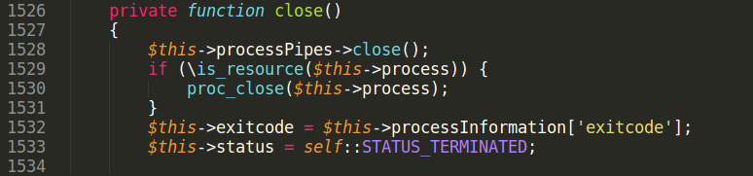
After that close() method executes where line of code to rewrite zval is located.
$this->exitcode is reference to GMP object in serialized string, writing into $this->exitcode rewrites zval of GMP object. Value to write is taken from $this→fallbackStatus[‘exitcode’] and equal to i:1; in exploit string.

Continue execution.
See what happened with GMP zval.
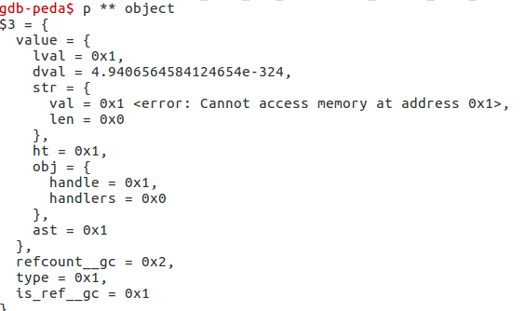

Handle of GMP zval is equal to fallbackStatus[‘exitcode’] it is 0x1.

See what function zend_std_get_properties does.
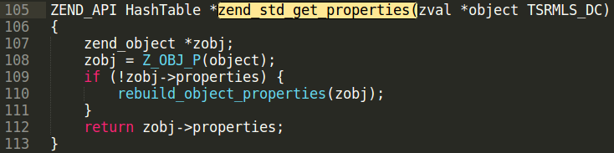
Z_OBJ_HANDLE_P(zval_p) Z_OBJ_HANDLE(*zval_p)
#define Z_OBJ_HANDLE(zval) Z_OBJVAL(zval).handle
#define Z_OBJVAL(zval) (zval).value.obj

Z_OBJ_HANDLE_P(zval_p) returns zval_p.value.obj.handle it is an object handle taken from zval structure. Z_OBJ_P macro takes a object handle number, and returns property hashtable of object with the given handle number. zend_hash_copy copies props of GMP object into this hashtable.
Handle number is fully controlled from exploit. Using this bug an attacker can rewrite props of any object in PHP script.

What object is good to rewrite properties?
Symfony packages were installed using Composer. Composer has class autoloading mechanism.
When autoload.php script included, object ClassLoader registered by spl_autoload_register as class autoload handler. When any new not loaded class is used, autoload handler executes.

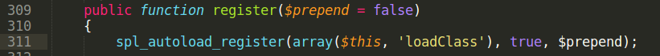
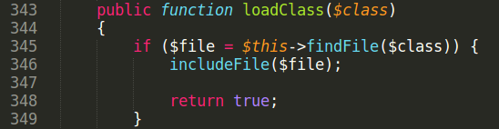

classMap property stores a dictionary of classes and files for this classes to be autoloaded. Rewrite classMap property of ClassLoader object results into arbitrary file include.

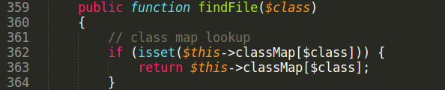

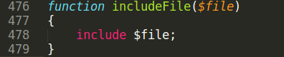

Many applications include ‘autoload.php’ very first. ClassLoader object will have handle = 0x1!
No need to bruteforce handle. It makes exploit very stable.

To write 0x1 into handle id no need to create integer zval, attacker can use boolean type. PHP boolean type is represented in memory as 0 or 1 integer.
Code lines like $this→prop = true are more common in real code than property assignment demonstrated previously. Most importantly, with boolean zval it is still possible to overwrite Composer object. Usage of $this→prop=true is demonstrated in another advisory.

References:
[1] https://bugs.php.net/bug.php?id=70513
[2] https://www.phpinternalsbook.com/php5/zvals/basic_structure.html
[3] https://www.php.net/manual/en/class.serializable
[4] http://packagist.org/packages/symfony/process
[5] http://packagist.org/packages/symfony/routing
[6] https://getcomposer.org/

