<https://github.com/pschatzmann/ESP32-A2DP>

<https://www.pschatzmann.ch/home/2021/01/07/esp32-tone/>

<https://www.reddit.com/r/esp32/comments/an8u1t/hacky_messy_notes_on_how_i_got_audio_playing_from/>

<https://www.reddit.com/r/esp32/comments/an8u1t/hacky_messy_notes_on_how_i_got_audio_playing_from/>

<https://github.com/gtalusan/esp-idf/tree/6a9927ee21524153504b08c078c676fdbf016d3f/examples/bluetooth/a2dp_source>

<https://www.esp32.com/viewtopic.php?f=19&t=12214&sid=95ef7379892411f2e56c8de476508fc8>

<https://esp32.com/viewtopic.php?t=2159>

<https://www.reddit.com/r/esp32/comments/ah9c2t/has_anyone_played_sound_from_an_esp32_to_a/>

**Adafruit HUZZAH32 – ESP32 Feather Board**

Product Dimensions: 51.0mm x 22.7mm x 7.3mm / 2.0" x 0.9" x 0.3"

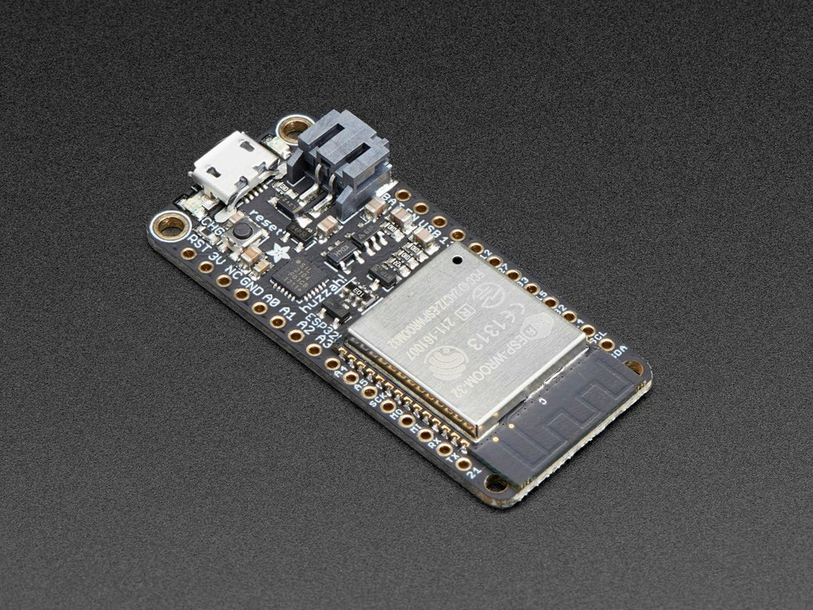

**Sending Sound from an ESP32 to a Bluetooth Sink (e.g. Bluetooth Speaker)**

<https://www.pschatzmann.ch/home/2020/09/15/sending-sound-from-an-esp32-to-a-bluetooth-sink-e-g-bluetooth-speaker/>