1. A steady-state heat balance for a rod can be represented as:
2. Obtain the analytical solution for a 10 m rod with T(0) = 240 and T(10) = 150
3. Use the shooting method to solve the problem
4. Use the finite-difference approach with Δx = 1 to solve the problem.

2. Fit the function to the data and compute the standard deviation

|  |  |  |  |  |  |
| --- | --- | --- | --- | --- | --- |
| x | 0.5 | 1.0 | 1.5 | 2.0 | 2.5 |
| y | 0.541 | 0.398 | 0.232 | 0.106 | 0.052 |

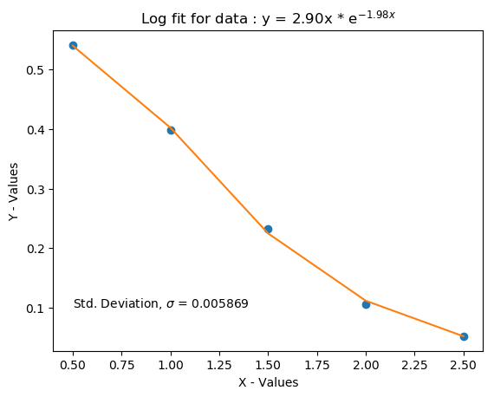

Description

3. The equations of motion for a double pendulum are given by: