Study Guide

Exam 2: Chapters 5 to 7

Feedback Control Theory

No books or notes on this exam. FE-exam approved calculators only.

Short Answer (50 points total)

These are the questions I will pick from when making the short answer portion of the exam. I will not change the questions.

Chapter 5

1. **Name the four components of a block diagram for a linear, time-invariant system. (pg. 237)**

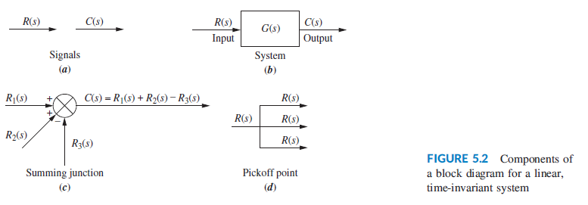

1. **Name three basic forms for interconnecting subsystems and for each of the forms, state how the equivalent transfer function is found. (pg. 238-240)**

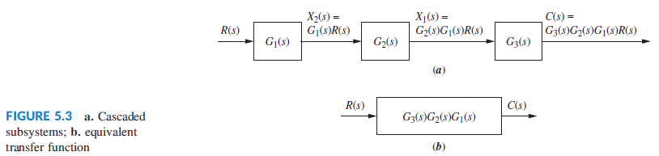

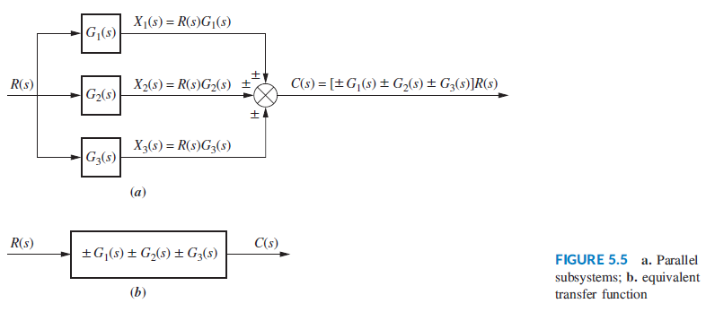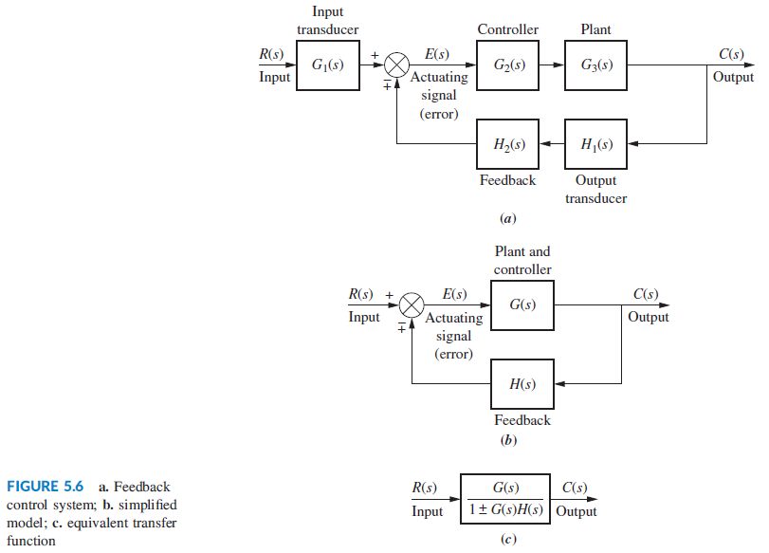

1. 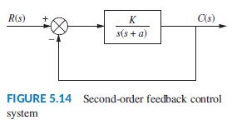**For a simple, second-order feedback control system of the type shown in Figure 5-14, describe the changes in damping ratio as the gain, K, is increased over the underdamped region. (pg. 246)**

$$T\left(s\right)= \frac{K}{s^{2}+as+K}$$

For gains above a2/4, the system is underdamped, with complex poles located at:

$$s_{1,2}= -\frac{a}{2} ±j \frac{\sqrt{4K-a^{2}}}{2}$$

As K increases, the real part remains constant and the imaginary part increases. This causes the peak time to decrease while the %OS increases. The settling time remains constant.

1. 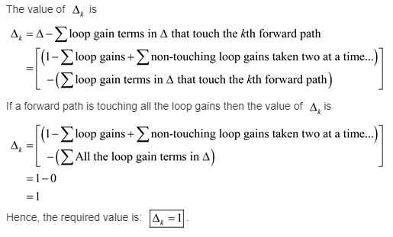**If a forward path touched all closed loops, what would be the value of deltak? (Chegg)**
2. **Name four of the five representations of systems in state space. (pg. 278)**
   1. Phase-variable
   2. Cascaded
   3. Parallel
   4. Controller Canonical
   5. Observer Canonical
3. **Which two forms of the state-space representation are found using the same method? (pg. 261, lecture notes 9/25/18)**

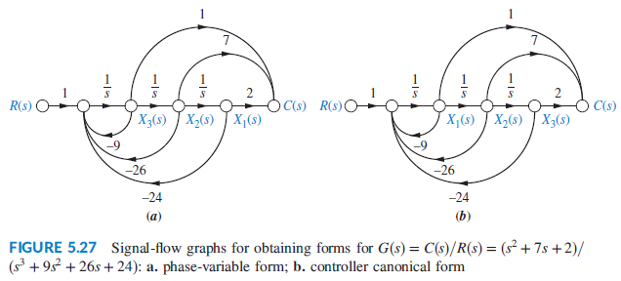

1. **When the system matrix is diagonal, what quantities lie along the diagonal? (pg. 258-259) [60% certain]**

In cascading form, the diagonal contains the system poles but the A matrix is not completely diagonal. In parallel form, the resulting diagonal system matrix contains a first order differential equation in only one variable. Parallel form requires that the denominator of the transfer function contains only unique and real roots.

1. **Give two reasons for wanting to represent a system by alternative forms. (pg. 256)**
   1. One set of state variables with its unique representation can model actual physical variables of a system such as amplifier and filter outputs. (ease of modeling)
   2. A particular choice of state variables can decouple the system of simultaneous differential equations into multiple first order differential equations that can be solved individually. (ease of solution)
2. **What is the definition of an eigenvector and what is the definition of an eigenvalue? (pg. 267-269)**

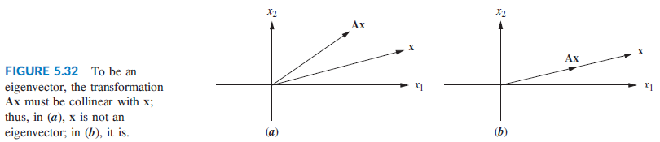

If matrix A is a transformation of vector x, then the eigenvector x is a vector that points along the same line both before and after the transformation. The transformation of eigenvector x by matrix A changes the length but not the direction of the vector. The eigenvalue is the amount of stretching or shrinking that the eigenvector undergoes due to the transformation.

1. **What is the significance of using eigenvectors as basis vectors for a system transformation? (pg. 269)**

Using the eigenvectors of matrix A as the basis for a transformation P, yields a diagonal matrix with eigenvalues of the system along the diagonal. Diagonal matrices are convenient for computations and the transformed system is the same result we would get from partial fraction decomposition of the transfer function with unique and real roots.

Chapter 6

1. What part of the output response is responsible for determining the stability of a linear system?
2. What does the Routh-Hurwitz criterion tell us? What does this mean about the system's stability?
3. Chapter 6, problem 1
4. What causes a zero to show up only in the first column of the Routh table?
5. What causes an entire row of zeros to show up in the Routh table?
6. Why do we sometimes multiply a row of a Routh table by a positive constant?
7. How do we find the eigenvalues from the state space representation?

Chapter 7

1. Name two sources of steady-state errors.
2. How many integrations in the forward path are required in order for there to be zero steady-state error for a ramp input?
3. Increasing system gain has what effect upon the steady-state error?
4. Define system type. Show it using a transfer function and a block diagram with feedback.
5. What effect does feedback have upon disturbances?
6. For a step input disturbance at the input to the plant, describe the effect of controller gain upon minimizing the effect of the disturbance. Also consider the effect of plant gain.
7. Explain the difference between the actuating signal and the error signal (as described section 7.6).
8. Define, in words, sensitivity and describe the goal of feedback-control-system engineering as it applies to sensitivity.

Problems: (50 points) I will ask problems that are similar, but not exactly the same, as some of the following book problems. Be sure to review the solutions to these problems before the exam.

Chapter 5 Problem 7

Chapter 5 Problem 34a (homework)

Chapter 6 Problem 28 (in class)

Chapter 6 Problem 33 (homework)

Chapter 7 Problem 13 (in class)

Chapter 7 Problem 53 (homework)