Study Guide

Exam 3: Chapters 8 to 9

Feedback Control Theory

No calculators, books or notes on this exam.

Short Answer (40 points total)

These are the questions I will pick from when making the short answer portion of the exam. I will not change the questions.

$$T_{p}= \frac{π}{ω_{n}\sqrt{1-ζ^{2}}}$$

Chapter 8

1. What is a root locus? PG 386

**The representation of the paths of the closed loop poles as gain is varied.**

1. Do the zeros of a system change with a change in gain? Why or why not?

**No, the zeros are dependent on the numerator in th forward path transfer function and are a characteristic of the system.**

1. What are two ways to find where the root locus crosses the imaginary axis?
   1. **Routh Array Method**
      1. **Generate routh array from Δ(s) = G{den} + G{num}**
      2. **Find the gain K that causes the system to oscillate.**
      3. **Use this gain to find the frequency of oscillation, ω. The locus crosses the imaginary axis at this frequency.**
   2. **Set s = jω and plug into Δ(s) = 0. This yields 2 equations (real and imaginary parts) and 2 unknowns to solve for K and ω. K is the gain that causes steady oscillation.**
2. How can you tell from the root locus if a system is unstable?

**Gain inputs to a system that create closed loop poles on the right half plane of the root locus plot will yield an unstable solution for that range of K.**

1. How can you tell from the root locus if the settling time does not change over a region of gain?

$T_{s}= \frac{4}{ζω_{n}}$ 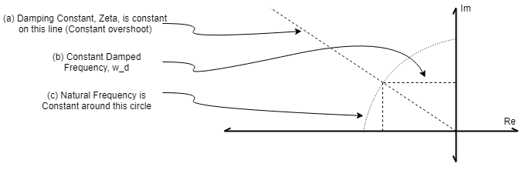

For settling time to remain the same, the product of the damping constant and the natural frequency must be the same.

1. How can you tell from the root locus that the natural frequency does not change over a region of gain?

**The natural frequency is the same for solutions that are the same distance away from the origin of the real and imaginary plane**

1. How would you determine whether or not a root locus plot crossed the real axis?

**Any time a system has a breakaway or break in point, the root locus plot crosses the real axis. Also, if the system has any zeroes or poles with imaginary parts, then at least a portion of the root locus plot will be on both sides of the real axis.**

1. Briefly describe how the zeros of the open-loop system affect the root locus and the transient response.

**Adding a zero can reduce the number of asymptotes. This can also affect the location of where the asymptote crosses the real axis. PD controllers can be used to reduce settling time by adding a zero in the system.**

Chapter 9

1. Name two major advantages of the design techniques of chapter 9 over the design techniques of chapter 8.

**Chapter 8 looked at only the response to the gains of a system along the root locus. Chapter 9 involves changing the root locus plot to induce desirable characteristics from the system by making modifications to the transfer function itself. This can allow for the design of a system response for parameters that are not on the root locus. The end effect is an improvement of the transient response or the reduction of steady-state error.**

1. What kind of compensation improves the steady-state error?

**Proportional-integral (PI) controllers induce lag compensation that raise the system type and reduce steady state error.**

1. What kind of compensation improves both steady-state error and transient response?

Lead-lag compensation both adds a derivative and an integral that increase the type number of the system reducing steady state error and dampen the overshoot

1. Cascade compensation to improve the steady-state error is based upon what pole-zero placement of the compensator? Also, state the reasons for this placement.
2. What are the advantages and disadvantages of using a passive lead network instead of an active PD controller?

**A passive lead network does not rely on an active circuit to perform differentiation. The active PD controller is vulnerable to input that contains high frequency noise from unwanted signals. The passive lead network is an approximation to the PD controller response. The result from lead compensation is that a compensator zero and pole come out where the pole must be further from the imaginary axis than the zero to contribute a positive angular contribution to the system.**

1. **No additional power supplies are required**
2. **Noise due to differentiation is reduced**
3. **Addition of the zero reduces the number of branches of the root locus that cross into the right half plane on the PD controller which does not happen with lead compensation**
4. In order to speed up a system without changing the percent overshoot, where must the compensated system’s poles on the s-plane be located in comparison to the uncompensated system’s poles?

**The desired dominant closed loop poles will be on the same damping ratio line but further away from the origin to reduce settling time.**

1. Why is there more improvement in steady-state error if a PI controller is used instead of a lag network?

**The PI controller increases the type of the system which drives the steady state error to zero over time. The lag compensator pole zero pair often must introduce a pole away from the origin to limit the angular contribution of the compensator. With the pole and zero close to one another.**

Problems: (60 points) I will ask problems that are similar, but not exactly the same, as some of the following book problems. Be sure to review the solutions to these problems before the exam.

Chapter 8: Problem 1

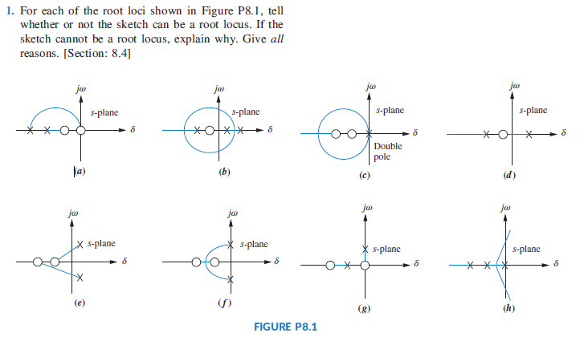

Chapter 8: Problem 26

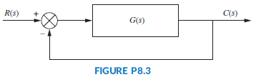

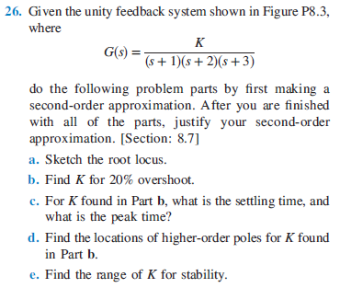

Chapter 8: Problem 30

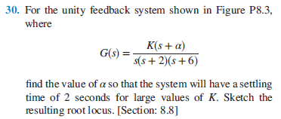

Chapter 9: Problem 6

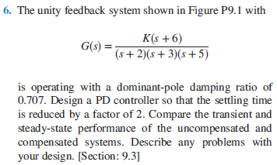

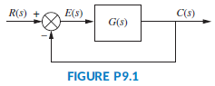

Chapter 9: Problem 21

