Study Guide

Exam 4: Chapters 10 and 11

Feedback Control Theory

No books or notes on this exam. FE exam-approved calculators only.

Short Answer

These are the questions I will pick from when making the short answer portion of the exam. I will not change the questions.

Chapter 10

**1. Name three advantages of frequency response techniques over the root locus**.

1. This method is easier to model transfer functions from physical data
2. It is easier to design a controller that is able to meet a steady-state error and a transient response requirement using lead compensators
3. It is better for finding the stability of nonlinear systems
4. It can be better at settling ambiguities when sketching a root locus

**2. Define frequency response as applied to a physical system.**

An input to a physical system will generate a sinusoidal response that is different in both magnitude and phase. The magnitude frequency response is the ratio of the output sinusoid’s magnitude to the input sinusoid’s magnitude. The phase frequency response is the difference in phase angle between the output and the input sinusoids.

$$M\left(ω\right)= \frac{M_{o}(ω)}{M_{i}(ω)} ϕ\left(ω\right)= ϕ_{o}\left(ω\right)- ϕ_{i}\left(ω\right)$$

**3. Each pole of a system contributes how much of a slope to the Bode magnitude plot?**

Pure integrations in the forward path produce an initial slope of -20dB/decade in the magnitude plot of a bode diagram. Each additional pole increases the final (high frequency) slope by -20dB/decade.

**4. A system with three poles and one zero would exhibit what value of slope at high frequencies in a Bode magnitude plot?**

Each pole contributes -20 dB/decade and the zero contributes +20dB/decade to the high frequencies in the Bode magnitude plot. The high frequency slope of a system with 3 poles and 1 zero is -40dB/decade.

**5. Describe the asymptotic phase response of a system with a single pole at s = -10.**

The phase diagram will begin at a phase angle of 0°, then break at a frequency of 1Hz, ending with a phase angle of -90° after 2 decades

**6. What are two differences between Bode magnitude plots for first-order systems and for underdamped second-order systems?**

First order systems can be approximated using straight line approximations. First order systems cannot have a final high frequency slope greater than ±20 dB/decade where second order systems can have a final high frequency slope between ±40 dB/decade.

**7. Illustrate phase margin and gain margin on a Nyquist diagram.**

**8. Illustrate phase margin and gain margin on a Bode diagram.**

**9. Name two different frequency response characteristics that can be used to determine a system's transient response.**

**10. Briefly explain how to find the static error constant from the Bode magnitude plot.**

**Chapter 11**

**1. What major advantage does compensator design by frequency response have over root locus design?**

**2. How is gain adjustment related to the transient response on the Bode diagrams?**

**3. Briefly explain how a lag network allows the low-frequency gain to be increased to improve steady-state error without having the system become unstable.**

**4. From the Bode diagram viewpoint, briefly explain how a lead network increases the speed of the transient response.**

**Problems: I will ask problems that are similar, but not exactly the same, as some of the following book problems. Be sure to review the solutions to these problems before the exam.**

**Chapter10: Draw the straight line approximation of the Bode diagram for the following transfer function:**

$$G\left(s\right)=2∙\frac{s+10}{(s+1)(s+100)}$$

**Chapter 10: Estimate phase margin and gain margin graphically from the following Bode plot of an open loop transfer function. Also, estimate the bandwidth of the closed loop transfer function**

.

**Chapter 10: From the following bode diagram, determine the functional form of the transfer function and then estimate any constants in that transfer function.**

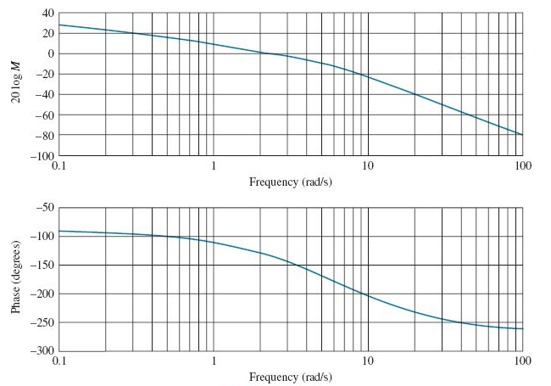

**Chapter 11 Problem 2b**

**Chapter 11 Problem 5: Given the problem statement and the resulting compensator that solves the problem, explain using complete sentences and diagrams why that specific compensator (the type of compensator and the values for the gain, pole and zero) was selected.**