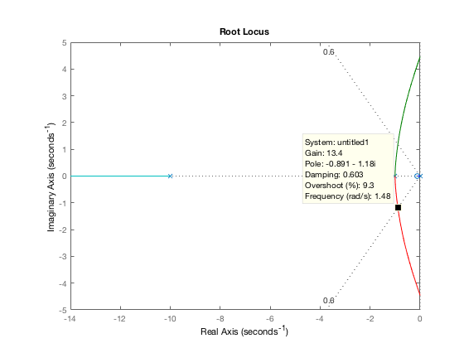Problem 1

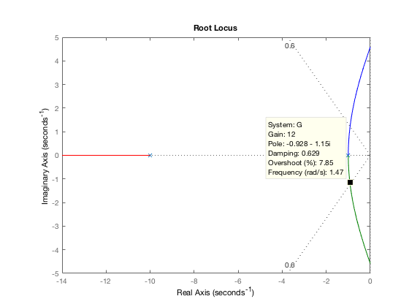Root locus plot of uncompensated system generates dominant poles at s1,2= -0.891± j1.18 with a gain of 13.4

Root locus plot of compensated system. Adding a zero at -0.1 creates pole zero cancellation that moves the dominant pole pair to -0.928 ± j1.15 with a corresponding gain of 12. Since the higher order pole stays at s=-10, the approximation is valid.

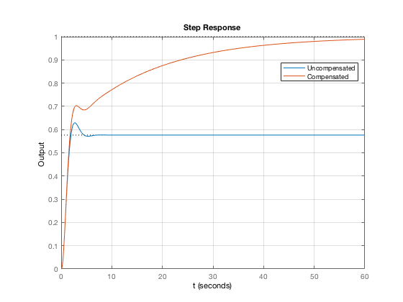

The step response for the compensated and uncompensated systems with the PI controller at a zero steady state error. PI controller for step response is $G\left(s\right)= \frac{K(s+0.1)}{s{\left(s+1\right)}^{2}(s+10)}$

G = zpk([], [-1 -1 -10],1);

rlocus(G);

sgrid(0.6, 0);

axis([-14 0 -5 5])

Gc = zpk([-0.1],[0],1);

rlocus(Gc\*G);

sgrid(0.6,0);

axis([-14 0 -5 5])

syms t

t = 0:0.0001:60;

G2 = zpk([],[-1 -1 -10],13.6);

G2c = zpk([-0.1], [0 -1 -1 -10],13.4);

step(feedback(G2,1),t);

hold on

step(feedback(G2c,1),t);

grid

xlabel t

ylabel Output

legend('Uncompensated','Compensated')