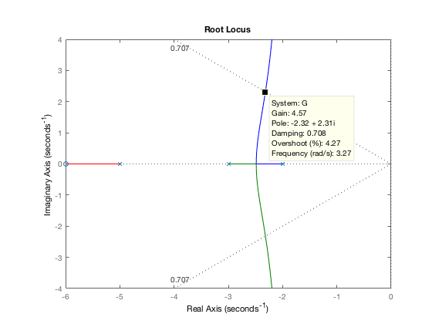Prob 6

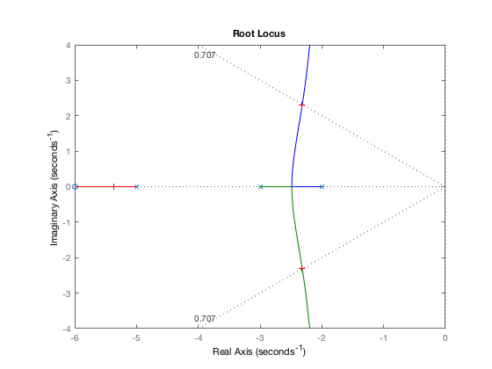Settling time for uncompensated system is 1.72 seconds.

Plot generated from selecting a point using the command rlocfind(G) as pole input to the matlab script. New gain was found to be K = 4.6319 and the compensator used was (s + 7.2073)

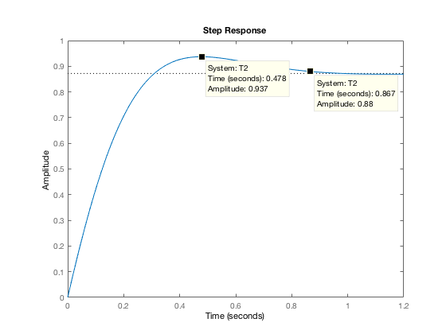Settling time was reduced to 0.86 seconds but the uncompensated steady state error was 0.94 while the compensated system generated a steady state error of 6.8151.

G = zpk([-6],[-2 -3 -5],1);

rlocus(G);

sgrid(1/sqrt(2), 0);

axis([-6 0 -4 4])

[gain, poles] = rlocfind(G);

t_settle = 4/-real(poles(2));

sigma_new = 8/t_settle;

s_new = -sigma_new +sigma_new*1i;

new_angle = ((s_new + 6) / ((s_new + 2)*(s_new + 3)*(s_new + 5)));

contrib = angle(new_angle)*(180/pi);

needed_angle = 180-contrib;

z_c = (sigma_new / tand(needed_angle)) + sigma_new

comp_gain = abs(((s_new + 2)*(s_new + 3)*(s_new + 5)) / ((s_new + 6)*(s_new + z_c)));

close

G2 = zpk([-6 -z_c],[-2 -3 -5],comp_gain);

T2 = feedback(G2, 1);

step(T2)

ess_uncomp = 6*comp_gain / (2*3*5)

ess_comp = 6*comp_gain*z_c / (2*3*5)