Historically, analog devices have been used in the design of systems that evoke an appropriate response to the state of a system. One classical example of an analog control device is the float valve on a toilet that closes when the water of the tank has reached a certain level. Servo motors can infer the position of the output arm using a potentiometer with the wiper set parallel to the motor arm which sends an analog voltage signal to the controller.

In more modern applications, analog devices have been replaced by digital electronics for a variety of reasons. Recent advances in computing power often mean that a digital signal can be represented with 12 or more bits of precision to represent a single measurement value. This means that there are usually at least 4096 registers to divide a measurement across, where analog signals are vulnerable to noise or power supply drift. The mathematical operations involved in digital signal processing are more precise, where analog devices rely on components that can operate along a tolerance range which can compound errors when multiple devices are used. Digital controllers are much easier to modify in the field using small changes in software whereas analog systems would likely need to exchange physical components. [1] After considering all these factors, and accounting for the comparable speed and decreased cost, it is apparent that digital controllers can play an important role in many engineering applications.

A unity feedback controller is a system that accepts a set point or desired signal value, passes the signal to a controller and a plant, and then compares the output signal to the desired signal and passes the error term back into the controller. In the simplest type, called proportional control, the error is adjusted through a single gain before moving on to the controller and the plant. The error signal is proportional to the output, without any other types of gain to

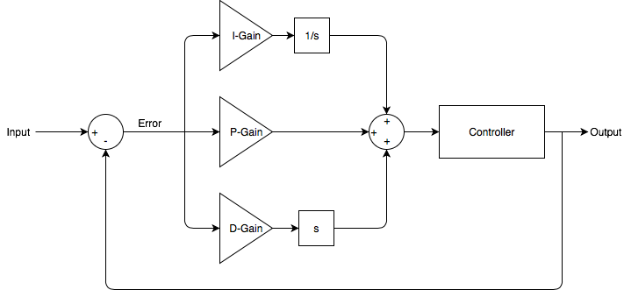

The proportional response is a direct reaction to the error or actuating signal

A PID controller relies on gain values to controls the ratio of each leg of the response to the error or actuating signal. One of the biggest problems with using PID is that the

The Ziegler-Nichols gain criteria is a method used to set gains on a PID controller system before it is installed in the field. These values are generated by finding the