Study Guide

Exam 4: Chapters 10 and 11

Feedback Control Theory

No books or notes on this exam. FE exam-approved calculators only.

Short Answer

These are the questions I will pick from when making the short answer portion of the exam. I will not change the questions.

Chapter 10

1. Name three advantages of frequency response techniques over the root locus.



2. Define frequency response as applied to a physical system.

3. Each pole of a system contributes how much of a slope to the Bode magnitude plot?

4. A system with three poles and one zero would exhibit what value of slope at high frequencies in a Bode magnitude plot?

5. Describe the asymptotic phase response of a system with a single pole at s = -10.

6. What are two differences between Bode magnitude plots for first-order systems and for underdamped second-order systems?

7. Illustrate phase margin and gain margin on a Nyquist diagram.

8. Illustrate phase margin and gain margin on a Bode diagram.

9. Name two different frequency response characteristics that can be used to determine a system's transient response.

10. Briefly explain how to find the static error constant from the Bode magnitude plot.

Chapter 11

1. What major advantage does compensator design by frequency response have over root locus design?

2. How is gain adjustment related to the transient response on the Bode diagrams?

3. Briefly explain how a lag network allows the low-frequency gain to be increased to improve steady-state error without having the system become unstable.

4. From the Bode diagram viewpoint, briefly explain how a lead network increases the speed of the transient response.

Problems: I will ask problems that are similar, but not exactly the same, as some of the following book problems. Be sure to review the solutions to these problems before the exam.

Chapter10: Draw the straight line approximation of the Bode diagram for the following transfer function:

$$G\left(s\right)=2∙\frac{s+10}{(s+1)(s+100)}$$

Chapter 10: Estimate phase margin and gain margin graphically from the following Bode plot of an open loop transfer function. Also, estimate the bandwidth of the **closed** loop transfer function

.

Chapter 10: From the following bode diagram, determine the functional form of the transfer function and then estimate any constants in that transfer function.

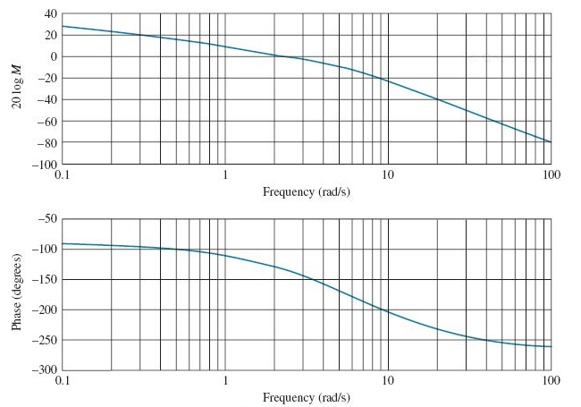

Chapter 11 Problem 2b

Chapter 11 Problem 5: Given the problem statement and the resulting compensator that solves the problem, explain using complete sentences and diagrams why that specific compensator (the type of compensator and the values for the gain, pole and zero) was selected.