Clay Freeman

ME486 : Finite Element Analysis

J. Mahoney – Fall 2018

FEM 010

26 November 2018

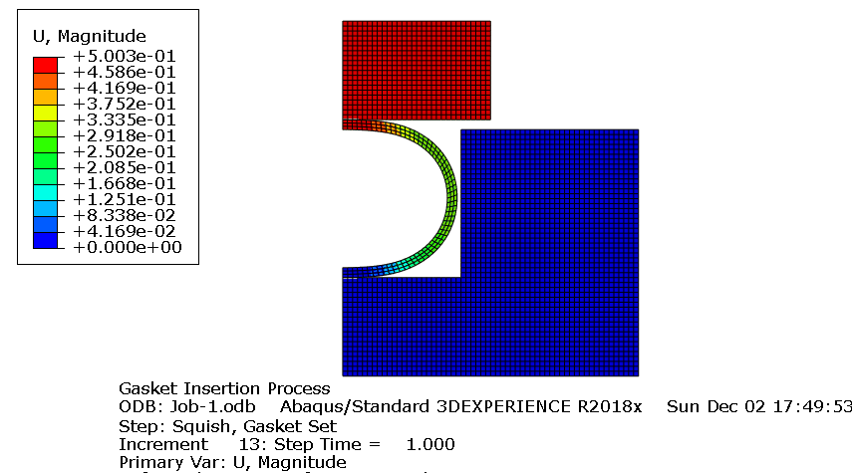

The tool displaced 0.5 inches, but the model did not show that the model tool made contact with the pocket during insertion.

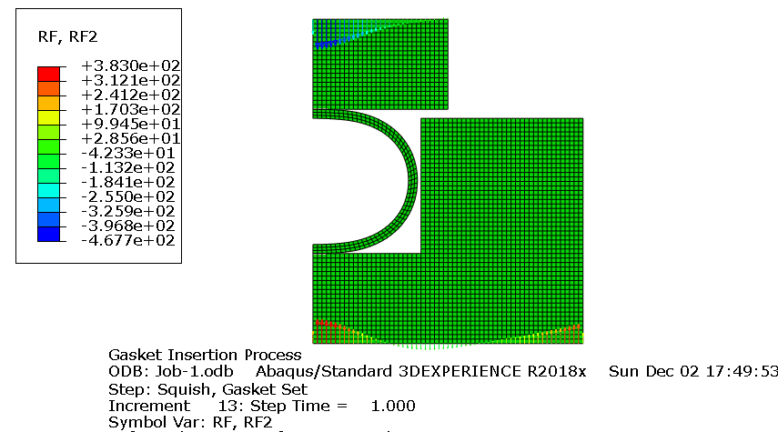

The gasket took 383 pounds of force to insert and seal against the pocket.

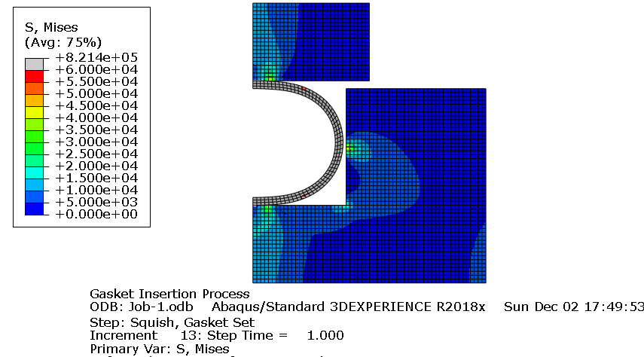

The shape of the von Mises stress curves follows the expected pattern for the compression forces on the gasket between pocket and tool.

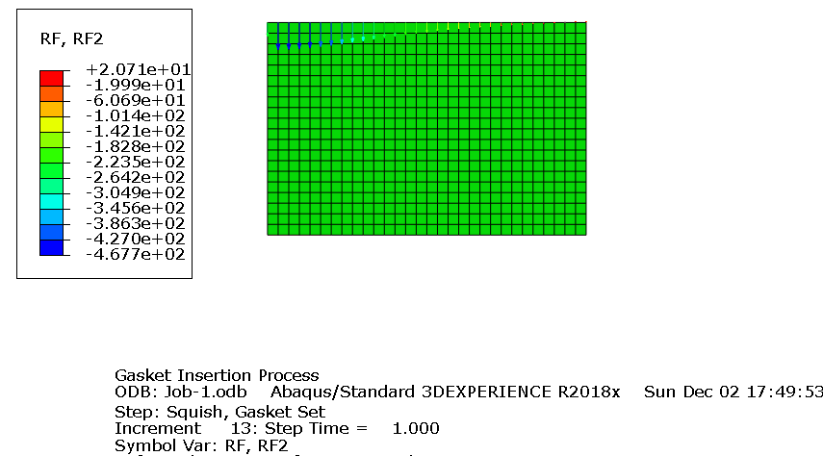

The reaction force on the tool is about 46.77 pounds.

Validation can take place from finding the surface stress forces acting against the tool or the pocket block.