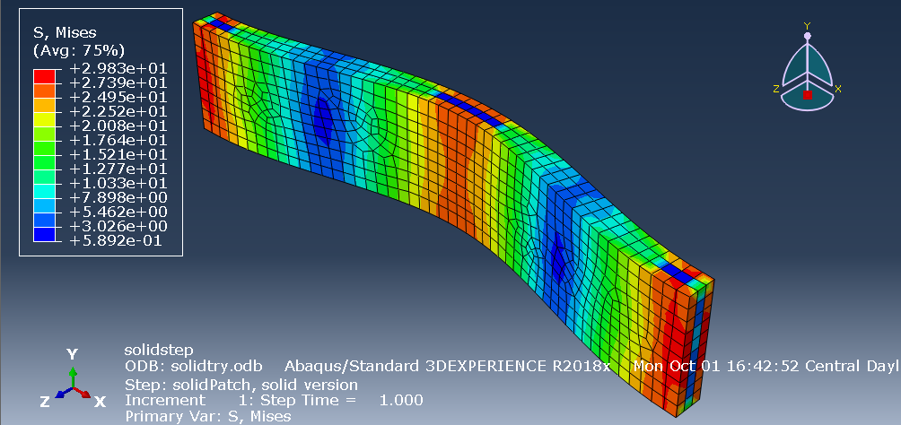

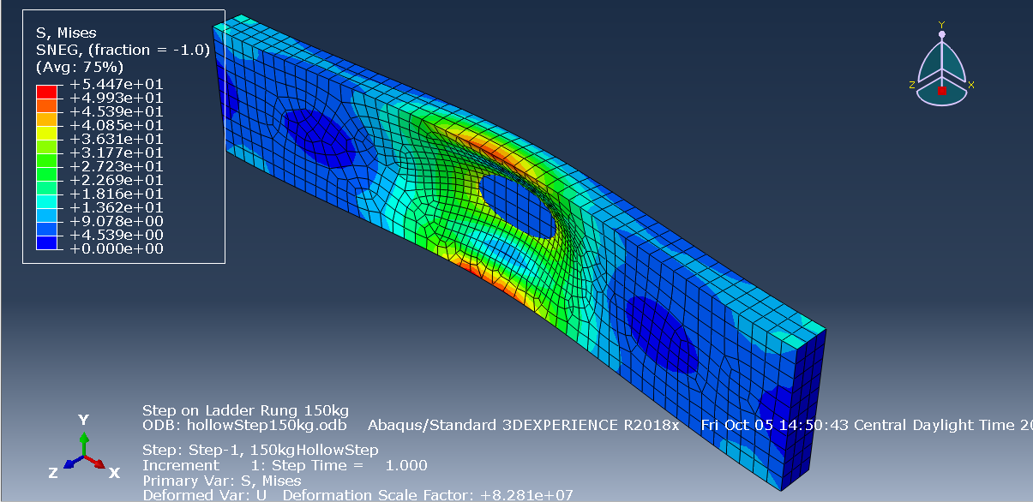

From the hand calculations, the solid bar can withstand 5740N before yielding. The hollow bar can resist 1971.4N before yielding. The Roark’s table equations and deformation results show that the hollow bar is not able to withstand the weight of a 150kg person stepping in the middle. Recommend thickening sheet metal section or continuing to use solid bar.