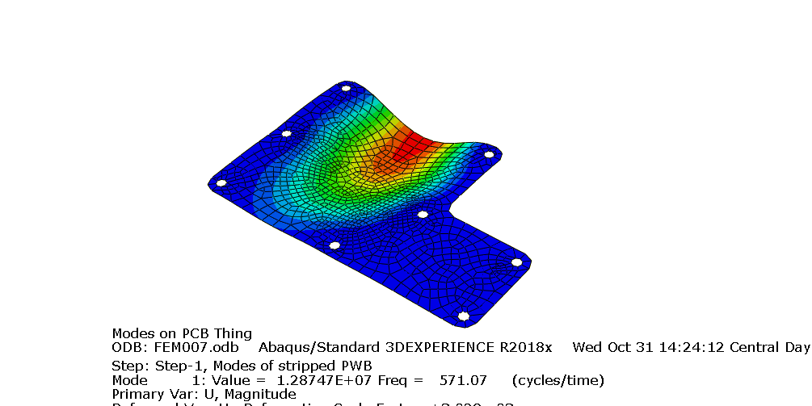

With all of the bolt holes mounted, the first mode (lowest frequency) is above the 500Hz threshold. This means that this resonance should not become a problem during normal operation.

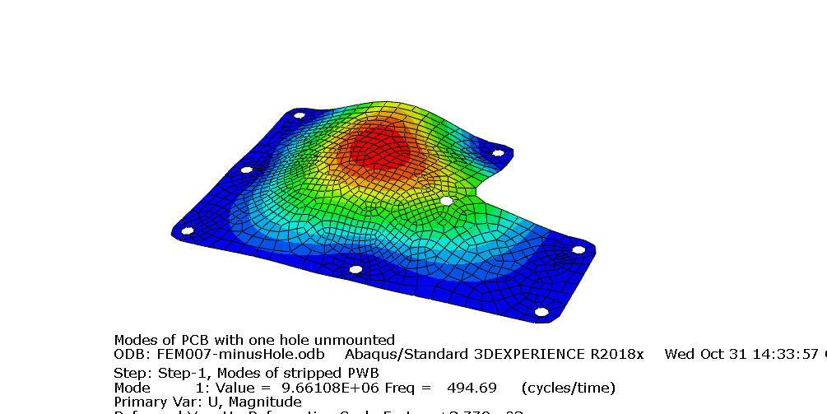

Unmounting the inside corner hole results in a mode that is at 494.69 Hz. Just below the operating frequency. Unmounting any other hole results in modes well within the operating range.

By adding a FET device. We added the mass density