Problem 1: RC Landing Gear

A.)

To close the landing gear, the device requires 2 control strings run down the length of the wing:

One string attached to a spring loaded locking mechanism for the landing legs to keep the mechanism vertical while the plane is on the ground. This string runs through eyelets along the underside of the wing and into the body. The other end of this string is tied to a small servo mounted inside the body of the plane. A signal is sent from a microcontroller to the servo which pulls on these strings, disengaging this lock so the legs can swing freely under the plane.

The second string runs along the underside of the wing and through an eyelet located approximately 30cm from the landing mount, and then tied off to another eyelet mounted on the landing gear leg just above the wheel. The other end of this string is attached to the outside of a pulley which is mounted to the output shaft of a gearbox and DC motor, all mounted in the body of the aircraft. If the landing legs are unlocked, then the microcontroller will send a signal to the motor which turns the pulley and retracts the control string, pulling the landing gear up.

Gearbox:

The Tamiya 72001 planetary gearbox kit has an available 25:1 gear ratio that will rotate the 1 inch pulley wheel fast enough to make our 1 second retraction time. Amazon says the item weighs 5.6oz or 159 grams. This one is nice because the planetary gears are aligned with the output shaft on the motor so it would fit inside the plane better. $19.20 (Pololu)

https://www.pololu.com/product/70

Motor:

Mabuchi Motor RC-260SA-2295 comes with the gearbox kit. The no-load speed is 10200 RPM with a stall torque of 13.0 mN-m. The 25:1 gear ratio will let this piece of equipment barely reach the requirements, however the datasheet shows a faster, more powerful version that should still meet the geometric requirements for the application. The motor weighs approximately 28g and Jameco sells this upgraded version for $2.75 (Jameco)

https://www.jameco.com/z/RC-260RA-2670-4-5-Volt-DC-Motor-1-58A-15-000-RPM_211246.html

Servo:

FEETECH RC Model Co. Model FS0307 is a tiny 4.4g servo that can handle the actuating of the locking mechanism for the landing gear legs. It has an operating speed of approximately 0.1sec/60 degrees, draws between 50 and 500 mA, and has a stall torque between 0.5 and 0.6 kg-cm. The exact specifications for this part depend on the tolerance, and geometry of the locking mechanism. It is possible to design a stopping lever that is gravity actuated, so the servo only needs to be strong enough to lift the lever out of the landing leg locking slot. $5.95 (Pololu)

https://www.pololu.com/product/3420

Cable:

Servocity.com sells part # 2908-0001-0005 as 5m of 100lb tensile strength cable which should be more than enough to do what is required. $2.99 (ServoCity)

https://www.servocity.com/100lb-tensile-strength-green-synthetic-cable-5-meters

Mounting Hub:

Pololu Item # 1081 is a set of universal mounting hubs to go on the end of the gearbox mounting shaft to interface with the pulley. Set of 2 $6.95 (pololu) 3.2g each.

https://www.pololu.com/product/1081

Pulley:

ServoCity Part # 615130 is a hub mount pulley that is 1” in diameter. If the cable is tied through the side plate hole carefully, with the help of a couple more metal eyelets for alignment, the cable should stay in the track. The pulley must pull 42.4 cm of cable into the body for retraction to horizontal against the wing. This means that the entire motion is completed in 5.31 revolutions. $5.99 (ServoCity) The mass is not given but the material is listed as aluminum. Assuming a solid disc, .25 inch thick and 1 inch diameter, that’s 0.196 in3 = 3.212 cm3 and aluminum density of 2700kg/m3  that comes out to about 8.6g.

https://www.servocity.com/smooth-hub-pulleys#361=267&368=229

B.)

The servo runs on 4.8 to 6v, the retracting cable runs on 3.0 - 4.5v, and the supply comes in at 12v.

POWER

5v:

A voltage from 12v to 5v can be converted by attaching the 12v wires to the prongs of a USB car charger adapter. Jameco sells one with 2.1A output for $5.95. This is plenty of current to drive the servo and power an Arduino. As a bonus, the output is in the form of a convenient USB connector.

https://www.jameco.com/z/CAR-D2A-White-Dual-Port-USB-Car-Charger-with-5V-at-2-1A-and-1A_2228391.html

3.3v:

The other side of the charger adapter puts out 1A, which can go into a LM1117T low dropout voltage regulator. $0.89 each

https://www.jameco.com/z/LM1117T-3-3-LD1117V33-Major-Brands-Low-Dropout-Regulator-3-3-Volt-1-5A-3-Pin-3-Tab-TO-220-Rail_242114.html

COMMUNICATION

Arduinos can handle the logic and different versions can operate at 3.3v or 5v. A pro mini is small and comes without headers so you can directly attach wires to the leads you need. $9.95. This makes the assumption that the transmitter has a channel that can broadcast to a 2.4GHz signal. These devices are also capable of producing a PWM output that can communicate with the servo motor.

https://www.sparkfun.com/products/11113

Sparkfun logic level shifter can bridge the gap between 3.3v or 5v logic. 6 channels for $2.95

https://www.sparkfun.com/products/12009

The NRF24L01+ is a 2.4GHz radio module that can communicate remotely with another device. These are sold for $0.99 each from Alibaba and used to be on the sparkfun website until they changed their offerings to something much more expensive. These run on 3.3v logic.

https://www.alibaba.com/product-detail/Micro-Wireless-Module-Wireless-Transmitter-Receiver_60685120213.html?spm=a2700.7724838.2017115.11.6d65308f4DWbvg&s=p

C.)

The mass of the motors, wheels, and gearbox is 201g. Electronics do not weigh much but they add up when including the wires and mounting screws etc. Estimate 100g for the electronics and we get 301g total added weight.

Some parts still need refinement and design, but the components discussed above come to a total of $57.61. This leaves plenty of room in the budget to upgrade the transponder or the driver motor to an even more powerful unit that will more easily meet the benchmarks.

D.)

In this iteration of the design, the radio signal comes from the transponder to the Arduino and out to the optocoupler to drive the motor. (don’t directly drive the motor from the Arduino power pins) The software can handle a forward or reverse command that will get relayed through the electronics to tell the motors what to do. The pilot can look at the plane and check the status of the landing gear, then adjust the position with an extra channel or switch on the transponder. I have been working on this for 3 days and it is too late to turn back and redesign it now.

Problem 2: RC Speed Control

A.)

Pololu has a magnetic wheel encoder kit that uses magnets and hall effect sensors to detect shaft rotation. This will give good feedback as to how fast the wheels are turning, assuming that the car is not slipping on dirt or gravel. This device features a simple digital output that is easy to pick up on a microcontroller.

https://www.pololu.com/product/1523

Another option is the MiniIMU combination gyro, accelerometer, and compass that uses an I2C protocol to get a signal out to a microcontroller. This could generate a similar setup as the quadcopters from lab. (Pololu)

https://www.pololu.com/product/2738

B.)

The gyroscope on the IMU should be good at detecting inclination and the hill adjustment can be made on the software level. The accelerometer would also be a good candidate for this task. Once the velocity has been calculated, the accelerometer should only have gravity remaining, which will be shared among the X, Y and Z axes (mostly the Z axis). The portion of the gravitational acceleration that is shared on an axis can be used to determine the inclination.

C.)

The GPS module would provide very useful data and help validate the results coming from the other instruments, but it would not make a good complimentary filter candidate. The sampling rate on the devices is dramatically different and the resolution on a GPS module is usually limited to a few meters’ radius from the device. Another limitation of GPS is the accuracy of the altitude measurements. The speed controller would be using feedback from the accelerometer and meshing the data with the horrible accuracy of the GPS data. If you really wanted to do this, then low pass the accelerometer and high pass the GPS.

3.) Filtering

A.)

The low pass filter on an accelerometer would be good starting place for detecting the physical position of the boat. This would attenuate the vibrations from tiny insignificant waves and the vibrations coming from the motor.

The sampling rate is over 3 times the rate coming from the quadcopters. This means that the accelerometer has the potential to produce much more noise than the datasets collected in class so far. If the low pass option does not yield the desired signal, then a band pass filter could be more appropriate. The boat motion is subject to many different forces and inputs. Careful selection of cutoff frequencies could yield the signals that most closely follow the motion of the boat.

B.)

The Butterworth filter is a good choice because it minimizes the ripple in the pass band. This is a good starting point because it usually works and the output can help inform decisions as to other filtering techniques to try. If using the band pass type, then an elliptic filter would create steep and clean transition bands at specific cutoff frequencies. The Bessel filter has a wider transition band but does not have any ripple in the pass band or the stop band.

C.)

A low pass cutoff frequency of 1Hz seems to work well with the fast and erratic motion of the quadcopters. The boat does not move as quickly so a cutoff frequency of 0.5Hz may be more appropriate. The Band pass cutoff frequencies should encompass the motion that is trying to be captured, so maybe a low cutoff of 0.25Hz and a high cutoff of 3Hz would be a good starting point. These parameters are best tuned through trial and error, so some adjustment would be necessary once the data has been plotted with these parameters.

D.)

Second order filters do not take too much computation power and they do not suffer from the phase lag of higher order filters. Since time is critical in this application, a second order filter seems the most appropriate. Also, the primary benefit of increasing the order is to generate a steeper transition band. If using an elliptic band pass filter, the transition band would be steep anyway so this benefit would not be significant in this case.

E.)

The best way to adjust the frequencies and parameters is to plot them on the same axis with the raw data. Too much noise in the desired signal could mean that the cutoff frequency needs to be adjusted. Changing the filter type can narrow the parameters down to certain frequencies if information is known about the dataset. If this does not work, then increasing the filter order will narrow the transition band allowing you to narrow in on more specific frequencies. Also, if all of these adjustments still produce excess noise, then changing the named filter type can generate data that has less ripple in the pass or stop bands. Increasing filter order can also be an indicator that the named filter type should be adjusted to get a similar suitable output from a second order filter to reduce phase lag.

Problem 4: State Estimation

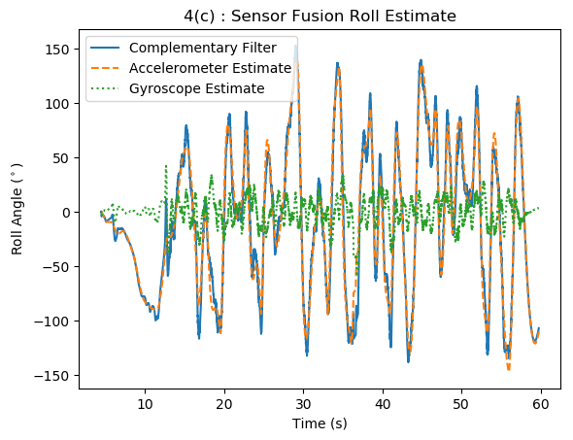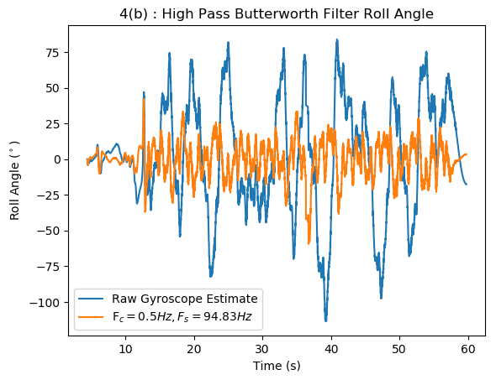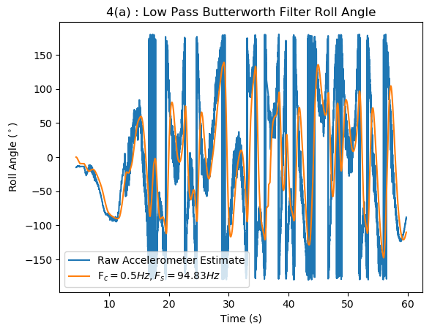

For filtering the raw data, a cutoff frequency of 0.5Hz was selected using trial and error. As the cutoff frequency increased, the Accelerometer included more noise and the gyroscope contributed less to the estimate. Decreasing the cutoff frequency resulted in data loss from the accelerometer and more noise inclusions from the gyroscope. The sampling frequency was determined by taking the average time step between the data points. Sensor fusion was performed in a complementary filter by summing the resulting roll estimates from both sensors at each data point. The accelerometer contributed the most to the complementary filter estimate while the gyroscope only made significant contributions when the accelerometer output was changing rapidly.