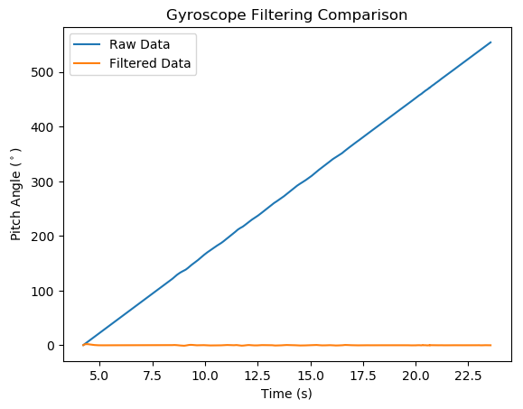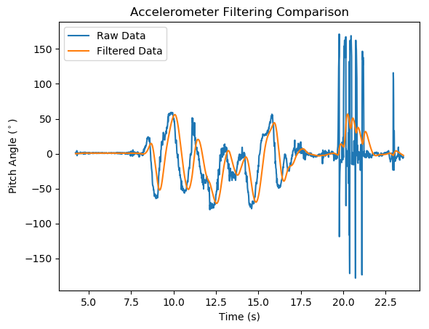Problem 1:

As expected, the accelerometer produced a noisy dataset but roughly followed the motions of the quadcopter. A second order low-pass Butterworth filter smoothed out the graph but caused a slight delay in the data output response. The sampling frequency was 100 Hz and the cutoff frequency was 1Hz for the filter output.

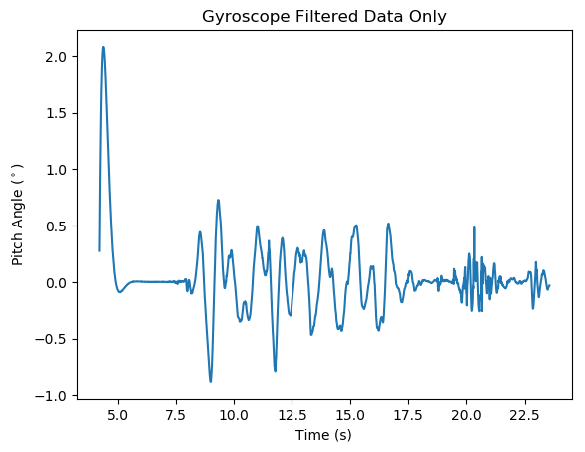The gyroscope raw data drift quickly dominated the output signal so that any variations from this device were drowned out by the scale between the two signals. Plotting the filtered data only shows modest spikes when the quad experienced motion. The direction of the graph approximates the actual movement during the trials but the gyroscope signal generally did not add more than 1 degree to the pitch angle measurement for the combination filter.

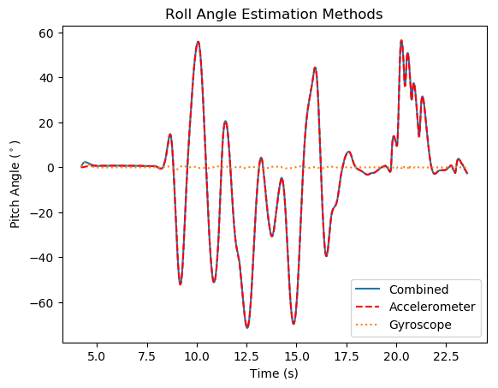Problem 2:

In the complementary filter, we simply added the output from the two instruments after filtering. The graph shows how the complimentary filter basically followed the accelerometer output while the gyroscope only contributed to the overall output when the quad was in fast motion. This can be seen by the small deviations in the gyroscope data where the accelerometer was generating a steep change in pitch angle. These results effectively mimic the actual motion of the quad during the trial.

Problem 3: