Problem 1:

1. Decreasing the proportional gain, Kp, results in slower rise time but creates less overshoot and slower steady state oscillation. This is the main damping factor that directly reflects the error value. When this value is too high, a small error creates a controller response that is too large. If this gain value is not big enough, the output does not respond strong enough to a high error value.
2. To decrease settling time, increase the integral gain, Ki. This also has the effect of decreasing the steady state error. Increasing the derivative term, Kd, will also decrease the amount of oscillations that the controller will undergo to reach the set point. The derivative term is predictive to the behavior of the system and is usually only used after the signal has been filtered.
3. Steady state error is usually corrected by increasing Ki, however in practice, this number must be extremely small for the quadcopters that are used in lab. From feedback controls, adding an integrator increases the type number of the system that causes the system response to converge to the set point. (Fadali, 2013 pg. 147)

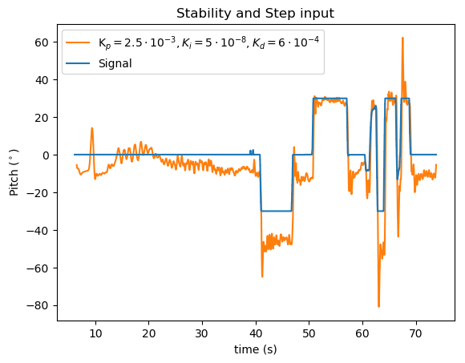Problem 2:

The first 30 seconds of this test show the stability of the quad and the steady state oscillation for a pitch input of 0 degrees. In the second half of the test, step input of 30 degrees in both directions are shown with the controller response. The faster input adjustments result in greater overshoot as the controller tries to settle back on the desired pitch angle. Throughout this test and other trials, the steady state error began near zero, oscillating around the set point but gradually increased with time. Increasing the integral gain resulted in introducing greater steady state oscillations in the data.

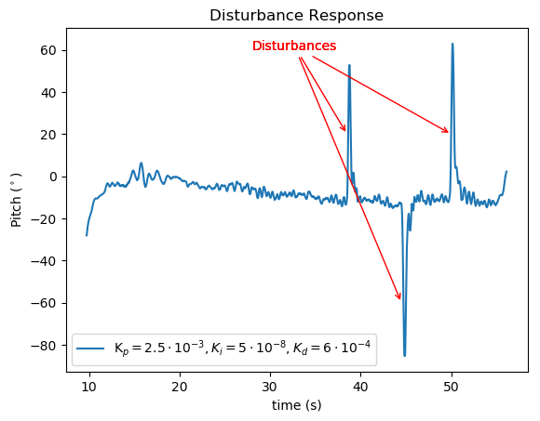Problem 3:

During this test, the quad compensated for the disturbances and immediately jumped back to the steady state oscillation values. The controller generated much more resistance to a disturbance in the clockwise (positive pitch angle) direction, while the motors were not as effective at resisting a manual disturbance that was in the same direction as the steady state error output from the controller. Another observation from this test and other trials is that this type of rotation resulted in a greater contribution to the steady state error in the long run, while the clockwise disturbances did not seem to affect the regular progression of the steady state error accumulation.