Benchmarking Design 1: Parker Hydraulic Hose Crimping Die

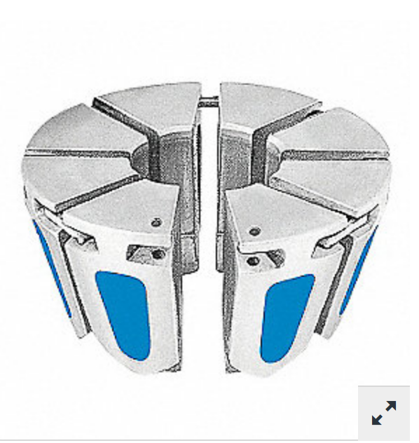
Previous attempts at a redesign for a crimping mechanism involve a collet type mechanism where a sleeve slides down from above against wedge shaped tools that close in on the case mouth to produce the first folding procedure. One current collet crimping idea would be similar to this crimping die. This device is used to attach brass or steel fittings to steel reinforced rubber tubing using a pressed crimp fit.

These dies cost around $250 each from grainger.com (Item # 21A869) and are made from hardened stainless steel. The blue wear strip inserts on each of the die segments create a low friction surface for the press to seat the tooling against the workpiece. This would be a modular design that could be exchanged out for crimping different calibers of ammunition using the same machine interface.

This is an example of the desired motion required to impart the initial mouth deformation to close the neck of the case. This type of device should be able to reliably impart the lateral forces for millions of cycles without scratching or deforming the case. The challenge with this type of geometric configuration is that the downward force from the actuating arm of the legacy loading machine needs to be converted to horizontal motion with some kind of sliding or lever actuating mechanism to convert the motion by 90 degrees.

This tool type would need to be redesigned with hardened oil impregnated steel teeth that could be quickly changed out for maintenance. Collet style devices tend to get stuck on the parts, which would defeat the purpose of this design. The internal case mouth waterproofing applied to all .50 caliber legacy style cases also has a tendency to squeeze out during this procedure. If the collet parts build up with this excess waterproofing tar then there is a chance that the tool could bind closed and cause a machine crash.

The government specification drawings for the cartridges and cases are very specific and difficult to change. The ammunition must conform to strict quality control standards to ensure the reliable and safe operation of the weapons. The new crimp design must produce a part that conforms to these dimensional requirements. The hose crimp die listed above has 8 parts, but the M1A1 cartridge crimp rosette consists of 6 points. This is another potential design focus that could create more room for a releasing movement during the machine stroke.
Benchmarking Design 2: C H Tool and Die Company Blank Crimper

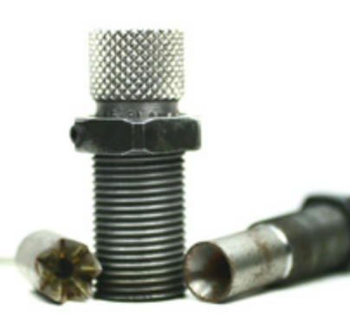
This benchmark is most similar to the existing process for generating blank ammunition. This is a two stage procedure that puts a partial fold in the case mouth at the first station, then a cone comes down to finish approximating the edges. The majority of commercially options for these crimping dies have a maximum case mouth diameter of 0.450 inches. A .50 BMG case has a case mouth opening of 0.5563 inches. This design would need to be modified in its current form, but even the hobbyists reloading dies do not address the problems that we are trying to solve.

The existing crimp die design is important because it shows the minimum required deformation in the case mouth to yield an acceptable cartridge closure. Even during normal operating conditions, the end of the crimp is not perfect, and some propellant consistently leaks from the case as the parts are inverted and placed in position for the mouth varnish.

The legacy loading machine was designed around the idea that the existing loading processes involved multiple stages of a downward stroke from above. This crimp was the state of the art design 80 years ago but materials and process knowledge has expanded since. One of the challenges with the redesign of this part is that the small profile for each of these dies has a tight fit to clear the rest of the moving parts within the machine. Collet or lever actuated devices would need to fit within a similar profile.

To improve this design, the crimping die profile geometry could be modified to be flatter to improve the release from the parts. The overall diameter might be increased or a lever movement mechanism might be included to help keep the surfaces from sticking.

These dies cost around $300 per set for a public buyer, but a failed lot of blank ammunition can cost the company thousands of dollars. There is no commercial market for these rounds if they do not meet the necessary standards to pass quality control, so everything is sent to scrap. The jammed weapons result in even more costs in man hours for cleaning and replacement parts. In this manufacturing environment, even a small improvement can result in a fast return on investment. The legacy loading machine has a maximum throughput of 60,000 parts per day. Machine crashes and down time can quickly eat into production goals. This, combined with the machine shop capabilities on plant, justifies considerable design freedom on this project to invest in a prototype if a design shows substantial promise to be effective.

