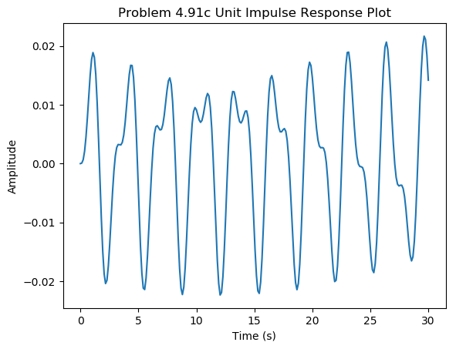

import numpy as np

import matplotlib.pyplot as plt

from scipy import signal

num = [3]

den = [10, 0, 180, 0, 540]

sys = signal.TransferFunction(num, den)

t = np.linspace(0, 30, 250)

time, imp = signal.impulse(sys, T=t)

plt.plot(time, imp)

plt.title('Problem 4.91c Unit Impulse Response Plot')

plt.xlabel('Time (s)')

plt.ylabel('Amplitude')

plt.savefig('me385p4_91plot.png', bbox_inches='tight')

plt.show()