**CS523 Computer Graphics Assignment A1**

**Group member:**

Michael Sulit (mts206), Lingyu Li(ll688), Yuyang Liu(yl1158)

Github Repository: <https://github.com/luke217/428.git>

Contribution:

Yuyang Liu: implement the curve.cpp file, fix the problems and the abnormal behaviors happened in curve3 and curve4, tried to solve the bonus problems.

Lingyu Li: generate own testcase, run all the curves testcase with and without animating Camera, record the video and upload online, debug.

Michael Sulit: none.

**Youtube Link:**

<https://www.youtube.com/playlist?list=PLXkh7XR1GR6p870BSPgh2vGWKEMWApZg3>

**Related Material:**

1. **Curve.cpp**
2. **Curve.h**
3. **mycurve.xml (our own testcase)**
4. **curve3.xml, curve4.xml (we solve the problems in these two xml file)**

**Question17:**

There is some abnormal behaviors when we ran the testcases of curve3.xml and curve4.xml. What showed out on screen is a scene shaking and the curves in stage seemed like straight.

After checking the curve4.xml file, we found the problems in curve4.xml are at the <agent> and <suggestedCameraview>. The some of tags <targetTime> are the same, which means we have control points colliding! Then we solve the problem by sorting all the control points and set new <targetTime> to some of them.

After checking the curve3.xml file, we found that:

1. In the <suggestedCameraview>, the <targetTangent>of three control points of the curve of the camera's moving routine is abnormal. The tangent of the end point should be (0,0,0), and the one of the middle point should not be (0,0,0). We solving it by reset the end point' tangent to (0,0,0), and the middle one to (-2,0,0)

2.also the problems as in curve4.xml. some of the <targetTime> are the same. We reset some of them in both <suggestedCameraview> and <agent>

3.and also, the camera shaking so fiercely. It is because the <fovy> of all the points are not the same. We reset all to 45.

4.Finally, the first camera's control point's targettime must not be 0; which can lead to unfinding the first start point! we set it to 30.

**Question18:**

To change the agent of our curves, we can simply alter the value of its size in the testcase.xml file. And we can change the color of it by modifying CurveAgent.cpp. In the part below, we can change its colors.

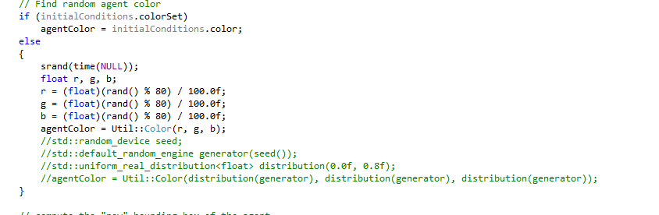

However, to change the model of our agents, we need to change the model database.

**Question19:**

After testing to replay the .rec file we created. We found that the curves were not drawed on the screen. And also the camera did not move.

The reason for this is that, the recorder only recorded the agent but leave out the drawing part and the camera part.The default command use the *SimulationRecorderModule.cpp* and *RecFilePlayerModule.cpp* to record and play.

To solve this problem, we can rewrite the *SimulationRecorderModule* to implement this kind of function.