1. Add the plugin to the Plugin Manager
   1. Make sure that the latest CGT_CoreEngine is there, too; most of my plugins will be needing that. Make sure it’s at a higher spot in the Plugin Parameters list than all my other plugins you have in there.
   2. This plugin also needs HimeWorks’s Enemy Reinforcements plugin somewhere above it in the PluginManager.
2. Double click the plugin’s entry in the manager. You should get something like this:

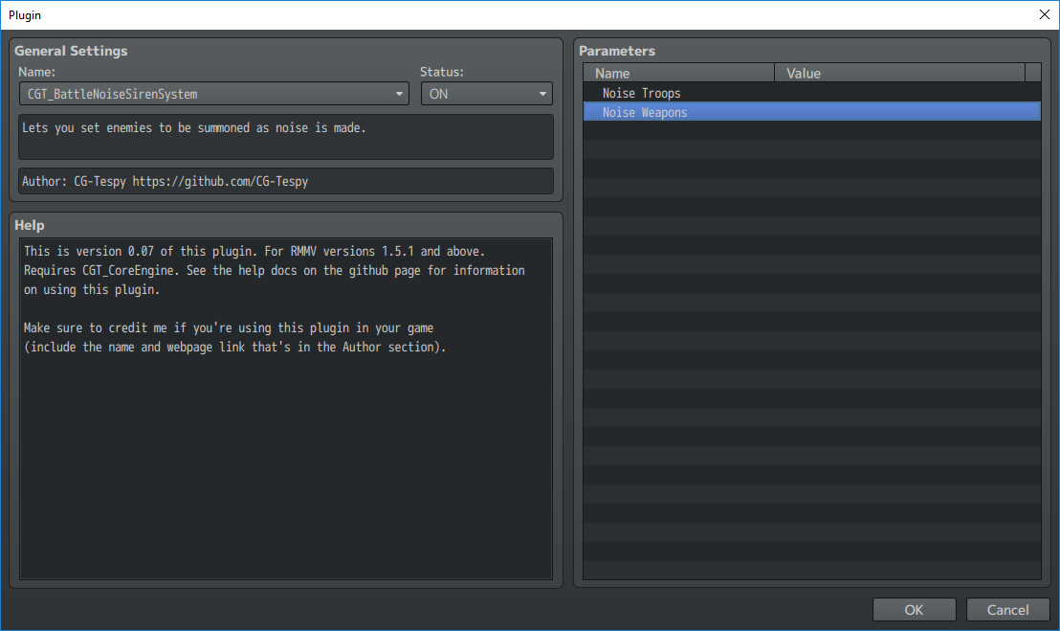

1. Double-click the Noise Troops parameter. You should then get a popup window that looks like this:

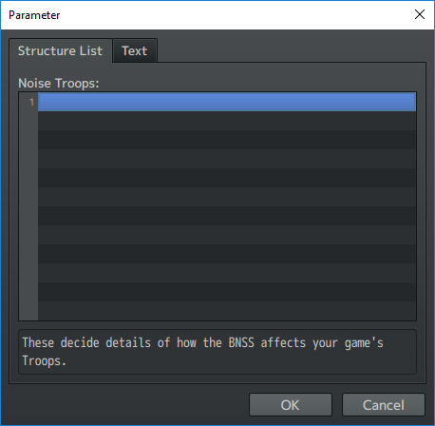

1. Double click any of the empty entries.

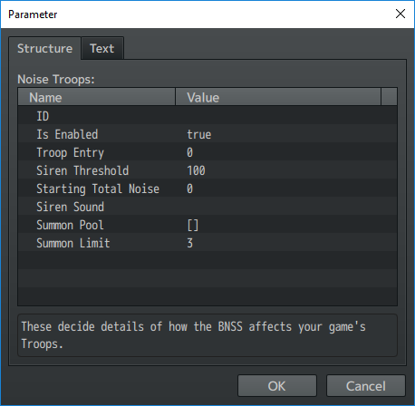

1. Be sure to enter a unique ID for this entry. Keep in mind that they’re case-sensitive to this plugin.
2. Then pick which Troop Entry this one represents. You may want some custom troops all set up before doing this step. 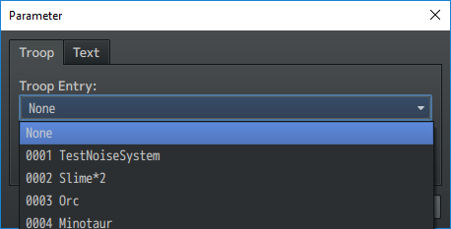
3. Set the fields as you like. Their windows should tell you what they’re for.
4. Now with a NoiseTroop all set up, we need to set up the NoiseWeapons. Create an entry for one in this plugin’s parameters.

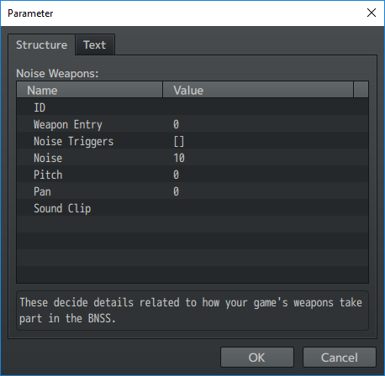

1. Set the fields as appropriate. Their windows should tell you what they do.
2. Playtest whatever troop you have your NoiseTroop representing. If there are any bugs, please PM Tespy at rpgmaker.net, or create an issue thread in this plugin’s Github page: