This tutorial assumes that you know the basics of Unity Visual Scripting.

For the demos to work, you need to make sure that some things are added to the UVS Project Settings. To start with…

Go into Project Settings → Visual Scripting and then expand the Type Options dropdown. Make sure that Double (shown at the bottom of the next screenshot) is on the list.

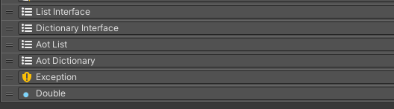

Due to how precise you need to be with loop points in audio, it’s best to use Doubles instead of Floats. Now do the same for the AudioManager class (which is under the CGT/ Aud Man Sys namespace).

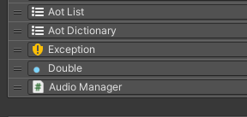

Now expand the Node Library dropdown (also in Project Settings → Visual Scripting) and make sure that Unity.TextMeshPro is on the list. It’s shown at the bottom of the next screenshot.

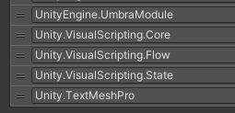

If you want to work with text fields in your own UVS projects, it’s best to use TextMeshPro instead of the legacy system anyway.

Now click Regenerate Units and have fun with the demo scenes!

