**HRM4200 Project Team and Stakeholder Management**

**Final Exam**

Please complete the following table.

| **Student Name(s)** |  |
| --- | --- |
| **Course Number** | HRM4200 |
| **Section Number** |  |
| **Professor Name** |  |
| **Date** |  |

**Please carefully read all examination instructions.**

1. This is a take-home exam to be completed in pairs. You may not collaborate with anyone outside of your pair.
2. This examination is subject to compliance with the college’s directive AA48: Academic Integrity.
3. Provide your name and date in the provided spaces.
4. This examination is worth 25 points and 25% of your total course grade.
5. Record answers directly in the space provided within this examination. You may create a diagram in another software application and cut and paste it into this document. Ensure that all your formatting is professional.
6. Submit this final exam via Turnitin through BrightSpace by the deadline provided.

***By submitting this examination you acknowledge that you have read and agree to each statement above.***

| **Grading (for Professor Use ONLY)** | |
| --- | --- |
| **Question 1** | **/out of 5 marks** |
| **Question 2** | **/out of 5 marks** |
| **Question 3** | **/out of 5 marks** |
| **Question 4** | **/out of 5 marks** |
| **Question 5** | **/out of 5 marks** |
| **TOTAL** | **/out of 25 marks** |

### Grading Rubric:

Each of the questions will be graded using the following rubric.

| Grade | Description |
| --- | --- |
| 5 | Demonstrates complete understanding of the problem/theory required. All requirements of task are included. Application of course concepts is thorough. |
| 4 | Demonstrates considerable understanding of the problem/theory required. All requirements of task are included. Application of course concepts is mostly evident. |
| 3 | Demonstrates good understanding of the problem/theory required. Many requirements of the task are included. Application of course concepts is somewhat evident. |
| 2 | Demonstrates partial understanding of the problem/theory required. Several requirements of the task are missing. Application of course concepts is limited. |
| 1 | Demonstrates little understanding of the problem/theory required. Most requirements of the task are missing. Lacks application of course concepts. |
| 0 | Demonstrates a lack of understanding of the problem/theory required, or no response provided. |

**Case Study:**

Read the following case study taken from the Catalogue of Catastrophe, as well as the background information, then answer the questions related to the case study in this document. Submit your This entire final exam via Turninin in BrightSpace by the due date.

# Super-League Soccer

*Posted on*[***April 24,***](https://calleam.com/WTPF/?p=9334)*by*[***admin***](https://calleam.com/WTPF/?author=1)

The following entry is a record in the “[**Catalogue of Catastrophe**](https://calleam.com/WTPF/?page_id=3)” – a list of failed or troubled projects from around the world.

**Organization:**Super League  
**Project type :**Establishment of a new professional sports league **Project name :** Super League  
**Date :** Apr 2021  
**Cost :** Unknown

**Synopsis :**

The public announcement of a new project can be a significant milestone. It’s an opportunity to draw media attention and generate some buzz about an upcoming product.  When done well it leaves the target stakeholders intrigued and eager for launch day to come.

Sadly, this week’s launch of the new European soccer super-league earns it a nomination for the millennium’s worst launch. With fanfare, twelve of Europe’s top soccer teams announced they were forming a new league. The plan was made public on 18th Apr 2021, but sinking like the proverbial lead balloon, the idea lasted just 2 days before being kicked to the curb!

According to reporting from the BBC: “The idea was for the clubs to remain in their national leagues, but also to play each other in a new midweek European competition, which would have rivalled the Champions League. The ESL would have had 20 teams, of which 15 founding members would be permanent and never face relegation. Five other sides would qualify each year.”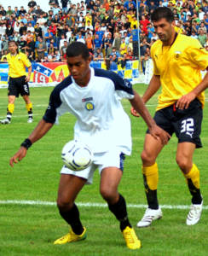

Such a plan triggered concern from fans, governing bodies and even at the highest levels of European governments.  One immediate concern was the teams who can’t be relegated to a lower league would result in less competition and chip away at the very heart of the merit based system upon which European soccer has been based for more than a hundred years: Teams that win rise up through the leagues. Teams who lose drop down.

The negative reaction seems to have come as a surprise to those behind the project.  The billionaire owners of the teams were left embarrassed and spurned.  Speaking via video to the fans of Liverpool FC, owner John Henry said

“I want to apologise to all the supporters of Liverpool football club … it should be said the project was never going to stand a chance without the support of fans … over the past 48 hours you were very clear it would not stand – we heard you. I heard you. I’m sorry … I alone am responsible for the unnecessary negativity brought forward over the past couple of days. It’s something I won’t forget and shows the power the fans have today and will rightly continue to have.”

Henry is indeed right and the project should act as a reminder to all those in the executive suit: Oftentimes the most important decision makers aren’t in the room – That is the consumers.

Reference link: <https://calleam.com/WTPF/?p=9334>

## Background Information:

### Super League: Why have the plans collapsed?

Published 21 April 2021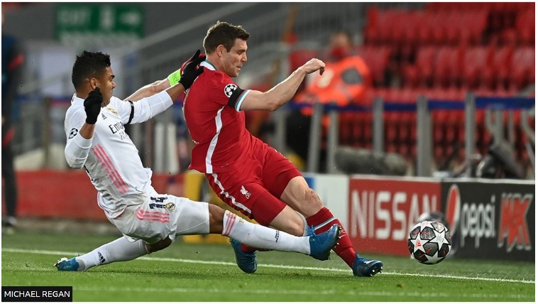

**Plans for a new football European Super League (ESL) have collapsed, following the withdrawal of most of the teams involved.**

The decision follows a massive backlash against the league, which had the support of some of the world's biggest clubs.

### What was the idea behind the Super League?

Six English Premier League teams had signed up to the ESL - Arsenal, Chelsea, Liverpool, Manchester City, Manchester United and Tottenham.

They joined AC Milan, Atletico Madrid, Barcelona, Inter Milan, Juventus and Real Madrid as founder members.

The idea was for the clubs to remain in their national leagues, but also to play each other in a new midweek European competition, which would have rivalled the Champions League.

The ESL would have had 20 teams, of which 15 founding members would be permanent and never face relegation. Five other sides would qualify each year.

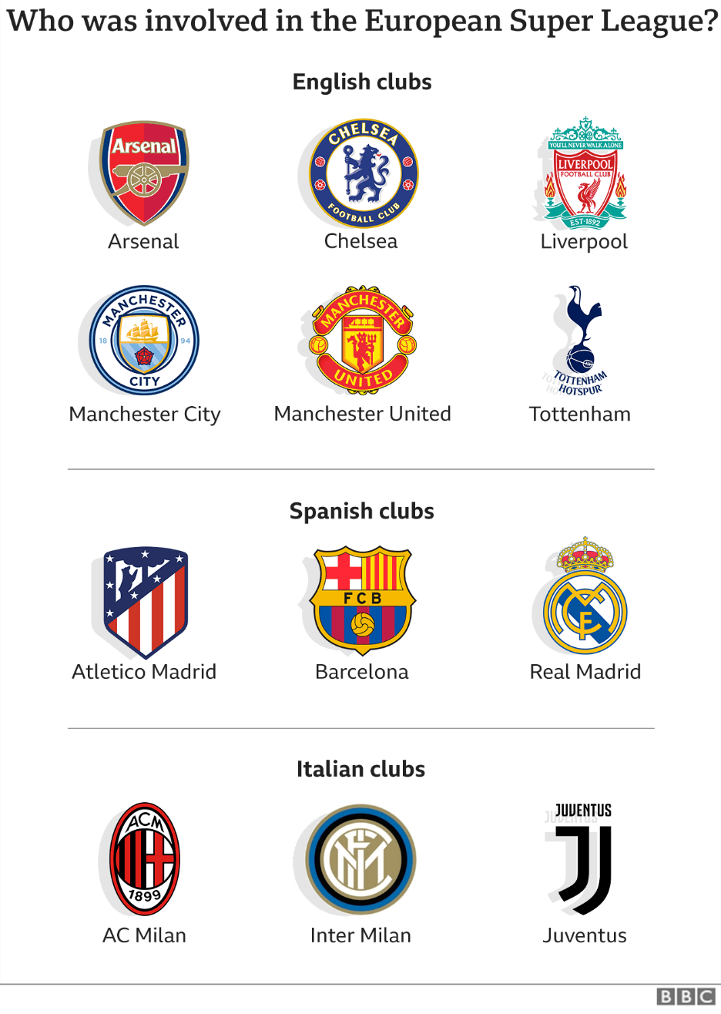

## What's now happened?

All six English Premier League clubs dropped out of the project on Tuesday night.

They have now been followed by Atletico Madrid in Spain and Italian team Inter Milan.

One of the chief movers behind the ESL, Juventus chairman Andrea Agnelli, has now admitted that the ESL is not likely to go ahead.

"I remain convinced of the beauty of that project," he said. "But evidently no, I don't think that project is now still up and running."

* [**ESL 'cannot now proceed'**](https://www.bbc.co.uk/sport/football/56830308)
* [**How football's volatile 72 hours unfolded**](https://www.bbc.com/sport/football/56825570)

## Why was the plan so controversial?

With 15 teams in the ESL not facing qualification or relegation, critics said it would have devalued the game because it was unfair and uncompetitive.

For instance, Arsenal have not qualified for the Champions League since the 2016-17 season, but they would have been guaranteed a place - regardless of how they performed in the domestic league.

However, a future winner of the Premier League would not necessarily have qualified for the ESL if they were not a permanent member.

If this were the case, that team would miss out on millions of pounds in revenue.

The ESL attracted widespread criticism from pundits, players, MPs and most football bodies not involved.

Fans of the clubs involved held several protests outside their grounds.

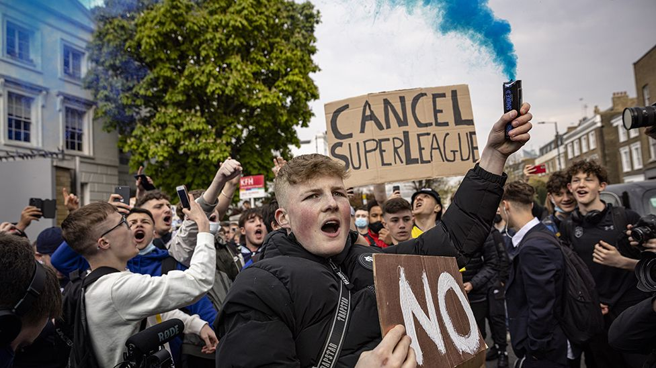IMAGE SOURCE,GETTY IMAGES

Image caption: Chelsea fans protest against plans for a European Super League ahead of the club's game against Brighton

## Why did the English teams drop out?

It appears they were taken aback by the strength of criticism.

Arsenal apologised in an open letter to their fans and said they had "made a mistake", adding they were withdrawing after listening to supporters and the "wider football community".

Tottenham chairman Daniel Levy said the club regretted the "anxiety and upset" caused by the proposal.

Manchester United said they had "listened carefully to the reaction from our fans, the UK government and other key stakeholders," in making their decision.

## Why did the teams want a Super League?

Real Madrid president Florentino Perez [**had claimed it would "save football"**](https://www.bbc.co.uk/sport/football/56812151), at a time when young people are "no longer interested" because of "a lot of poor quality games".

The founding clubs were promised a share of a €3.5bn (£3bn) grant, provided by investment bank JP Morgan.

Most are in considerable debt, [**made worse by the Covid pandemic**](https://www.bbc.co.uk/sport/football/54631788), due to disrupted fixtures and a lack of spectators.

Big clubs also have superstar players with multi-million pound salaries.

If they could guarantee taking part in a major European football competition every year, they would have become more valuable and stable businesses.

* [**Super League makes financial sense for top clubs**](https://www.bbc.co.uk/news/business-56800611)

## How would it have worked?

The 20-team league would have been split into two groups of 10, playing each other at home and away.

The top three in each group would have qualified for the quarter-finals, with the fourth and fifth-placed teams competing in a two-legged play-off for the two remaining spots.

It would then have the same two-leg knockout format used in the Champions League, with a final in May.

## What have football's ruling bodies said?

The president of Uefa (the Union of European Football Associations), Aleksander Ceferin, had warned that participating clubs could be banned from European competition, and their players prevented from appearing at the Euros and the World Cup.

Mr Ceferin welcomed the English clubs' reversal, saying, "the important thing now is that we move on, rebuild the unity that the game enjoyed before this, and move forward together".

Reference link: [**Super League: Why have the plans collapsed?**](https://www.bbc.com/news/business-56768728)

# European Super League: All six Premier League teams withdraw from competition

Last updated on 21 April 2021

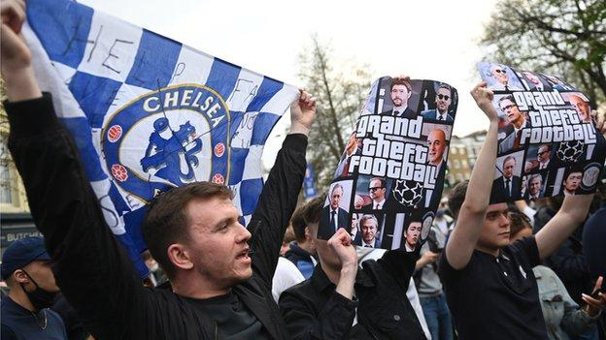Chelsea fans protested against their involvement in the European Super League outside Stamford Bridge

**All six Premier League teams involved in the European Super League (ESL) have now withdrawn from the competition.**

Manchester City were the first club to pull out after Chelsea had signalled their intent to do so by preparing documentation to withdraw.

The other four sides - Arsenal, Liverpool, Manchester United and Tottenham - have all now followed suit.

Italian side Inter Milan are also set to withdraw as they no longer wish to be involved with the project.

BBC Sport understands bosses at the Serie A club are preparing for their exit following Tuesday night's dramatic developments.

* [**How football's volatile 48 hours unfolded**](https://www.bbc.co.uk/sport/football/56825570)

The 12-team Super League, set up by the seven afore-mentioned teams and Spain's Atletico Madrid, Barcelona and Real Madrid and Italy's AC Milan and Juventus was [**announced on Sunday**](https://www.bbc.co.uk/sport/football/56795811) to widespread condemnation.

"Despite the announced departure of the English clubs, forced to take such decisions due to the pressure put on them, we are convinced our proposal is fully aligned with European law and regulations," the ESL said on Wednesday, adding it was "convinced that the current status quo of European football needs to change".

In an interview with Italian newspaper la Repubblica, Juventus chairman Andrea Agnelli said the remaining clubs will "press ahead" and the project still had "a 100% chance of being a success".,

"Real Madrid president Florentino Perez is insisting on the idea of keeping the group together to push for change," says Spanish football expert Guillem Balague.

Liverpool owner John W Henry apologises in message to fans

"Barcelona say they agreed to the ESL, but only if the Season Ticket Holders Assembly approve it, which could be their way out."

Balague also says Atletico Madrid are meeting on Wednesday morning to review their position.

* [**'Owners of big six must beg for forgiveness'**](https://www.bbc.co.uk/sport/football/56825352)
* [**Super League unravels; Woodward to resign - how dramatic evening unfolded**](https://www.bbc.co.uk/sport/live/football/56812305)

Manchester City confirmed they have "formally enacted the procedures to withdraw" from the Super League.

Liverpool said their involvement in the proposed breakaway league "has been discontinued".

Manchester United said they had "listened carefully to the reaction from our fans, the UK government and other key stakeholders" in making their decision to not take part.

Arsenal apologised in an open letter to their fans and said they had "made a mistake", adding they were withdrawing after listening to them and the "wider football community".

Tottenham chairman Daniel Levy said the club regretted the "anxiety and upset" caused by the proposal.

Chelsea confirmed they have "begun the formal procedures for withdrawal from the group" that they only joined "late last week".

### 'Admirable to admit a mistake ' - Uefa

Uefa president Aleksander Ceferin welcomed the reversal, adding: "I said yesterday that it is admirable to admit a mistake and these clubs made a big mistake.

"But they are back in the fold now and I know they have a lot to offer not just to our competitions but to the whole of the European game.

"The important thing now is that we move on, rebuild the unity that the game enjoyed before this and move forward together."

UK Prime Minister Boris Johnson [**posted on Twitter:**](https://twitter.com/BorisJohnson/status/1384741796664823808) "I welcome last night's announcement. This is the right result for football fans, clubs, and communities across the country. We must continue to protect our cherished national game."

Labour leader Keir Starmer [**added**](https://twitter.com/Keir_Starmer/status/1384568257047302146) that this "must be a watershed moment, where we change our game to put fans first again", while Liberal Democrats leader Ed Davey [**tweeted:**](https://twitter.com/EdwardJDavey/status/1384632496659308546) "This must be the start of a fans-led football revolution."

In a statement, the European Super League said: "Given the current circumstances we shall reconsider the most appropriate steps to reshape the project, always having in mind our goals of offering fans the best experience possible while enhancing solidarity payments for the entire football community."

English football's 'big six' were part of a group that announced plans to form the breakaway league, which they hoped to establish as a new midweek competition.

It was condemned by fans, football authorities and government ministers in the UK and across Europe by Uefa and league associations.

Around 1,000 fans gathered outside Chelsea's Stamford Bridge ground [**before their game against Brighton on Tuesday**](https://www.bbc.co.uk/sport/live/football/56581964) to protest at their club's involvement.

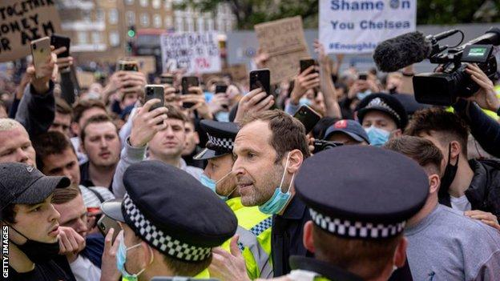Chelsea legend Petr Cech pleaded with fans to disperse outside the ground before their match against Brighton

Manchester United executive vice-chairman Ed Woodward, who was involved in the Super League discussions, has [**announced he will step down**](https://www.bbc.co.uk/sport/football/56824130) from his role at the end of 2021.

Leading players at some of the six clubs signalled their disapproval of the planned breakaway league.

Liverpool captain [**Jordan Henderson said on social media**](https://twitter.com/JHenderson/status/1384597901079371778) his side's "collective position" is they do not want the Super League to take place.

"We don't like it and we don't want it to happen," read a message that was also posted by many fellow Liverpool players.

After City confirmed their withdrawal, England winger Raheem Sterling posted: "Ok bye."

Uefa had hoped to stave off the threat of a European Super League with a new 36-team Champions League, which was [**agreed on Monday.**](https://www.bbc.co.uk/sport/football/56771500)

In announcing their proposals for a Super League that would eventually comprise of 20 teams, the 12-club group said the Champions League reforms did not go far enough.

Real Madrid president Florentino Perez, who was named as the ESL's chairman, said the competition [**was set up "to save football"**](https://www.bbc.co.uk/sport/football/56812151) because young people are "no longer interested" in the game because of "a lot of poor quality games".

None of the Spanish and Italian sides have yet released a statement after the six Premier League teams pulled out.

### What did each club say?

The **Arsenal**board said they did not intend to "cause such distress" and that they joined the Super League because they "did not want to be left behind" and wanted to ensure the club's future.

"Our aim is always to make the right decisions for this great football club, to protect it for the future and to take us forward," they added.

"We didn't make the right decision here, which we fully accept."

**Manchester United**said that they "remain committed to working with others across the football community to come up with sustainable solutions to the long-term challenges facing the game".

**Liverpool**said the club had "received representations from various key stakeholders, both internally and externally" before reaching their decision and thanked them for their "valuable contributions".

Levy said that **Tottenham** felt it was "important" to take part in "a possible new structure that sought to better ensure financial fair play and financial sustainability whilst delivering significantly increased support for the wider football pyramid".

He added: "We should like to thank all those supporters who presented their considered opinions."

**Chelsea**said that after having had "time to consider the matter fully" they had decided that their "continued participation in these plans would not be in the best interests of the club, our supporters or the wider football community".

**Manchester City**said they have "formally enacted the procedures to withdraw from the group developing plans for a European Super League".

Reference link: [**European Super League: All six Premier League teams withdraw from competition**](https://www.bbc.com/sport/football/56823501)

### Instructions:

For all of the following questions, use as much space as you deem appropriate to thoroughly answer the question. Answers must be logically organized, comprehensive, and thorough. Ensure that sentences are structured and words are chosen to communicate ideas clearly, and that ideas are sequenced and transitioned logically to make your ideas clear and concise. Ensure that your final document is professionally formatted, i.e. fonts and margins are consistently used, and bullets (if used) are properly structured.

In all instances, be specific and provide supporting evidence from the case study, the PMBOK®, and course materials. You may leverage all knowledge gained throughout this program. Your depth of analysis, understanding and thorough application of the program material are the critical items being assessed.

**Questions:**

1. **Conduct a Lessons Learned analysis on this project, specifying what went well and what did not go well. Provide the root cause of each issue identified. What are the top factors that you feel contributed to the failure of this project? (5 points)**

**What Went Well**

- Successful communication: The project efficiently presented its objectives to stakeholders via a well-planned media release that attracted many types of media and created public concern about the Super League.

- Swift response to feedback: Even though the project had a very short lifespan, the project team exhibited agility and responsiveness by acknowledging negative feedback from fans, clubs, governing bodies and governments which led to the cancelation of the project in two days.

**What Did Not Go Well**

- Absence of stakeholder consultation: The stakeholder at all levels were never consulted on this issue as they ought to have been especially considering the fact that no one ever talked to fans concerning their opinion on development of the super league. This was a serious omission with disastrous consequences for both perception and reality.

- Neglecting historical background: The initiatives disregarded deeply entrenched European football traditions like promotion or relegation based on merit, which has been used as a foundation for over 100 years. This miscalculation encouraged hatred among fans, clubs and governing authorities.

- Poor management of risks: The team underestimated potential reactions and costs after ignoring regulated institutions such as UEFA and FIFA. These risks were unforeseen because of failure by the projects steering committee to predict or even control them.

- Support overestimated: They thought they had enough club support without any analysis or consent from any other person thus it resulted in shock when there was mass dissent.

**Root Causes**

- Lack of stakeholder consultation arose from narrow-mindedness within top management who concentrated on financial benefits and reputation associated with Super League while failing broader stakeholder interests. As per myopia approach taken up alienated key players thereby undermining itself legally

- Ignoring historical context was arrogance by people behind this dream who refused to embrace tradition hence in turn with Europe’s economic heritage. In contrast, the lack realization that NFL has never experienced posts and relegation yet the project could not really identify with the fans.

- Poor risk management was due to failure in comprehensive assessment of risks, threat response planning and contingency plans that resulted in being caught unawares. It came as a shock because the team did not expect the level of devastation caused by this decision and had no plan B.

- Overestimation of support was due to confirmation bias on side of project team where expectations did not match reality. The confident assumption of full backing from within rather than external perspectives meant that, internally it appeared as though there were some issues around any stakeholder group members.

**Top Contributing Factors to Failure**

Lack of stakeholder consultation and engagement: stakeholder buy-in was not solicited at the formative stages of the Super League project with greatest emphasis on fans leading to a loss of its legitimacy and serious public outcry. The secrecy in which this plan was developed made supporters feel cheated hence sparking widespread demonstrations, online petitions among others disapproval on social platforms. Thus, without support from key stakeholders and lack of buying in, a project has no foundation making it impossible for it to go forward.

Ignoring historical context and traditions: overlooking Europe’s immediate soccer past that is rooted in culture and promoted a sport based on promotion of relegation systems which alienated fans, clubs, and governing bodies. Football is more than just a game; it incarnates rich heritage as well as tradition. The project became controversial because it aimed to override existing conventions within European football itself. It was wrong to disregard the emotional connections between people who root for their favorite teams passionately and those who play or manage those teams which led to failure of this undertaking.

Poor risk management and response to feedback: they failed also to take into account what would happen if they ignored established governance entities such as FIFA and UEFA, there could be negative reaction which ended up proving them wrong once again. Moreover, the rejection by individuals involved in this matter increased even after receiving humongous protests denouncing the idea thereby indicating that they are too rigid when it comes to accepting any opinion that differs from theirs. Nevertheless, if anticipatory steps were taken before things happened then due precautions would have been taken at an early stage therefore curbing reactions against the project.

Overestimation of support and failure to gauge stakeholder sentiment accurately: those spearheading the project naively felt that they had enough backing from other clubs, fans and other stakeholders without thoroughly analyzing and gaining consent in an explicit manner. Confirmation bias as well as a lack of consulting wider football community led to the perception that this initiative could have succeeded despite signs to the contrary. By assuming there was more backing than opposition to what was happening, the odds were against it because it never had enough support to navigate through all these opponents who were criticizing it.

Arrogance and disconnect from the broader soccer community: the project leaders showed pride by going ahead with their plans believing that they can restructure European football despite old conventions and interests of key stakeholders. This created tensions between those involved in this project on one side and others such as fans, clubs or governing bodies on the other side which increased resistance against them. Thus, such approach might have helped put more collaboration towards achieving better results for this project because through humility amongst all parties concerned reflectivity of different things could have been done leading to a great success of this undertaking.

In conclusion, insufficiency stakeholder consultation; neglecting historical context and traditions; inept risk-based decision making capacities; excessively high estimated support levels; proudness & separation from greater football society contributed to Super League’s collapse. In order to overcome these challenges there is need for an all-encompassing change emphasizing issues like engaging stakeholders; being humble as well as transparent which sets up a foundation for sustained prosperity.

1. **Create a Stakeholder Register and conduct a stakeholder analysis for this project. Who are your most critical stakeholders? Explain. (5 points)**

Critical Stakeholders:

1. Fans: These are main customers for soccer clubs who drive their revenues and success through loyalty and passion; they have significant influence on club decisions plus public opinion since absence of consultation with fans was one major reason for failing in their initiative.

2. Football Clubs: They include both participating and non-participating clubs which are directly affected in terms of financial stability, reputation, competitive environment by creation super league – fan backlash against participating clubs while non-participating ones remained uncertain about their future path forward;

3. European and international soccer’s governing bodies are UEFA and FIFA respectively whose authority over competitions and regulations was challenged by the activities of Super League, with their opposition and threats of sanctions being central to the project’s failure.

4. Government regulators: These were national governments, as well as supranational entities, which had oversight on sports governance, legislation and regulation; they posed serious threats to this initiative through their intervention and opposition. Political pressure from governments, especially in the UK, contributed to the demise of the Super League.

5. Sponsors and broadcasters: They are financiers or media companies for football clubs or tournaments who rely on success or stability of a sport for their partnerships or investments. Sponsors as well as broadcasters voiced out their anxiety regarding possible implications of that league on their commercial interests and viewership numbers.

1. **Describe this project’s governance and team structure. How effective are these? What changes would you make to the governance and/or team structure if you were to run this project to effectively meet the project objectives? (5 points)**

**Governance**

The management system of this project was such that its decision making power rested with owners or executives from those founding clubs while other stakeholders like non-participating teams, governing bodies plus fans were underrepresented. In reality this top-bottom approach failed to anticipate let alone address concerns raised by key stakeholders when it led to an outrage.

**Team Structure**

Executive members hailing from founding institutions probably made up the team involved in initiating it along with its legal-financial advisers. Nonetheless due to absence different perspectives involving various stakeholders during decision making process there were blind spots hence miscalculations about feasibility/viability of this plan.

**Effectiveness and Changes**

It is said that the governance and team structure lacked inclusivity making them ineffective thus failed because they didn’t involve all important stakeholders in it such as fans, governing bodies together with non-participating clubs. This project can become more effective if its governance model changes into one that is inclusive transparently incorporating fan representatives from governing organs as well as non-participating clubs. Furthermore enhancing decision making through involving such experts in stakeholder engagement, risk management and change management would also minimise risks.

1. **Create a stakeholder engagement plan that addresses the issues you have identified and would set up a project such as this one to effectively meet the project objectives. (5 points)**

**Objectives**

1. Ensure continuous communication with key stakeholders such as fans, clubs, governing bodies and governments.

2. Obtain input from the various categories of stakeholders at all stages of project execution from idea formulation to implementation time.

3. Be proactive in handling concerns and objections by being sensitive to what the stakeholders need or value most.

4. Engage all relevant stakeholders when making decisions in order to build trust and consensus among them through transparent, inclusive and collaborative processes

**Strategies**

1. Identify major concerns, expectations and priorities through a stakeholder analysis process.

2. Using different channels like forums, social media platforms and town hall meetings come up with customized approaches for each stakeholder group.

3. Deploy feedback mechanisms that include surveys, focus groups or advisory panels capable of gathering information about needs/sentiments of concerned parties.

4. Create a dedicated team responsible for engaging these players more effectively while dealing with inquiries as well as relating with leaders behind this project.

1. **Create a communication and change management plan to effectively meet the project objectives. (5 points)**

**Objectives**

1. All stakeholders should be able to clearly see the objectives of the program while getting an understanding of why it has been set up by communicating project goals consistently.

2. Articulate people’s concerns that help manage apprehension amongst them hence reducing resistance resulting from misinformed skeptics.

3. The provision of timely accurate information on; milestones achieved developments or changes made will go a long way in ensuring smooth transitions as well as minimizing disruptions resulting from this project.

4.To encourage buy-in for its intended results therefore promote open collaboration working relationships among members involved in promoting mutual trust amongst different parties.

**Strategies**

1.A detailed communication plan that contains target audience(s), timetable(s) plus message points must be prepared.

2. A single centralized place for updating, posting things to stakeholders should be made.

3. Effective communication techniques like active listening and conflict resolution skills have to be learned by both team members as well as key stakeholders for this project.

4. To enhance project changes and initiatives, use change management strategies such as stakeholder involvement, training and support.

5. Strategies may be modified to address changing concerns or emerging issues based on feedback mechanisms and performance metrics used in monitoring communication effectiveness.